RF, Microwave, and Transceivers
Book 4 of the Electrical Engineering Series
Lothar J. Musiol
Copyright © 2026 Lothar J. Musiol. All rights reserved. Kindle edition.
Lines, Matching, Filters, Antennas, Power Amplifiers, Receivers, and Synthesizers, from 1 GHz to Millimeter Wave

How to Use This Book
Books 1 to 3 built circuits on the assumption that a wire has no length. This book drops that assumption and follows a radio from the copper to the air. Part I, Chapters 1 to 19, is the passive structure: the transmission line and reflection, lumped and distributed matching and the Smith chart, scattering parameters, resonators, filters and waveguide, the antenna and the array, couplers and dividers, microstrip and stripline, broadband matching, cavities, small antennas and horns, propagation, ferrites and circulators, antenna measurement, noise in passive networks, a filter carried from specification to layout, and RF switches.
Part II, Chapters 20 to 41, follows the active radio from transmitter to antenna and through the receiver, oscillator, and radar. It covers the load line, amplifier classes, Doherty amplification, heat and power combining, receiver noise and dynamic range, the oscillator and PLL, and radar.
Chapters 28 to 40 deepen this chain: the low-noise amplifier, mixers and frequency planning, the link budget, bias and ruggedness, vacuum tubes, RF exposure, transceiver isolation, class E and F design, envelope tracking and outphasing, amplifier measurement, digital predistortion, frequency synthesis, and power detection and control. Chapter 41 compares amplifier classes A through S, Doherty, and outphasing, then explains how an envelope-tracking supply can raise average efficiency by boosting its rail on signal peaks.
Part III, Chapters 42 to 47, moves from amplifier principles to device technologies and design. Chapter 42 treats CMOS power amplifiers and breakdown limits; Chapter 43 is a class-by-class design cookbook. Chapter 44 develops a GaAs handset amplifier and pHEMT; Chapter 45 designs GaN broadband, Doherty, and space amplifiers. Chapter 46 designs RF SOI switches and surveys SiGe, InP, and emerging materials for millimeter and submillimeter waves. Chapter 47 designs with acoustic and micromechanical filters used in smartphone front ends.
Part IV, Chapters 48 to 52, starts with measured data and ends at the bench. It covers Touchstone files and noise parameters, FMCW radar front ends, microwave photonics and optical phased arrays, buildable receivers, and antennas for satellites, GPS, LoRa, and the wider radio spectrum.

The series gives each subject one home. Device physics, including why gallium nitride withstands high voltage, is Book 3's. The waveform, OFDM, and the band plan are Book 5's. Power conversion, including pulse modulators for tube transmitters, is Book 6's. Laminate properties at 10 GHz, packages, emission limits, test chambers, and certification are Book 7's. Readers who want the next level of depth should turn to the texts in Appendix C; this book's explanations, examples, and problems are its own.

Contents
Part I. Passive Structures: Lines, Matching, Filters, and Antennas
Chapter 1. When a Wire Stops Being a Wire
Chapter 2. Transmission Lines and Reflection
Chapter 3. Lumped Matching: The L-Network and Its Q
Chapter 4. Distributed Matching and the Smith Chart at Work
Chapter 5. Scattering Parameters
Chapter 6. Resonators, Filters, and Waveguide
Chapter 7. The Antenna
Chapter 8. Arrays, Beam Steering, and Millimeter Wave
Chapter 9. Couplers, Dividers, and Hybrids
Chapter 10. Microstrip and Stripline by Design
Chapter 11. Broadband Matching and the Bode-Fano Limit
Chapter 12. Cavities and Dielectric Resonators
Chapter 13. Small Antennas, Monopoles, Loops, and Horns
Chapter 14. Propagation Beyond Free Space
Chapter 15. Ferrites, Circulators, and Isolators
Chapter 16. Measuring Antennas: Ranges and Gain
Chapter 17. Noise in Passive Networks
Chapter 18. A Bandpass Filter from Specification to Coupling Design
Chapter 19. RF Switches
Part II. Active Circuits: Amplifiers, Receivers, Oscillators, and Synthesizers
Chapter 20. The Transmitter Chain and Its Devices
Chapter 21. The Load Line
Chapter 22. Amplifier Classes and Efficiency
Chapter 23. Linearity, Back-Off, and the Doherty Amplifier
Chapter 24. Heat, Combining, and the Path to the Antenna
Chapter 25. Receiver Noise and Dynamic Range
Chapter 26. Oscillators, Phase Noise, and the PLL
Chapter 27. Radar
Chapter 28. The Low-Noise Amplifier
Chapter 29. Mixers and Frequency Planning
Chapter 30. The Link Budget
Chapter 31. Bias, Ruggedness, and Protection
Chapter 32. Vacuum Tubes: Klystrons, TWTs, and Magnetrons
Chapter 33. RF Exposure and Safety
Chapter 34. Transceiver Architectures and Isolation
Chapter 35. Designing Class E and Class F Amplifiers
Chapter 36. Envelope Tracking, Polar, and Outphasing
Chapter 37. Measuring a Power Amplifier
Chapter 38. Digital Predistortion
Chapter 39. Frequency Synthesis: Fractional-N and DDS
Chapter 40. Power Detection and Power Control
Chapter 41. Power Amplifier Classes Side by Side, and Boosting the Supply on Peaks
Part III. Device Technologies and Power-Amplifier Design
Chapter 42. CMOS Power Amplifiers: Beating the Breakdown Limit
Chapter 43. A Design Cookbook, Class by Class
Chapter 44. Gallium Arsenide: The Handset Amplifier and the pHEMT
Chapter 45. Gallium Nitride: Broadband, Doherty, and Space Amplifiers
Chapter 46. RF SOI, SiGe, InP, and the Materials Still in the Lab
Chapter 47. Acoustic and Micro-Mechanical Filters: SAW, BAW, XBAR, and the Smartphone Front End
Part IV. Measured Data, Sensing, Light, and the Bench Radio
Chapter 48. Touchstone Files and Noise Parameters: Designing from Measured Data
Chapter 49. FMCW Radar Front Ends at 24, 60, and 77 GHz
Chapter 50. Microwave Photonics: Radio over Light and Optical Phased Arrays
Chapter 51. Receivers and Transmitters You Can Build
Chapter 52. Antennas and the Sky: LoRa, GPS, Satellites, and the Hydrogen Line
Appendix A. Constants and Formulas Used in This Book
Appendix B. Answers to the Practice Problems
Appendix C. Sources
About the Author
Also by Lothar J. Musiol

Part I. Passive Structures: Lines, Matching, Filters, and Antennas

Chapter 1. When a Wire Stops Being a Wire
Mount a 10 pF capacitor on its pads, feed it 2.45 GHz, and it is no longer a capacitor. Its 0.8 nH of mounted inductance resonates with it at 1.78 GHz, and above that frequency the part behaves as a small inductor. Nothing about the part changed. The frequency did, and that is the whole subject of this book.
Where you meet this: Every Wi-Fi, Bluetooth, and cellular board, every SMA connector and coax jumper, and every data sheet that quotes power in dBm.
Book 1 solved circuits in which a wire has no length: the voltage at one end equals the voltage at the other, at every instant. That assumption is excellent as long as a signal's wavelength is much longer than the circuit. At radio frequencies it fails, and the failure is the whole subject of this book. A trace becomes a transmission line, a capacitor becomes an inductor, and a connection becomes a radiator. This chapter sets out where the boundary lies, fixes the units the rest of the book uses, and makes one claim that shapes the series: millimeter wave is not a separate subject. It is this subject at a shorter wavelength, with less forgiveness.

1.1 Wavelength sets the scale
A signal of frequency f travels at the speed of light in vacuum, c = 2.998 × 10⁸ m/s, and more slowly in a dielectric. In a line fully surrounded by a dielectric of relative permittivity εr, such as a stripline buried inside a circuit board, the speed falls by √εr, and so does the wavelength. A partially surrounded line, such as a microstrip on the surface of a board, uses an effective permittivity εeff between 1 and εr, which Chapter 2 calculates.
λ0 = c / f, λg = λ0 / √εeff
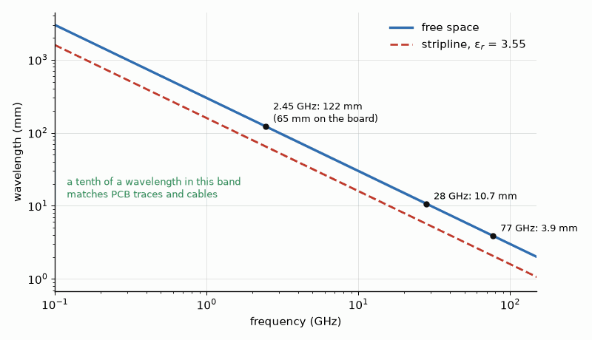
Figure 1.1 — Wavelength shrinks with frequency. At 2.45 GHz it is 122 mm in air and 65 mm on a stripline board, about the length of a credit card; at 77 GHz it is under 4 mm.

Worked Example 1.1
Problem. Find the free-space wavelength at 2.45 GHz, 28 GHz, and 77 GHz, and the guided wavelength at 2.45 GHz in a stripline on a laminate with εr = 3.55.
Solution. λ0 = 2.998 × 10⁸/2.45 × 10⁹ = 12.24 cm at 2.45 GHz, 10.7 mm at 28 GHz, and 3.89 mm at 77 GHz. In the stripline, λg = 12.24/√3.55 = 12.24/1.884 = 6.49 cm. A Wi-Fi signal's wavelength on the board is the size of a credit card; a 77 GHz automotive radar's wavelength in air is smaller than a fingernail.
A common rule of thumb treats a circuit as lumped when its largest dimension is below about one tenth of the guided wavelength. A 1 cm trace in the stripline above reaches that limit at the frequency where λg = 10 cm, which is 2.998 × 10⁸/(1.884 × 0.10) = 1.6 GHz. Below that, Book 1's circuit laws work with small corrections. Above it, the trace must be treated as a line with a characteristic impedance and a delay.
Key idea. A wire is a wire only when it is short compared with a wavelength. Shorter wavelength is not a new subject; it is the same subject with less forgiveness.

1.2 Decibels and dBm
Radio engineering adds and subtracts in decibels because gains and losses multiply along a chain and span many orders of magnitude. A power ratio in decibels is 10 log₁₀(P₂/P₁). Absolute power is expressed relative to one milliwatt: P(dBm) = 10 log₁₀(P/1 mW). In a 50 Ω system, 0 dBm is 0.224 V rms, and every 20 dB is a factor of ten in voltage. Antenna gain relative to an isotropic radiator is written dBi. A decibel figure is always a ratio; adding two dBm values is meaningless, while adding a dBm value and a dB gain gives a dBm result.

Worked Example 1.2
Problem. A transmitter delivers 20 dBm. It passes through a cable with 3 dB of loss and an antenna with 6 dBi of gain. Find the power at the antenna input in milliwatts and the effective isotropic radiated power in dBm. Then express −100 dBm as a voltage across 50 Ω.
Solution. 20 dBm is 100 mW. After the cable, 20 − 3 = 17 dBm, which is 50 mW. The radiated power referred to an isotropic antenna is 17 + 6 = 23 dBm. For the received signal, −100 dBm is 10⁻¹³ W, and V = √(PR) = √(10⁻¹³ × 50) = 2.24 µV rms. A receiver works with microvolts while the transmitter beside it handles volts, a range of 120 dB that every layout decision must respect.

1.3 Parts that are not what they say
Every real component carries parasitic elements that a schematic leaves out, and at radio frequencies those parasitics decide what the part does. A capacitor in a small surface-mount package has an equivalent series inductance (ESL) of roughly 0.5 to 1 nH from its terminations and mounting. A resistor has a shunt capacitance across its body. An inductor has capacitance between its turns. Each part therefore has a self-resonant frequency (SRF), above which it behaves as its opposite.
fSRF = 1 / (2π √(ESL × C))

Worked Example 1.3
Problem. A 10 pF capacitor in an 0603 package has 0.8 nH of ESL as mounted. Find its self-resonant frequency and its net reactance at 2.45 GHz.
Solution. fSRF = 1/(2π √(0.8 × 10⁻⁹ × 10 × 10⁻¹²)) = 1.78 GHz. At 2.45 GHz the capacitive reactance is 1/(2π × 2.45 GHz × 10 pF) = 6.50 Ω and the inductive reactance is 2π × 2.45 GHz × 0.8 nH = 12.32 Ω, so the net reactance is +5.82 Ω: the part is an inductor of about 0.38 nH. As a DC block that is harmless; in a matching network it is a different component from the one drawn. RF designers choose capacitors by their SRF, often using a value whose series resonance falls at the operating frequency, where the part is nearly a short circuit.

1.4 The plan of this book
Chapter 2 develops the transmission line, reflection, and standing waves. Chapters 3 and 4 match one impedance to another, first with lumped components and then with lines and the Smith chart, which Book 1 introduced and this book uses as a working tool. Chapter 5 describes networks by their scattering parameters, the language of every RF datasheet and network analyzer. Chapter 6 builds resonators, filters, and waveguide. Chapter 7 treats the antenna, and Chapter 8 the array and the millimeter-wave link. Chapters 9 to 19 extend the toolkit: couplers, dividers, and hybrids; microstrip and stripline design; broadband matching and the Bode-Fano limit; cavities and dielectric resonators; small antennas, monopoles, loops, and horns; propagation beyond free space; ferrites, circulators, and isolators; antenna measurement; noise in passive networks; a bandpass filter carried from specification to layout; and RF switches. Part II, Chapters 20 to 41, turns to the active radio: amplifiers, receivers, oscillators, synthesizers, and the measurements that prove them, ending with the amplifier classes set side by side and a supply that tracks the signal and rises above its rail on the peaks. Parts III and IV, Chapters 42 to 52, follow the amplifier down to its device technologies and the acoustic filters of the phone, and then turn to measured data files, radar sensors, signals carried on light, and radios built on the bench. Transmitter power, power-amplifier design, and receiver noise belong to Part II; laminate properties at 10 GHz, the package, and emissions limits belong to Book 7. This book supplies the passive structure that connects them, and it owns the antenna gains that every link budget in the series uses.
From the Bench
Above a few hundred megahertz, check every passive part's self-resonant frequency before you trust its value. A DC-blocking capacitor works best near its series resonance, and a bypass capacitor above it is an inductor, so the 100 nF part from the digital schematic may be the wrong choice on an RF line. Think in dBm from the first day: gains and losses add, and mistakes in milliwatts get caught faster in decibels.

Practice
1. Find the free-space and stripline wavelengths at 5.8 GHz for εr = 3.55.
2. At what frequency does a 2 cm trace in the stripline of Worked Example 1.1 reach one tenth of a guided wavelength?
3. Convert 27 dBm to milliwatts and −90 dBm to microvolts rms in 50 Ω.
4. A 100 pF capacitor has 0.6 nH of ESL. Find its self-resonant frequency.
5. A signal of −30 dBm passes a 20 dB amplifier, a 2 dB filter, and a 6 dB attenuator. Find the output power.
6. Explain in one or two sentences why a capacitor is sometimes chosen so that its self-resonance falls at the operating frequency.

What You’ll Actually Use
Everyday working tools
- Wavelength λ = c/f, and λ/√εr on a board.
- dBm, dB, and the habit of adding gains and losses.
- Self-resonance of real capacitors and inductors.
Mostly for exams and deeper study
- The full field theory behind why lumped elements fail.

Chapter 2. Transmission Lines and Reflection
Clip 2 m of ordinary 50 Ω coax to an oscilloscope and at DC it looks like a 202 pF capacitor. Send a fast edge into it and for the first 20 ns, the time the edge takes to reach the far end and come back, the scope sees a plain 50 Ω resistor. Same cable, two answers. Which one is right depends on whether the edge is shorter than the trip.
Where you meet this: Every coax cable, PCB trace above a few hundred megahertz, scope probe, and antenna feed, and every VSWR or return-loss number on a data sheet.
A transmission line is two conductors with a fixed geometry along their length: a coaxial cable, a pair of traces, a trace over a ground plane. A signal launched into it travels as a wave, and the ratio of voltage to current in that wave is fixed by the geometry, not by what is connected at the far end. When the wave arrives at a load that does not have the same ratio, part of it reflects. Everything in RF design, from matching to filters to antennas, is a way of controlling those reflections, and this chapter gives the four or five formulas that describe them.

2.1 Characteristic impedance and velocity
A short piece of line has series inductance L and shunt capacitance C per unit length. A wave on a lossless line sees the ratio of voltage to current set by those two quantities alone, and travels at a speed set by their product.
Z0 = √(L / C), vp = 1 / √(L C) = c / √εeff

Worked Example 2.1
Problem. A 50 Ω coaxial cable has a velocity factor of 0.66. Find its capacitance and inductance per meter, and the delay of a 2 m length.
Solution. vp = 0.66 × 2.998 × 10⁸ = 1.98 × 10⁸ m/s. From Z0 = √(L/C) and vp = 1/√(LC), C = 1/(Z0 vp) = 1/(50 × 1.98 × 10⁸) = 101 pF/m and L = Z0/vp = 253 nH/m. A 2 m length delays the signal by 2/1.98 × 10⁸ = 10.1 ns. The same 2 m of cable at DC is 202 pF of capacitance, which is how an oscilloscope probe cable looks to a slow circuit; at 2.45 GHz it is twenty wavelengths of line.
A microstrip, a trace of width W on a dielectric of thickness h over a ground plane, is the standard line on a circuit board. Part of its field is in the dielectric and part in the air above, so its effective permittivity lies between 1 and εr. Closed-form approximations by Hammerstad and Jensen give Z0 and εeff to about 1%, and field solvers do better. On a 0.508 mm laminate with εr = 3.55, a 50 Ω microstrip is about 1.14 mm wide and has εeff ≈ 2.79, so its guided wavelength at 2.45 GHz is 12.24/√2.79 = 7.33 cm, longer than the 6.49 cm of the stripline in Chapter 1 because some of its field travels in air.

2.2 Reflection coefficient, VSWR, and return loss
At a load ZL, the reflected wave's voltage divided by the incident wave's voltage is the reflection coefficient Γ. It is a complex number of magnitude between 0 (a perfect match) and 1 (an open, a short, or a pure reactance). The incident and reflected waves add along the line into a standing wave whose maximum-to-minimum ratio is the voltage standing-wave ratio (VSWR). Three further figures express the same information: return loss, the reflected power below the incident power; mismatch loss, the power that fails to reach the load; and the transmitted fraction 1 − |Γ|².
Γ = (ZL − Z0) / (ZL + Z0), VSWR = (1 + |Γ|) / (1 − |Γ|)
RL = −20 log₁₀ |Γ| dB, ML = −10 log₁₀ (1 − |Γ|²) dB
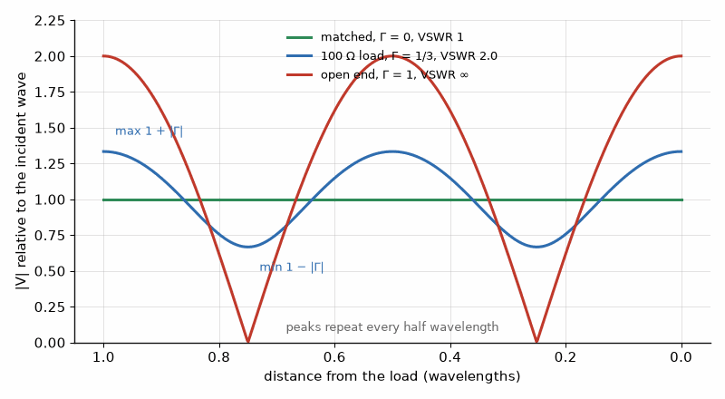
Figure 2.1 — Standing waves along a line. A matched load gives a flat voltage; a 100 Ω load on 50 Ω (VSWR 2) ripples between 2/3 and 4/3; an open end swings from zero to double.

Worked Example 2.2
Problem. A 50 Ω line is terminated in 100 Ω. Find Γ, the VSWR, the return loss, and the mismatch loss.
Solution. Γ = (100 − 50)/(100 + 50) = 1/3. VSWR = (4/3)/(2/3) = 2.0. RL = −20 log₁₀(1/3) = 9.54 dB. ML = −10 log₁₀(1 − 1/9) = 0.51 dB. A VSWR of 2 sounds alarming but costs only half a decibel of delivered power; what it more often costs is the behavior of whatever drives the line, because an amplifier designed for 50 Ω sees a load that moves around the Smith chart with cable length and frequency.
Key idea. A reflection depends only on the ratio of load to line impedance. A line of the right impedance carries any amount of power to a matched load without reflection, and a mismatch at either end reflects part of every wave that reaches it.

2.3 What a line does to an impedance
Looking into a line of length l terminated in ZL, the impedance is not ZL. The reflected wave returns with a phase delay of 2βl, where β = 2π/λg, and the input impedance rotates accordingly. Three special cases are worth remembering. A half-wavelength line repeats its load. A quarter-wavelength line inverts it, Zin = Z0²/ZL, which is the basis of the quarter-wave transformer of Chapter 4. A short-circuited line shorter than a quarter wavelength is an inductor, and an open-circuited one a capacitor.
Zin = Z0 (ZL + j Z0 tan βl) / (Z0 + j ZL tan βl)

Worked Example 2.3
Problem. Find the input impedance of a 50 Ω line one tenth of a wavelength long terminated in 100 Ω. Then find the inductance that a short-circuited 50 Ω stub one eighth of a wavelength long represents at 2.45 GHz.
Solution. βl = 36°, tan βl = 0.727. Zin = 50 (100 + j36.3)/(50 + j72.7) = 49.1 − j35.0 Ω. Only 0.1λ of line has turned a resistive 100 Ω load into an impedance with half the resistance and a large capacitive reactance, which is why a load must be specified at a reference plane. For the stub, βl = 45° and Zin = jZ0 tan 45° = j50 Ω, an inductance of 50/(2π × 2.45 × 10⁹) = 3.25 nH, realized with no wire-wound part at all.

2.4 Loss on the line
Real lines lose power in the conductors, through skin effect, and in the dielectric, through its loss tangent. Loss is quoted in decibels per meter and rises with frequency: conductor loss roughly as √f and dielectric loss as f. The skin-depth numbers belong to Book 6 and the laminate loss tangents at 10 GHz to Book 7; this book uses their consequences. One consequence surprises people: a lossy cable improves the apparent match of whatever is at its far end, because the reflected wave is attenuated twice.

Worked Example 2.4
Problem. An antenna with a 9.54 dB return loss (VSWR 2.0) is fed through a cable with 3 dB of loss. What return loss does the transmitter measure, and what fraction of the transmitter's power is radiated, ignoring antenna efficiency?
Solution. The reflection passes the cable twice, so the measured return loss is 9.54 + 2 × 3 = 15.5 dB, which looks like a VSWR of 1.4. The power is worse than it looks: half is lost in the cable on the way out, and of the half that arrives, 1 − 1/9 = 89% enters the antenna, so the antenna receives 44% of the transmitter's power. Measuring the match at the transmitter end of a long cable flatters the antenna; the measurement belongs at the antenna's terminals.
From the Bench
Learn to convert in your head: VSWR 2 is |Γ| = 1/3, about 9.5 dB return loss and half a decibel of mismatch loss. Most of the time that half decibel isn't the problem. The problem is what the reflection does to the amplifier driving the line. When a reading looks too good, remember that cable loss flatters return loss twice: 3 dB of cable makes a poor antenna look 6 dB better than it is.

Practice
1. A 75 Ω cable has a velocity factor of 0.85. Find its capacitance and inductance per meter.
2. A 50 Ω line is terminated in 75 Ω. Find Γ, VSWR, return loss, and mismatch loss.
3. A 50 Ω line is terminated in 25 Ω. Find Γ and the VSWR.
4. Find the input impedance of a quarter-wave 50 Ω line terminated in 200 Ω.
5. An open-circuited 50 Ω stub is one eighth of a wavelength long at 2.45 GHz. What capacitance does it represent?
6. Explain in one or two sentences why a load impedance must always be quoted with its reference plane at RF.

What You’ll Actually Use
Everyday working tools
- Γ = (ZL − Z0)/(ZL + Z0), VSWR, and return loss, and quick conversion between them.
- Delay per meter from the velocity factor.
- Cable loss appears twice in a return-loss measurement.
Mostly for exams and deeper study
- The telegrapher's equations in full.
- Closed-form input impedance of lossy lines.

Chapter 3. Lumped Matching: The L-Network and Its Q
A 100 W GaN transistor on a 50 V rail wants to see about 10 Ω. A 28 V transistor of the same power wants about 3. Neither one wants 50, which is what every cable, connector, and antenna offers. A matching network bridges that gap, and it comes with a price tag: the bigger the ratio, the narrower the band.
Where you meet this: The output of every power amplifier, the input of every LNA, and the two or three small parts between a radio chip and its antenna.
A source delivers its maximum power to a load whose impedance is the complex conjugate of its own. Most loads are not: a transistor's output wants a few ohms, an antenna offers whatever its geometry gives, and a cable is 50 Ω. A matching network transforms one impedance into another without dissipating power, which means it is built only from reactances. This chapter builds the simplest one, the two-element L-network, shows that its bandwidth is fixed by the ratio it must transform, and then adds a third element to trade bandwidth for control.

3.1 The L-network
An L-network has one series and one shunt reactance. The shunt element always sits across the larger resistance. Its job is to convert that large resistance, in parallel with a reactance, into an equivalent series combination whose resistance equals the smaller one; the series element then cancels the leftover reactance. Working through the conversion gives a single number that fixes both reactances: the network's Q.
Q = √(Rhigh / Rlow − 1), Xseries = Q × Rlow, Xshunt = Rhigh / Q
Each reactance may be an inductor or a capacitor, provided the two are of opposite type. A series inductor with a shunt capacitor is a low-pass network, which also attenuates harmonics, the usual choice at an amplifier output. A series capacitor with a shunt inductor is high-pass, which blocks DC and can carry bias through the inductor.

Worked Example 3.1
Problem. Design a low-pass L-network that matches a 10 Ω load to a 50 Ω source at 2.45 GHz. Then find the frequencies between which the return loss stays above 10 dB.
Solution. Q = √(50/10 − 1) = 2.0. The series reactance next to the 10 Ω load is 2.0 × 10 = 20 Ω, an inductor of 20/(2π × 2.45 × 10⁹) = 1.30 nH. The shunt reactance across the 50 Ω side is 50/2.0 = 25 Ω, a capacitor of 1/(2π × 2.45 × 10⁹ × 25) = 2.60 pF. At 2.45 GHz the network presents exactly 50 Ω. A frequency sweep of the input reflection shows the return loss stays above 10 dB from 1.94 to 2.87 GHz, a bandwidth of 38% of the center frequency.
Key idea. An L-network's Q is set entirely by the impedance ratio it must transform. A large ratio forces a high Q, and a high Q means a narrow bandwidth and large circulating currents in the components.

3.2 Three elements: pi and T networks
When the bandwidth of an L-network is too wide, which matters when the network must also filter, or the component values it demands are impractical, a third element provides a free choice of Q. A pi network is two back-to-back L-networks that transform both terminations down to a smaller virtual resistance Rv in the middle; a T network transforms them up to a larger one. The designer chooses the Q of the higher-resistance side, which fixes Rv, and then designs each half as an L-network.
Pi network: Rv = Rhigh / (Q² + 1), Q₂ = √(Rlow / Rv − 1)
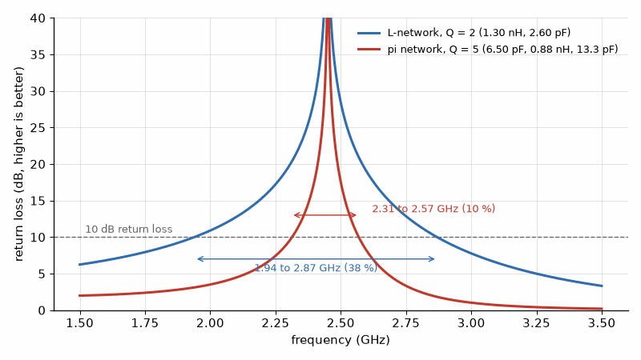
Figure 3.1 — Two matches from 10 Ω to 50 Ω at 2.45 GHz, swept from their component values. The L-network (Q = 2) holds 10 dB return loss from 1.94 to 2.87 GHz; the pi network (Q = 5) only from 2.31 to 2.57 GHz.

Worked Example 3.2
Problem. Design a pi network that matches 10 Ω to 50 Ω at 2.45 GHz with a Q of 5 on the 50 Ω side, using shunt capacitors and a series inductor. Compare its bandwidth with that of Worked Example 3.1.
Solution. Rv = 50/(5² + 1) = 1.92 Ω. The 50 Ω half has a shunt reactance of 50/5 = 10 Ω (6.50 pF) and a series reactance of 5 × 1.92 = 9.62 Ω. The 10 Ω half has Q₂ = √(10/1.92 − 1) = 2.05, a series reactance of 2.05 × 1.92 = 3.94 Ω, and a shunt reactance of 10/2.05 = 4.88 Ω (13.3 pF). The two series inductors combine into 9.62 + 3.94 = 13.56 Ω, which is 0.88 nH. A sweep gives a 10 dB return-loss bandwidth from 2.31 to 2.57 GHz, about 10%, against 38% for the L-network. The narrower match is also a better harmonic filter. The 0.88 nH inductor is no larger than the inductance of a component pad and its vias, so at this frequency it is built as a short length of narrow line, not as a part.

3.3 Real components and loss
The matching network's own losses come from the finite Q of its components, which Chapter 1 defined through their parasitics. An inductor with quality factor QL = X/R has a series resistance X/QL. In a network that transforms down to a low resistance, that resistance sits in series with the low-resistance side, where a fraction of an ohm is a significant fraction of the load. The loss rises with the network Q, which is the second reason, after bandwidth, to keep the transformation ratio of each section modest. Large ratios are often split into two cascaded L-networks, each with a Q near the square root of the single-section value.

Worked Example 3.3
Problem. The 1.30 nH inductor of Worked Example 3.1 has QL = 40 at 2.45 GHz. Estimate the loss it adds.
Solution. Its series resistance is 20 Ω/40 = 0.50 Ω, in series with the 10 Ω load. The fraction of the power delivered to the network that reaches the load is 10/10.5 = 0.952, a loss of 0.21 dB. For a power amplifier delivering 10 W into the network, 0.48 W heats the inductor. With a load of 2 Ω instead of 10 Ω, the same inductor Q would cost about 1 dB.

3.4 Matching complex loads
A load with a reactive part is matched by first absorbing or canceling its reactance. A series reactance in the load can be absorbed into the network's series element; a shunt reactance into the shunt element. If the load is 10 + j5 Ω and the L-network calls for a series reactance of +j20 Ω, the network supplies only j15 Ω, because the load already contains j5 Ω. When the load's reactance is larger than the network needs, a component of the opposite sign cancels the excess. The Smith chart of the next chapter makes these steps visual, and it is how most designers carry them out.
From the Bench
Before you design a match, compute its Q. Q = √(R_high/R_low − 1) tells you the bandwidth you can expect and how much the parts' own losses will cost. A 5:1 ratio is easy, while 25:1 in one step is narrow and lossy, so split it into two L-sections. Leave footprints for a pi network even when the design says L: the third pad costs nothing and saves a board spin when the antenna turns out different from its data sheet.

Practice
1. Design a low-pass L-network to match 5 Ω to 50 Ω at 900 MHz. Give Q, the series inductance, and the shunt capacitance.
2. Design a high-pass L-network to match 200 Ω to 50 Ω. Find Q, and say which side the shunt element goes on.
3. For the pi network of Worked Example 3.2, find Rv if Q on the 50 Ω side is raised to 8.
4. The series inductor of Practice Problem 1 has QL = 30. Estimate the loss.
5. A load of 10 + j8 Ω is matched by the network of Worked Example 3.1. What series reactance must the network itself supply?
6. Explain in one or two sentences why a large impedance ratio is often matched with two cascaded L-networks.

What You’ll Actually Use
Everyday working tools
- Q = √(R_high/R_low − 1) and the series and shunt reactances from it.
- Two cascaded L-sections for large ratios.
- Inductor Q as the main source of matching loss.
Mostly for exams and deeper study
- Exact bandwidth formulas for multi-element networks.

Chapter 4. Distributed Matching and the Smith Chart at Work
In 1939 Phillip Smith, an engineer at Bell Telephone Laboratories, published a chart in Electronics magazine that turned transmission-line arithmetic into geometry. Every network analyzer still draws it. Moving along a line becomes a rotation, adding a shunt part becomes a slide along a circle, and the center of the chart is the match you are steering toward.
Where you meet this: The network analyzer screen, matching above a few gigahertz, bias tees and quarter-wave chokes, and the stubs and radial pads visible on microwave boards.
Above a few gigahertz the lumped components of Chapter 3 run out: the values become fractions of a nanohenry or a picofarad, comparable to the parasitics of the pads they sit on. The cure is to build the matching network from the transmission line itself. A quarter-wave section transforms resistance, a stub supplies reactance, and a length of line moves an impedance to wherever it is most convenient to correct. Book 1 introduced the Smith chart as a map of impedance; this chapter uses it as the drawing board on which such designs are made.

4.1 The quarter-wave transformer
Chapter 2 showed that a quarter-wavelength line inverts its load: Zin = Zq²/ZL. Choosing the section's impedance as the geometric mean of the two resistances makes the input equal the source impedance exactly.
Zq = √(Z0 RL), length = λg / 4

Worked Example 4.1
Problem. Match a 25 Ω load to a 50 Ω line at 2.45 GHz with a quarter-wave stripline section on εr = 3.55. Find its impedance and length, and the fractional bandwidth over which |Γ| stays below 0.1.
Solution. Zq = √(25 × 50) = 35.36 Ω. From Chapter 1, λg = 6.49 cm, so the section is 1.62 cm long. Away from the design frequency the section is no longer a quarter wave, and the reflection grows. For a single section, the bandwidth for a maximum reflection Γm is Δf/f0 = 2 − (4/π) arccos[(Γm/√(1 − Γm²)) × 2√(Z0RL)/|RL − Z0|]. With Γm = 0.1 this gives 0.367, so the match holds from about 2.00 to 2.90 GHz. Two sections in a binomial (maximally flat) design, of 42.0 Ω and 29.7 Ω, widen the same specification to 72%, at the cost of twice the length.
The quarter-wave transformer matches only resistances. A complex load is first moved along a line to a point where its impedance is purely resistive, which happens twice in every half wavelength, at the maximum and the minimum of the standing wave, and the transformer is placed there.

4.2 Reading the Smith chart as a tool
On the Smith chart, a point is a normalized impedance z = Z/Z0, and its distance from the center is |Γ|. Three moves account for nearly every design. Moving along a lossless line toward the generator rotates the point clockwise around the center at constant |Γ|, a full turn for every half wavelength. Adding a series reactance moves the point along a circle of constant resistance. Adding a shunt susceptance moves it along a circle of constant conductance, which is easiest to see by switching to the admittance chart, the same chart rotated by 180°. A match is the center. A design is a path from the load to the center using only those moves.
Key idea. A line changes an impedance's angle, a series element moves it along a resistance circle, and a shunt element along a conductance circle. Any match is a sequence of those three moves that ends at the center of the chart.

4.3 The single-stub match
The most common distributed match uses one length of line and one shunt stub. Starting at the load, the line rotates the admittance until its real part equals 1/Z0, which on the admittance chart means reaching the unit-conductance circle. At that point the admittance is 1/Z0 + jB. A shunt stub, short-circuited or open-circuited, supplies the susceptance −jB and lands the point at the center. There are always two solutions within a half wavelength, one on each side of the chart, and the shorter combination is normally preferred because it has the wider bandwidth.
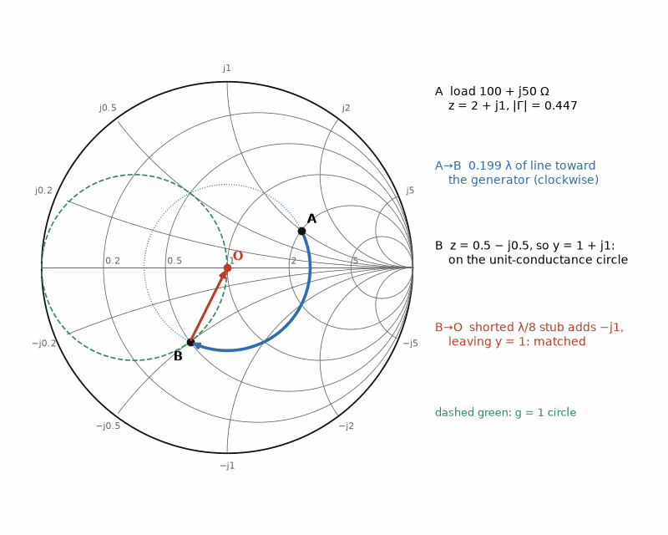
Figure 4.1 — The single-stub match of Worked Example 4.2 on the Smith chart. The load (A) rotates 0.199 λ toward the generator to B, where the admittance is 1 + j1; a shorted λ/8 stub cancels the j1 and lands on the center.

Worked Example 4.2
Problem. A load of 100 + j50 Ω on a 50 Ω line is to be matched with a short-circuited shunt stub at 2.45 GHz in the stripline of Chapter 1. Find the reflection coefficient, the stub position, and the stub length.
Solution. Γ = (100 + j50 − 50)/(100 + j50 + 50) = 0.447 at an angle of 26.6°, a VSWR of 2.62. The line length d that brings the normalized admittance onto the unit-conductance circle satisfies tan βd = 3 or tan βd = −1. The first solution, βd = 71.6°, is d = 0.199λ, where the normalized admittance is y = 1 + j1. A short-circuited stub has normalized admittance −j cot βl, so −j1 requires cot βl = 1 and l = λ/8. In the stripline, d = 0.199 × 6.49 = 1.29 cm and l = 0.81 cm. The second solution is d = 0.375λ, where y = 1 − j1, matched by a 3λ/8 short-circuited stub or a λ/8 open-circuited one.

4.4 Why stubs are short, and when they are radial
A stub's reactance changes with frequency faster the longer it is, because its electrical length grows in proportion to frequency. Choosing the shortest stub and the shortest line keeps the match broad. Open stubs avoid the via a short needs, but their end radiates a little and adds fringing capacitance, so the physical length is trimmed shorter than the calculation. Where a stub must present a very low impedance over a wide band, as when it feeds DC bias to an amplifier while blocking the RF, a radial stub, a fan-shaped open stub, gives a broader short circuit than a straight one.

Worked Example 4.3
Problem. A bias feed must present a high impedance to the RF at its connection to a 50 Ω line. It uses a quarter-wave high-impedance line ending in a capacitor that is a short circuit at 2.45 GHz. Explain why the arrangement works and find the line's length in the stripline of Chapter 1.
Solution. A quarter-wave line inverts its termination. A short circuit at the far end, provided by the bypass capacitor or a radial stub, becomes an open circuit at the near end, so the bias line does not load the RF path, while DC passes freely along it. The length is λg/4 = 1.62 cm. Using a narrow, high-impedance line keeps the impedance high across a wider band around the design frequency, and the inversion works only near the frequencies at which the line is an odd number of quarter wavelengths long.
From the Bench
Use the Smith chart to see a design, not to calculate it; let the software do the arithmetic. What the chart shows at a glance is direction. Clockwise is toward the generator. Series parts move along constant-resistance circles, and shunt parts move along constant-conductance circles. A good habit is to sweep a match and look at the shape it traces: a tight knot around the center means wide bandwidth, a long arc means a narrow one.

Practice
1. Find the impedance of a quarter-wave transformer matching 100 Ω to 50 Ω.
2. Find the single-section bandwidth for |Γ| < 0.1 when matching 100 Ω to 50 Ω.
3. A load is 25 − j25 Ω on a 50 Ω line. Show that a short-circuited shunt stub placed directly at the load can match it, and find the stub length.
4. On the Smith chart, how many degrees does a point rotate when it moves 0.1λ toward the generator?
5. A two-section binomial transformer matches 25 Ω to 50 Ω. Which section impedance sits next to the load?
6. Explain in one or two sentences why the shorter of the two single-stub solutions usually gives a wider bandwidth.

What You’ll Actually Use
Everyday working tools
- Quarter-wave transformer Zq = √(Z0 RL).
- Reading impedance, VSWR, and the direction 'toward generator' on the chart.
- A quarter-wave line that turns a short into an open, for bias feeds.
Mostly for exams and deeper study
- Graphical stub design done fully by hand.

Chapter 5. Scattering Parameters
A VSWR of 1.5 sounds harmless. Put a generator with that VSWR into a power sensor with the same one, and the reading can be off by a third of a decibel either way, with no instrument fault anywhere. S-parameters are the language that makes such numbers visible, and the reason RF engineers never quote a power level without its uncertainty.
Where you meet this: Every network analyzer measurement, every component data sheet above 100 MHz, every amplifier stability check, and every S2P file you import into a simulator.
At low frequencies, two-port impedance and admittance parameters can be measured with open- and short-circuit terminations. At microwave frequencies, ideal opens and shorts are hard to realize: fixtures add capacitance and inductance, radiation and calibration errors matter, and a strongly mismatched termination may drive an active device outside its safe operating conditions. S-parameters avoid requiring ideal open or short circuits at the ports; they describe traveling waves referenced to matched impedances, normally 50 Ω. Every RF datasheet, simulator, and network analyzer uses this language, and this chapter teaches enough to read, convert, and use the numbers.

5.1 Waves in, waves out
At each port n, an incident wave aₙ and a reflected wave bₙ are defined so that |aₙ|² and |bₙ|² are the powers traveling toward and away from the port. For a two-port the outgoing waves are linear combinations of the incoming ones, and the four coefficients are the S-parameters.
b₁ = S₁₁ a₁ + S₁₂ a₂, b₂ = S₂₁ a₁ + S₂₂ a₂
With the output terminated in Z0, a₂ = 0, so S₁₁ is the input reflection coefficient and S₂₁ the forward transmission coefficient. S₂₂ and S₁₂ are the same quantities seen from the output. Each is a complex number, a magnitude and a phase. In decibels, the return loss is −20 log₁₀|S₁₁|, the gain or insertion loss is 20 log₁₀|S₂₁|, and the reverse isolation is −20 log₁₀|S₁₂|. Because S₁₁ is a reflection coefficient, the input impedance follows from Chapter 2's formula turned around.
Zin = Z0 (1 + S₁₁) / (1 − S₁₁)

Worked Example 5.1
Problem. A network analyzer measures S₁₁ = 0.5 at 90° on a component in a 50 Ω system. Find the input impedance and the return loss. A second component has S₁₁ = 0.2 at 0°; find its impedance.
Solution. Zin = 50 (1 + j0.5)/(1 − j0.5) = 50 (1 + j0.5)²/1.25 = 50 (0.75 + j1.0)/1.25 = 30 + j40 Ω. The return loss is −20 log₁₀ 0.5 = 6.0 dB. For S₁₁ = 0.2, Zin = 50 × 1.2/0.8 = 75 Ω, purely resistive because the reflection has zero phase.

5.2 Lossless, reciprocal, and matched
Three properties can be read directly from the matrix. A network is reciprocal, as every passive network without ferrites or active parts is, when S₁₂ = S₂₁. It is lossless when the power that comes out equals the power that goes in, which for a two-port driven from port 1 means |S₁₁|² + |S₂₁|² = 1. And it is matched at a port when that port's reflection coefficient is zero. A lossless network that is not matched must reflect whatever it does not pass, so measuring S₁₁ alone tells how much a lossless filter passes.

Worked Example 5.2
Problem. A lossless filter has |S₁₁| = 0.3 at some frequency in its passband. Find its insertion loss there. Then a lossy attenuator has |S₂₁| = 0.5 and |S₁₁| = 0.1; find the fraction of incident power it absorbs.
Solution. For the lossless filter, |S₂₁|² = 1 − 0.09 = 0.91, an insertion loss of −10 log₁₀ 0.91 = 0.41 dB, all of it reflected rather than dissipated. For the attenuator, |S₂₁|² = 0.25 and |S₁₁|² = 0.01, so 1 − 0.25 − 0.01 = 0.74 of the incident power is absorbed. Its insertion loss is 6.0 dB and its return loss 20 dB, the specification of a good 6 dB pad.

5.3 Mismatch uncertainty in a chain
S-parameters are defined with ideal Z0 terminations, but real components are cascaded with imperfect ones. When a source with reflection coefficient Γs drives a load with Γl, the wave bounces between them, and the power delivered differs from the matched value by a factor that depends on the phase of the product, which changes with cable length and frequency. The limits of the uncertainty are easy to state.
Mismatch uncertainty = 20 log₁₀ (1 ± |Γs| |Γl|) dB
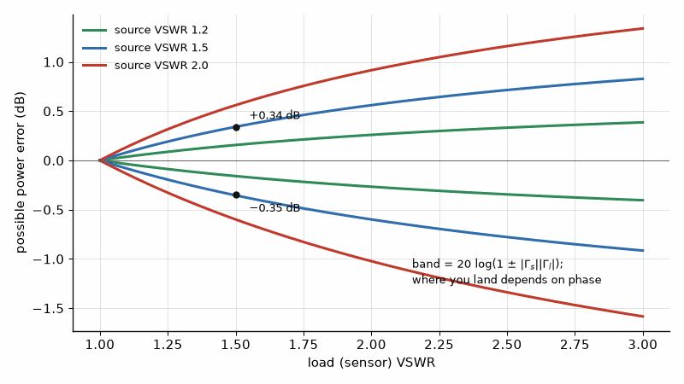
Figure 5.1 — Mismatch uncertainty. A generator and a sensor that both have a VSWR of 1.5 can make a power reading wrong by +0.34 to −0.35 dB; the worse either match, the wider the band.

Worked Example 5.3
Problem. A signal generator with a VSWR of 1.5 drives a power sensor with a VSWR of 1.5. Find the range of the mismatch uncertainty. Repeat for a generator VSWR of 2.0 and a sensor VSWR of 1.2.
Solution. VSWR 1.5 corresponds to |Γ| = 0.5/2.5 = 0.2, so |Γs||Γl| = 0.04 and the uncertainty is +0.34 dB to −0.35 dB. With VSWR 2.0 (|Γ| = 1/3) and 1.2 (|Γ| = 0.091), the product is 0.030, giving +0.26 to −0.27 dB. The uncertainty is often the largest term in an RF power measurement, and the standard remedy is a well-matched attenuator between the two, which reduces the effective reflection on each side by twice its loss in decibels.
Key idea. S-parameters describe a network by its waves with every port matched. They are measured, not calculated from opens and shorts, and they are only as meaningful as the reference impedance and reference planes they were measured at.

5.4 Stability of an amplifier from its S-parameters
A transistor at RF is usually specified as a table of S-parameters at its bias point. Before matching networks are designed, the designer must know whether some passive source or load impedance could make the device oscillate. The Rollett stability factor K and the determinant Δ answer the question: a two-port is unconditionally stable, stable for every passive termination, when K > 1 and |Δ| < 1. When it is, its maximum available gain (MAG), the gain with both ports conjugately matched, follows from the same quantities.
Δ = S₁₁S₂₂ − S₁₂S₂₁, K = (1 − |S₁₁|² − |S₂₂|² + |Δ|²) / (2 |S₁₂ S₂₁|)
MAG = (|S₂₁| / |S₁₂|) (K − √(K² − 1))

Worked Example 5.4
Problem. A transistor at 2.4 GHz has S₁₁ = 0.6∠−120°, S₂₁ = 3.5∠80°, S₁₂ = 0.06∠40°, and S₂₂ = 0.4∠−60°. Determine its stability and its maximum available gain, and compare with its gain in a plain 50 Ω system.
Solution. S₁₁S₂₂ = 0.24∠−180°, and S₁₂S₂₁ = 0.21∠120°. Their difference has magnitude |Δ| = 0.226. K = (1 − 0.36 − 0.16 + 0.051)/(2 × 0.21) = 0.531/0.42 = 1.265. Since K > 1 and |Δ| < 1, the device is unconditionally stable. MAG = (3.5/0.06)(1.265 − √(1.265² − 1)) = 58.3 × 0.490 = 28.6, or 14.6 dB. In 50 Ω without matching, the gain is |S₂₁|² = 12.25, or 10.9 dB, so conjugate matching networks of the kind in Chapters 3 and 4 add about 3.7 dB. The power-amplifier version of this design, with load lines and heat, is Part II.

5.5 Measuring S-parameters
A vector network analyzer measures incident and reflected waves with directional couplers and compares them in magnitude and phase. Its raw measurement includes the errors of its own cables, connectors, and couplers, which are removed by calibration: the analyzer measures known standards, such as a short, an open, a load, and a through connection (SOLT), and solves for its error terms. Calibration moves the reference plane to the end of the cables. Fixtures and board launches between that plane and the device are removed by de-embedding, and the quality of an S-parameter file depends on how carefully that last step was done.
Where this continues. Chapter 48 reads S-parameters as vendors deliver them, in Touchstone files, and adds the noise parameters a .s2p file can carry. The calibration and de-embedding that set a measurement's reference plane are in Book 9, Test and Measurement Instruments, chapters "The Vector Network Analyzer" and "VNA Calibration, De-embedding, and Time-Domain Gating".
From the Bench
Calibrate at the plane you care about, not at the instrument's port; the cable and adapter between them are part of the measurement. Check a new transistor's S-parameters for stability over the whole band where it has gain, including far below and above your operating band. Amplifiers usually oscillate somewhere you weren't looking. A quick K and |Δ| check from the S2P file takes a minute and saves a board turn.

Practice
1. A device has |S₁₁| = 0.1 and |S₂₁| = 0.995 and is passive. Find its return loss and insertion loss, and state whether it is lossless.
2. Find Zin for S₁₁ = 0.3∠−45° in a 50 Ω system.
3. A source with |Γ| = 0.3 drives a load with |Γ| = 0.2. Find the mismatch uncertainty.
4. A transistor has S₁₁ = 0.5∠−60°, S₂₁ = 2.0∠100°, S₁₂ = 0.1∠30°, S₂₂ = 0.5∠−40°. Given |Δ| = 0.41, find K and state whether it is unconditionally stable.
5. A reciprocal network has S₂₁ = 0.7∠−30°. What is S₁₂?
6. Explain in one or two sentences why S-parameters, rather than open- and short-circuit parameters, are measured at microwave frequencies.

What You’ll Actually Use
Everyday working tools
- |S11| as return loss and |S21| as gain or insertion loss.
- Mismatch uncertainty 20 log(1 ± |Γs||Γl|).
- Rollett's K and |Δ| as the quick stability check.
Mostly for exams and deeper study
- Conversions between S, Z, Y, and ABCD parameters by hand.
- Signal-flow-graph derivations.

Chapter 6. Resonators, Filters, and Waveguide
A third-order low-pass filter with a 1 GHz cutoff takes only 18 dB off a 2 GHz harmonic. A transmitter's harmonics usually need to be several tens of decibels down, so that filter alone is not nearly enough. How steep a filter must be, and what its steepness costs in loss and size, is the question every filter design starts with.
Where you meet this: Harmonic filters after power amplifiers, band filters in front of receivers, the duplexer in every phone, and the waveguide on radar and satellite hardware.
A filter is a network designed to transmit one frequency range and attenuate others. In an ideal lossless prototype with matched terminations, stopband power is reflected. Real filters also dissipate power, and absorptive designs intentionally terminate stopband energy rather than reflect it. This chapter builds filters in three steps: the low-pass prototype that sets the response shape, the transformations that turn it into a real low-pass or band-pass circuit, and the resonator quality factor that determines passband loss. That leads from microstrip to cavities and waveguide, where high-power and low-loss filters are built.

6.1 The low-pass prototype
Filter design starts from a normalized ladder of alternating series inductors and shunt capacitors, designed for a 1 Ω termination and a cutoff of 1 rad/s. Its element values gₖ are tabulated for each response type. A Butterworth (maximally flat) filter of order n has a monotonic response that falls by 3 dB at cutoff and then by 20n dB per decade. A Chebyshev filter allows a specified ripple in the passband in exchange for a steeper fall just beyond cutoff. The third-order values are g = 1, 2, 1 for Butterworth and g = 1.0316, 1.1474, 1.0316 for a Chebyshev response with 0.1 dB ripple. Scaling to a real impedance R0 and cutoff frequency ωc gives the components.
Lₖ = gₖ R0 / ωc, Cₖ = gₖ / (R0 ωc), Butterworth: |S₂₁|² = 1 / (1 + (ω/ωc)^(2n))
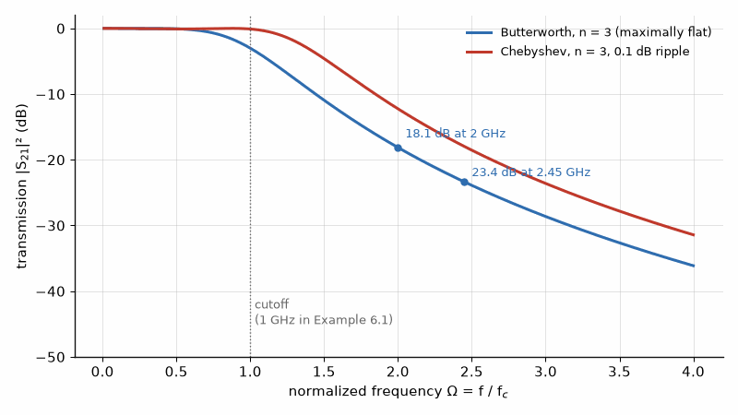
Figure 6.1 — Third-order low-pass responses. The Butterworth is flat and takes 18.1 dB off twice the cutoff; the 0.1 dB Chebyshev trades a small ripple for a steeper skirt.

Worked Example 6.1
Problem. Design a third-order Butterworth low-pass filter with a 1 GHz cutoff in a 50 Ω system, as shunt capacitor, series inductor, shunt capacitor. Find its attenuation at 2 GHz and at 2.45 GHz.
Solution. ωc = 2π × 10⁹ rad/s. C₁ = C₃ = 1/(50 × 2π × 10⁹) = 3.18 pF; L₂ = 2 × 50/(2π × 10⁹) = 15.9 nH. At 2 GHz, ω/ωc = 2 and the attenuation is 10 log₁₀(1 + 2⁶) = 18.1 dB. At 2.45 GHz it is 10 log₁₀(1 + 2.45⁶) = 23.4 dB. A harmonic filter after a 1 GHz amplifier must suppress the second harmonic by more than this, so a real design would use a higher order or a Chebyshev response, and would check the inductor's self-resonance, which for 15.9 nH in a small package can fall near the frequencies the filter is meant to stop.

6.2 Band-pass filters and resonator Q
A band-pass filter replaces each series inductor of the prototype with a series resonator and each shunt capacitor with a parallel resonator, all tuned to the center frequency f0. The fractional bandwidth FBW = Δf/f0 scales the element values: the narrower the band, the higher the stored energy in each resonator relative to the power passing through. That is why narrow filters are lossy. Each resonator has an unloaded quality factor Qu, the ratio of stored energy to energy lost per radian, set by its conductors and dielectric. Cohn's estimate gives the midband insertion loss of a filter from its prototype values, its bandwidth, and its resonators' Qu.
IL₀ ≈ 4.343 × Σ gₖ / (FBW × Qu) dB

Worked Example 6.2
Problem. A three-pole 0.1 dB Chebyshev band-pass filter is centered at 2.45 GHz with a 100 MHz bandwidth. Estimate its midband loss with microstrip resonators of Qu = 200 and with cavity resonators of Qu = 2000.
Solution. FBW = 100/2450 = 0.0408 and Σgₖ = 3.21. With Qu = 200, IL₀ ≈ 4.343 × 3.21/(0.0408 × 200) = 1.71 dB. With Qu = 2000 it is 0.17 dB. In a receiver the 1.5 dB difference adds directly to the noise figure; after a transmitter it is heat in the filter: at 100 W, a 1.71 dB loss burns 33 W, and a 0.17 dB loss 3.9 W. This is why filters that follow power amplifiers are cavities, as Part II assumes.
Key idea. A filter's shape comes from its prototype, but its loss comes from its resonators. Narrowing the bandwidth or adding poles multiplies the stored energy, and the loss rises in proportion unless the resonator Q rises with it.

6.3 Waveguide
A hollow metal pipe guides waves without a center conductor, with lower loss and higher power capacity than any coaxial line of similar size. It has a cutoff frequency below which nothing propagates. In a rectangular guide of broad dimension a, the dominant TE₁₀ mode cuts off where half a free-space wavelength equals a. Above cutoff the wave travels with a guide wavelength longer than the free-space wavelength, and the guide is used from about 1.25 to 1.9 times its cutoff, where only the dominant mode propagates and the loss is low.
fc = c / (2a), λg = λ0 / √(1 − (fc/f)²)

Worked Example 6.3
Problem. WR-90 waveguide has a = 22.86 mm. Find its cutoff frequency and its guide wavelength at 10 GHz. Then find the length d of a rectangular TE₁₀₁ cavity in the same guide that resonates at 10 GHz.
Solution. fc = 2.998 × 10⁸/(2 × 0.02286) = 6.56 GHz, so the guide is used across the X band, 8.2 to 12.4 GHz. At 10 GHz, λ0 = 29.98 mm and λg = 29.98/√(1 − 0.430) = 39.7 mm. The cavity resonates when its length is half a guide wavelength, d = λg/2 = 19.9 mm; equivalently f = (c/2)√((1/a)² + (1/d)²) = 10 GHz with d = 19.85 mm. Such a cavity in copper has an unloaded Q of several thousand, ten times a microstrip resonator. At millimeter wave the same formula sets the size of the guide: WR-28, for 26.5 to 40 GHz, has a = 7.11 mm and a cutoff of 21.1 GHz.

6.4 Which technology at which frequency
Lumped LC filters work to a few gigahertz, limited by component self-resonance and Q near 50 to 100. Microstrip and stripline filters, built from coupled line resonators, work from about 1 GHz into the millimeter range, with Qu of 100 to 300. Ceramic coaxial resonators reach Qu near 500 to 1000 in a small volume for handset and base-station front ends. Acoustic filters, surface and bulk acoustic wave devices, are tiny and steep up to about 6 GHz and dominate mobile phones; their resonators are mechanical, and Chapter 47 designs with them, while the piezoelectric films they are made from are Book 3's. Cavities and waveguide, with Qu in the thousands, take the high-power and lowest-loss jobs. A filter is chosen by the loss it can afford, the power it must carry, and the space it may occupy, roughly in that order.
Where this continues. Chapter 47 builds filters from acoustic resonators, SAW, BAW, and XBAR, which reach Q values near a thousand in a fraction of a cubic millimeter and fill every phone.
From the Bench
Pick the technology from Q before you pick the topology. A microstrip resonator with a Q of 200 costs nearly 2 dB in a narrow filter, a cavity with a Q of 2000 costs a fifth of a decibel, and no amount of optimization makes the microstrip version match the cavity. On a real board, the parasitic inductance of each shunt capacitor's via limits the rejection you can reach, so place a ground via right at each capacitor.

Practice
1. Scale the third-order Butterworth prototype to a 500 MHz cutoff in 50 Ω.
2. Find the attenuation of a third-order Butterworth low-pass filter at three times its cutoff frequency.
3. A three-pole 0.1 dB Chebyshev filter has a 2% fractional bandwidth and resonators with Qu = 500. Estimate its midband loss.
4. Find the guide wavelength of WR-90 at 12 GHz.
5. Find the cutoff frequency of a rectangular waveguide with a = 15.8 mm.
6. Explain in one or two sentences why a narrowband filter after a power amplifier is usually a cavity rather than microstrip.

What You’ll Actually Use
Everyday working tools
- Butterworth vs Chebyshev: flat passband vs steeper skirt.
- Midband loss ≈ 4.343 Σg/(FBW·Qu).
- Waveguide cutoff fc = c/2a.
Mostly for exams and deeper study
- Exact synthesis of the prototype element values.
- Higher-order waveguide mode theory.

Chapter 7. The Antenna
Cut a dipole to a twentieth of a wavelength, give it 2 Ω of wire loss, and half the power you feed it simply heats the wire. Double its length and the efficiency jumps to more than 80 %. Small antennas aren't just weaker; they are inefficient, and that one fact shapes every gadget that radiates.
Where you meet this: Every phone, router, key fob, satellite dish, and car radar, and every link budget that uses dBi.
An antenna is a transducer between guided waves on a transmission line and electromagnetic waves in space. Its input impedance determines how much power is accepted at its feed; an external matching network may transform the line impedance to that input impedance. Matching and radiation are related, but they are different jobs.

7.1 Directivity, efficiency, and gain
An isotropic radiator, a reference that no real antenna achieves, spreads its power equally over a sphere. A real antenna concentrates it. Directivity D is the ratio of the power density in the strongest direction to the density an isotropic radiator would produce with the same total radiated power. Radiation efficiency η is the fraction of the power accepted at the terminals that is radiated rather than lost in conductors and dielectric. Gain is their product, and in decibels it is quoted in dBi.
G = η D, η = Rrad / (Rrad + Rloss)
The resistance seen at an antenna's terminals has two parts: the radiation resistance Rrad, which represents power leaving as a wave, and the loss resistance Rloss. A half-wave dipole has Rrad ≈ 73 Ω and D = 1.64, or 2.15 dBi. An antenna much smaller than a wavelength has a radiation resistance that falls as the square of its size; for a short dipole of length l it is 80π²(l/λ)².

Worked Example 7.1
Problem. A short dipole one twentieth of a wavelength long has 2 Ω of conductor loss. Find its radiation resistance and efficiency. Then find the efficiency of a dipole one tenth of a wavelength long with 1.5 Ω of loss.
Solution. For l = λ/20, Rrad = 80π² × (0.05)² = 1.97 Ω, and η = 1.97/(1.97 + 2) = 0.50, so half the accepted power heats the wire: the gain is 3 dB below the directivity. For l = λ/10, Rrad = 80π² × 0.01 = 7.90 Ω and η = 7.90/9.40 = 0.84. Small antennas are inefficient because their radiation resistance shrinks faster than their loss, and they are also hard to match, because a 2 Ω resistance must be transformed to 50 Ω with the high-Q network that Chapter 3 warned against.

7.2 Effective aperture and the link equation
A receiving antenna captures the power flowing through an effective area Ae, related to its gain by a factor that depends only on wavelength. The relation, applied to both ends of a link at distance R, gives the Friis transmission equation. The factor (λ/4πR)² is the free-space path factor between two isotropic antennas; antenna gains multiply it.
Ae = G λ² / (4π), Pr / Pt = Gt Gr (λ / 4πR)²

Worked Example 7.2
Problem. Find the free-space path factor at 2.45 GHz over 100 m between isotropic antennas. Then find the received power if a 20 dBm transmitter and the receiver both use 10 dBi antennas, and the effective aperture of an isotropic antenna at this frequency.
Solution. λ = 0.1224 m, so (λ/4πR)² = (0.1224/1256.6)² = 9.48 × 10⁻⁹, or −80.2 dB. This is the book's reference number. With 10 dBi at each end, Pr = 20 + 10 + 10 − 80.2 = −40.2 dBm, about 95 nW. An isotropic antenna's aperture is λ²/4π = 0.0150/12.57 = 1.19 × 10⁻³ m², about 12 cm². Increasing the distance tenfold to 1 km lowers the path factor to −100.2 dB: free-space loss grows 20 dB per decade of distance. One decibel lost in the feed between transmitter and antenna is one decibel of radiated power lost, the rule Part II uses for EIRP.
Key idea. Gain does not create power; it concentrates it. A higher-gain antenna both radiates more strongly in its main direction and captures more power from it, because its effective aperture is proportional to its gain.

7.3 Apertures and beamwidth
For an antenna that is large compared with a wavelength, such as a reflector dish, the gain follows from its physical area and an aperture efficiency ηap, typically 0.55 to 0.7. Its half-power beamwidth is roughly 70 λ/D degrees. Gain and beamwidth trade directly: a narrower beam covers less sky and must be pointed more precisely.
G = ηap (π D / λ)², θ₃dB ≈ 70 λ / D degrees

Worked Example 7.3
Problem. A 0.6 m satellite-television dish has ηap = 0.65 at 12 GHz. Find its gain and beamwidth.
Solution. λ = 2.50 cm. G = 0.65 × (π × 0.6/0.025)² = 0.65 × 5,690 = 3,700, or 35.7 dBi. θ₃dB ≈ 70 × 0.025/0.6 = 2.9°. The dish must be aimed to within about a degree, which is why its mounting bracket is the most carefully specified part of the installation.

7.4 Polarization
The electric field of a radiated wave points in a definite direction, its polarization, which may be linear (vertical, horizontal, or slanted) or circular (rotating once per cycle, left- or right-handed). A receiving antenna captures only the component matching its own polarization. Between two linear antennas misaligned by an angle ψ, the polarization loss factor is cos²ψ. Between a linear and a circular antenna it is 0.5, a fixed 3 dB loss in exchange for indifference to orientation, which is why satellite navigation and many mobile links use circular polarization.

Worked Example 7.4
Problem. Two linearly polarized antennas are misaligned by 30° and by 45°. Find the polarization loss in each case.
Solution. At 30°, cos² 30° = 0.75, a loss of 1.25 dB. At 45°, cos² 45° = 0.5, a loss of 3.0 dB. At 90° the loss is in theory infinite and in practice 20 to 30 dB, limited by the antennas' cross-polarized radiation, which is the basis of polarization reuse in point-to-point links.

7.5 The dipole and the patch
A half-wave dipole is cut slightly shorter than half a free-space wavelength, about 0.47 to 0.48 λ, so that its input reactance is zero; at that length its resistance is near 70 Ω and matches a 50 Ω line with VSWR about 1.4. A dipole is balanced, while coaxial cable is not, so it is fed through a balun to keep current off the outside of the cable. The microstrip patch, a rectangle of copper over a ground plane, is the dipole of circuit boards. It resonates when its length is about half a guided wavelength in the substrate, slightly reduced because the fields fringe past its edges, and it radiates broadside with a gain of about 5 to 7 dBi. The Balanis design equations give its width, effective permittivity, and edge extension ΔL.
W = (c / 2f) √(2 / (εr + 1)), L = c / (2f √εeff) − 2ΔL
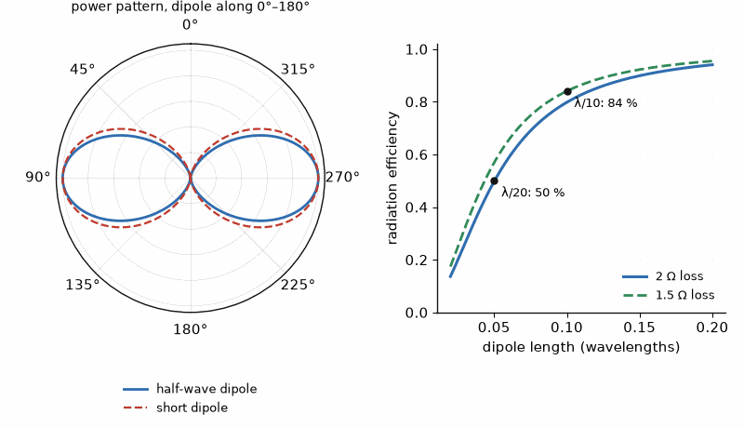
Figure 7.1 — Left: power patterns of a half-wave and a short dipole, both doughnuts with a null along the wire. Right: a short dipole's efficiency collapses as its length falls; at λ/20 with 2 Ω of loss, half the power heats the wire.

Worked Example 7.5
Problem. Size a rectangular patch for 2.45 GHz on a 0.813 mm laminate with εr = 3.55.
Solution. W = (0.1224/2) × √(2/4.55) = 6.12 cm × 0.663 = 40.6 mm. The effective permittivity is (εr + 1)/2 + ((εr − 1)/2)(1 + 12h/W)^(−1/2) = 3.42, and the edge extension from the Balanis formula is ΔL = 0.39 mm. Then L = 2.998 × 10⁸/(2 × 2.45 × 10⁹ × √3.42) − 2 × 0.39 mm = 33.1 − 0.78 = 32.3 mm. A simulator and one trimmed prototype normally adjust the length by a few percent, because the patch's resonance, and therefore its narrow bandwidth of a few percent, depends sensitively on the substrate's actual permittivity.
From the Bench
An antenna data sheet's gain was measured on a reference ground plane, usually larger than yours, with nothing nearby. Your plastic case, battery, and the user's hand all detune it. Budget several decibels for that and tune the match in the final enclosure, not on a bare board. Keep the antenna's keep-out area free of copper on every layer; a ground pour under a chip antenna is one of the most common ways to kill its efficiency.

Practice
1. Find the length of a half-wave dipole cut to 0.48λ at 5.8 GHz.
2. A small antenna has Rrad = 5 Ω and Rloss = 3 Ω. Find its efficiency and the gain in dBi if its directivity is 1.5 (1.76 dBi).
3. Find the free-space path factor at 2.45 GHz over 1 km between isotropic antennas.
4. A 0.3 m dish has ηap = 0.6 at 10 GHz. Find its gain and beamwidth.
5. Find the effective aperture of a 6 dBi antenna at 2.45 GHz.
6. Explain in one or two sentences why a linear antenna receiving a circularly polarized signal loses 3 dB regardless of its orientation.

What You’ll Actually Use
Everyday working tools
- Gain = efficiency × directivity, in dBi.
- Friis link equation and the 20 log R path loss.
- Dish gain from aperture, and beamwidth ≈ 70λ/D degrees.
Mostly for exams and deeper study
- Radiation integrals and the vector potential.

Chapter 8. Arrays, Beam Steering, and Millimeter Wave
How does a flat panel on a 5G mast point its beam at a phone a block away without moving a single part? It changes the relative phase of the signals fed to its elements. With half-wavelength spacing, a phase step of −90° from one element to the next steers the beam 30° off broadside. A true-time-delay array uses actual delays; phase-shifter arrays approximate them at a chosen frequency and can show beam squint across wide bandwidths.
Where you meet this: 5G and satellite-internet terminals, automotive radar, Wi-Fi beamforming, and every phased-array radar.
A single antenna's beam is fixed by its shape. An array of identical antennas, each fed with a controlled amplitude and phase, has a beam that can be shaped and steered electronically, with no moving parts, as fast as the phases can be changed. Arrays are how 5G base stations, automotive radars, satellite terminals, and Wi-Fi access points point their energy. They are also the reason millimeter-wave links work at all, and this chapter ends by showing, with the Friis equation of Chapter 7, why higher frequency can mean a stronger link rather than a weaker one.

8.1 The array factor
Consider N identical elements along a line with spacing d, each fed with equal amplitude and a progressive phase step β from one element to the next. In a direction θ from broadside, the waves from adjacent elements differ in phase by ψ = kd sin θ + β, where k = 2π/λ. The array's pattern is the element's pattern multiplied by the array factor, which depends only on N and ψ. The main beam points where ψ = 0, so the phase step that steers it to an angle θ₀ follows directly.
AF(ψ) = sin(Nψ/2) / (N sin(ψ/2)), ψ = kd sin θ + β, β = −kd sin θ₀

Worked Example 8.1
Problem. An array has half-wavelength spacing. Find the phase step between elements that steers its beam to 30° and to 20° from broadside.
Solution. With d = λ/2, kd = π, which is 180°. For θ₀ = 30°, β = −180° × sin 30° = −90° per element. For 20°, β = −180° × 0.342 = −61.6°. A 16-element array steered to 30° needs phases of 0°, −90°, −180°, and so on to −1,350°, which modulo 360° repeats the four values 0°, −90°, −180°, and −270°.

8.2 Gain, beamwidth, and grating lobes
With uniform excitation and negligible coupling, an array of N elements has about N times the gain of one element, so 16 elements add 12 dB and 64 add 18 dB. Its broadside half-power beamwidth narrows in proportion to its length: for a uniform linear array of length Nd, it is about 0.886 λ/(Nd) radians, and it widens by 1/cos θ₀ as the beam is steered away from broadside, because the array's projected length shrinks. The element pattern also falls off with angle, so the gain drops roughly as cos θ₀, about 3 dB at 60°, the scan loss.
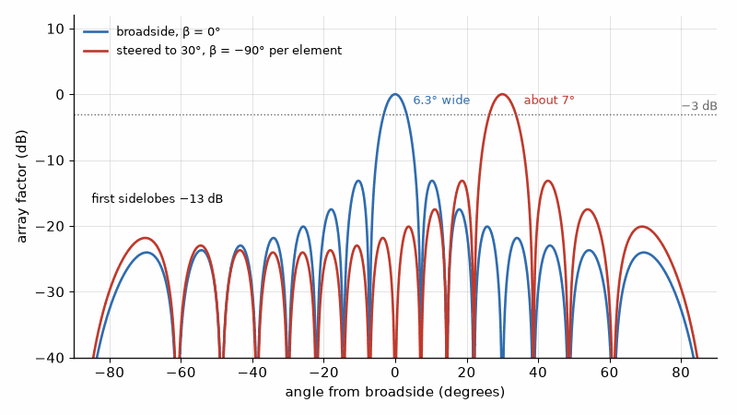
Figure 8.1 — Array factor of 16 elements at half-wavelength spacing. A −90° phase step per element moves the 6.3° main beam from broadside to 30°, and the beam widens slightly as it scans.
The spacing has an upper limit. If the elements are too far apart, the array factor has other directions where ψ is a multiple of 2π, and full-strength copies of the main beam, grating lobes, appear in visible space. To keep them out while scanning to θmax, the spacing must satisfy a simple inequality, which is why arrays are built at about half a wavelength.
d / λ < 1 / (1 + |sin θmax|)

Worked Example 8.2
Problem. A linear array of 16 patch elements, each 5 dBi, uses half-wavelength spacing. Find its broadside gain and beamwidth. What is the largest spacing that allows scanning to ±45° without grating lobes?
Solution. G ≈ 5 + 10 log₁₀ 16 = 17.0 dBi. The beamwidth is 0.886/(16 × 0.5) = 0.111 rad = 6.3° at broadside, and about 9° at a 45° scan. For scanning to 45°, d/λ < 1/(1 + 0.707) = 0.586, so the spacing may grow to 0.59λ, which reduces the number of elements, and of their amplifiers, needed for a given aperture. Scanning to 60° would require d < 0.54λ.
Key idea. An array's gain grows with the number of elements and its beamwidth shrinks with its length. Half-wavelength spacing is not a tradition; it is the largest spacing that keeps grating lobes out of a wide scan.

8.3 Phase shifters and their quantization
An active electronically scanned array puts a phase shifter, and usually a small amplifier, behind every element; those amplifiers are Part II's subject. A digital phase shifter with b bits sets phases in steps of 360°/2^b. The rounding errors are close to uniformly distributed, with a standard deviation of the step divided by √12, and a random phase error of σ radians reduces the array's gain by about a factor of exp(−σ²). Beamforming chips commonly use five or six bits, partly for this reason and partly to keep the sidelobes low.

Worked Example 8.3
Problem. Estimate the gain loss of a large array from phase quantization with 3-bit and with 4-bit phase shifters.
Solution. A 3-bit shifter has 45° steps, so σ = 45°/√12 = 13.0° = 0.227 rad, and the loss is −10 log₁₀ exp(−0.0514) = 0.22 dB. A 4-bit shifter has 22.5° steps, σ = 6.5° = 0.113 rad, and a loss of 0.056 dB. The gain loss is small even at three bits; what more bits buy is lower quantization sidelobes and finer pointing.

8.4 Millimeter wave is the same subject
Above about 24 GHz the wavelength is around a centimeter or less, and three things change. The free-space path factor between isotropic antennas falls as λ², so it looks 20 dB worse for every factor of ten in frequency. Losses rise: line and dielectric loss per meter, which is why the laminate choices of Book 7 matter, and the atmosphere's oxygen absorption near 60 GHz, about 15 dB/km, which limits 60 GHz links to short range and makes the band easy to reuse. And every interconnect becomes significant: a bond wire carries roughly 1 nH per millimeter, and a 0.3 mm wire at 77 GHz has a reactance of 145 Ω, which is why millimeter-wave chips are flip-chip mounted or put the antenna in the package, as Book 7 describes. None of this needs new physics. What changes is the size of every mistake.

Worked Example 8.4
Problem. Two terminals 100 m apart each have a fixed antenna aperture of 0.01 m², a square 10 cm on a side, with full aperture efficiency. Compare the link factor Gt Gr (λ/4πR)² at 2.45 GHz and at 28 GHz. Check that 100 m is in the far field at 28 GHz.
Solution. At 2.45 GHz, G = 4πAe/λ² = 4π × 0.01/0.1224² = 8.39, or 9.2 dBi, and the path factor is −80.2 dB, so the link factor is 9.2 + 9.2 − 80.2 = −61.8 dB. At 28 GHz, λ = 1.07 cm, G = 1,096, or 30.4 dBi, and the path factor is −101.4 dB, so the link factor is 30.4 + 30.4 − 101.4 = −40.6 dB, 21 dB stronger. With equal apertures, each antenna's gain rises as f² while the path factor falls as 1/f², and the link improves by 20 log₁₀(28/2.45) = 21 dB. The price is beamwidth: each 28 GHz beam is a few degrees wide and must be steered at the other terminal, which is exactly what the arrays of this chapter do. The far-field distance 2D²/λ = 2 × 0.1²/0.0107 = 1.9 m is far shorter than 100 m.

8.5 Where this book stops
This book has supplied the passive structure of a radio: lines, matches, filters, antennas, and arrays, and the gain of every antenna in a link budget. Book 5 builds the modem that decides what waveform these structures carry and how the band plan divides the spectrum. Part II supplies the transmitter power, the power amplifier with its load line, the receiver's noise, and the oscillator. Book 7 measures what the antenna actually radiated against the legal masks and the chamber methods. Book 7 supplies the laminates, packages, and antenna-in-package structures that turn the millimeter-wave designs of this chapter into hardware.
Where this continues. Chapter 50 steers beams with light: true-time-delay beamforming over optical fiber, which removes the beam squint of phase shifters, and optical phased arrays, the counterpart of this chapter's arrays at 1550 nm. The signal processing of large arrays is in Book 5, in its chapter "Massive MIMO and Beamforming".
From the Bench
Grating lobes are the array's version of aliasing. Keep element spacing below about 0.6 λ at the highest frequency and widest scan angle you need, or a second full-strength beam appears where nobody wanted it. Calibration usually limits an array more than the phase-shifter bit count does. Element-to-element gain and phase errors from manufacturing, temperature, and aging raise sidelobes long before 3-bit quantization matters.

Practice
1. An array with 0.5λ spacing must steer to 45°. Find the phase step between elements.
2. Find the approximate gain of a 64-element array of 6 dBi elements.
3. Find the broadside half-power beamwidth of a 32-element uniform linear array at half-wavelength spacing.
4. What is the largest element spacing for scanning to ±30° without grating lobes?
5. Find the gain loss from phase quantization with 5-bit phase shifters.
6. Repeat the fixed-aperture comparison of Worked Example 8.4 for 2.45 GHz and 60 GHz, ignoring atmospheric absorption. By how many decibels does the link factor change?

What You’ll Actually Use
Everyday working tools
- Phase step β = −kd sin θ0 for steering.
- Array gain ≈ element gain + 10 log N.
- Grating-lobe limit d/λ < 1/(1 + sin θmax).
Mostly for exams and deeper study
- Array synthesis by Chebyshev and Taylor weighting.

Chapter 9. Couplers, Dividers, and Hybrids
The splitter that feeds two televisions from one antenna lead looks like the simplest part in the house. It isn't. Splitting a signal in two without reflecting any back, and without letting one output hear the other, takes either a transformer or, at microwave frequencies, a pair of quarter-wave lines and one well-placed resistor.
Where you meet this: Antenna splitters and combiners, the power detector's coupler in every transmitter, balanced amplifiers, IQ modulators, and every network analyzer's reflectometer.
Many RF systems need to split a signal into parts, combine parts into one, or sample a wave traveling in one direction without disturbing it. The structures that do these jobs, power dividers, hybrids, and directional couplers, are built from the transmission lines of Chapter 2 and described by the scattering parameters of Chapter 5. They appear in every balanced amplifier, Doherty combiner, phased-array feed, and reflectometer. This chapter explains the main types and the figures that describe them.

9.1 What a three-port can and cannot do
A lossless, reciprocal three-port cannot be matched at all three ports, a consequence of the unitary S-matrix of Chapter 5. A simple T-junction splits power but reflects from its outputs and couples them to each other. The Wilkinson divider avoids that by adding a resistor between the outputs. It is matched at all ports and isolates the outputs, because the resistor absorbs power only when the outputs are unbalanced; when they are driven equally, no current flows through it and the divider is lossless.

9.2 The Wilkinson divider
The equal-split Wilkinson uses two quarter-wave lines of impedance √2 Z0 from the input to the outputs and a resistor of 2Z0 between the outputs. Each output receives half the power, a 3.01 dB split, in phase. As a combiner it adds two equal, in-phase signals without loss and dissipates the difference if they are unequal, which is why Part II's combiners degrade gracefully when one amplifier fails. Its bandwidth is limited by the quarter-wave lines; multisection versions extend it to an octave or more.
Wilkinson: Zline = √2 Z0, R = 2Z0, |S21|² = |S31|² = ½
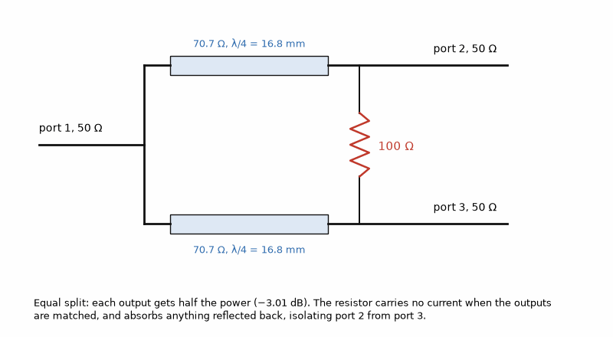
Figure 9.1 — The equal-split Wilkinson divider of Worked Example 9.1: two 70.7 Ω quarter-wave lines, 16.8 mm long at 2.45 GHz, and a 100 Ω resistor across the outputs.

Worked Example 9.1
Problem. Design an equal-split Wilkinson divider for a 50 Ω system at 2.45 GHz on a microstrip with an effective permittivity of 3.3. Find the line impedance, the resistor, and the physical line length.
Solution. The lines are 50√2 = 70.7 Ω and the resistor is 100 Ω. The guided wavelength is 299.8/(2.45 × √3.3) = 67.4 mm, so each quarter-wave line is 16.8 mm long. Splitting four ways with two stages loses 6.02 dB per output, the same as 3.01 dB twice.

9.3 Quadrature hybrids
The branch-line hybrid is a square of quarter-wave lines: two series arms of Z0/√2 and two shunt arms of Z0. A signal at port 1 divides equally between ports 2 and 3, 90° apart, and port 4 is isolated. Balanced amplifiers use a pair of these hybrids: reflections from the two identical amplifiers cancel at the input and go to the isolated port's load, so the pair presents a good match even when each amplifier alone is poorly matched. The rat-race, or 180° hybrid, does the same with in-phase and anti-phase outputs and serves balanced mixers and baluns.
branch-line: series arms Z0/√2 = 35.4 Ω, shunt arms Z0 = 50 Ω (for Z0 = 50 Ω)
Key idea. Dividers and hybrids are networks of quarter-wave lines arranged so that waves add at the wanted ports and cancel at the isolated one. Their resistors or isolated loads absorb only the imbalance.

9.4 The directional coupler
A directional coupler samples a small part of a wave traveling one way. Two parallel lines close together couple through their mutual capacitance and inductance; a wave on the main line couples into the adjacent line traveling backward, toward the coupled port. The coupling sets the sample's level, and the directivity, how much more strongly the coupler responds to the forward wave than to the reverse one, sets how well it distinguishes the two. The isolation is the coupling plus the directivity. A coupled-line coupler is designed from its even- and odd-mode impedances, which for a voltage coupling factor C are Z0e = Z0√((1 + C)/(1 − C)) and Z0o = Z0√((1 − C)/(1 + C)).
isolation = coupling + directivity, Z0e Z0o = Z0²

Worked Example 9.2
Problem. Find the even- and odd-mode impedances of a 10 dB and a 20 dB coupled-line coupler in 50 Ω.
Solution. For 10 dB, C = 10^(−10/20) = 0.316, Z0e = 50√(1.316/0.684) = 69.4 Ω and Z0o = 36.0 Ω. For 20 dB, C = 0.1, Z0e = 55.3 Ω and Z0o = 45.2 Ω. Looser coupling needs the two impedances closer together, which means the lines are farther apart.

Worked Example 9.3
Problem. A reflectometer uses a coupler with 30 dB of directivity to measure a load with a true return loss of 20 dB. What range of return loss might it report?
Solution. The true |Γ| is 0.1. The leakage of the forward wave into the reverse port, 30 dB down, is 0.0316 in amplitude and adds with an unknown phase, so the measured |Γ| lies between 0.068 and 0.132: a return loss reading anywhere from 17.6 to 23.3 dB. Measuring a good match needs a coupler whose directivity is well beyond the return loss being measured, or vector error correction as in Chapter 5.
From the Bench
A coupler's directivity, not its coupling value, decides how well it measures a good match. A coupler with 30 dB directivity can't tell a 20 dB return loss from 17.6 or 23.3 dB. For Wilkinson dividers, choose a small package for the isolation resistor (0402 or smaller) and keep it right at the line ends; its parasitic length is what limits isolation at the top of the band.

Practice
1. Find the line impedance and resistor of a Wilkinson divider in a 75 Ω system.
2. What is the loss to each output of an eight-way divider built from equal Wilkinson stages, ignoring dissipation?
3. A coupler has 20 dB coupling and 25 dB directivity. Find its isolation.
4. Find the possible return-loss readings for a true 20 dB return loss with 25 dB directivity.
5. Why does a balanced amplifier present a good input match even if each amplifier is poorly matched?
6. Why can't a lossless reciprocal three-port be matched at all ports?

What You’ll Actually Use
Everyday working tools
- Wilkinson: λ/4 lines of √2·Z0 and a 2Z0 resistor.
- Directivity sets the error of a reflected-power reading.
- Quadrature hybrids for balanced amplifiers.
Mostly for exams and deeper study
- Even- and odd-mode analysis in full.
- Proofs of the three-port impossibility theorem.

Chapter 10. Microstrip and Stripline by Design
On a 0.508 mm laminate with a permittivity of 3.55, a 50 Ω trace is 1.14 mm wide, and the 70.7 Ω line beside it is 0.62 mm. The board house's etching tolerance is a few hundredths of a millimeter, which makes it part of your impedance specification whether you write it down or not.
Where you meet this: Every RF and high-speed PCB stack-up, controlled-impedance fabrication notes, and the trace widths in any reference layout.
Chapter 2 treated a transmission line through its characteristic impedance and velocity without asking how a given geometry produces them. On a circuit board the line is a copper trace over a ground plane, microstrip, or a trace buried between two planes, stripline. This chapter gives the closed-form design equations for both, shows how to find the trace width for a wanted impedance, and estimates the dielectric loss. The laminate's measured properties at 10 GHz are Book 7's; here a typical value stands in, and the method is the subject.

10.1 Microstrip and its effective permittivity
In microstrip, part of the field lies in the substrate and part in the air above it, so the wave travels at a speed set by an effective permittivity between 1 and εr. Wider traces put more field in the substrate and lower the impedance. The Hammerstad models give compact quasi-static estimates from the width-to-height ratio u = W/h. The narrow- and wide-strip equations differ; their assumptions include negligible copper thickness and a uniform substrate. Designers invert the model numerically for a target impedance, then use a field solver and fabrication coupon when thickness, discontinuities, or frequency make the approximation inadequate.
For u ≥ 1: εeff = (εr + 1)/2 + (εr − 1)/(2√(1 + 12/u)); Z₀ = 120π/[√εeff (u + 1.393 + 0.667 ln(u + 1.444))]
For u ≤ 1: εeff = (εr + 1)/2 + (εr − 1)/2 × [(1 + 12/u)^(−1/2) + 0.04(1 − u)²]; Z₀ = (60/√εeff) ln(8/u + u/4)
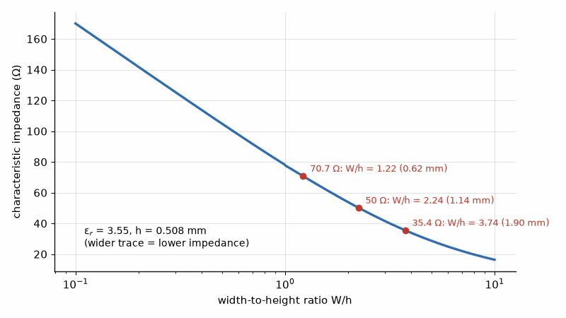
Figure 10.1 — Microstrip impedance against trace width on a 0.508 mm laminate with εr = 3.55. The three widths Chapter 9 needs are marked: 50 Ω at 1.14 mm, 70.7 Ω at 0.62 mm, 35.4 Ω at 1.90 mm.

Worked Example 10.1
Problem. A laminate has εr = 3.55 and a thickness of 0.508 mm. Find the trace widths for 50 Ω, 70.7 Ω, and 35.4 Ω, the impedances the Wilkinson and branch-line designs of Chapter 9 need, and the guided wavelength of the 50 Ω line at 10 GHz.
Solution. The synthesis gives u = 2.24 for 50 Ω, a width of 1.14 mm, with εeff = 2.78; checking with Hammerstad's analysis gives 50.3 Ω. For 70.7 Ω, u = 1.22, a width of 0.62 mm, εeff = 2.66. For 35.4 Ω, u = 3.74, a width of 1.90 mm, εeff = 2.90. At 10 GHz the 50 Ω line's guided wavelength is 30.0/√2.78 = 18.0 mm. On a 1.6 mm FR-4 board with εr = 4.4, the 50 Ω width would be 3.06 mm, with εeff = 3.33.

10.2 Stripline
In stripline the trace is fully embedded in dielectric between two ground planes, so the wave is a true TEM wave with εeff = εr, and the line is shielded, which keeps its fields away from neighbors and from the outside world. For a thin strip of width W centered between planes separated by b, Pozar's formula gives Z0 = 30π b /(√εr (We + 0.441b)), with We ≈ W for wide strips. Stripline is slower than microstrip on the same laminate and its traces are narrower for the same impedance, but it radiates less and couples less, which suits dense digital and RF boards alike.
stripline: Z0 = 30π b / [√εr (W + 0.441 b)] (for √εr Z0 < 120 Ω)

Worked Example 10.2
Problem. Find the width of a 50 Ω stripline with εr = 3.55 and a 1.0 mm plane spacing. Compare its velocity with the microstrip of Example 10.1.
Solution. W/b = 30π/(√3.55 × 50) − 0.441 = 0.559, so W = 0.56 mm, half the microstrip's width. Its velocity is c/√3.55 = 0.531c, against c/√2.78 = 0.600c for the microstrip, so a stripline delay line is about 12% shorter for the same delay.
Key idea. A line's impedance is set by the ratio of its width to its height above the ground, and its velocity by how much of the field lies in the dielectric. Closed-form formulas get within about a percent; a field solver and a test coupon confirm the rest.

10.3 Dielectric and conductor loss
The dielectric's loss tangent, tan δ, converts part of the stored electric energy to heat every cycle, giving an attenuation that rises in proportion to frequency. For microstrip, only the part of the field in the substrate contributes, so αd = k0 εr (εeff − 1) tan δ / (2√εeff (εr − 1)) nepers per meter. Conductor loss rises with the square root of frequency through the skin effect of Book 6's Chapter 6 and is increased by copper roughness, which at tens of gigahertz can add half again to the smooth-copper value. Above a few gigahertz on low-cost laminates, dielectric loss dominates; on low-loss laminates, conductor loss often does.
αd = k0 εr (εeff − 1) tan δ / [2 √εeff (εr − 1)] Np/m; 1 Np = 8.686 dB

Worked Example 10.3
Problem. The 50 Ω microstrip of Example 10.1 is on a laminate with tan δ = 0.0027. Find its dielectric loss at 10 GHz.
Solution. k0 = 2π × 10¹⁰/2.998 × 10⁸ = 209.6 rad/m. αd = 209.6 × 3.55 × 1.78 × 0.0027 / (2 × 1.667 × 2.55) = 0.421 Np/m, or 3.65 dB/m, 0.037 dB/cm. A 10 cm feed line therefore loses about 0.37 dB to the dielectric alone, before conductor loss is added.

10.4 Dispersion, modes, and discontinuities
Microstrip is not perfectly TEM, so its εeff rises slowly with frequency, an effect called dispersion that matters for wideband pulses and at millimeter waves. Thick substrates and wide traces can also support higher-order and surface-wave modes above a cutoff, so millimeter-wave boards use thin substrates. Bends, steps in width, T-junctions, and vias add parasitic capacitance and inductance; mitered bends and teardrop transitions reduce them, and circuit simulators model each discontinuity explicitly. The via between layers, discussed in Book 7, is often the largest single discontinuity on a fast board.
From the Bench
Get the stack-up from your fabricator before you draw a single RF trace, and use their dielectric constant at your frequency, not the 1 MHz value in a generic table. FR-4's permittivity and loss both vary between suppliers and with glass weave. Put the impedance requirement and the reference layer on the fabrication drawing and ask for a test coupon; an impedance-controlled order costs little more and removes a whole class of surprises.

Practice
1. Find εeff for a microstrip with εr = 3.55 and u = 2.24.
2. Find the guided wavelength at 28 GHz on a line with εeff = 2.78.
3. Find the 50 Ω stripline width for εr = 3.0 and b = 0.8 mm.
4. A line loses 0.037 dB/cm to the dielectric at 10 GHz. Estimate the loss at 20 GHz.
5. Why is a stripline's effective permittivity equal to εr?
6. Why do millimeter-wave boards use thin substrates?

What You’ll Actually Use
Everyday working tools
- Microstrip width from impedance tables or a calculator.
- εeff and guided wavelength on the board.
- Dielectric loss rising with frequency and tan δ.
Mostly for exams and deeper study
- Hammerstad's closed-form expressions in detail.
- Dispersion and higher-order mode formulas.

Chapter 11. Broadband Matching and the Bode-Fano Limit
In 1950 Robert Fano proved that no lossless network, however clever, can match a reactive load perfectly over a band. A transistor input of 50 Ω in parallel with 5 pF can be matched to 17 dB return loss across 1 GHz, but only to under 9 dB across 2 GHz. That limit isn't a weakness of your design. It is a law.
Where you meet this: Wideband test equipment, octave-band amplifiers, antenna matching across several cellular bands, and every broadband transformer.
Chapters 3 and 4 matched one impedance to another at a single frequency. Real signals occupy bands, and many systems, from wideband radios to test equipment, must match over an octave or more. This chapter asks how wide a match can be. Multisection transformers and low-Q networks widen it, and the Bode-Fano criterion sets a hard limit that no network, however clever, can exceed when the load stores energy in a reactance.

11.1 Q and bandwidth
An L-network's Q, from Chapter 3, is fixed by the resistance ratio. For a given topology and a stated match criterion, higher Q generally means narrower bandwidth; Δf/f₀ ≈ 1/Q is a rough estimate, not a universal bandwidth law. Matching 50 Ω to 100 Ω needs Q = 1 and is naturally broad compared with a 50 Ω to 500 Ω match, which needs Q = 3. A high-ratio transformation can be split into steps, each with a lower Q: two L-sections through an intermediate resistance or several quarter-wave sections whose impedances step gradually.

11.2 Multisection transformers
A single quarter-wave transformer is matched exactly only at its design frequency. A multisection transformer uses several quarter-wave sections whose small reflections are chosen to cancel over a band. The binomial design makes the response maximally flat at the center; the Chebyshev design allows a ripple of chosen size in return for a wider band. Pozar gives the bandwidth for a maximum tolerated reflection Γm in closed form. For a single section, Δf/f0 = 2 − (4/π) arccos[(Γm/√(1 − Γm²)) × 2√(Z0ZL)/|ZL − Z0|]; for an N-section binomial design, Δf/f0 = 2 − (4/π) arccos[½(Γm/A)^(1/N)], with A = 2^(−N)(ZL − Z0)/(ZL + Z0).
binomial: ln(Zn+1/Zn) ≈ 2^(−N) C(N, n) ln(ZL/Z0)
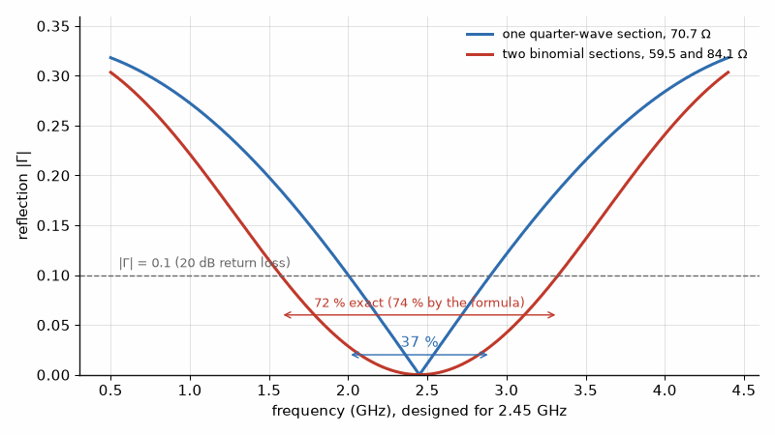
Figure 11.1 — Matching 50 Ω to 100 Ω with quarter-wave sections. One section stays below |Γ| = 0.1 over 37 % of the center frequency; two binomial sections double that, at twice the length.

Worked Example 11.1
Problem. Match 50 Ω to 100 Ω with a maximum reflection of 0.1 (20 dB return loss). Find the fractional bandwidth of a single quarter-wave section and of a two-section binomial transformer, and the section impedances.
Solution. The single section has impedance √(50 × 100) = 70.7 Ω and a fractional bandwidth of 0.367, or 36.7%. For two binomial sections, A = ¼ × 50/150 = 0.0833, and the bandwidth is 2 − (4/π) arccos(½ × (0.1/0.0833)^½) = 0.738, or 73.8%, twice as wide. The section impedances are 50 × 2^(1/4) = 59.5 Ω and 50 × 2^(3/4) = 84.1 Ω.

11.3 The Bode-Fano limit
Many loads are not resistive: a transistor's input looks like a resistance in parallel or series with a capacitance, and an antenna has stored reactive energy. Bode and Fano showed that for a parallel RC load matched by any lossless network, the integral of ln(1/|Γ|) over angular frequency cannot exceed π/(RC). If the match is held at a constant reflection Γ over a band Δω and is total reflection elsewhere, the best achievable is ln(1/Γ) = π/(RC Δω). A wider band forces a worse match, and a larger capacitance makes it worse still. The limit applies to every possible network, so it tells a designer when to stop trying.
∫ ln(1/|Γ(ω)|) dω ≤ π/(RC); rectangular best case: Γ = exp[−π/(RC Δω)]

Worked Example 11.2
Problem. A transistor's input is 50 Ω in parallel with 5 pF. What is the best return loss any lossless network can achieve over a 1 GHz band, and over a 2 GHz band?
Solution. For Δf = 1 GHz, π/(RC Δω) = π/(50 × 5 × 10⁻¹² × 2π × 10⁹) = 2.0, so Γ = e^(−2) = 0.135, a return loss of 17.4 dB and a mismatch loss of 0.08 dB. For 2 GHz the exponent halves to 1.0, so Γ = 0.368, a return loss of only 8.7 dB and a mismatch loss of 0.63 dB. Doubling the bandwidth halves the logarithm of the achievable return loss.
Key idea. A reactive load limits the product of bandwidth and match quality. The Bode-Fano integral sets that limit for every possible lossless network, so wideband designs must accept a poorer match, add loss, or reduce the load's reactance.

11.4 Ways around the limit
Since the limit applies to lossless matching of a fixed load, designers escape it in three ways. They can change the load: smaller transistors or distributed amplifiers, which absorb the device capacitance into an artificial transmission line, achieve multioctave bandwidths. They can add loss: resistive matching or feedback flattens the response at the cost of gain and noise figure, a trade that Part II's LNA chapter weighs. Or they can use balanced structures, like the balanced amplifier of Chapter 9, which hide each device's poor match behind hybrids. Test equipment and wideband receivers use all three.
From the Bench
Run the Bode-Fano number before promising a bandwidth; it takes a minute and settles arguments. When the limit bites, the honest choices are to accept a little loss (a resistor or a lossy match flattens the band), to use a balanced or feedback amplifier that hides the mismatch, or to switch between narrower matches. Multisection transformers trade length for bandwidth, so check that the extra length fits before you add sections.

Practice
1. Find the L-network Q to match 10 Ω to 50 Ω.
2. Find the section impedances of a two-section binomial transformer from 50 Ω to 200 Ω.
3. For a 50 Ω ∥ 2 pF load, what is the best return loss over a 2 GHz band?
4. What is the widest band over which a 50 Ω ∥ 2 pF load can be matched to a 10 dB return loss?
5. Why does a Chebyshev transformer give more bandwidth than a binomial one with the same number of sections?
6. Why does a distributed amplifier escape the Bode-Fano limit of a single transistor?

What You’ll Actually Use
Everyday working tools
- Single-section bandwidth for a given maximum reflection.
- The Bode-Fano limit for an RC load.
- Resistive and feedback broadbanding.
Mostly for exams and deeper study
- Chebyshev multisection synthesis by hand.

Chapter 12. Cavities and Dielectric Resonators
A copper cavity filter that's perfect at room temperature can be useless after warming 50 K. Its 1.28 MHz passband drifts 8.5 MHz, more than six times its own width. The same cavity in Invar moves only 0.6 MHz. Whether the filter still works in the sun is decided by the material, not the circuit.
Where you meet this: Base-station and satellite multiplexers, radar front ends, dielectric-resonator oscillators, and the high-Q filters between a power amplifier and its antenna.
Chapter 6 showed that a filter's insertion loss depends on the unloaded Q of its resonators. A microstrip resonator has a Q of a few hundred; the narrowband filters of base stations, satellites, and radars need thousands. Those come from cavities, closed metal boxes whose walls confine the field, and from dielectric resonators, pucks of low-loss ceramic in which the field is concentrated. This chapter computes a cavity's resonant frequency and Q, shows what that Q buys in a filter, and explains how dielectric resonators shrink the result.

12.1 The rectangular cavity
A length of the rectangular waveguide of Chapter 6, shorted at both ends, becomes a cavity. The lowest mode, TE101, has a half wavelength across the broad wall a and another along the length d, so its resonant frequency is f = (c/2)√(1/a² + 1/d²). The fields are confined, nothing radiates, and the only losses are the currents in the walls, which flow in a skin depth set by the surface resistance Rs = √(ωμ0/(2σ)). Pozar gives the conductor Q of the TE101 mode in closed form, and for copper at X band it is several thousand.
f101 = (c/2)√(1/a² + 1/d²), Rs = √(ωμ0 / 2σ)
Qc = (k a d)³ b η / (2π² Rs) × 1 / (2a³b + 2bd³ + a³d + ad³)

Worked Example 12.1
Problem. A copper cavity is made from WR-90 waveguide, a = 22.86 mm and b = 10.16 mm. Find the length for a 10 GHz TE101 resonance and its conductor Q. How much lower would the Q be in aluminum, with σ = 3.5 × 10⁷ S/m?
Solution. Solving for d gives 1/d² = (2f/c)² − 1/a², so d = 19.85 mm. At 10 GHz copper's surface resistance is 0.0261 Ω, and the formula gives Qc = 7820, a 3 dB bandwidth of only 1.28 MHz. Q scales with √σ, so aluminum gives 7820 × √(3.5/5.8) = 6080. Real cavities, with seams, tuning screws, and surface roughness, reach perhaps 70% to 90% of the ideal value.

12.2 What the Q buys
A band-pass filter's midband insertion loss is about 4.343 Σgk/(FBW × Qu) dB, from Chapter 6. For a five-pole filter with Σgk near 5 and a 1% fractional bandwidth, resonators with a Q of 200 give 10.9 dB of loss, unusable; with a Q of 7800, the loss is 0.28 dB. Narrow filters therefore need high-Q resonators, and the narrower the band, the more the Q matters. That is why the duplexers and channel filters of cellular base stations, the output multiplexers of satellites, and the preselectors of radars are cavity or dielectric-resonator filters, while handsets use the acoustic filters of Chapter 47, built from the piezoelectric films of Book 3.
Key idea. A resonator's unloaded Q sets how narrow a filter can be without excessive loss. Confining the fields in a metal cavity or a low-loss dielectric raises the Q from hundreds to thousands.

12.3 Coupling and loaded Q
A cavity is useful only if energy can enter and leave it, through a probe, a loop, or an iris. The coupling coefficient β compares the power lost to the external circuit with that lost in the walls. The loaded Q, which sets the observed bandwidth, is Qu/(1 + β); at critical coupling, β = 1, the cavity is matched at resonance and its loaded Q is half its unloaded Q. In a multipole filter, the irises between cavities set the coupling coefficients that the prototype of Chapter 6 calls for, and tuning screws trim each resonance.
QL = Qu / (1 + β)

12.4 Temperature and the dielectric resonator
A cavity's frequency follows its dimensions, so thermal expansion detunes it: copper expands about 17 ppm/K, shifting a 10 GHz cavity by about 170 kHz per kelvin, a large fraction of a 1 MHz bandwidth over a 50 K range. Invar, at about 1.2 ppm/K, or temperature-compensating structures solve this at a cost. Dielectric resonators solve it and the size problem at once: a ceramic puck with εr of 30 to 45 shrinks the resonator by about √εr, has a loss tangent near 10⁻⁴ for a Q of up to about 10,000, and can be formulated to have a temperature coefficient of frequency near zero. A puck for 3.5 GHz with εr = 45 is about 13 mm across, against several centimeters for an air cavity.
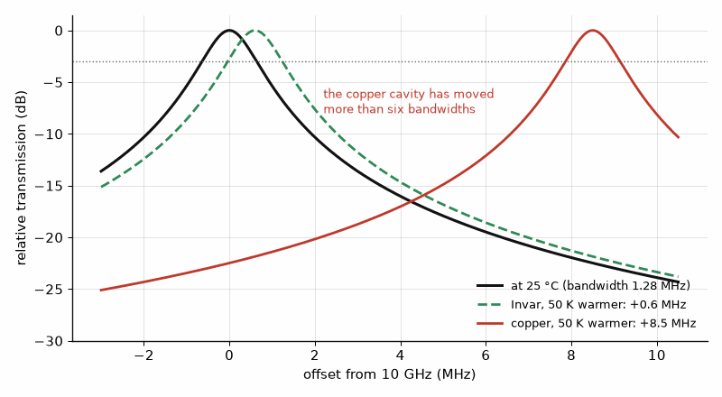
Figure 12.1 — A 10 GHz cavity with a 1.28 MHz bandwidth, warmed by 50 K. Copper drifts 8.5 MHz, far out of its own passband; Invar drifts 0.6 MHz, less than half a bandwidth.

Worked Example 12.2
Problem. A copper cavity at 10 GHz has a 1.28 MHz bandwidth. How far does it drift over a 50 K temperature range, and how does an Invar cavity compare?
Solution. Copper: 17 ppm/K × 10 GHz = 170 kHz/K, so 8.5 MHz over 50 K, more than six bandwidths. Invar: 1.2 ppm/K gives 12 kHz/K, or 0.6 MHz over 50 K, half a bandwidth. Satellite multiplexers therefore use Invar or temperature-compensated designs, and terrestrial filters often use dielectric resonators with near-zero drift.
Where this continues. Chapter 47 covers the acoustic resonators that replace cavities where size matters, and their Butterworth-Van Dyke model.
From the Bench
Every high-Q resonator is also a thermometer. Ask for the drift in ppm/K and multiply by your temperature range before you look at anything else. Tuning screws raise loss and become a long-term stability risk, so lock them and plan for vibration. When unloaded Q is the specification, surface finish and plating matter more than the drawing suggests; specify the plating and its thickness.

Practice
1. Find the TE101 frequency of a WR-90 cavity 25 mm long.
2. A resonator's unloaded Q is 5000 and it is critically coupled. Find its loaded Q.
3. Find the insertion loss of a five-pole filter with Σgk = 5, FBW = 0.5%, and Qu = 10,000.
4. A cavity's Q is 6000 in copper. Estimate it in a metal with a quarter of copper's conductivity.
5. Why does a cavity have no radiation loss?
6. Why do handsets not use cavity or dielectric-resonator filters?

What You’ll Actually Use
Everyday working tools
- Qu, QL, and external Q, and how coupling sets QL.
- Drift = (ppm/K) × f × ΔT.
- Q scaling with √σ.
Mostly for exams and deeper study
- Field solutions for TE and TM cavity modes.

Chapter 13. Small Antennas, Monopoles, Loops, and Horns
Why does every small gadget fight its antenna? Because in 1948 Lan Jen Chu put a ceiling on it. An antenna that fits in a 20 mm sphere at 915 MHz can never cover more than about 3.5 % bandwidth at a 2:1 VSWR, whatever its shape, and real antennas fall short of even that.
Where you meet this: Chip antennas on IoT boards, key-fob loops, quarter-wave whips over ground planes, and the horns that feed dishes and test ranges.
Chapter 7 treated the dipole, the patch, and the large aperture. Most antennas in products are none of these: they are monopoles over a circuit board, small loops in key fobs, chip antennas squeezed into a corner, or horns feeding reflectors and test ranges. This chapter covers those types and the physical limit that governs every small antenna: the smaller it is relative to the wavelength, the narrower its bandwidth and the harder it is to make efficient.

13.1 The monopole
A quarter-wave monopole over a large ground plane behaves like half of a dipole: its image in the plane completes the dipole. All its power goes into the half-space above the plane, so its directivity is twice the dipole's, 5.15 dBi, and its input resistance is half, about 36.5 Ω. On a real product the ground plane is the circuit board, which is often not large compared with a wavelength, so the board itself radiates and the pattern, gain, and tuning depend on its size and on the hand holding it. At 2.45 GHz a quarter wave is 30.6 mm in air, which is why most handheld antennas are folded, meandered, or loaded to fit.

13.2 The small-antenna limit
An antenna contained inside a sphere of radius a much smaller than a wavelength stores far more reactive energy than it radiates, so its radiation Q is high and its lossless matched bandwidth is narrow. Chu’s bound, refined by McLean, gives the minimum radiation Q for this idealized enclosing-sphere problem: Q = 1/(ka)³ + 1/(ka), with k = 2π/λ. The following VSWR bandwidth relation is an approximate single-resonance estimate; real bandwidth also depends on the matching network, efficiency, and the antenna’s frequency-dependent pattern.
Qmin = 1/(ka)³ + 1/(ka), FBW ≤ (s − 1)/(Q√s)
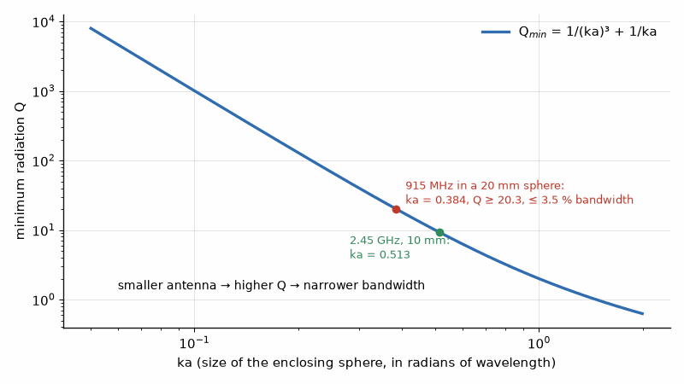
Figure 13.1 — The Chu limit. As an antenna shrinks inside its sphere, its minimum Q climbs as 1/(ka)³ and its bandwidth falls. A 915 MHz antenna in a 20 mm sphere can reach at best about 3.5 %.

Worked Example 13.1
Problem. A 915 MHz sensor's antenna must fit in a sphere of 20 mm radius. Find ka, the minimum Q, and the maximum bandwidth for a 2:1 VSWR. Repeat for a 2.45 GHz antenna in a 10 mm sphere.
Solution. At 915 MHz, k = 2π/0.3277 m = 19.2 rad/m, so ka = 0.384 and Qmin = 1/0.0564 + 1/0.384 = 20.3. The bandwidth for a 2:1 VSWR is at most 1/(20.3 × √2) = 3.5%, or 32 MHz, enough for the 26 MHz ISM band with little margin, and only if the antenna reaches the limit, which practical antennas rarely do. At 2.45 GHz in a 10 mm sphere, ka = 0.513 and Qmin = 9.3, so the bandwidth limit is about 7.6%.
Key idea. A small antenna's bandwidth is limited by its size in wavelengths: the minimum Q grows as 1/(ka)³. When a product shrinks its antenna, it pays in bandwidth, efficiency, or both.

13.3 The small loop
A loop much smaller than a wavelength has a radiation resistance of 31,171 (A/λ²)² ohms for one turn of area A, minute for practical sizes. Its conductor loss, set by the surface resistance of Chapter 12 and the wire's circumference, is usually much larger, so a small loop is an inefficient radiator. It is used anyway in key fobs, pagers, and hearing aids, because it is compact, responds to the magnetic field, and is less detuned by the body than a small electric antenna. As a receiving antenna at low frequencies, where atmospheric noise dominates, its inefficiency costs little sensitivity.
Rrad = 31,171 (A/λ²)² Ω (one turn)

Worked Example 13.2
Problem. A key fob uses a single-turn copper loop 10 mm in diameter, of wire 0.5 mm in radius, at 433 MHz. Find its radiation resistance, its loss resistance, and its efficiency.
Solution. A = π × 0.005² = 7.85 × 10⁻⁵ m² and λ = 0.692 m, so Rrad = 31,171 × (7.85 × 10⁻⁵/0.479)² = 0.84 mΩ. The surface resistance of copper at 433 MHz is 5.43 mΩ per square; the loss resistance is Rs times the circumference over the wire's perimeter, 5.43 mΩ × 31.4 mm / 3.14 mm = 54.3 mΩ. The efficiency is 0.84/(0.84 + 54.3) = 1.5%, or −18.2 dB. Short-range remote controls tolerate that, and regulations limit their radiated power anyway.

13.4 Horns
A horn flares a waveguide into an aperture, transforming the guide's impedance gradually to free space. Its gain follows the aperture formula of Chapter 7, G = εap 4πA/λ², with an aperture efficiency of about 0.5 for an optimum pyramidal horn. Horns are broadband, predictable, and low-loss, which makes them the standard gain references for antenna measurement and the feeds of reflector antennas. Corrugated horns produce symmetrical, low-sidelobe patterns for satellite feeds.

Worked Example 13.3
Problem. A pyramidal horn at 10 GHz has an aperture of 100 × 80 mm and an aperture efficiency of 0.51. Find its gain.
Solution. λ = 30.0 mm, so G = 0.51 × 4π × 0.1 × 0.08/0.0300² = 57.0, or 17.6 dBi.
Where this continues. Chapter 52 puts these antennas to work: a quarter-wave whip for a 915 MHz LoRa reader, a ceramic patch for GPS at 1575.42 MHz, a crossed-dipole or turnstile for weather satellites, and a dish for the hydrogen line, each with numbers a reader can measure.
From the Bench
For a small antenna, the ground plane matters as much as the antenna itself. A monopole on a 30 mm board isn't the monopole in the data sheet, because the board is half the antenna. Leave a pi-match footprint, measure with the device in its final enclosure with the battery installed, and tune last. A small loop's radiation resistance is in milliohms, so copper loss and capacitor ESR set its efficiency; use the highest-Q tuning capacitor you can find.

Practice
1. Find the length of a quarter-wave monopole at 868 MHz.
2. An 868 MHz antenna fits in a sphere of 30 mm radius. Find ka and the minimum Q.
3. Find the gain of a horn of 50 × 40 mm at 20 GHz with an aperture efficiency of 0.51.
4. How does a small loop's radiation resistance scale with its diameter?
5. Why is a quarter-wave monopole's directivity twice a half-wave dipole's?
6. Why do small antennas on products often include deliberate loss?

What You’ll Actually Use
Everyday working tools
- The Chu limit: Qmin = 1/(ka)³ + 1/ka.
- Quarter-wave monopole over ground, about 36 Ω.
- Horn gain from aperture area and efficiency.
Mostly for exams and deeper study
- Wheeler's and McLean's refinements of the Chu limit.

Chapter 14. Propagation Beyond Free Space
Stand at one dish and see the other clearly through binoculars, and a 10 km link at 5.8 GHz can still fade. Radio doesn't travel on the thin line you see. It needs a fat ellipse around that line clear of obstacles, 11.4 m in radius at mid-path, and a ridge poking into it can take 11 dB out of the fade margin.
Where you meet this: Point-to-point microwave links, cell-site planning, rooftop installations, millimeter-wave rain fades, and every coverage prediction tool.
The Friis equation of Chapter 7 assumes empty space between two antennas. Real paths run over the ground, past buildings and hills, and through air and rain. This chapter adds the corrections that matter most to a radio engineer: the Fresnel zone that a line-of-sight path must keep clear, the ground reflection that changes the distance law, diffraction over an obstacle, and absorption by oxygen and rain at millimeter waves. Each correction is a number of decibels added to the free-space loss.

14.1 The Fresnel zone
Energy does not travel along an infinitely thin ray. The first Fresnel zone is the ellipsoid around the direct path within which the excess path length is less than half a wavelength; obstacles inside it reduce the received power even if they do not block the line of sight. Its radius at a point a distance d1 from one end and d2 from the other is r1 = √(λd1d2/(d1 + d2)). Microwave links are designed to keep at least 60% of the first zone clear, allowing for the Earth's bulge, which with the standard effective-Earth-radius factor k = 4/3 rises by d1d2/(2kR) at the midpoint.
r1 = √(λ d1 d2 / (d1 + d2)), bulge h = d1 d2 / (2 k R), k = 4/3, R = 6371 km
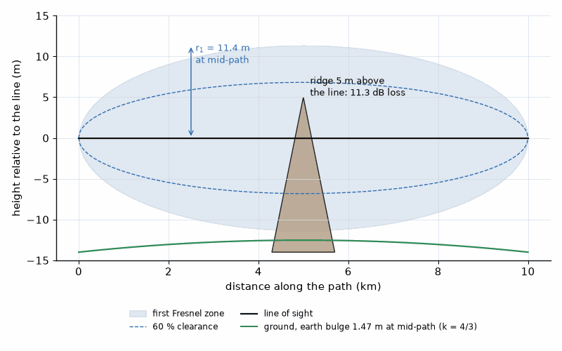
Figure 14.1 — The first Fresnel zone of the 10 km, 5.8 GHz link, 11.4 m in radius at mid-path. A ridge reaching 5 m above the line of sight intrudes deep into it and costs 11.3 dB.

Worked Example 14.1
Problem. A 5.8 GHz link spans 10 km. Find the first Fresnel radius at the midpoint, the 60% clearance, and the Earth bulge there.
Solution. λ = 51.7 mm, so r1 = √(0.0517 × 5000 × 5000/10,000) = 11.4 m, and 60% clearance is 6.8 m. The bulge is 5000²/(2 × 4/3 × 6.371 × 10⁶) = 1.47 m. The antennas must therefore be mounted high enough that the line between them clears the terrain at mid-path by at least 6.8 + 1.5 = 8.3 m.

14.2 The ground reflection
Over flat ground, the receiver sees the direct wave and a wave reflected from the ground, nearly 180° out of phase at grazing incidence. Close in, the two alternately add and cancel; beyond a breakpoint distance db = 4hthr/λ, they cancel more and more completely, and the received power falls as 1/d⁴ instead of 1/d². In that region the path loss is approximately 40 log10 d − 20 log10(hthr), independent of frequency. This two-ray model is the simplest explanation of why cellular path loss grows faster than free space, and why antenna height matters so much.
db = 4 ht hr / λ; beyond db: L ≈ 40 log10 d − 20 log10(ht hr) dB

Worked Example 14.2
Problem. A 2.4 GHz base antenna is 10 m high and the handset 1.5 m. Find the breakpoint and the two-ray path loss at 2 km, compared with free space.
Solution. λ = 0.125 m, so db = 4 × 10 × 1.5/0.125 = 480 m. At 2 km the two-ray loss is 40 × 3.301 − 20 log10 15 = 132.0 − 23.5 = 108.5 dB, against 106.1 dB in free space. The difference grows by 20 dB per decade of distance beyond the breakpoint: at 20 km it would be 22.5 dB.
Key idea. Real propagation adds losses to free space: obstacles in the Fresnel zone, ground reflections that steepen the distance law beyond a breakpoint, and absorption by gases and rain that grows with frequency.

14.3 Diffraction over an obstacle
An obstacle that blocks the line of sight does not create a perfect shadow; the wave diffracts over its edge. The knife-edge model expresses the obstruction as a dimensionless parameter ν = h√(2(d1 + d2)/(λd1d2)), with h the height of the edge above the line of sight, and the diffraction loss as approximately 6.9 + 20 log10(√((ν − 0.1)² + 1) + ν − 0.1) dB for ν > −0.7. An edge exactly on the line of sight, ν = 0, costs 6.0 dB. Real terrain with several obstacles and rounded hills is handled by extensions of the model and by terrain databases in planning tools.
ν = h √(2(d1 + d2)/(λ d1 d2)), J(ν) ≈ 6.9 + 20 log10[√((ν − 0.1)² + 1) + ν − 0.1] dB

Worked Example 14.3
Problem. On the link of Example 14.1, a ridge at mid-path rises 5 m above the line of sight. Find the diffraction loss.
Solution. ν = 5 × √(2 × 10,000/(0.0517 × 5000 × 5000)) = 0.622, so J = 6.9 + 20 log10(√(0.522² + 1) + 0.522) = 11.3 dB. The link's fade margin, 27.3 dB in Example 30.1, would fall to 16 dB.

14.4 Gases and rain
Above about 10 GHz the atmosphere absorbs. Water vapor has a line near 22 GHz, and oxygen a strong band near 60 GHz, where absorption reaches about 15 dB/km at sea level, which limits 60 GHz links to short ranges but also isolates neighboring links from one another. Rain attenuates more strongly with frequency and rain rate. The ITU-R P.838 model gives the specific attenuation as γ = kR^α dB/km with coefficients tabulated by frequency; at 30 GHz with horizontal polarization, k ≈ 0.240 and α ≈ 0.949, so a heavy 25 mm/h rain costs about 5.1 dB/km. Millimeter-wave link budgets must include these losses with the availability statistics of Chapter 30.
γrain = k R^α dB/km
Where this continues. Chapter 52 turns propagation into projects: a propagation monitor that logs beacon signals through the day, and satellite passes whose Doppler and path loss change by the minute.
From the Bench
Survey the path for 60 % of the first Fresnel zone, using the earth bulge for k = 4/3, and add clearance for trees that will grow. Above 10 GHz, check the rain region before you promise availability; a link that clears every hill can still drop in a thunderstorm. Raise the antennas rather than buying more power: height fixes a Fresnel-zone problem, while power only partly compensates for it.

Practice
1. Find the first Fresnel radius at the midpoint of a 2 km, 24 GHz path.
2. Find the two-ray breakpoint for 30 m and 2 m antennas at 3.5 GHz.
3. Find the free-space loss of a 500 m, 60 GHz link and the total with 15 dB/km of oxygen absorption.
4. What is the diffraction loss when the edge just grazes the line of sight?
5. How much rain attenuation does a 2 km, 30 GHz link suffer at 25 mm/h?
6. Why is path loss beyond the breakpoint independent of frequency in the two-ray model?

What You’ll Actually Use
Everyday working tools
- Fresnel radius r1 = √(λ d1 d2/d) and 60 % clearance.
- Two-ray breakpoint 4 ht hr/λ.
- Rain and gas attenuation as added dB/km.
Mostly for exams and deeper study
- Full knife-edge diffraction integrals.
- ITU-R model derivations.

Chapter 15. Ferrites, Circulators, and Isolators
Disconnect the antenna from a transmitter at full power and the whole forward wave comes back at the output transistor. Put an isolator in the path and the transistor barely notices: with a 3:1 antenna and 20 dB of isolation, the amplifier sees a VSWR of about 1.1. A magnetized piece of ferrite does what no network of resistors, capacitors, and inductors can. It lets power through one way and not the other.
Where you meet this: Radar and base-station duplexers, isolators after power amplifiers, test benches that protect expensive sources, and satellite transponders.
Every network in this book so far has been reciprocal: a signal travels from port 1 to port 2 exactly as it travels from port 2 to port 1, and S₂₁ equals S₁₂. Magnetized ferrite breaks that symmetry. In a ferrite the electron spins precess about the bias field in one direction only, so a wave that rotates with the precession sees a different material from one that rotates against it. That single fact gives the circulator, which sends power around its ports in one direction, and the isolator, which passes power forward and absorbs it backward. This chapter explains how they work, what their datasheet numbers mean, and how they protect amplifiers and share antennas.

15.1 Gyromagnetic resonance
An electron spin in a magnetic field precesses like a top at a rate proportional to the field: about 28 GHz per tesla. In a ferrite, a ceramic of iron oxide with other metal oxides such as yttrium iron garnet, the spins act together, and a microwave field rotating in the same sense as the precession is absorbed strongly near the resonance, while a field rotating in the opposite sense passes almost untouched. Devices operate a safe distance from resonance, where the two senses still see different permeabilities but the loss is low. The bias field comes from a small permanent magnet built into the device.
f_res = γ H, γ ≈ 28 GHz/T

Worked Example 15.1
Problem. Find the gyromagnetic resonance for an internal field of 0.1 T.
Solution. f_res = 28 GHz/T × 0.1 T = 2.8 GHz. A device for the 2.45 GHz band biased at 0.1 T would be too close to resonance to have low loss, so the designer chooses either a weaker field, operating below resonance, or a stronger field, operating above it. The choice is made by the manufacturer; the user meets it as the device's specified band.

15.2 The three-port circulator
The junction circulator is a ferrite disk between two ground planes, or under a microstrip conductor, with three lines meeting it at 120°. Biased correctly, the disk sets up a field pattern rotated so that power entering port 1 leaves at port 2, power entering port 2 leaves at port 3, and power entering port 3 leaves at port 1. An ideal circulator's S-matrix has zeros on its diagonal and ones in a rotating pattern; a real one has an insertion loss of a few tenths of a decibel and an isolation, the leakage in the wrong direction, of about 20 dB over its band.
S = [[0, 0, 1], [1, 0, 0], [0, 1, 0]] (ideal circulator)

15.3 The isolator
Terminating port 3 of a circulator in a matched resistor makes an isolator. Power from the source passes from port 1 to port 2 and on to the load; any power the load reflects enters port 2, is routed to port 3, and is dissipated in the resistor instead of returning to the source. The source therefore sees a good match regardless of the load. The resistor must be rated for the reflected power, which in a fault, such as a disconnected antenna, is all the forward power.

Worked Example 15.2
Problem. A 10 W amplifier drives an antenna whose VSWR is 3:1 through an isolator with 20 dB isolation. Find the power reflected by the antenna, the power dissipated in the isolator's termination, and the effective reflection coefficient the amplifier sees.
Solution. VSWR 3:1 gives |Γ| = (3 − 1)/(3 + 1) = 0.5, so 25% of the power, 2.5 W, is reflected. Nearly all of it goes to the termination, which must therefore handle at least 2.5 W and, for the open-antenna fault, the full 10 W. The leakage back toward the amplifier is 0.25 × 0.01 = 0.0025 of the forward power, an effective |Γ| of √0.0025 = 0.05 or a VSWR of 1.11. The amplifier sees nearly a perfect load, which keeps its gain, linearity, and stability as designed in Part II.
Key idea. Biased ferrite is non-reciprocal. A circulator routes power around its ports in one direction, and an isolator, a circulator with a terminated port, sends reflected power into a resistor instead of back to the source.

15.4 Circulators as duplexers
A circulator can let a transmitter and receiver share one antenna at the same frequency: transmitter at port 1, antenna at port 2, receiver at port 3. Two leakage paths limit it. The first is the circulator's own isolation from port 1 to port 3. The second is usually larger: the antenna's mismatch reflects part of the transmitted power back into port 2, and the circulator dutifully routes it to the receiver. The antenna's return loss therefore sets the isolation as much as the ferrite does, and radar and full-duplex systems add cancellation or a limiter in front of the receiver.
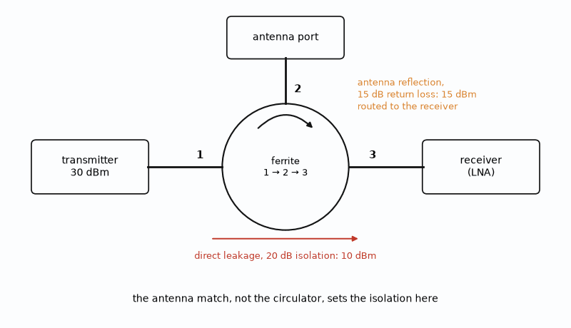
Figure 15.1 — A circulator as duplexer (Worked Example 15.3). Direct leakage through 20 dB of isolation is 10 dBm, but a 15 dB antenna return loss sends 15 dBm straight to the receiver.

Worked Example 15.3
Problem. A 30 dBm transmitter feeds an antenna through a circulator with 20 dB isolation. The antenna's return loss is 15 dB. Estimate the power reaching the receiver port by each path.
Solution. Direct leakage is 30 − 20 = 10 dBm. The antenna reflection is 30 − 15 = 15 dBm, routed to the receiver with only the circulator's insertion loss. The reflection dominates, and 15 dBm is enough to compress or damage a low-noise amplifier. Improving the antenna's match to 25 dB return loss lowers that path to 5 dBm, which shows why the antenna is part of the isolation budget.

15.5 Practical limits
Ferrite devices are band-limited, typically to an octave or less, because the bias must stay in the low-loss region across the band. Their properties drift with temperature, since the ferrite's magnetization falls as it warms, and they can be detuned by nearby steel or magnets. High power heats the ferrite and can drive it nonlinear. At millimeter wave, and on chips where a magnet is not practical, designers turn to active circulators built from transistors or to time-modulated networks, which break reciprocity electronically at the cost of noise and linearity.
Where this continues. Acoustic circulators, which break reciprocity without a magnet, are a research alternative to ferrites; Chapter 47 surveys them with the other acoustic devices.
From the Bench
An isolator protects only as well as its termination survives. Rate the load for the full forward power, because an open antenna sends all of it there. Check the temperature range and the magnet's sensitivity to nearby steel; mounting an isolator next to a ferrous bracket can shift its band. In a circulator duplexer the antenna's match sets the transmit-to-receive leakage, so the antenna belongs in the isolation budget.

Practice
1. Find the gyromagnetic resonance for an internal field of 0.05 T.
2. An antenna has VSWR 2:1. What fraction of the forward power does it reflect?
3. With 25 dB isolation, what effective |Γ| does a source see behind an isolator when the load reflects all its power?
4. What happens at a circulator's port 3 when power enters port 2?
5. A 33 dBm transmitter feeds an antenna with 12 dB return loss through a circulator. Find the power the antenna reflects toward the receiver.
6. Why must an isolator's termination be rated for the full forward power?

What You’ll Actually Use
Everyday working tools
- Port order 1 → 2 → 3, and the isolator as a circulator with one port terminated.
- Power into the termination: |Γ|² × forward power.
- Antenna return loss as part of transmit-receive isolation.
Mostly for exams and deeper study
- Polder tensor and gyromagnetic resonance theory.

Chapter 16. Measuring Antennas: Ranges and Gain
A 1 m dish at 30 GHz isn't in its own far field until 200 m away. Measure it closer and the pattern you record isn't the pattern it radiates. That is why large high-frequency antennas are measured outdoors, in compact ranges, or by scanning the near field and computing the rest.
Where you meet this: Antenna data sheets, anechoic chambers, over-the-air certification tests, and the gain numbers in every link budget.
Chapter 7 defined an antenna's gain and pattern, and every link budget in the series uses those numbers. They come from measurement. Measuring an antenna is harder than measuring a circuit because the quantity of interest exists only at a distance, in the far field, and because the room itself reflects. This chapter explains the far-field condition, the ranges built to satisfy it, and the two standard ways to measure gain.

16.1 The far-field distance
Near an antenna, the field has reactive components and its shape changes with distance. Far away, the wave from every part of the aperture arrives nearly in phase, and the pattern stops changing. The usual criterion is that the phase difference between a ray from the center of the aperture and a ray from its edge be no more than π/8, or 22.5°. That gives the far-field distance in terms of the largest dimension D of the antenna, and it grows with the square of the size.
R_ff = 2D² / λ
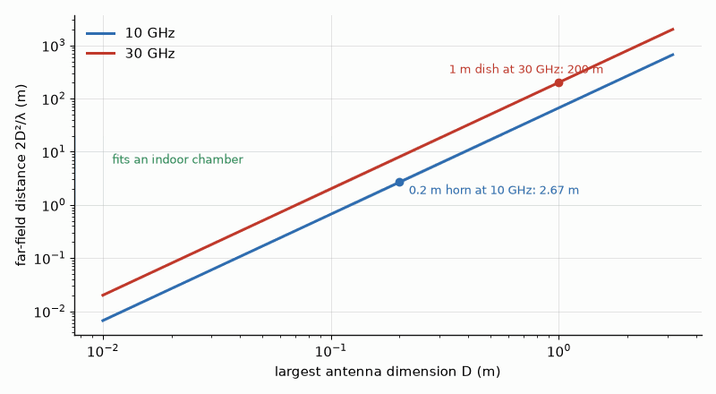
Figure 16.1 — Far-field distance 2D²/λ grows with the square of antenna size. A 0.2 m horn at 10 GHz needs 2.67 m and fits indoors; a 1 m dish at 30 GHz needs 200 m.

Worked Example 16.1
Problem. Find the far-field distance of a horn with a 0.2 m aperture at 10 GHz and of a 1 m dish at 30 GHz.
Solution. At 10 GHz, λ = 0.03 m, so R_ff = 2 × 0.04/0.03 = 2.67 m, which fits indoors. At 30 GHz, λ = 0.01 m, so R_ff = 2 × 1/0.01 = 200 m, which does not. Large, high-frequency antennas are measured outdoors, in a compact range, or with near-field scanning.

16.2 Ranges
An anechoic chamber lined with pyramidal absorber, reflecting −40 dB or better at the frequencies of use, provides a far-field range for small antennas. The region where the incident field is uniform enough for measurement is the quiet zone. A compact range uses a large, precise reflector to convert the spherical wave of a feed into a plane wave within a few meters, so a large antenna can be measured indoors. A near-field scanner samples the field's amplitude and phase on a surface close to the antenna, at spacings of no more than half a wavelength, and computes the far-field pattern by a Fourier transform; it trades room size for precise positioning and computation.
Key idea. Gain and pattern are far-field quantities. When 2D²/λ is too far for a room, a reflector or a near-field scan with a transform provides the plane wave instead.

16.3 Gain by comparison
The most common gain measurement compares the antenna under test with a reference antenna of known gain, usually a calibrated standard-gain horn. Each is placed in turn at the receiving position under identical conditions, and the received powers are recorded. The difference in received power in decibels is the difference in gain.
G_AUT (dBi) = G_ref (dBi) + P_AUT (dBm) − P_ref (dBm)

Worked Example 16.2
Problem. A 15.0 dBi standard horn receives −32.4 dBm. With the antenna under test in its place, the received power is −29.8 dBm. Find the gain of the antenna under test.
Solution. G_AUT = 15.0 + (−29.8) − (−32.4) = 17.6 dBi. The method relies on both antennas being matched equally well, so the mismatch loss of each, from Chapter 2, is measured and corrected.

16.4 Gain from the Friis equation
Without a reference, the gain follows from the link equation of Chapter 7. With two identical antennas facing each other at a known distance, the measured ratio of received to transmitted power equals the product of the gains times the path factor. With three different antennas, measured in all three pairs, the three equations can be solved for each gain without assuming any two are identical. This three-antenna method is how standard horns are themselves calibrated.
Pr/Pt = G₁ G₂ (λ / 4πR)²

Worked Example 16.3
Problem. Two identical horns are 5 m apart at 10 GHz. The measured Pr/Pt is −36.4 dB. Find each horn's gain.
Solution. The path factor is 20 log(0.03/(4π × 5)) = −66.4 dB. Then G₁G₂ = −36.4 − (−66.4) = 30.0 dB, and since the horns are identical, each is 15.0 dBi. With D = 0.2 m, the far-field distance is 2.67 m, so 5 m satisfies it.

16.5 Pattern, polarization, and efficiency
A pattern is measured by rotating the antenna under test on a positioner while recording the received power, usually in two principal planes, and then over a full sphere when the total radiated power is wanted. Rotating the source antenna's polarization measures the cross-polar level. Integrating the pattern over the sphere gives directivity; comparing it with the measured gain gives the radiation efficiency, which for a small antenna, as Chapter 13 explained, can be far below unity. For phones and IoT devices, over-the-air tests measure total radiated power and total isotropic sensitivity with the device's own radio running, which captures the antenna, the matching, and the body of the product together.
Where this continues. A NanoVNA measures an antenna's match on the bench for the price of a meal; Chapter 52 trims a dipole and a LoRa whip with one, and Book 9, Test and Measurement Instruments, covers the instrument in "The Budget Bench: NanoVNA, tinySA, SDRs, and Low-Cost Scopes and Supplies".
From the Bench
Know where an antenna's gain figure came from: a calibrated standard horn, a three-antenna measurement, or a simulation with idealized materials. Indoors, check the far-field distance 2D²/λ first, then look for reflections from the floor, the mounting fixture, and the cables. Route the feed cable away from the antenna along a null and put ferrite on it; a radiating cable shield is the classic error in small-antenna measurements.
On the Job
Antenna and OTA test engineers run anechoic chambers and compact ranges, calibrate them with standard-gain horns, and measure the radiated power and sensitivity of finished phones and IoT devices for carriers and regulators. The work mixes RF measurement, mechanical fixturing, and statistics: a chamber's uncertainty budget is often ±1 dB, and knowing which part of it comes from the positioner, the cable, or the reference antenna is the job. Employers are test labs, handset and module makers, and chamber vendors; the path in is often an RF technician or test role, with Python for automation.

Practice
1. Find the far-field distance of a 0.3 m antenna at 5 GHz.
2. Find the far-field distance of a 0.1 m antenna at 60 GHz.
3. A 20.0 dBi reference receives −40.0 dBm and the antenna under test receives −43.5 dBm. Find the antenna's gain.
4. Find the path factor at 10 GHz and 10 m.
5. Two identical antennas at 10 GHz and 10 m give Pr/Pt = −52.4 dB. Find each gain.
6. What maximum sample spacing does a near-field scanner use?

What You’ll Actually Use
Everyday working tools
- Far-field distance 2D²/λ.
- Gain by comparison with a standard horn.
- Gain from the two- or three-antenna Friis method.
Mostly for exams and deeper study
- Near-field to far-field transformation mathematics.

Chapter 17. Noise in Passive Networks
Half a decibel of cable sounds like nothing. Put it between a ground-station antenna and its LNA and the system noise temperature rises from 86 K to 125 K, about 1.7 dB worse. Every lossy part at room temperature adds its own noise to the signal, and in front of the first amplifier nothing else costs as much per decibel.
Where you meet this: Satellite ground stations, GPS antennas at the end of long cables, tower-mounted amplifiers on cell sites, and any receiver with a filter or switch before the LNA.
A passive network adds no gain, but it does add noise. Any component that absorbs power at a physical temperature also emits thermal noise, and in a receiver the loss in front of the first amplifier is often the largest single term in the noise budget. Chapter 25 develops the receiver's noise cascade; this chapter supplies the passive parts of it: the noise of a lossy line or attenuator, the noise temperature of an antenna, and the rule that explains why the low-noise amplifier goes at the antenna.

17.1 Noise temperature
Noise power in a bandwidth B is kTB, where k is Boltzmann's constant, 1.381 × 10⁻²³ J/K. It is often convenient to describe a component's added noise by an equivalent temperature Te, the temperature a matched resistor at the input would need to produce the same added noise. Noise figure and noise temperature are two expressions of the same quantity, related through the reference temperature T₀ = 290 K.
N = kTB, Te = T₀(F − 1), F = 1 + Te/T₀

17.2 The lossy line and the attenuator
A matched attenuator with loss factor L (L > 1) at the physical temperature T passes 1/L of its input and emits noise of its own. Thermodynamics fixes the amount: if the input were a resistor at the same temperature T, the output must still look like a resistor at T. That condition gives the attenuator's equivalent input noise temperature and, at T₀, a noise figure equal to its loss. A cable with 2 dB of loss at room temperature has a noise figure of 2 dB.
Te = (L − 1)T, F = L at T = T₀, Tout = Tin/L + (1 − 1/L)T
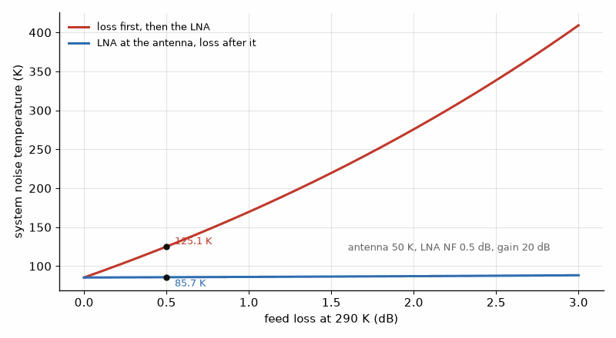
Figure 17.1 — System noise temperature with the feed loss before or after the LNA (Worked Example 17.2). At only 0.5 dB of loss, putting the LNA first lowers the system temperature from 125.1 K to 85.7 K.

Worked Example 17.1
Problem. A 2 dB cable at 290 K feeds an amplifier with a 1 dB noise figure and high gain. Find the cascade noise figure.
Solution. By the cascade of Chapter 25, F = F_cable + (F_amp − 1)/G_cable = L + (F_amp − 1)L = L F_amp, so in decibels the noise figures simply add: 2 + 1 = 3.0 dB. Every decibel of loss in front of the first amplifier adds a decibel to the noise figure.

17.3 Antenna temperature
An antenna delivers the noise of whatever it sees, weighted by its pattern. Pointed at the clear sky at high elevation, a microwave antenna sees a cold background, a few kelvin from space plus the atmosphere's emission, and its antenna temperature may be tens of kelvin. Pointed at the ground or a wall, it sees about 290 K. This is why satellite ground stations, whose antennas look at the cold sky, can benefit from an LNA with a noise temperature of tens of kelvin, while a terrestrial antenna looking at the horizon gains little from an amplifier much better than its surroundings.

Worked Example 17.2
Problem. An antenna with T_A = 50 K is connected through 0.5 dB of feed loss at 290 K to an LNA with a 0.5 dB noise figure and 20 dB gain. Find the system noise temperature referred to the antenna terminals, then repeat with the LNA moved ahead of the loss. Find the noise power in 1 MHz for each.
Solution. L = 10^0.05 = 1.122, so the loss and the LNA each have Te = 0.122 × 290 = 35.4 K. With the loss first, the system temperature at the antenna is T_A + Te,loss + L·Te,LNA = 50 + 35.4 + 39.7 = 125.1 K. With the LNA first, it is T_A + Te,LNA + Te,loss/G = 50 + 35.4 + 0.35 = 85.7 K. In 1 MHz, kTB is −117.6 dBm for 125.1 K and −119.3 dBm for 85.7 K. Moving the LNA ahead of only half a decibel of loss improves the noise floor by 1.6 dB, which is why masthead and feed-mounted LNAs exist.
Key idea. Loss at physical temperature T adds noise temperature (L − 1)T, so a passive loss at 290 K adds its full decibel value to the noise figure. Put the first amplifier before the loss.

17.4 Mismatch and noise
A low-noise transistor reaches its minimum noise figure only when it sees a particular source impedance, generally not the conjugate match that gives maximum gain. The input network of an LNA is therefore a compromise between noise match and power match, drawn on the Smith chart of Chapter 4 as circles of constant noise figure and constant gain. The input mismatch that results is often accepted, and an isolator or a balanced amplifier, Chapter 9's hybrids at each end, restores a good return loss without disturbing the noise match.
From the Bench
Every decibel of loss in front of the LNA adds a decibel to the noise figure, so put the LNA as close to the antenna as its survival allows. That is why tower-mounted amplifiers and active GPS antennas exist. When filters and switches must come first for protection, choose them for insertion loss before anything else, and count the connector and trace losses too. Each is only a tenth of a decibel or so, which is why they get forgotten.

Practice
1. Find the noise temperature of an amplifier with a 2 dB noise figure.
2. Find the noise figure of an amplifier with Te = 75 K.
3. Find the equivalent noise temperature of a 3 dB attenuator at 290 K.
4. Find kTB at 290 K in 1 MHz, in dBm.
5. A 1.5 dB cable precedes an LNA with a 0.8 dB noise figure. Find the cascade noise figure.
6. Find the output noise temperature of a 3 dB attenuator at 290 K whose input is a 10 K source.

What You’ll Actually Use
Everyday working tools
- Te = (L − 1)·290 K for a lossy part at room temperature.
- Loss before an amplifier: NF_total = L + NF_amp, in dB.
- System temperature Tsys and kTB.
Mostly for exams and deeper study
- Noise-wave and noise-correlation matrix theory.

Chapter 18. A Bandpass Filter from Specification to Coupling Design
A filter specification often arrives as one line: three poles, 4 % bandwidth at 2.45 GHz, 0.1 dB ripple. By the end of this chapter that line has become two coupling coefficients, an external Q, a rejection figure at every frequency that matters, and a loss estimate the system engineer can put in the budget.
Where you meet this: Every custom band-pass filter, from a ceramic block in a phone to a cavity on a tower, and the conversation between a filter vendor and the system designer.
Chapter 6 gave the prototype values and the loss formula for filters, and Chapter 12 gave the resonators. This chapter carries one filter all the way through, from a specification to the coupling numbers a layout must realize, so that the steps can be seen in order. The example is a third-order Chebyshev bandpass filter for the 2.45 GHz band on the book's reference microstrip, with a comparison against the same filter built from cavities.

18.1 The specification
The filter must pass 2.40 to 2.50 GHz with at most 0.1 dB of ripple, and it should reject a signal at 2.60 GHz as strongly as possible with three resonators. The center frequency is f₀ = 2.45 GHz, and taking the passband edges as about 2.40 and 2.50 GHz with a little margin gives a fractional bandwidth FBW of 4%, about 98 MHz.

18.2 From prototype to couplings
A coupled-resonator filter is described by two kinds of numbers: the external quality factor Qe, which sets how strongly the first and last resonators are loaded by the source and load, and the coupling coefficients Mᵢ,ᵢ₊₁ between adjacent resonators. Both follow directly from the lowpass prototype values gₖ and the fractional bandwidth. For the 0.1 dB Chebyshev prototype of third order, g₁ = g₃ = 1.0316 and g₂ = 1.1474.
Qe = g₀g₁ / FBW, Mᵢ,ᵢ₊₁ = FBW / √(gᵢ gᵢ₊₁)

Worked Example 18.1
Problem. Find Qe and the coupling coefficients for the 4% filter.
Solution. Qe = 1.0316/0.04 = 25.8. M₁₂ = M₂₃ = 0.04/√(1.0316 × 1.1474) = 0.04/1.088 = 0.0368. The layout must now produce a tap or gap that loads the end resonators to Qe = 25.8, and gaps between resonators that couple them by 3.68%. Electromagnetic simulation of two resonators at a time finds those dimensions: the coupling is half the fractional separation of the two resonant peaks a pair of coupled resonators shows.
These coupling numbers are not physical gap dimensions. A buildable layout requires a specified substrate stack-up, resonator geometry, feed launches, copper thickness, and enclosure. Simulate resonator pairs in that stack-up, tune their gaps or overlap until the extracted coupling matches M₁₂, extract the end-resonator external Q, then simulate the complete filter with its feeds and finite ground. The ideal response above is a target for that process, not a prediction of the fabricated response; measure and tune the prototype before treating its rejection as achieved.

18.3 The resonators
On the reference microstrip, with εeff = 2.79, the guided wavelength at 2.45 GHz is λ₀/√εeff = 12.24/1.670 = 7.33 cm, so a half-wave resonator is about 3.66 cm long before corrections for end effects. Folding the resonators into hairpins or squares shortens the filter and lets the coupling be set by the spacing of parallel arms. The unloaded Q of such microstrip resonators is typically about 200, set by conductor and dielectric loss, and it, not the topology, determines the passband loss.

Worked Example 18.2
Problem. Find the midband loss with Qu = 200 and with Qu = 2000.
Solution. The formula of Chapter 6 gives loss ≈ 4.343 Σgₖ/(FBW Qu). Σgₖ = 3.2106, so with Qu = 200 the loss is 4.343 × 3.2106/(0.04 × 200) = 1.74 dB, and with Qu = 2000, as with Chapter 12's cavities or dielectric resonators, it is 0.17 dB. The tenfold Q costs volume and money, and it is needed only when the 1.6 dB matters, as it does ahead of an LNA by Chapter 17's rule.
Key idea. A coupled-resonator filter is specified by its external Q and coupling coefficients, which follow from the prototype and the bandwidth. The resonators' unloaded Q then sets the loss.

18.4 Rejection
The rejection of the Chebyshev response at a frequency f follows from the lowpass prototype after the bandpass transformation, which maps f to a normalized frequency Ω. For the 0.1 dB ripple, ε² = 10^0.01 − 1 = 0.0233, and the attenuation of an n-th order filter is computed from the Chebyshev polynomial.
Ω = (1/FBW)(f/f₀ − f₀/f), A = 10 log₁₀[1 + ε² cosh²(n arccosh |Ω|)]
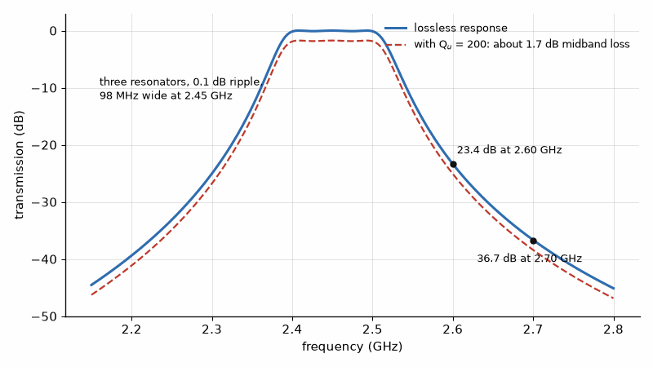
Figure 18.1 — The three-pole, 4 % Chebyshev filter of this chapter at 2.45 GHz. It rejects 23.4 dB at 2.60 GHz and 36.7 dB at 2.70 GHz; with microstrip resonators (Qu = 200) its passband sits about 1.7 dB lower.

Worked Example 18.3
Problem. Find the rejection of the third-order filter at 2.60 GHz and at 2.70 GHz.
Solution. At 2.60 GHz, f/f₀ − f₀/f = 1.0612 − 0.9423 = 0.1189, so Ω = 2.97 and A = 23.4 dB. At 2.70 GHz, Ω = 4.87 and A = 36.7 dB. If 2.60 GHz needs 40 dB, the designer must add a resonator, narrow the bandwidth, or add a transmission zero by cross-coupling the first and third resonators. Each choice raises the passband loss, so the specification and the loss are negotiated together.

18.5 Tuning and tolerance
A 4% filter is sensitive to its dimensions. The resonant frequency of a half-wave resonator scales with 1/√εeff, so a laminate whose εr varies by ±2% moves the center by about ±1%, a quarter of the passband. Production filters therefore either use laminates with tight εr control, as Book 7 discusses, or provide tuning screws or laser trimming. Simulation should include a tolerance sweep before the layout is released.
From the Bench
Specify a filter by what the system needs: passband, loss, rejection at named frequencies, power, and temperature, and let the vendor pick the order. Ask for measured data over temperature, not just at 25 °C, and for the rejection far out of band, where spurious resonances and package parasitics can bring the response back up. Leave room for tuning; most narrowband filters are adjusted after assembly, by hand or by machine.

Practice
1. Find Qe for a 0.1 dB, third-order filter with FBW = 5%.
2. Find M₁₂ for the same filter.
3. Find the half-wave resonator length on a microstrip with εeff = 2.79 at 5.0 GHz.
4. Find the midband loss of the 4% filter with Qu = 500.
5. Find Ω for the 4% filter at 2.30 GHz.
6. Find the rejection at 2.30 GHz.

What You’ll Actually Use
Everyday working tools
- External Q and coupling coefficients from the prototype values.
- Rejection from the Chebyshev formula at an offset frequency.
- Midband loss from Qu, as in Chapter 6.
Mostly for exams and deeper study
- Coupling-matrix synthesis with cross-couplings.

Chapter 19. RF Switches
An RF switch that is 'off' still has 0.1 pF across its open contacts. At 2.45 GHz that tiny capacitance limits isolation to about 16 dB, which won't protect a receiver from its own transmitter. Real switches add a second element that shorts the leftover signal to ground when the series element opens.
Where you meet this: Antenna and band selection in every phone, transmit/receive switching in TDD radios, step attenuators, and automated test systems.
Every radio selects paths: one antenna or another, one band filter or another, the transmit or the receive side. The element that does it is a switch, a PIN diode, a silicon-on-insulator transistor, or a MEMS contact, and at RF it is analyzed with the impedances and reflection coefficients of this book. This chapter computes a switch's insertion loss and isolation and shows how series and shunt elements combine. The passive mixer, which is also a switch, is treated with the other mixers in Chapter 29.

19.1 The series switch
A PIN diode, a silicon-on-insulator transistor, or a MEMS contact can act as a switch. In series with a 50 Ω line, the switch's on-state resistance R causes insertion loss, and its off-state capacitance C lets signal leak through, limiting isolation. For a series element of impedance Z between matched source and load, the transmission is 2Z₀/(2Z₀ + Z).
IL = 20 log₁₀|1 + Z/(2Z₀)|, Z_on = R, Z_off = 1/(jωC)

Worked Example 19.1
Problem. A series switch has R = 1 Ω on and C = 0.1 pF off. Find the insertion loss and the isolation at 2.45 GHz.
Solution. On, IL = 20 log(1 + 1/100) = 0.086 dB. Off, the capacitance has a reactance of 1/(2π × 2.45×10⁹ × 0.1×10⁻¹²) = 650 Ω, and the isolation is 20 log|1 − j6.50| = 16.4 dB. That isolation is poor for a transmit-receive switch, and it worsens with frequency as the reactance falls.

19.2 Shunt switches and the series-shunt pair
A switch to ground across the line works the other way: off, its small capacitance barely loads the line; on, its low resistance shorts the line and reflects the signal. For a shunt element Z, the transmission is 2Z/(2Z + Z₀). Practical switches combine a series element in the through path with a shunt element that turns on when the series one turns off, so the off state both blocks and shorts the signal. A quarter-wave line between a shunt switch and the junction, Chapter 2's impedance inverter, turns the short into an open at the junction so the off arm does not load the on arm.
S₂₁(shunt) = 2Z / (2Z + Z₀)
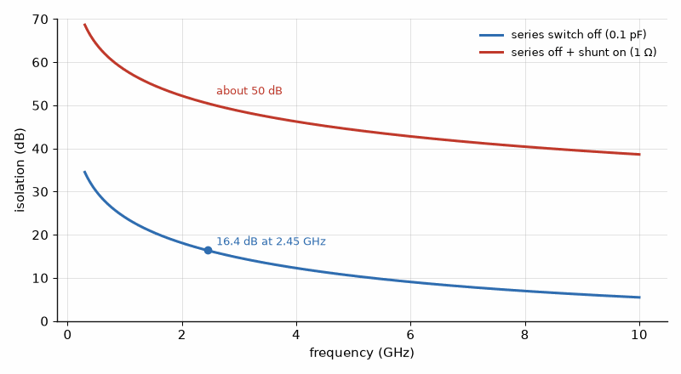
Figure 19.1 — Isolation of an RF switch against frequency. A series switch with 0.1 pF off-capacitance gives only 16.4 dB at 2.45 GHz; adding a shunt element that turns on raises it to about 50 dB.

Worked Example 19.2
Problem. A shunt switch has R = 1 Ω when on. Find the isolation it provides.
Solution. |S₂₁| = 2/(2 + 50) = 0.0385, an isolation of 28.3 dB, in addition to the 16 dB of the series element if both are used. Isolations of 40 dB and more come from such series-shunt combinations, at the cost of slightly more insertion loss.
Key idea. A series switch's isolation is set by its off capacitance and falls with frequency; a shunt switch to ground, or a series-shunt pair, restores it.
Where this continues. Chapter 46 designs the switch that most phones use, a stack of RF SOI transistors, and sets its stack height from the voltage at the worst mismatch.
From the Bench
Read three switch numbers together: insertion loss, isolation at your highest frequency, and power handling at your worst VSWR, because the data-sheet power rating usually assumes a perfect match. Watch switching time and the settling of insertion phase in TDD systems. If the switch carries transmit power, check its harmonics and intermodulation; a cheap switch can generate spurs that fail a regulatory test.

Practice
1. Find the insertion loss of a series switch with R = 2 Ω.
2. Find the isolation of a series switch with C = 0.1 pF at 5.8 GHz.
3. Find the isolation of a shunt switch with R = 2 Ω.

What You’ll Actually Use
Everyday working tools
- Series switch loss and isolation from R_on and C_off.
- Series-shunt pairs for high isolation.
- Power handling derated for mismatch.
Mostly for exams and deeper study
- PIN-diode charge-storage models.

Part II. Active Circuits: Amplifiers, Receivers, Oscillators, and Synthesizers
Part I guided the signal and radiated it, but nothing in it could add a single milliwatt. Every structure there, from the transmission line to the RF switch, was passive: it could match, filter, couple, or steer, and it always lost a little on the way. Part II adds the circuits that supply gain and power. It follows the transmitter from the device to the antenna, then turns around and follows the weak signal back in through the receiver, the mixer, and the oscillator that tunes both halves. The lines, matches, filters, and antennas of Part I come back in every chapter, now as the networks that surround an active device.

Chapter 20. The Transmitter Chain and Its Devices
One decibel lost in the cable after a 100 W amplifier burns 20.6 W as heat and buys nothing. Recovering that decibel with a bigger amplifier costs far more than recovering it with a better cable. That arithmetic runs through every transmitter, from a phone's power amplifier to a radar with sixteen combined modules.
Where you meet this: Transmitter line-ups, EIRP limits in regulatory filings, base-station feeder runs, and the choice between GaN, LDMOS, GaAs, and SiGe devices.
The waveform that Book 5 designs must be made powerful enough to cross a room, a city, or the distance to a satellite, and then received again when it arrives weak and noisy. The transmitter is a chain, and every link in it either delivers watts or loses them: the device, the load line it is designed to, the amplifier class, the output match, the bias, the heat sink, the combiner, the isolator, the harmonic filter, the feed line, the duplexer, and the antenna, whose output is the effective isotropic radiated power that the regulator limits. The receiver half of a radio, the low-noise amplifier, the noise cascade, and the oscillator that tunes both halves belong in this part as well, because they share the same box and the same engineering. Why gallium nitride withstands the voltage is Book 3's question, antenna gain is the subject of Chapters 7 and 8, and the test chamber is Book 7's. Part II owns the watts.

20.1 Power in decibels
Radio engineers count power in dBm, decibels relative to one milliwatt: P(dBm) = 10 log₁₀(P/1 mW). One watt is 30 dBm, 100 W is 50 dBm, and 1 kW is 60 dBm. Gains and losses in decibels add. The effective isotropic radiated power is the transmitter output, minus the loss between the amplifier and the antenna, plus the antenna gain in dBi. A loss of 1 dB is a factor of 10^(−0.1) = 0.794 in power: a fifth of the watts, gone as heat in a cable.
EIRP (dBm) = Pout (dBm) − Lfeed (dB) + Gant (dBi)
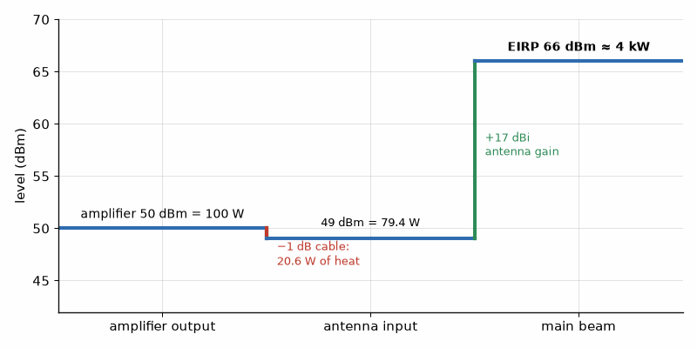
Figure 20.1 — Level diagram of Worked Example 20.1. One decibel of cable after a 100 W amplifier burns 20.6 W; the 17 dBi antenna then lifts the EIRP to 66 dBm, about 4 kW.

Worked Example 20.1
Problem. A 100 W amplifier feeds a 17 dBi sector antenna through 1 dB of cable and connectors. Find the power at the antenna and the EIRP in dBm and watts.
Solution. 100 W is 50 dBm. After 1 dB the power is 49 dBm, or 100 × 0.794 = 79.4 W. The EIRP is 49 + 17 = 66 dBm, which is 10^(3.6) mW = 3981 W, about 4 kW. The 20.6 W lost in the feed heats the cable and buys nothing; one decibel saved after the last amplifier is worth exactly as much as one decibel of extra amplifier output, and it is almost always cheaper.
Key idea. One decibel after the last amplifier is one decibel of EIRP. Every loss between the device and the antenna must be paid for by a bigger, hotter, more expensive amplifier.

20.2 The device families
Five technologies cover nearly all power amplifiers in 2026. Silicon LDMOS, the laterally diffused MOS transistor, dominates from HF to about 3 GHz: it is cheap, rugged, and runs from 28 or 50 V supplies, and it powers broadcast transmitters, industrial heating, and most sub-3 GHz cellular base stations built before gallium nitride took over. Gallium nitride on silicon carbide, GaN-on-SiC, covers roughly 0.5 to 40 GHz. Its wide bandgap lets it run at 28 to 50 V with power densities several times those of gallium arsenide per millimeter of gate, and its silicon-carbide substrate conducts heat well; it is the default for new base stations, radar, and satellite links. Gallium arsenide, as heterojunction bipolar transistors and pHEMTs, supplies drivers and the few-watt amplifiers in phones and Wi-Fi. Indium phosphide offers the highest transistor speed and is used for sub-terahertz work and low noise, not for kilowatts. Vacuum tubes, the traveling-wave tube, klystron, and magnetron, remain where kilowatts to megawatts are needed at high frequency, because combining enough transistors becomes more expensive than one tube.

20.3 Supply voltage and power
A transistor's output power is set by how much voltage and current it can swing. The voltage is limited by breakdown, which sets the supply, and the current by the device's size. Chapter 21 makes this precise with the load line, but the consequence is already clear: at a given power, a higher supply means a lower current and a higher optimum load resistance, which is closer to the 50 Ω of the outside world and easier to match. That is the main reason high-voltage gallium nitride displaced gallium arsenide in base stations, and why a phone amplifier running from a 3.4 V battery must transform its load by a large ratio, losing efficiency in the process.

Worked Example 20.2
Problem. A radar transmitter needs 2 kW peak at the antenna through 0.6 dB of loss. Its GaN modules each deliver 250 W at the combiner input, and the combiner loses 0.4 dB. How many modules are needed?
Solution. The total loss is 1.0 dB, a factor of 0.794, so the modules together must supply 2000/0.794 = 2518 W. At 250 W each, that is 10.07 modules, so eleven, or in a binary combiner tree, sixteen. A tree of eight would deliver only 8 × 250 × 0.794 = 1589 W. The arithmetic shows why combining loss limits the solid-state route: every doubling of the module count adds a combining stage and its loss.
Where this continues. Part III, Chapters 42 to 47, designs with each of these device families in turn: CMOS, the GaAs handset amplifier and pHEMT, GaN broadband and Doherty amplifiers, RF SOI, SiGe, and InP, and the acoustic filters that sit between them and the antenna.
From the Bench
Draw the level diagram before anything else, with dBm at every stage from the modem to the antenna. It shows where power is lost, which stage compresses first, and how much margin each stage has. A decibel saved after the final amplifier is the cheapest decibel in the system. Count combining losses honestly: going from eight modules to sixteen adds another combining stage, and its loss, along with the modules.

Practice
1. Convert 5 W, 250 W, and 2 kW to dBm.
2. A 20 W amplifier feeds a 3 dB cable run to a 12 dBi antenna. Find the EIRP in dBm and the power lost in the cable.
3. What fraction of the power is left after 2 dB of loss?
4. Which device family would you choose for a 200 W amplifier at 3.5 GHz, and why?
5. An amplifier loses 0.5 dB in its output isolator and 0.5 dB in its harmonic filter. What output power does it need to deliver 40 W after both?
6. Why does a higher supply voltage make the output match easier?

What You’ll Actually Use
Everyday working tools
- EIRP = P_out − losses + antenna gain.
- dBm to watts in your head.
- Module count from required power and combining loss.
Mostly for exams and deeper study
- Device physics of each semiconductor family in depth.

Chapter 21. The Load Line
The maximum-power-transfer theorem is the first thing taught about matching, and the first thing a power amplifier designer sets aside. A transistor can't swing beyond twice its supply or below its knee, so its best load is set by voltage swing, Ropt = (VDD − Vknee)²/(2P), not by the conjugate of its output impedance.
Where you meet this: Every power amplifier output network, load-pull data in device application notes, and the impedance targets on transistor data sheets.
A small-signal amplifier is matched for gain: its load is chosen so that the most power is transferred, which means a conjugate match to the device's output impedance. A power amplifier is matched for power, and that is a different load. The device can swing its voltage only between a knee, below which its current collapses, and a maximum set by the supply and breakdown, and it can swing its current only between zero and a maximum. The load that lets it use the whole of both ranges at once is the optimum load, Ropt, and finding it is the first step of every power-amplifier design. The method is due to Steve Cripps, whose RF Power Amplifiers for Wireless Communications remains the reference.

21.1 The optimum load
With a supply VDD and a knee voltage Vknee, the drain voltage can swing by VDD − Vknee on either side of the supply, so the peak fundamental voltage is VDD − Vknee. With a sinusoidal current, the fundamental output power is the product of the peak voltage and peak current divided by two. For a target output power P, the optimum load resistance follows directly, and it is a resistance at the intrinsic drain, behind the device's output capacitance and package parasitics, which the matching network must also absorb.
Ropt = (VDD − Vknee)² / (2P)
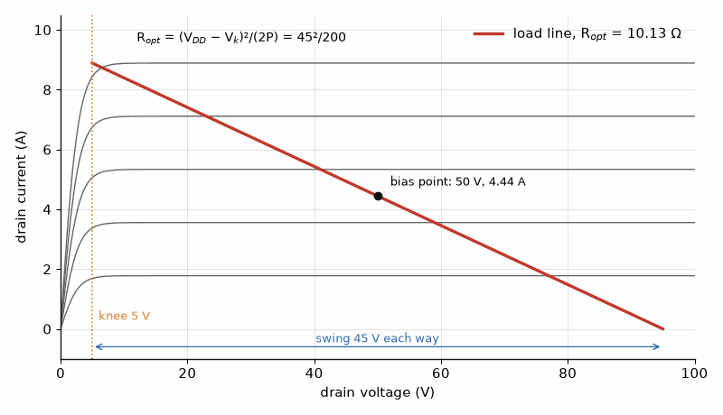
Figure 21.1 — The load line of a 100 W, 50 V GaN amplifier with a 5 V knee. The voltage swings 45 V each way about the 50 V bias, setting Ropt = 45²/200 = 10.13 Ω.

Worked Example 21.1
Problem. Find Ropt for a 100 W amplifier on a 50 V GaN process with a 5 V knee, and on a 28 V LDMOS process with a 3 V knee. Find the ratio of 50 Ω to each, and the peak fundamental current in each case.
Solution. At 50 V, Ropt = 45²/200 = 10.125 Ω, which this book writes as 10.13 Ω. At 28 V, Ropt = 25²/200 = 3.125 Ω, written 3.13 Ω. The transformation ratios to 50 Ω are 4.9 and 16. The peak fundamental currents are 2P/(VDD − Vknee) = 200/45 = 4.44 A and 200/25 = 8.0 A. The 28 V design needs nearly twice the current and so a larger device, with more output capacitance to tune out, and a matching network with three times the impedance ratio.

21.2 Why the conjugate match is wrong
The device's output resistance, the slope of its current against drain voltage, is typically hundreds of ohms for a large transistor. A conjugate match would present that resistance as the load, and the voltage swing would hit the knee and the supply long before the current reached its maximum: the device would deliver a small fraction of the power it could. The load-line match accepts a lower gain in exchange for using the full current and voltage range. The difference between the two, often 2 to 3 dB of output power, is the reason power amplifiers are designed by load-pull measurements, which sweep the load and map power and efficiency contours, rather than by small-signal S-parameters.
Key idea. A power amplifier is matched for power, not gain. The optimum load is set by the voltage and current the device can swing, and at a given power it scales with the square of the voltage.

21.3 The matching network
The output network must transform 50 Ω down to Ropt and absorb the device's output capacitance. For a single L-section, Chapter 3's result gives Q = √(Rhigh/Rlow − 1). For the 50 V design, Q = √(4.94 − 1) = 1.98; for the 28 V design, Q = √(16 − 1) = 3.87. A higher Q means a narrower bandwidth, larger circulating currents, and more loss in the network's finite-Q components. Wideband or high-ratio designs use two or more sections, each with a lower ratio, or a transmission-line transformer. In a phone the problem is worse: at 3.4 V with a 0.3 V knee, 1 W needs Ropt = 3.1²/2 = 4.8 Ω, and 2 W needs 2.4 Ω, a 21:1 ratio.

Worked Example 21.2
Problem. A 200 W design on the 50 V process uses the same 5 V knee. Find Ropt, the single-section Q to 50 Ω, and compare it with the 100 W design.
Solution. Ropt = 45²/400 = 5.06 Ω. The ratio is 50/5.06 = 9.9, so Q = √(9.9 − 1) = 2.98. Doubling the power at the same voltage halves Ropt and raises the single-section Q from 1.98 to 2.98. To get back to the 100 W impedance level, the designer would combine two 100 W devices, Chapter 24's subject, or move to a higher supply.

21.4 Raising the rail
The scaling Ropt ∝ V²/P is the main argument of high-voltage design. Doubling the supply at constant power quadruples the optimum load and halves the current. Gallium nitride's breakdown field, about ten times that of silicon, permits 48 to 50 V supplies at microwave frequencies, and some designs use 65 V or more. The cost is that the knee voltage, the drain-source capacitance, and the trapping effects that cause memory in the amplifier's response all change with voltage, and the designer must characterize them at the operating point.
Measure it yourself. Load-pull, which refines this chapter's starting point into measured contours, is described as an instrument setup in Book 9, Test and Measurement Instruments, chapter "Scalar Analysis, Amplifier Test, and Load Pull". Chapters 42 to 45 apply the load line to CMOS, GaAs, and GaN designs.
From the Bench
Start every power amplifier from the load line. It gives you the right impedance to within what load-pull will refine, and it tells you at once whether the matching ratio is reasonable. The device's output capacitance and package parasitics sit between the intrinsic drain and the package leads, and data-sheet load impedances are usually given at the leads. Check which reference plane a number refers to before you compare it with yours.

Practice
1. Find Ropt for 200 W at 50 V with a 5 V knee, and for 50 W at 28 V with a 3 V knee.
2. Find the peak fundamental drain current for 100 W at 50 V with a 5 V knee.
3. Find the single-section L-network Q to transform 50 Ω to 3.13 Ω.
4. A phone amplifier at 3.4 V has a 0.3 V knee. Find Ropt for 1 W.
5. By what factor does Ropt change when the supply is doubled at constant power and negligible knee?
6. Why is a power amplifier's output not conjugately matched?

What You’ll Actually Use
Everyday working tools
- Ropt = (VDD − Vknee)²/(2P).
- Matching ratio and Q from Ropt to 50 Ω.
- Why a conjugate match wastes the voltage swing.
Mostly for exams and deeper study
- Large-signal device model equations.

Chapter 22. Amplifier Classes and Efficiency
Shrink a transistor's conduction from half the cycle to a third and its efficiency rises from 78.5 % to 89.7 %. The same transistor now delivers 39 % less power. Every amplifier class is a trade between how much of the supply becomes signal and how much signal the device can deliver, and the class letter tells you where on that trade you stand.
Where you meet this: Amplifier data sheets and application notes, the bias network on every power stage, and the efficiency number in every base-station or handset specification.
Chapter 21 fixed the load. This chapter fixes the bias, and with it the fraction of each RF cycle during which the transistor conducts. That choice, named by the amplifier's class, decides the efficiency: how much of the DC supply power becomes RF and how much becomes heat. In a base station that heat is the operator's largest electricity bill after air conditioning; in a phone it is battery life. The classes fall into two families: the current-source classes A, AB, B, and C, which trade linearity for efficiency by conducting for less of the cycle, and the switching and harmonic-tuned classes D, E, and F, which shape the voltage and current waveforms so that they do not overlap.

22.1 Efficiency measures
Drain efficiency is the RF output power divided by the DC supply power. Power-added efficiency subtracts the input drive, which matters when the gain is low, as it is at millimeter wave. The power dissipated in the device is the DC input plus the RF input minus the RF output, and it is the number the heat sink of Chapter 24 must handle.
ηD = Pout / PDC, PAE = (Pout − Pin) / PDC, Pdiss = PDC + Pin − Pout

Worked Example 22.1
Problem. A 100 W amplifier has 15 dB of gain and 65% drain efficiency. Find the input power, DC power, PAE, and dissipation.
Solution. The gain is a factor of 31.6, so Pin = 100/31.6 = 3.16 W. PDC = 100/0.65 = 153.8 W. PAE = (100 − 3.16)/153.8 = 62.9%. The dissipation is 153.8 + 3.16 − 100 = 57.0 W. At 12 dB of gain and 70% drain efficiency, a 40 W millimeter-wave stage would have PAE = (40 − 2.52)/57.1 = 65.6%, already four and a half points below its drain efficiency; at lower gains the gap grows quickly.

22.2 Conduction angle: classes A, AB, B, and C
In class A the transistor is biased at half its maximum current and conducts for the whole cycle. Its peak theoretical efficiency is 50%, and it is the most linear. Lowering the bias reduces the conduction angle, the part of the cycle over which current flows. In class B, biased at the threshold, the device conducts for half the cycle, 180°, and the theoretical peak efficiency is π/4 = 78.5%. Class AB lies between. In class C the angle is less than 180° and the efficiency rises further, but the fundamental output falls and the gain falls with it. For a conduction angle α, with an ideal linear device and a harmonic short at the output, the peak efficiency is given below.
η(α) = (α − sin α) / [4 (sin(α/2) − (α/2) cos(α/2))]
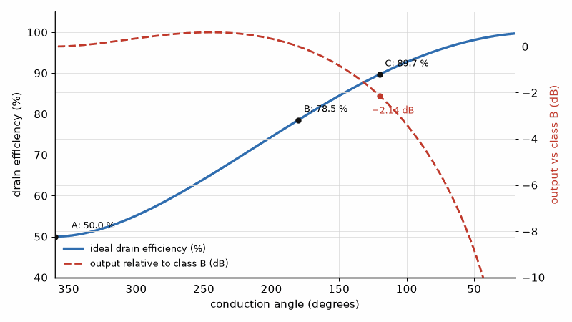
Figure 22.1 — Efficiency and output against conduction angle. Class A (360°) reaches 50 %, class B (180°) 78.5 %, class C at 120° 89.7 %, but that class C stage delivers 2.14 dB less than class B.
The formula gives 50.0% for class A at 360°, 60.2% at 270°, 78.5% for class B at 180°, 89.7% at 120°, and 94.0% at 90°. The fundamental output power, relative to class A with the same peak current and voltage, is +0.55 dB at 270°, 0 dB at 180°, −2.1 dB at 120°, and −4.2 dB at 90°. Deep class C therefore buys efficiency with power and gain, and is used for constant-envelope signals such as FM broadcast, where linearity does not matter. Most linear amplifiers run in class AB, a little above the threshold, to keep the gain flat at low drive.

Worked Example 22.2
Problem. A device biased for a 120° conduction angle delivers its maximum output with a drain efficiency at the theoretical limit. If the same device in class B delivers 100 W, what does it deliver in this class C condition, and how much dissipation is saved?
Solution. At 120° the output is 2.14 dB below class B, so 100 × 10^(−0.214) = 61.1 W. In class B the DC power is 100/0.785 = 127.3 W and the dissipation 27.3 W. At 120°, the DC power is 61.1/0.897 = 68.1 W and the dissipation 7.0 W. Efficiency rose from 78.5% to 89.7%, but the device now delivers 39% less power: class C is a trade, not a free gain.
Key idea. Efficiency comes from keeping voltage and current from being large at the same time. Reducing the conduction angle does it at a cost in power and gain; shaping the waveforms with harmonics or switching does it without that cost, in principle reaching 100%.

22.3 Switching and harmonic-tuned classes
If the transistor acts as a switch, it has either zero voltage across it or zero current through it, and an ideal switch dissipates nothing. Class D uses two switches and a filter; it is common at audio and low radio frequencies. Class E uses one switch with a shunt capacitor and a tuned load designed so that the voltage returns to zero, with zero slope, at the instant the switch closes; this removes the loss of discharging the capacitor and makes class E practical into the gigahertz range. Class F adds open circuits at the odd harmonics and short circuits at the even ones, so the drain voltage approaches a square wave and the current a half-sine; inverse class F swaps them. Real devices have finite on-resistance, output capacitance, and transition times, and practical class E and F amplifiers reach 70 to 85% drain efficiency at a few gigahertz. All of these are efficient only at full drive. Chapter 23 addresses what happens when the signal's envelope varies.

22.4 Device technologies at the load line
The classes above describe what the transistor does in each cycle; the technology decides how far it can swing while doing it. Every power amplifier in this book starts from the same load line, Ropt = (V − Vknee)²/(2P), whatever the device, so the technologies differ in the numbers that go into it: the supply the device survives, the current per millimeter of gate or square micrometer of emitter, the frequency at which it still has gain, and the heat it can shed. CMOS comes first here, because it is the technology of nearly every integrated radio, and the other families are described by what changes. Why each material behaves as it does is Book 3's subject, in its chapter "Materials for Speed, Power, and Heat"; Part III of this book designs with each of them.
The comparison is given as rows, one per technology, each in the same order: breakdown and supply, power density, speed, efficiency and linearity, cost and integration, and typical uses. The figures are typical of commercial processes in 2026 and vary by a factor of two or more between processes.
Bulk CMOS and RF SOI: thin-oxide core devices tolerate about 1 V and thick-oxide input-output devices 1.8 to 3.3 V, so a battery-powered stage needs cascodes or stacks, Chapter 42; current density is set by gate width, and power is limited by voltage rather than current; fT and fmax reach a few hundred gigahertz in advanced nodes; efficiency is moderate, 30 to 50 % for linear Wi-Fi stages at average power; the PA shares a die with the transceiver and the processor, which is the decisive advantage; Wi-Fi, Bluetooth, IoT radios such as the ESP32, and integrated millimeter-wave beamformers.
SiGe HBT: a fast silicon-germanium bipolar device in a BiCMOS process; high-speed devices with fT near 300 GHz and fmax near 500 GHz have a BVCEO of only about 1.5 V, while slower power variants tolerate several volts; very high gain per stage at millimeter waves; automotive radar at 77 GHz, optical transceivers, and millimeter-wave front ends, Chapter 46.
GaAs HBT (InGaP emitter): a collector breakdown BVCEO of about 15 to 20 V lets it run from a 3.4 to 4.5 V battery with wide margin for mismatch; fT of a few tens of gigahertz; good linearity and efficiency at a few watts; a separate die in a front-end module; the cellular handset power amplifier, Chapter 44.
GaAs pHEMT: a high-electron-mobility FET with very low noise, about 0.5 dB at 2 GHz in a packaged part, and low switch loss; power density near 1 W/mm; LNAs, switches, and microwave MMICs, Chapters 28 and 48.
GaN HEMT on silicon carbide or silicon: supplies of 28 to 50 V, power densities of about 4 to 6 W/mm at 28 V and up to about 10 W/mm at 50 V in commercial processes, and channel temperatures rated to about 225 °C; efficient and broadband at the high impedance its voltage gives; depletion-mode, so it needs a negative gate and a bias sequence; base stations, radar, satellite amplifiers, and broadband test amplifiers, Chapter 45.
LDMOS: a laterally diffused silicon MOSFET for 28 to 50 V supplies, rugged and cheap, with useful gain to about 3 to 4 GHz; broadcast, industrial heating, and older base stations, Chapter 20.
Ropt = (V − Vknee)² / (2P), Ropt,2 / Ropt,1 = [(V₂ − Vk₂) / (V₁ − Vk₁)]² at equal power

Worked Example 22.3
Problem. Find Ropt for a 1 W stage in four technologies: a CMOS cascode on 3.3 V with a 0.5 V knee, a GaAs HBT on 3.4 V with a 0.3 V knee, and GaN on 28 V with a 3 V knee and on 48 V with a 4 V knee. Find the single-section L-network Q to 50 Ω for each, and the ratio of the GaN and CMOS loads.
Solution. CMOS: Ropt = 2.8²/2 = 3.92 Ω, a ratio of 12.8 to 50 Ω and Q = √(12.8 − 1) = 3.43. GaAs HBT: Ropt = 3.1²/2 = 4.81 Ω and Q = 3.07. GaN at 28 V: Ropt = 25²/2 = 312.5 Ω, above 50 Ω, so the network transforms up, with Q = √(312.5/50 − 1) = 2.29. GaN at 48 V: Ropt = 44²/2 = 968 Ω and Q = 4.28. At equal power the GaN load at 28 V is 312.5/3.92 = 80 times the CMOS load, the square of the ratio of the voltage swings; a figure of 10 sometimes quoted would compare supplies only √10 = 3.2 times apart. A 1 W GaN device is therefore an unusual part: GaN's voltage pays off at tens to hundreds of watts, where its load comes back down near 50 Ω, while a 1 W handset stage on a battery needs a large step-down ratio.
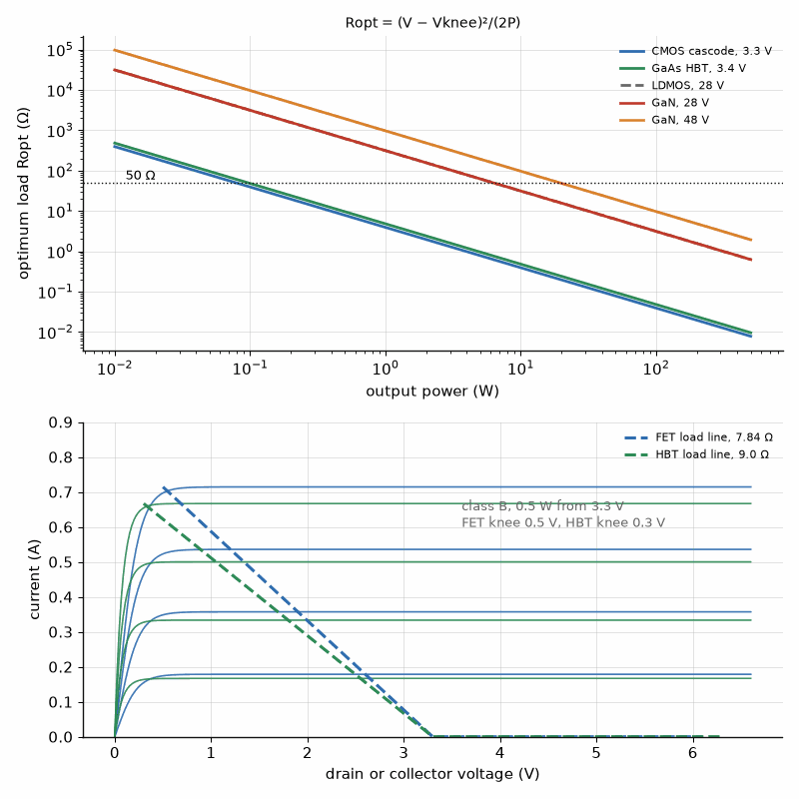
Figure 22.2 — Above: the optimum load against output power for five technologies at their usual supplies and knees, from Ropt = (V − Vknee)²/(2P); the 50 Ω line shows where each needs no transformation. Below: output curves of a FET (square-law transfer, knee near 0.5 V) and an HBT (exponential transfer, knee near 0.3 V) on the same axes, each with its class B load line for 0.5 W from 3.3 V.
Bipolar version. Where the rest of this book designs a CMOS or FET stage, a bipolar stage changes in five ways, and each design in Part III closes with a short note on them.
- Drive and bias: an HBT is driven by base current, with collector current exponential in VBE; a FET is driven by gate voltage with a roughly square-law, and in short channels nearly linear, transfer. An HBT needs a current mirror or ballasted bias, a FET a gate voltage.
- Breakdown and swing: SiGe and GaAs HBTs tolerate more collector swing than thin-oxide CMOS, so they need less stacking; BVCBO, with the base driven from a low impedance, is the limit that matters under drive, and it is well above BVCEO.
- Knee: VCE,sat of 0.2 to 0.3 V is comparable to or below a FET's knee, and the load-line formula is the same.
- Linearity: the exponential base-emitter junction gives different AM-AM and AM-PM curves, and HBT stages often need less predistortion at moderate back-off.
- Heat: an HBT's VBE falls about 1 to 2 mV per kelvin at constant current, so hot fingers hog current; multi-finger HBTs need emitter or base ballast, Chapter 44, while FETs share current more evenly because their mobility falls with temperature.
Key idea. One load line serves every technology; what changes is the voltage it may swing. At equal power the optimum load scales with the square of that swing, which is why a battery-powered stage must transform down by a large ratio and a 48 V GaN stage meets 50 Ω only at hundreds of watts.
From the Bench
Measure efficiency the way your customer will: at the average power of the real signal, not at saturation with a single tone. Give a class AB stage's bias temperature compensation, because the quiescent current that's right at 25 °C can double on a hot heat sink. Check the bias network for low-frequency resonances too. A large bypass capacitor and a long bias line can resonate, and under modulation the resonance shows up as sidebands.

Practice
1. An amplifier delivers 50 W from 75 W of DC with 1 W of drive. Find its drain efficiency, PAE, and dissipation.
2. Find the theoretical efficiency at a conduction angle of 270°.
3. Why does class C reduce gain?
4. A class AB amplifier runs at 60% drain efficiency at 200 W output. Find the dissipation, neglecting the input.
5. A 30 dBm stage has 8 dB of gain and 50% drain efficiency. Find its PAE.
6. What condition at switch closing defines class E?
7. A 2 W stage runs on a 3.4 V battery with a 0.3 V knee, or on 28 V GaN with a 3 V knee. Find Ropt for each and the ratio between them.
8. List two ways a multi-finger HBT stage differs in bias and thermal design from a multi-finger CMOS stage.

What You’ll Actually Use
Everyday working tools
- Peak efficiencies: A 50 %, B 78.5 %, C up to 100 %.
- Drain efficiency vs power-added efficiency.
- Conduction angle set by bias.
Mostly for exams and deeper study
- Fourier analysis of reduced-conduction-angle waveforms.

Chapter 23. Linearity, Back-Off, and the Doherty Amplifier
In 1936 William Doherty of Bell Telephone Laboratories published an amplifier made of two tubes that shared the work. One carried the average signal, the other woke up only for the peaks, and each changed the load the other saw. Nearly every macro base station built today uses his idea, with transistors in place of the tubes.
Where you meet this: Base-station power amplifiers, broadcast transmitters, ACLR and spectral-mask tests, and every amplifier that carries OFDM.
Chapter 22's efficiencies are peak values, reached only when the amplifier is driven to its full output. The signals of Book 5 are not like that. An OFDM signal has a peak-to-average power ratio of 8 to 11 dB, so a linear amplifier that must pass its peaks spends most of its time at a fraction of its rated power, where its efficiency is poor. This chapter measures the linearity an amplifier needs, computes how much efficiency back-off costs, and shows how the Doherty amplifier, digital predistortion, and envelope tracking recover it. The Doherty is the default architecture of cellular base stations in 2026.

23.1 Compression and intermodulation
As drive rises, a real amplifier's gain begins to fall. The 1 dB compression point, P1dB, is the output power at which the gain is 1 dB below its small-signal value. With two closely spaced tones at the input, the amplifier's curvature generates third-order intermodulation products at 2f1 − f2 and 2f2 − f1, which fall inside or next to the wanted band and cannot be filtered out. Their power rises 3 dB for every 1 dB of input. Extrapolating the fundamental and third-order lines to their intersection defines the output third-order intercept, OIP3, a figure of merit that is typically about 10 dB above P1dB for a well-behaved amplifier.
OIP3 = Pout,tone + ΔIM3 / 2, where ΔIM3 is the carrier-to-IM3 ratio in dB

Worked Example 23.1
Problem. With two tones of 30 dBm each at the output, the third-order products are 40 dB below each tone. Find OIP3, and the IM3 ratio after backing the drive off by 3 dB.
Solution. OIP3 = 30 + 40/2 = 50 dBm. At 27 dBm per tone, the tones have fallen 3 dB and the products 9 dB, so the ratio becomes 40 + 6 = 46 dBc. Each decibel of back-off buys two decibels of intermodulation ratio, which is why the first remedy for a failing spectral mask, a subject for Book 7's chamber, is often less drive, at a cost in efficiency.

23.2 What back-off costs
A class A amplifier draws constant DC power, so its efficiency falls in proportion to output power: at 8 dB below peak it is 50% × 10^(−0.8) = 7.9%. A class B amplifier's DC current falls with the signal amplitude, so its efficiency falls only with the square root of output power: η = (π/4)√(Pout/Pmax), giving 55.6% at 3 dB back-off, 39.4% at 6 dB, and 31.3% at 8 dB. For a 100 W-peak class B stage carrying a signal with 8 dB of PAPR, the average output is 15.8 W and the DC input 50.7 W.

23.3 The Doherty amplifier
William Doherty's 1936 design uses two amplifiers. The main, or carrier, amplifier runs in class AB or B and handles the signal up to a set back-off; the auxiliary, or peaking, amplifier runs in class C and turns on only for the peaks. A quarter-wave line between them acts as an impedance inverter. At low power the main amplifier sees twice its optimum load, so it saturates and reaches peak efficiency at half its full voltage swing, which is 6 dB below the combined peak. Above that, the peaking amplifier's current pulls the main amplifier's load back down toward Ropt, a mechanism called load modulation, and both reach full power together. In the ideal symmetric Doherty the efficiency is 78.5% both at peak and at 6 dB back-off, dips only to about 70% between, and falls linearly with amplitude below 6 dB.
Below 6 dB back-off: η = (π/4) (v / 0.5), v = normalized output amplitude
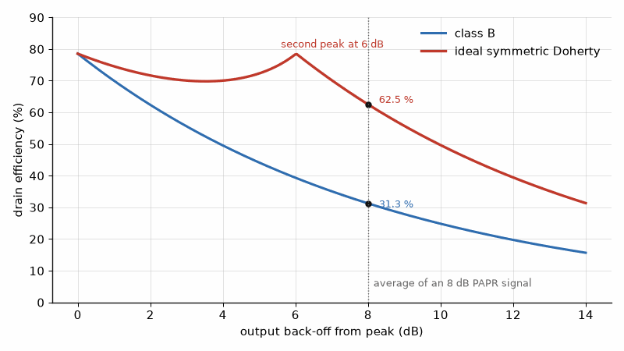
Figure 23.1 — Efficiency against back-off. At the 8 dB average of a typical OFDM signal, class B gives 31.3 % while an ideal symmetric Doherty gives 62.5 %, thanks to its second peak at 6 dB.

Worked Example 23.2
Problem. A 100 W-peak amplifier carries a signal with 8 dB of PAPR. Compare the efficiency and DC power at the average output for class B and for an ideal symmetric Doherty.
Solution. At 8 dB back-off the normalized amplitude is v = 10^(−8/20) = 0.398. Class B gives (π/4)(0.398) = 31.3%; the Doherty gives (π/4)(0.398/0.5) = 62.5%. For the 15.8 W average output, the class B stage draws 50.7 W and the Doherty 25.3 W, halving the DC power and cutting the dissipation from 34.8 W to 9.5 W. Real Doherty amplifiers reach 45 to 55% average efficiency on such signals, below the ideal because the peaking device turns on gradually and the inverter has loss and limited bandwidth. Asymmetric versions, with a larger peaking device, place the second efficiency peak at 8 to 10 dB to match the signal.
Key idea. A linear amplifier's average efficiency is set by the signal's peak-to-average ratio. The Doherty restores efficiency at back-off by modulating the main amplifier's load, and digital predistortion then restores the linearity the Doherty gives up.

23.4 Predistortion and envelope tracking
A Doherty amplifier is efficient but not linear: its gain and phase change with drive, the AM-to-AM and AM-to-PM distortion, and they depend on the recent history of the signal through heating and charge trapping, which are memory effects. Digital predistortion measures the amplifier's output through a feedback receiver, fits a model, often a memory polynomial, and pre-distorts the baseband signal with the inverse, so that the cascade is linear. It typically improves the adjacent-channel leakage ratio by 15 to 20 dB. Envelope tracking takes a different route: it varies the supply voltage with the signal's envelope, so the amplifier always runs close to saturation. It is widely used in phones, where a fast DC-DC converter can follow the envelope of a 100 MHz signal, and less in base stations, where Doherty is simpler at high power.
Where this continues. Chapter 45 designs an asymmetric GaN Doherty amplifier for a 3.5 GHz base station, with its inverter and load impedances computed from the signal's peak-to-average ratio.
From the Bench
Every decibel of back-off buys two decibels of IM3 ratio, so drive level is the first thing to adjust when a spectral mask fails. A Doherty that looks excellent at one frequency can lose much of its back-off efficiency at the band edges, because its quarter-wave inverter and offset lines are narrowband. Characterize it across the whole band, at the real signal's PAPR, and at temperature.

Practice
1. Two tones of 20 dBm each produce IM3 products at −46 dBc. Find OIP3.
2. For the amplifier of the previous problem, what IM3 ratio results when each tone is reduced to 17 dBm?
3. Find a class B amplifier's efficiency at 10 dB back-off.
4. Find an ideal symmetric Doherty's efficiency at 10 dB back-off.
5. A 200 W-peak Doherty carries a signal with 9 dB of PAPR at 55% average efficiency. Find the average output and the DC power.
6. Why does an amplifier's IM3 ratio improve by 2 dB for each decibel of back-off?

What You’ll Actually Use
Everyday working tools
- OIP3 = P_out + ΔIM3/2.
- Class B efficiency falls in proportion to the output amplitude.
- Doherty's second efficiency peak at 6 dB back-off.
Mostly for exams and deeper study
- Load-modulation analysis with non-ideal devices.

Chapter 24. Heat, Combining, and the Path to the Antenna
A 100 W amplifier dissipating 57 W runs its junction at 108 °C on a 40 °C day, with plenty of margin. Block the fan, let the air get hotter, or mismatch the antenna, and that margin is what keeps it alive. Heat is the quiet limit on every transmitter, and it is designed in the mechanical drawing as much as in the schematic.
Where you meet this: Heat sinks and thermal pads on every power stage, combiner trees in radars and broadcast transmitters, harmonic filters, and the feeder between a rack and its antenna.
An amplifier that meets its power and efficiency targets on the bench can still fail in service, by overheating, by a single failed device taking down a combined array, or by losing its gains in the hardware between the device and the antenna. This chapter follows the power out of the transistor: through the thermal path that removes its waste heat, the combiners that add several devices together, the isolator and harmonic filter that protect and clean it, and the feed line that carries it to the antenna.

24.1 The thermal path
Heat flows from the transistor's channel, or junction, through the die and package to the flange, then through an interface material to the heat sink and into the air or coolant. Each step has a thermal resistance θ in °C/W, and the temperature rises add like voltage drops in a series circuit. The junction temperature sets the device's lifetime: GaN-on-SiC parts are typically rated for channel temperatures up to about 225 °C, and designers usually hold them well below 200 °C to keep the predicted lifetime long. Pulsed operation, as in radar, lets the peak temperature stay below the steady-state value, and transient thermal impedance curves give the peak rise for a given pulse width and duty cycle.
Tj = Tambient + Pdiss (θjc + θcs + θsa)
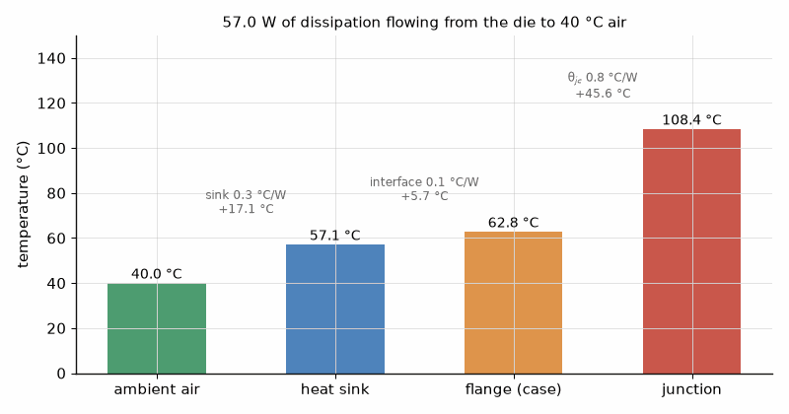
Figure 24.1 — Temperatures along the thermal path of Worked Example 24.1. With 57 W flowing out to 40 °C air, the sink sits at 57.1 °C, the flange at 62.8 °C, and the junction at 108.4 °C.

Worked Example 24.1
Problem. The 100 W amplifier of Worked Example 22.1 dissipates 57.0 W. Its θjc is 0.8 °C/W, the interface adds 0.1 °C/W, and the heat sink 0.3 °C/W to air at 40 °C. Find the junction temperature. What sink resistance would hold Tj to 200 °C?
Solution. The total resistance is 1.2 °C/W, so the junction rises 57.0 × 1.2 = 68.4 °C, to 108.4 °C. The flange sits at 40 + 57.0 × 0.4 = 62.8 °C. For Tj = 200 °C, the total may be (200 − 40)/57.0 = 2.81 °C/W, so the sink could be as poor as 2.81 − 0.9 = 1.91 °C/W. The design has ample margin; the margin is what allows the amplifier to survive a hot day, a blocked fan, or a mismatched antenna.

24.2 Combining
When one device cannot supply the power, several are combined. The Wilkinson divider and combiner, the 90° hybrid, and spatial or radial combiners all add N equal, in-phase signals into one port without loss in the ideal case, and each dissipates the difference in an isolation resistor or load when the inputs are unequal. The output of an ideal combiner with N inputs is the square of the sum of the input amplitudes, divided by N. A phase error θ between two equal inputs leaves a fraction cos²(θ/2) of the power: 99.2% at 10°, 97.0% at 20°, and 93.3% at 30°. A failed device is more costly: with one of N inputs dead, the output falls to (N − 1)²/N² of full power, which is 25% for N = 2, 56% for N = 4, and 77% for N = 8. The rest is dissipated in the isolation loads, which must be rated for it.
Pout = (Σ √Pi)² / N (ideal N-way in-phase combiner)

Worked Example 24.2
Problem. Four 100 W modules feed a combiner with 0.3 dB of loss. Find the output with all four working and with one failed.
Solution. With all four, the output is 400 × 10^(−0.03) = 373 W. With one failed, the ideal output is (3√100)²/4 = 225 W, 56% of 400 W, and after the combiner loss 210 W. The isolation loads absorb 75 W, and must be rated for at least that continuously. The combined transmitter loses 2.5 dB, not the 1.25 dB that a quarter of the hardware might suggest.
Key idea. Combining multiplies power but also adds loss and creates a failure mode. A combiner's output falls by more than the failed fraction, because the surviving inputs no longer add in amplitude.

24.3 Isolator, harmonic filter, and duplexer
A ferrite isolator passes power forward and diverts reflected power into a load, so the amplifier always sees close to its design impedance even when the antenna is damaged or iced. A 2:1 VSWR at the antenna reflects 11.1% of the power; without an isolator, that reflection shifts the load seen by the device and can push its voltage beyond breakdown. The harmonic filter, a lowpass after the amplifier, attenuates the second and third harmonics, which a class AB stage generates at 20 to 30 dB below the carrier and which emission limits, the subject of Book 7, typically require at 60 dB or more below. A duplexer in a frequency-division system adds the receive filter, so the transmitter and receiver can share one antenna. Each element typically costs 0.2 to 0.5 dB.

24.4 The feed line
The last loss is the line to the antenna, which can be tens of meters on a tower. A cable with 6.6 dB of loss per 100 m at 2 GHz loses 1.98 dB in 30 m, leaving 63% of the power. Mounting the amplifier at the top of the mast, as in a remote radio head or an active antenna unit, removes that loss, and the same choice on the receive side improves the noise figure, as Chapter 25 shows. That is why modern base stations put the radio beside the antenna and carry the signal down the mast on optical fiber.

Worked Example 24.3
Problem. A transmitter delivers 100 W through a 0.3 dB isolator, a 0.5 dB harmonic filter and duplexer, and 1.98 dB of cable. Find the power at the antenna. How much is recovered by mounting the radio at the antenna, keeping only 0.2 dB of jumper?
Solution. The losses total 2.78 dB, leaving 100 × 10^(−0.278) = 52.7 W. With the radio at the antenna, the loss is 1.0 dB, leaving 79.4 W. Moving the radio recovers 26.7 W, more than a quarter of the amplifier's output, with no change to the amplifier.
From the Bench
Compute the junction temperature with every resistance in the stack, including the interface material, which is easy to forget. Then check what happens at the highest ambient temperature with one fan failed. Device life falls steeply as junction temperature rises, so lowering it is often the best single reliability improvement. In combiners, plan for a failed module: know what the remaining modules deliver and where the lost power goes.

Practice
1. A device dissipates 30 W with a total thermal resistance of 2.5 °C/W in 45 °C air. Find Tj.
2. Two equal amplifiers combine with a 15° phase error. What fraction of the power is delivered?
3. An 8-way combiner loses one input. By how many decibels does the output fall?
4. What fraction of the power is reflected at a VSWR of 1.5?
5. Find the loss of 45 m of cable rated at 6.6 dB per 100 m, and the power left from 40 W.
6. Why must a combiner's isolation resistors be rated for more than the normal imbalance power?

What You’ll Actually Use
Everyday working tools
- Tj = Ta + Pdiss × Σθ.
- Combining loss and graceful degradation.
- Feeder loss after the last amplifier.
Mostly for exams and deeper study
- Transient thermal impedance modeling.

Chapter 25. Receiver Noise and Dynamic Range
The signal at a phone's antenna can be 10⁻¹³ W, −100 dBm: about two microvolts across 50 Ω. Recovering it means adding as little noise as possible while surviving a nearby transmitter a billion times stronger. Every receiver design is a negotiation between those two numbers.
Where you meet this: Every receiver specification, sensitivity tests, blocking and desense tests in certification, and the line-up spreadsheet behind every radio.
A transmitter's job ends at the antenna; a receiver's begins there, with a signal that may be a billionth of a billionth of a watt. Whether that signal can be recovered depends on how much noise the receiver adds to it, and whether the receiver survives the strong signals that arrive alongside. This chapter defines the noise figure and noise temperature, derives the cascade formula that shows why the first amplifier matters most, and sets the receiver's dynamic range between its noise floor and its intercept point. Book 5 used the resulting sensitivity; this is where it comes from. The receiver belongs in this book because it shares the radio, the antenna, the duplexer, and often the heat with the transmitter.

25.1 Noise figure and noise temperature
A resistor at temperature T delivers available noise power kTB into a matched load, which at the reference temperature T0 = 290 K is −174 dBm in each hertz. A two-port's noise factor F is the ratio of the input SNR to the output SNR when the source is at T0; the noise figure is NF = 10 log₁₀F. Equivalently, the two-port adds noise as if its input were connected to an extra resistor at the effective noise temperature Te = T0(F − 1). A 3 dB noise figure corresponds to 288.6 K, almost exactly T0; a 1 dB noise figure to 75.1 K; and 0.5 dB to 35.4 K. Noise temperature is the more natural measure for low-noise systems such as satellite ground stations and radio telescopes, where the sky itself may be at only a few tens of kelvin.
Te = T0 (F − 1), T0 = 290 K, kT0 = −174 dBm/Hz

25.2 The cascade
In a chain of stages, each stage's noise is divided by the total gain ahead of it when referred to the input. The result, Friis's formula for noise factor, shows that once the first stage has enough gain, the later stages hardly matter, and that any loss ahead of the first amplifier adds directly to the noise figure. A passive loss of L dB at T0 has a noise figure of L dB.
F = F1 + (F2 − 1)/G1 + (F3 − 1)/(G1G2) + …
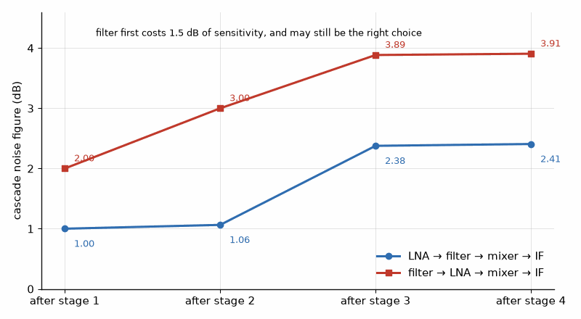
Figure 25.1 — Noise figure building up through the receiver of Worked Example 25.1. With the LNA first the chain ends at 2.41 dB; with the filter first it ends at 3.91 dB.

Worked Example 25.1
Problem. A receiver has an LNA with NF 1 dB and gain 15 dB, a filter with 2 dB loss, a mixer with NF 10 dB and gain 8 dB, and an IF amplifier with NF 4 dB and gain 20 dB. Find the cascade noise figure. Repeat with the filter ahead of the LNA.
Solution. In linear terms the LNA contributes F1 = 1.259. The filter contributes (1.585 − 1)/31.6 = 0.018, the mixer (10 − 1)/(31.6 × 0.631) = 0.451, and the IF amplifier 0.012. The total is 1.740, a noise figure of 2.41 dB. With the filter first, its 2 dB adds directly and the LNA's gain no longer shields the mixer as well, giving 3.91 dB. The filter-first arrangement costs 1.5 dB of sensitivity, and it is used anyway when strong out-of-band signals would otherwise overload the LNA: the trade between noise and survival is the central decision of receiver design.

Worked Example 25.2
Problem. The same receiver sits at the bottom of a mast with 3 dB of cable between the antenna and the LNA. Find the noise figure, and the noise figure with the LNA moved to the top of the mast.
Solution. With the cable first, its 3 dB adds to the cascade: 5.41 dB. With the LNA at the top, the cable follows the LNA's 15 dB of gain and the cascade is 3.52 dB. The tower-mounted amplifier recovers 1.9 dB. The transmit side of Chapter 24 made the same argument for power; the remote radio head serves both.
Key idea. The first stage sets the noise figure. Loss ahead of the first amplifier adds decibel for decibel, and gain in the first stage hides the noise of everything after it.

25.3 Sensitivity and dynamic range
The noise floor of a receiver is −174 dBm/Hz + 10 log₁₀B + NF. Sensitivity adds the SNR the demodulator needs, as in Book 5. The upper end of the receiver's range is set by distortion: two strong signals generate third-order products, Chapter 23's mechanism, and they become a problem when they rise to the noise floor. The spurious-free dynamic range is the range of input levels over which the products remain below the floor. Two-thirds appears because the products rise 3 dB per decibel while the signals rise one.
SFDR = (2/3) (IIP3 − Nfloor)

Worked Example 25.3
Problem. The receiver of Worked Example 25.1, with a 2.41 dB noise figure, uses a 1 MHz channel and has an input third-order intercept of −10 dBm. Find the noise floor and the spurious-free dynamic range.
Solution. The floor is −174 + 60 + 2.41 = −111.6 dBm. SFDR = (2/3)(−10 + 111.6) = 67.7 dB. Raising the LNA gain lowers the noise figure but lowers the cascade's IIP3 too, because every later stage sees bigger signals; the designer sets the gain to balance the two. A phone receiver faces a further limit: its own transmitter, a few tens of megahertz away, leaks through the duplexer and can desensitize the receiver, which is why duplexer isolation of 50 dB or more is standard.

25.4 Blocking and reciprocal mixing
A strong signal outside the channel can also harm reception through the local oscillator. The oscillator's phase noise, Chapter 26's subject, spreads the oscillator's power around its nominal frequency, and a strong blocker mixes with that skirt into the wanted channel. This reciprocal mixing sets a floor that no amount of low-noise gain can remove: the blocker power, plus the phase noise in dBc/Hz at the blocker's offset, plus 10 log₁₀B.
Measure it yourself. Noise figure is measured with a calibrated noise source by the Y-factor method or with a network analyzer by the cold-source method; Book 9, Test and Measurement Instruments, compares them in "Noise Figure and Phase Noise Analyzers".
From the Bench
Build the line-up spreadsheet first, with gain, noise figure, and IP3 for every stage, cascaded. It shows where the noise comes from and which stage limits linearity. Watch the stages after the LNA: a mixer with a high noise figure behind too little gain shows up directly in sensitivity. When the filter has to go before the LNA for protection, accept the noise penalty knowingly and keep that filter's loss as low as you can.
On the Job
RF systems engineers own the line-up: the spreadsheet of gain, noise figure, and intercept that this chapter builds, the frequency plan of Chapter 29, and the link budget of Chapter 30. They negotiate with the circuit designers who own each block and the standards that set the targets, and they are the first people asked why a prototype misses its sensitivity. The job rewards fluency in decibels, a feel for which stage limits what, and the habit of writing every assumption down. It is found at chip, module, and radio makers and in defense and satellite companies.

Practice
1. Find the noise temperature corresponding to a 2 dB noise figure.
2. A two-stage chain has an LNA with NF 0.8 dB and gain 20 dB, then a stage with NF 12 dB. Find the cascade noise figure.
3. Find the noise floor of a 20 MHz receiver with a 2 dB noise figure.
4. Find the SFDR for the receiver of the previous problem with an IIP3 of 0 dBm.
5. A blocker at −30 dBm meets oscillator phase noise of −120 dBc/Hz at its offset. Find the reciprocal-mixing noise in a 1 MHz channel.
6. Why does a filter placed ahead of the LNA raise the noise figure by its full loss?

What You’ll Actually Use
Everyday working tools
- Friis noise cascade F = F1 + (F2 − 1)/G1 + …
- Noise floor −174 dBm/Hz + 10 log B + NF.
- SFDR = (2/3)(IIP3 − floor).
Mostly for exams and deeper study
- Noise-parameter theory beyond the cascade.

Chapter 26. Oscillators, Phase Noise, and the PLL
Why can't a Wi-Fi 7 radio, with its 4096-QAM, use an ordinary oscillator? An oscillator with flat phase noise of −110 dBc/Hz across its band sets an EVM floor of −37 dB, just short of the −38 dB that mode needs. The oscillator alone would block the fastest mode before the amplifier, the channel, or the converter had any say.
Where you meet this: Local oscillators in every radio, clock synthesizers for data converters, EVM and jitter specifications, and the phase-noise plot on every synthesizer data sheet.
Every radio needs a frequency reference: a local oscillator that moves the signal up to the carrier in the transmitter and back down in the receiver. Its frequency must be exact and adjustable in fine steps, and its spectrum must be clean, because any noise on it is copied onto every signal it mixes with. Real oscillators spread their power into a skirt of phase noise around the carrier. This chapter quantifies that skirt, shows how a phase-locked loop combines a clean but fixed reference with a tunable but noisy oscillator, and connects the result to the EVM and reciprocal-mixing limits of Book 5 and Chapter 25. The loop's mathematics is Book 2's feedback, but the PLL lives here, because its specifications come from the radio.

26.1 Phase noise
An oscillator's phase noise is written L(Δf), the noise power in a 1 Hz band at an offset Δf from the carrier, relative to the carrier power, in dBc/Hz. Leeson's model explains its shape. The resonator, with loaded quality factor QL, filters the amplifier's noise; within the resonator's half-bandwidth f0/(2QL), the feedback turns amplitude noise into phase noise that rises as 1/Δf², and closer in, flicker noise steepens it to 1/Δf³. Far from the carrier the noise is flat. The model shows the two levers: a higher QL, and a higher signal power Ps in the resonator.
L(Δf) ≈ 10 log₁₀{ (2FkT/Ps) [1 + (f0 / (2QL Δf))²] } (without the flicker term)
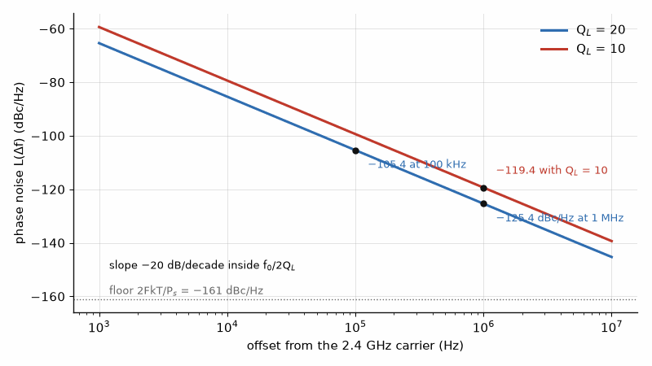
Figure 26.1 — Leeson's model for the 2.4 GHz oscillator of Worked Example 26.1: −125.4 dBc/Hz at 1 MHz with QL = 20, and 6 dB worse when the resonator Q halves.

Worked Example 26.1
Problem. A 2.4 GHz oscillator has QL = 20, a resonator power of 1 mW, and an amplifier noise factor of 10. Find its phase noise at 1 MHz and 100 kHz offsets, and at 1 MHz if QL falls to 10.
Solution. 2FkT/Ps = 2 × 10 × 4.0 × 10⁻²¹/10⁻³ = 8.0 × 10⁻¹⁷, which is −161 dBc/Hz. At 1 MHz, f0/(2QLΔf) = 60, and the bracket is 3601, adding 35.6 dB: L = −125.4 dBc/Hz. At 100 kHz the factor is 600, adding 20 dB more: −105.4 dBc/Hz. Halving QL to 10 raises the noise at 1 MHz by 6 dB, to −119.4 dBc/Hz. The integrated LC resonators of a CMOS chip have QL of about 10 to 20, which is why on-chip oscillators are noisier than discrete ones.

26.2 The phase-locked loop
A PLL divides the oscillator output by N, compares its phase with a crystal reference at fref, and steers the voltage-controlled oscillator so that the two stay in phase; the output is then N × fref. Inside the loop bandwidth, the output follows the reference, and the reference's phase noise appears multiplied by N, which is 20 log₁₀N in decibels. Outside the loop bandwidth, the VCO runs free and its own noise appears. The designer chooses the loop bandwidth near the offset where the two contributions cross. An integer-N synthesizer steps in multiples of fref, so fine steps need a low reference and therefore a large N. A fractional-N synthesizer dithers N between integers with a delta-sigma modulator, allowing a high reference, a small N, and fine steps; the dithering's quantization noise is shaped to high offsets, where the loop filters it.
fout = N fref, in-band noise = Lref + 20 log₁₀N

Worked Example 26.2
Problem. A 2.4 GHz synthesizer must step in 1 MHz increments. The reference, referred to the phase detector, contributes −150 dBc/Hz. Compare the in-band phase noise of an integer-N design with a 1 MHz reference and a fractional-N design with a 40 MHz reference.
Solution. The integer-N design needs N = 2400, so the in-band noise is −150 + 20 log₁₀2400 = −150 + 67.6 = −82.4 dBc/Hz. The fractional-N design has N ≈ 60, adding 35.6 dB, for −114.4 dBc/Hz, 32 dB better. Fractional-N synthesis is the reason modern radios can have both fine channel steps and clean in-band noise.
Key idea. A PLL copies the reference inside its bandwidth, multiplied by N, and leaves the VCO's own noise outside it. Keep N small, the reference clean, and the loop bandwidth where the two noise curves cross.

26.3 Settling
A PLL must also settle quickly when the channel changes. For a second-order loop with natural frequency ωn and damping ζ, the frequency error after a step decays roughly as e^(−ζωnt), so the time to settle to a fraction ε of the step is about −ln(ε√(1 − ζ²))/(ζωn). With fn = 100 kHz and ζ = 0.707, settling to one part per million of the step takes 31.9 µs. A wider loop settles faster and suppresses more VCO noise, but passes more reference and delta-sigma noise, and the loop must remain stable with margin: Book 2's phase-margin analysis applies directly.

26.4 From phase noise to EVM and jitter
Integrating the phase noise over the offsets that matter gives the oscillator's rms phase error σφ = √(2∫L(f)df), in radians, with L in linear units. The factor 2 counts both sidebands. The phase error rotates every constellation point, and for small errors it acts as an EVM of σφ. In a clock, the same quantity divided by 2πf0 is the rms jitter, which sets the converter limit of Book 5.

Worked Example 26.3
Problem. An oscillator at 2.4 GHz has flat phase noise of −110 dBc/Hz from 10 kHz to 10 MHz offset. Find its rms phase error, the EVM floor it sets, and its rms jitter.
Solution. The integral is 2 × 10⁻¹¹ × (10⁷ − 10⁴) = 2.0 × 10⁻⁴ rad², so σφ = 0.0141 rad, or 0.81°. As an EVM floor that is 1.41%, or −37.0 dB, just short of the −38 dB that Book 5 found for Wi-Fi 7's 4096-QAM, so this oscillator would limit that mode before any other impairment. The jitter is 0.0141/(2π × 2.4 × 10⁹) = 0.94 ps rms.
Measure it yourself. Phase noise is measured with a spectrum analyzer for coarse work and with a phase-noise analyzer for the levels of this chapter; Book 9, Test and Measurement Instruments, covers both in "Noise Figure and Phase Noise Analyzers" and the references behind them in "Counters, Timers, and Frequency References".
From the Bench
Read a phase-noise plot by region: inside the loop bandwidth the reference and divider set the noise, outside it the VCO does. Integrate the noise over the band your modulation cares about to get rms phase error or jitter, and compare it with the EVM budget. Keep the VCO tuning line and loop filter away from switching supplies and digital lines; a few microvolts of ripple there appears as spurs next to the carrier.

Practice
1. By how much does the in-band reference noise rise in a PLL with N = 145?
2. In Leeson's model, how much does doubling the resonator power change the far-out phase noise?
3. An oscillator has flat phase noise of −100 dBc/Hz from 1 kHz to 1 MHz at 1 GHz. Find σφ in degrees and the rms jitter.
4. A synthesizer with a 40 MHz reference must produce 5.8 GHz. Find N and the in-band noise if the reference contributes −150 dBc/Hz.
5. Find the approximate settling time of a loop with fn = 50 kHz and ζ = 0.707 to one part per million.
6. Why does a small N improve in-band phase noise?

What You’ll Actually Use
Everyday working tools
- Leeson's model and the role of loaded Q.
- Integer-N in-band noise rising 20 log N.
- Integrated phase noise to rms phase error and jitter.
Mostly for exams and deeper study
- Nonlinear oscillator theory and the impulse sensitivity function.

Chapter 27. Radar
On 26 February 1935, near Daventry in England, Robert Watson-Watt and Arnold Wilkins watched the signal from a BBC shortwave transmitter flicker as an RAF bomber flew through its beam. Within a few years Britain had a chain of radar stations along its coast. The physics they relied on hasn't changed: the echo fades as the fourth power of range.
Where you meet this: Automotive 77 GHz radar, weather and air-traffic radar, level sensors, presence detectors in smart-home devices, and military systems.
Radar is the application in which this book's two halves meet most directly. A transmitter sends a pulse of hundreds of watts to megawatts, a target reflects a tiny fraction of it, and a receiver with the lowest possible noise must detect the echo. Because the signal travels out and back, the received power falls as the fourth power of range, not the square, and that one fact shapes everything else: the high peak powers, the long pulses compressed after reception, and the integration of many echoes. This chapter derives the radar equation, computes range, resolution, and Doppler, and finishes with the 77 GHz FMCW radar of a modern car. Antenna gain is taken from Chapters 7 and 8; if the last stage is a tube, its pulse modulator is Book 6's.

27.1 The radar equation
A transmitter of power Pt with antenna gain G produces a power density of PtG/(4πR²) at range R. A target of radar cross-section σ intercepts and reradiates σ times that density, which spreads again over 4πR² on the way back, and the receiving antenna, of effective area Gλ²/(4π), collects part of it. Multiplying gives the monostatic radar equation, with one antenna for both directions.
Pr = Pt G² λ² σ / [(4π)³ R⁴]
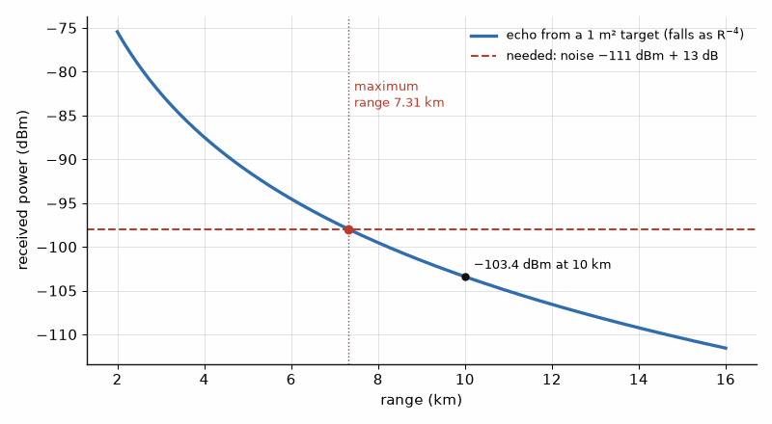
Figure 27.1 — The radar echo falls as the fourth power of range. For the radar of Worked Example 27.1 it crosses the −98 dBm detection threshold at 7.31 km.

Worked Example 27.1
Problem. A 10 GHz radar transmits 1 kW peak through a 30 dBi antenna at a 1 m² target 10 km away. Its receiver has a 1 MHz bandwidth and a 3 dB noise figure, and detection needs 13 dB of SNR. Find the received power and the maximum range.
Solution. λ = 3.00 cm. Pr = 10³ × 10⁶ × (0.0300)² × 1/[(4π)³ × 10¹⁶] = 4.53 × 10⁻¹⁴ W, or −103.4 dBm. The noise floor is −174 + 60 + 3 = −111 dBm, so the required power is −98 dBm. The echo at 10 km is 5.4 dB too weak; since Pr ∝ R⁻⁴, the maximum range is 10 km × 10^(−5.4/40) = 7.31 km. Doubling the transmitter power would extend it only by 2^(1/4) = 1.19, to 8.69 km.
Key idea. Radar's echo falls as 1/R⁴. Doubling the range takes sixteen times the power, so radar designers buy range with antenna gain, pulse energy, and integration rather than with peak watts alone.

27.2 Pulses, energy, and resolution
Detection depends on the energy of the pulse, not its peak power: a matched filter's output SNR is the received pulse energy divided by kTF, as in Book 5. The range resolution, the smallest separation at which two targets appear distinct, is ΔR = c/(2B), where B is the pulse bandwidth; for a simple pulse of length τ, B ≈ 1/τ. A long pulse has more energy but poor resolution. Pulse compression removes the conflict: the transmitter sends a long pulse with a wide bandwidth, usually a linear frequency chirp, and the receiver's matched filter compresses it into a short one. The compression ratio is the time-bandwidth product Bτ.
ΔR = c / (2B), Runamb = c × PRI / 2, duty = τ / PRI

Worked Example 27.2
Problem. The radar of Example 27.1 uses a 1 µs pulse at a pulse repetition interval of 1 ms. Find its range resolution, unambiguous range, duty cycle, and average power. It is changed to a 10 µs pulse chirped over 10 MHz at the same peak power. Find the new resolution, the compression ratio, and the new maximum range.
Solution. With 1 µs, B ≈ 1 MHz and ΔR = 150 m. The unambiguous range is c × 1 ms/2 = 150 km, the duty cycle 0.1%, and the average power 1 W. The chirped pulse has ΔR = c/(2 × 10 MHz) = 15 m and Bτ = 100, or 20 dB of compression. Its energy is ten times larger, so its SNR rises by 10 dB, and the maximum range becomes 7.31 × 10^(10/40) = 13.0 km, while the resolution improves tenfold. The average power rises to 10 W at 1% duty cycle, which the transmitter's thermal design of Chapter 24 must accept.

27.3 Doppler
A target moving with radial velocity v shifts the echo by fd = 2v/λ, twice the one-way shift because both paths shorten. Pulse-Doppler radars measure that shift across a train of pulses to separate moving targets from stationary clutter. At 10 GHz, a target closing at 100 m/s shifts the echo by 6.67 kHz.
fd = 2v / λ

27.4 The 77 GHz automotive radar
Automotive radars use the 76 to 81 GHz band and a frequency-modulated continuous wave instead of pulses. The transmitter sweeps linearly over a bandwidth B in a time Tc, a slope S = B/Tc. The echo from a target at range R arrives 2R/c later, so mixing it with the current transmit signal produces a beat frequency fb = 2RS/c, which an FFT turns into a range profile. The resolution is again c/(2B): a 4 GHz sweep resolves 3.75 cm, enough to separate a pedestrian from a nearby car. A sequence of chirps gives the Doppler, and an array of receive antennas, the subject of Chapter 8, gives the angle. The whole radar is a single CMOS or SiGe chip with a few milliwatts per transmit channel; the R⁴ law is overcome by the short ranges and by integrating hundreds of chirps.

Worked Example 27.3
Problem. A 77 GHz FMCW radar sweeps 1 GHz in 50 µs. Find the slope, the beat frequency for a target at 50 m, the range resolution, and the Doppler shift for a closing speed of 30 m/s.
Solution. S = 10⁹/(50 × 10⁻⁶) = 2 × 10¹³ Hz/s. fb = 2 × 50 × 2 × 10¹³/2.998 × 10⁸ = 6.67 MHz, within reach of an inexpensive converter. ΔR = c/(2 × 1 GHz) = 15.0 cm. λ = 3.89 mm, so fd = 2 × 30/0.00389 = 15.4 kHz.
Where this continues. Chapter 49 designs FMCW front ends at 24, 60, and 77 GHz, from chirp slope and IF bandwidth to MIMO angle resolution and gesture sensing. The ranging signal processing is in Book 5, "Ranging and Positioning", the chirp measurements in Book 9, Test and Measurement Instruments, "Bursts, Chirps, and Pulses: BLE, LoRa, FMCW Radar, and Pulsed RF", and point-cloud processing on the host in Book 8, Firmware and Software for Electronics, "Sensor Fusion: IMU Filters, Kalman, and SLAM Basics".
From the Bench
Because echo power falls as R⁻⁴, doubling the range takes 12 dB more of something: power, antenna gain, integration time, or lower noise. Work out which is cheapest. In FMCW radars, chirp linearity and leakage from transmitter to receiver often limit performance before thermal noise does, so look at the close-in spectrum and the beat-frequency spurs before chasing noise figure.

Practice
1. By what factor must the transmitter power rise to double a radar's range, all else equal?
2. Find the range resolution of a 150 MHz chirp.
3. Find the unambiguous range at a pulse repetition interval of 500 µs.
4. A radar transmits 1 µs pulses of 1 kW peak every 1 ms. Find its average power.
5. Find the Doppler shift at 77 GHz for a closing speed of 30 m/s.
6. An FMCW radar sweeps 4 GHz in 40 µs. Find the beat frequency for a target at 100 m.

What You’ll Actually Use
Everyday working tools
- Radar equation and Pr ∝ R⁻⁴.
- Range resolution c/2B and unambiguous range c·PRI/2.
- FMCW beat frequency and Doppler shift 2v/λ.
Mostly for exams and deeper study
- Ambiguity functions and detection statistics.

Chapter 28. The Low-Noise Amplifier
The first transistor after the antenna decides how weak a signal the whole radio can hear. Give a 1 dB LNA 15 dB of gain and the full receiver lands at 2.41 dB; give it 5 dB and the stages behind it come back into the noise figure. How much gain to give it is the real design decision, and it depends mostly on what comes after it.
Where you meet this: GPS and GNSS front ends, cellular and Wi-Fi receivers, satellite LNBs, radio telescopes, and test-equipment preamplifiers.
Chapter 25 showed that the first stage of a receiver sets its noise figure. This chapter designs that stage. A low-noise amplifier must add as little noise as possible, provide enough gain to hide the stages after it, remain stable, survive the strong signals and transmitter leakage around it, and match the antenna well enough not to reflect the signal away. Those goals conflict, because the source impedance that minimizes a transistor's noise is not the one that maximizes its gain or its input match. The LNA designer's craft is resolving that conflict. Stability from S-parameters, which every amplifier must satisfy, is treated in Chapter 5; this chapter assumes a stable device.

28.1 The noise parameters
A transistor's noise figure depends on the impedance of the source driving it, which the input matching network sets. Four noise parameters describe the dependence: the minimum noise factor Fmin, the optimum source reflection coefficient Γopt at which it occurs, and the noise resistance Rn, which says how fast the noise rises as the source moves away from Γopt. A device with small Rn is forgiving; one with large Rn must be matched precisely. Manufacturers give the four parameters at each frequency, and they are measured with a tuner that sweeps the source impedance.
F = Fmin + (4Rn/Z0) |Γs − Γopt|² / [(1 − |Γs|²) |1 + Γopt|²]

Worked Example 28.1
Problem. A transistor has NFmin = 0.5 dB, Rn = 8 Ω, and Γopt = 0.5∠60° in a 50 Ω system. Find its noise figure with a 50 Ω source, Γs = 0, and with Γs = 0.3∠60° and 0.5∠30°.
Solution. With Γs = 0, F = 1.122 + (32/50) × 0.25/(1 × |1 + 0.5∠60°|²) = 1.122 + 0.64 × 0.25/1.75 = 1.213, or 0.84 dB. At Γs = Γopt the figure is the minimum, 0.50 dB. With Γs = 0.3∠60°, a partial step toward the optimum, it is 0.56 dB, and with 0.5∠30°, the right magnitude at the wrong angle, 0.62 dB. Driving the device straight from 50 Ω would cost 0.34 dB, which in a satellite ground receiver, where the antenna's noise temperature is only tens of kelvin, is a large fraction of the system noise.

28.2 Noise match versus gain match
The source impedance for minimum noise is generally not the conjugate of the device's input impedance, so a noise-matched LNA reflects part of the incoming power and has a poor input return loss. Two techniques reconcile them. Inductive source degeneration, a small inductance in the emitter or source, adds a real part to the input impedance without adding noise, moving the input match toward Γopt's conjugate; it is the standard narrowband CMOS and HEMT LNA. Balanced amplifiers place two identical noise-matched stages between 90° hybrids, so that their reflections cancel at the input port and appear instead in the hybrid's load, giving both low noise and good match at the cost of twice the devices.
Key idea. A transistor has one source impedance for lowest noise and another for best match. The LNA's input network chooses between them, and degeneration or a balanced pair lets it have both.

28.3 Gain and the cascade
The LNA's gain should be high enough that later stages hardly affect the system noise figure, but not so high that it overloads them or lowers the cascade's intercept point, as Chapter 25 showed. A lower-noise device with less gain may give a worse system than a noisier device with more gain. Any loss before the LNA, in a connector, a filter, or a switch, adds decibel for decibel to the noise figure, so in the most sensitive systems the LNA is mounted directly at the antenna, and sometimes cooled.
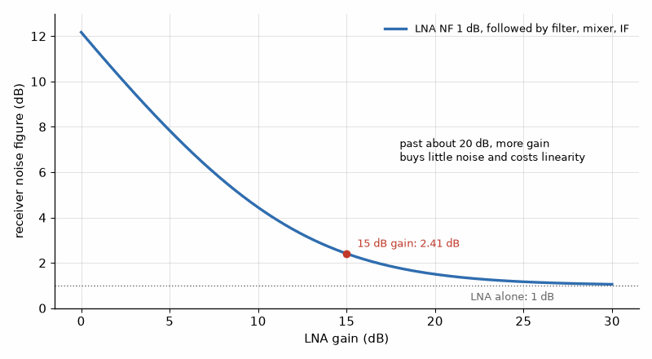
Figure 28.1 — Receiver noise figure against LNA gain, for the chain of Chapter 25. At 15 dB of gain the receiver reaches 2.41 dB; beyond about 20 dB, extra gain buys little and costs linearity.

Worked Example 28.2
Problem. An LNA is followed by a stage with a 6 dB noise figure. Compare device A, with 0.8 dB noise figure and 10 dB gain, and device B, with 0.6 dB and 6 dB gain. Then find the system noise figure if a 0.3 dB loss precedes device A.
Solution. For A, F = 1.202 + (3.981 − 1)/10 = 1.500, a system noise figure of 1.76 dB. For B, F = 1.148 + 2.981/3.981 = 1.897, or 2.78 dB. The lower-noise device gives the worse receiver by a full decibel. With 0.3 dB of loss before device A, the system figure becomes 2.06 dB, and the loss has cost as much as the whole difference between the two devices' own noise figures.

28.4 Linearity and protection
An LNA in a phone or base station sits beside its own transmitter, and in a radar beside a kilowatt pulse. It must tolerate out-of-band blockers without compressing, survive the leakage that the duplexer or switch lets through, Chapter 34's subject, and recover quickly after an overload. Limiters, diodes that clip large signals before the LNA, protect radar receivers, but they add loss and therefore noise. GaN LNAs, which tolerate several watts of input, are increasingly used where survivability matters more than the last tenth of a decibel.

28.5 A pHEMT LNA from a real data sheet
The noise parameters of Section 28.1 are published for real devices, usually in a table and in a Touchstone file whose format Chapter 48 explains. The Broadcom ATF-54143, an enhancement-mode GaAs pHEMT in a four-lead plastic package, is a long-lived LNA part whose data sheet gives them at 3 V and 60 mA. At 2.0 GHz it lists NFmin = 0.45 dB, Γopt = 0.27∠120.1°, and a normalized noise resistance of 0.04, so Rn = 0.04 × 50 = 2.0 Ω, with an associated gain of 18.29 dB at Γopt. Its S-parameters at the same bias give S11 = 0.62∠−168.3°, S21 = 7.31∠73.3°, S12 = 0.06∠33.3°, and S22 = 0.17∠−117.0°. The reference planes are the ends of the leads on the vendor's alumina test carrier with four source vias, so a board with longer source vias will not reproduce these numbers.

Worked Example 28.3
Problem. Using the ATF-54143 data at 2.0 GHz, find the noise figure with a 50 Ω source and at Γopt, and decide how precisely the input match must hit Γopt. Then find Rollett's K and say what it implies for the design.
Solution. With Γs = 0: |Γs − Γopt|² = 0.0729 and |1 + Γopt|² = |0.865 + j0.234|² = 0.803, so F = 1.109 + (4 × 2.0/50) × 0.0729/0.803 = 1.109 + 0.0145 = 1.124, a noise figure of 0.51 dB, only 0.06 dB above NFmin. The small Rn, 2.0 Ω against Worked Example 28.1's 8 Ω, makes the device forgiving: the input match can favor return loss and stability with little noise penalty. K computes to 0.81 at 2 GHz, below 1, so the device is only conditionally stable; the data sheet accordingly quotes the maximum stable gain, MSG = |S21|/|S12| = 20.86 dB, not a MAG. The design needs stabilization, typically a small resistance in the drain feed and the source inductance of the vias, before the input network is drawn. Chapter 48 does the rest: reading the file, plotting noise circles, and designing the match.
Where this continues. Chapter 48 reads the same device's Touchstone file, computes K, μ, and MSG across frequency, draws the noise and gain circles, and designs an L-section that presents Γopt from 50 Ω. Noise parameters themselves are measured with a tuner and a noise-figure analyzer, as Book 9, Test and Measurement Instruments, describes in its chapter "Noise Figure and Phase Noise Analyzers".
From the Bench
Match the LNA input for noise, not gain, and check the price in return loss, because the filter or switch in front of it may not like the mismatch. Stability matters more than a tenth of a decibel of noise figure, so add resistive loading at the output if K is marginal anywhere. Protect the input against the strongest signal it will see, including the radio's own transmitter, and remember that the protection diode's capacitance and loss come straight off the noise figure.

Practice
1. Find the noise factor of a device with NFmin = 1.0 dB, Rn = 10 Ω, and Γopt = 0.4∠90°, with a 50 Ω source.
2. A system has 0.5 dB of cable loss before an LNA with 1.0 dB noise figure and 20 dB gain, followed by a 10 dB stage. Find the system noise figure.
3. What does inductive source degeneration add to an LNA's input impedance?
4. An LNA has 15 dB gain and the next stage a 12 dB noise figure. How much does the second stage add to the noise factor?
5. Why might a lower-noise transistor give a worse receiver?
6. Why does a balanced LNA have a good input match even when each half is noise-matched?
7. With the ATF-54143 data of Section 28.5, find the noise figure for a source of Γs = 0.27∠60°, the right magnitude at the wrong angle.

What You’ll Actually Use
Everyday working tools
- Noise figure set by the LNA plus the next stage's excess noise divided by the LNA gain.
- Noise match Γopt vs gain match.
- Input protection and its noise cost.
Mostly for exams and deeper study
- Noise-parameter derivation from device physics.

Chapter 29. Mixers and Frequency Planning
Tune a 2.45 GHz receiver with a 400 MHz IF and it hears 1.65 GHz just as well, unless something stops it. A mixer can't tell the wanted signal from its image, and it responds to a whole list of other frequencies made from LO harmonics. The frequency plan is the part of radio design you get right on paper, before the hardware exists.
Where you meet this: Superheterodyne and zero-IF receivers, upconverters in transmitters, spectrum analyzers, and the spur table in every radio design review.
Every superheterodyne and zero-IF radio of Book 5 contains a mixer, the circuit that shifts a signal from one frequency to another by multiplying it with a local oscillator. A mixer is a deliberately nonlinear device, and it produces not only the wanted product but a family of unwanted ones. Choosing the intermediate and oscillator frequencies so that those products fall where filters can remove them is frequency planning, and it is one of the decisions that most shape a radio's architecture. This chapter covers mixer types and figures of merit, the image problem, and the spur chart.

29.1 What a mixer does
Multiplying a signal at fRF by an oscillator at fLO produces components at their sum and difference. The receiver keeps the difference, fIF = |fRF − fLO|; the transmitter keeps the sum or difference that lands at the carrier. A double-balanced mixer, a diode ring or a Gilbert cell of transistors, suppresses the oscillator and the input at its output port and cancels many even-order products. Passive mixers have a conversion loss of about 6 to 7 dB and a noise figure roughly equal to it, but very high intercept points; active Gilbert-cell mixers have conversion gain but lower linearity. The oscillator drive must be large enough to switch the mixer cleanly, and the oscillator's phase noise, Chapter 26's subject, is transferred onto every signal.
fIF = |fRF − fLO|, spurs at |m fLO ± n fRF| = fIF

29.2 The image
Two radio frequencies produce the same difference with a given oscillator: the wanted one, and the image on the opposite side of the oscillator at the same distance. A mixer cannot tell them apart, so the image must be removed before the mixer by a filter, or cancelled by an image-reject mixer that uses quadrature paths, as in Book 5's I/Q receiver. A high intermediate frequency puts the image far from the wanted band, where a filter can remove it easily, but makes the later IF filtering harder; a low IF does the opposite. Many receivers use two conversions to get both.
fimage = fRF − 2fIF (low-side LO), fRF + 2fIF (high-side LO)
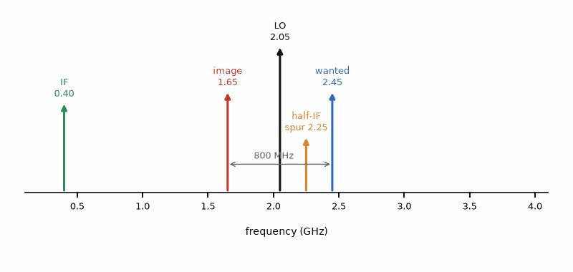
Figure 29.1 — Frequency plan of a 2.45 GHz receiver with a 400 MHz IF and low-side LO at 2.05 GHz. The image at 1.65 GHz converts just as well as the wanted signal, and the half-IF spur sits only 200 MHz below it.

Worked Example 29.1
Problem. A 2.45 GHz receiver uses a 400 MHz IF with low-side injection. Find the oscillator frequency and the image. An interferer at the image is 40 dB stronger than the wanted signal, which needs 20 dB of SNR. How much image rejection is needed?
Solution. fLO = 2.45 − 0.40 = 2.05 GHz, and the image is at 2.05 − 0.40 = 1.65 GHz, 800 MHz below the wanted signal. The image must end up at least 20 dB below the wanted signal after conversion, so the filter and mixer together must reject it by 40 + 20 = 60 dB. At an 800 MHz separation a modest ceramic filter can provide that; with a 40 MHz IF the image would be only 80 MHz away and would need a much sharper filter or an image-reject architecture.
Key idea. A mixer converts every input that satisfies |m fLO ± n fRF| = fIF, not only the one you want. Frequency planning places the oscillator and IF so that the image and the strong spurs land where a filter can remove them.

29.3 The spur chart
Because a real mixer is not an ideal multiplier, it converts inputs at every frequency where some combination m fLO ± n fRF equals the IF, with m and n small integers. Each such response, a spur, is weaker for higher orders, but a strong interferer at a low-order spur frequency can still block the receiver. The half-IF spur, with m = n = 2, lies halfway between the wanted signal and the oscillator, where it is hard to filter. A frequency plan lists the low-order spur frequencies, checks them against the filter's response and the expected interferers, and moves the IF if a dangerous spur falls in band.

Worked Example 29.2
Problem. For the receiver of Example 29.1, find the radio frequencies between 1 and 4 GHz that convert to the 400 MHz IF for m and n up to 3.
Solution. Solving m × 2.05 ± n fRF = ±0.40 gives, for (m, n) = (1, 1), the wanted 2.45 GHz and the image 1.65 GHz. For (1, 2), 1.225 GHz. For (2, 1), 3.70 GHz. For (2, 2), 2.25 GHz and 1.85 GHz; 2.25 GHz is the half-IF spur, only 200 MHz below the wanted signal. For (2, 3), 1.50 and 1.233 GHz; for (3, 2), 3.275 and 2.875 GHz; for (3, 3), 2.183 and 1.917 GHz. The front-end filter must reject the half-IF spur at 2.25 GHz and the (3, 3) response at 2.183 GHz, both near the band; the others are far enough away to be easy.

29.4 The passive mixer as a switch
Multiplying a signal by a square wave at the LO frequency is the same as switching its polarity at that rate, which is what a ring of four diodes or four transistors does in a double-balanced mixer. The square wave's fundamental has an amplitude of 4/π times its peak, and the product contains the sum and difference frequencies. For an ideal commutating mixer, the fraction of the RF power that reaches the wanted IF is (2/π)², a conversion loss of 3.9 dB. Real diode mixers show 6 to 7 dB because of diode resistance, the transformers or baluns, and imperfect switching. The switches themselves are the series and shunt elements of Chapter 19.
L_conv,ideal = −20 log₁₀(2/π) = 3.92 dB
The balance of a double-balanced mixer cancels the LO at the RF and IF ports and the RF at the IF port, so port-to-port isolation, often 30 to 40 dB, depends on how well the baluns and diodes are matched. Because the switches are driven hard by the LO, a passive mixer is quite linear; a rule of thumb for diode mixers is an input third-order intercept about 10 dB above the LO drive.

29.5 Transmit mixers and direct conversion
A transmitter that upconverts with a mixer produces the wanted sideband, the image sideband, and oscillator leakage, all of which the emission mask of Book 7 constrains. Quadrature upconverters cancel the image sideband to the extent that their I and Q paths match, the same imbalance arithmetic as in Book 5's receiver, and they null the oscillator leakage by trimming DC offsets. Direct conversion, with the oscillator at the carrier, avoids the image entirely but places the oscillator in band, where its leakage, pulling by the power amplifier, and radiation must be controlled. Many modern transmitters avoid analog mixers altogether by synthesizing the signal digitally at a high rate and converting it with a fast DAC directly at the carrier.
Where this continues. Chapter 51 builds receivers that use these frequency plans: a superheterodyne FM receiver with a 10.7 MHz IF and an RTL-SDR, whose tuner and 8-bit converter show every spur and image of this chapter on a waterfall display.
From the Bench
Draw the spur chart for the whole tuning range before choosing the IF, and look hardest at the half-IF spur and at LO harmonics landing in band. Image rejection is shared between the preselector and any image-reject mixer, so assign the budget explicitly. In zero-IF designs, DC offset, LO leakage, and IQ imbalance replace the image problem; plan their calibration from the start.

Practice
1. Find the image of a 5.8 GHz signal with a high-side LO and a 1 GHz IF.
2. Find the half-IF spur for a 900 MHz receiver with a 70 MHz IF and low-side LO.
3. An image interferer 30 dB above the wanted signal must end 15 dB below it. How much rejection is needed?
4. A passive mixer has 6.5 dB conversion loss. Estimate its noise figure.
5. Why does a higher IF make image rejection easier?
6. Why does a direct-conversion transmitter need careful control of LO leakage?
7. What is the ideal conversion loss of a commutating mixer?
8. Estimate the IIP3 of a diode mixer driven with +7 dBm of LO.

What You’ll Actually Use
Everyday working tools
- Image = the frequency an IF away on the other side of the LO.
- Spur chart: m·LO ± n·RF = IF.
- Conversion loss and LO drive level.
Mostly for exams and deeper study
- Time-varying mixer analysis with conversion matrices.

Chapter 30. The Link Budget
A 5.8 GHz link across 10 km starts at 27 dBm and arrives at −52.7 dBm, a drop of almost 80 dB even with two 25 dBi antennas helping. What's left over, 27.3 dB above the receiver's sensitivity, is the fade margin, the number that decides how often the link drops on a bad day.
Where you meet this: Microwave backhaul, satellite ground terminals, IoT coverage estimates, drone and telemetry links, and every system proposal that promises a range.
A link budget adds up every gain and loss between the transmitter's output and the receiver's detector and compares the result with what the demodulator needs. It ties together almost every topic in this book and Book 5: power amplifier output, feeder loss, antenna gain, path loss, receiver noise, and the SNR or Eb/N0 that a modulation needs. Because everything is in decibels, the budget is a column of additions, and the bottom line, the margin, says how much fading or degradation the link can tolerate. This chapter builds a terrestrial budget in dBm and a satellite budget in the G/T form.

30.1 The terrestrial budget
The received power is the transmitter power, minus the feeder losses, plus both antenna gains, minus the path loss. In free space the path loss is the Friis term, which grows 20 dB per decade of distance and 20 dB per decade of frequency. The fade margin is the received power minus the receiver's sensitivity, which Chapter 25 defined as the noise floor plus the noise figure plus the required SNR. Real paths add atmospheric absorption, rain at millimeter waves, obstruction of the Fresnel zone, and multipath fading, so a microwave link is usually designed for a margin of 20 to 40 dB depending on the availability required.
Pr = Pt − Lt + Gt − Lpath + Gr − Lr, Lpath = 20 log10(4πd f / c)
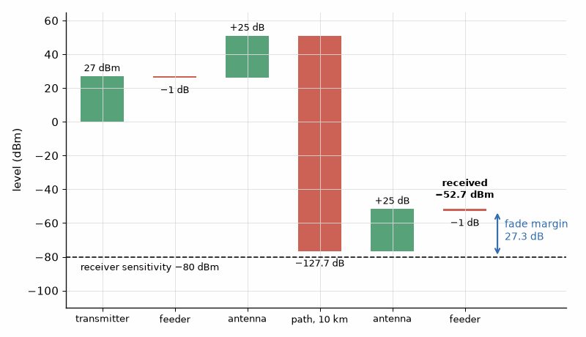
Figure 30.1 — The link budget of Worked Example 30.1 as a waterfall: 27 dBm out, 127.7 dB of path loss, two 25 dBi antennas, and −52.7 dBm received, 27.3 dB above the receiver's sensitivity.

Worked Example 30.1
Problem. A 5.8 GHz point-to-point link spans 10 km. The transmitter delivers 27 dBm, each feeder loses 1 dB, each antenna has 25 dBi, and the receiver sensitivity is −80 dBm. Find the path loss, the received power, and the fade margin.
Solution. Path loss = 20 log10(4π × 10⁴ × 5.8 × 10⁹ / 2.998 × 10⁸) = 127.7 dB. Received power = 27 − 1 + 25 − 127.7 + 25 − 1 = −52.7 dBm. The fade margin is −52.7 − (−80) = 27.3 dB, comfortable for a clear line-of-sight path at this frequency. Doubling the distance to 20 km would add 6.0 dB of path loss and leave 21.3 dB.
Key idea. A link budget is a sum in decibels: transmit power plus antenna gains minus losses gives the received power, and the margin over the receiver's sensitivity is what protects the link against fading.

30.2 The satellite budget and G/T
Satellite links use a different bookkeeping. The transmitter's power and antenna are combined into the effective isotropic radiated power, EIRP, in dBW. The receiver's antenna gain and system noise temperature are combined into a figure of merit, G/T, in dB/K, because a larger antenna and a quieter receiver are interchangeable ways of improving the link. The carrier-to-noise-density ratio then follows from Boltzmann's constant, −228.6 dBW/K/Hz, and dividing by the noise bandwidth gives C/N. The system temperature is the antenna temperature, the sky noise the antenna sees, plus the receiver's equivalent temperature Te = 290(F − 1).
C/N0 = EIRP − Lpath + G/T − k (dBHz), C/N = C/N0 − 10 log10 B

Worked Example 30.2
Problem. A Ku-band satellite at 12 GHz is 38,000 km from the ground station. Its EIRP is 52 dBW; the ground terminal's G/T is 15 dB/K. Find C/N0 and the C/N in a 30 MHz channel, clear sky and with a 3 dB rain fade.
Solution. Path loss = 20 log10(4π × 3.8 × 10⁷ × 1.2 × 10¹⁰ / 2.998 × 10⁸) = 205.6 dB. C/N0 = 52 − 205.6 + 15 + 228.6 = 90.0 dBHz. In 30 MHz, 10 log10(3 × 10⁷) = 74.8 dB, so C/N = 15.2 dB in clear sky and 12.2 dB in the rain fade (strictly, rain also raises the sky noise and so lowers G/T a little more). Both exceed the roughly 6 to 10 dB that common satellite modulation and coding formats need.

Worked Example 30.3
Problem. A ground antenna has 40 dBi of gain and sees an antenna temperature of 50 K. Its LNA has a 0.8 dB noise figure. Find the system temperature and G/T.
Solution. Te = 290(10^0.08 − 1) = 58.7 K, so Tsys = 50 + 58.7 = 108.7 K, or 20.4 dBK. G/T = 40 − 20.4 = 19.6 dB/K. If the system temperature were 150 K, G/T would fall to 18.2 dB/K; the quieter LNA is worth about 1.4 dB, the same as a 17% larger dish diameter.

30.3 Margins and availability
The margin a link needs depends on how often it may fail. Rain fading at frequencies above about 10 GHz is described statistically: a link designed for 99.99% availability, about 53 minutes of outage per year, needs far more rain margin than one designed for 99.9%. Multipath fading on terrestrial links is countered by diversity, two antennas spaced vertically or two frequencies, rather than by power alone. Adaptive modulation, as in Book 5, trades throughput for margin, dropping to a robust format during a fade instead of losing the link.
Where this continues. Chapter 52 works link budgets a reader can check on the roof: GPS at −128.5 dBm, LoRa at 915 MHz, and amateur satellites with Doppler. Satellite systems are in Book 5, "Satellites and Non-Terrestrial Networks".
From the Bench
Write every link budget with the source of each number beside it, and keep the margins separate: fade margin, implementation loss, and the unknowns you can name. Optimistic antenna gains and forgotten connector losses are the usual errors. When the margin is thin, more antenna gain usually costs less than more transmitter power, because the gain helps both directions of the link.

Practice
1. Find the free-space path loss at 24 GHz over 2 km.
2. A link has 20 dBm transmit power, 30 dBi antennas at both ends, no feeder loss, and 120 dB path loss. Find the received power.
3. A 20 GHz satellite at 36,000 km has an EIRP of 50 dBW. The terminal's G/T is 10 dB/K. Find C/N in 10 MHz.
4. An LNA has a noise figure of 1.5 dB. Find its equivalent noise temperature.
5. How much path loss is added by tripling the distance?
6. Why is G/T a useful single figure of merit for a receiving station?

What You’ll Actually Use
Everyday working tools
- Free-space path loss 20 log(4πd/λ).
- Received power and fade margin.
- C/N0 from EIRP, path loss, and G/T.
Mostly for exams and deeper study
- Availability statistics and rain-fade models in detail.

Chapter 31. Bias, Ruggedness, and Protection
A disconnected antenna is a well-known way to destroy a power transistor. At a 10:1 VSWR, two-thirds of a 100 W output comes back, and the peak voltage on the line rises from 100 V to about 182 V. A rugged amplifier is one designed to survive exactly that, and to notice it in time.
Where you meet this: Ruggedness tests in device qualification, reflected-power alarms in transmitters, bias sequencing in GaN designs, and the protection circuitry of every power amplifier.
A power amplifier that meets every specification on the bench can still fail in the field: an antenna is disconnected, a connector corrodes, the supply comes up in the wrong order, or the device heats and its bias drifts. This chapter covers the practical engineering that keeps the amplifier of Chapters 21 to 24 alive: setting and stabilizing the bias, surviving a mismatched load, and detecting faults fast enough to act on them.

31.1 Biasing the device
The quiescent current sets the amplifier's class and therefore its linearity and efficiency, so it must be set accurately and held there as temperature changes. A gallium nitride or LDMOS transistor is biased by its gate voltage; for depletion-mode GaN that voltage is negative, a few volts below zero, and the drain must not be powered while the gate is at zero, because the device is then fully on. The safe sequence is gate negative first, then drain on, and on shutdown drain off first, then gate. Bipolar devices bring the opposite hazard: the base-emitter voltage needed for a given current falls by about 2 mV for each kelvin of temperature rise, so a fixed bias voltage gives a current that rises as the device heats, which heats it further. Emitter ballast resistors and bias circuits that track the device's temperature, often a diode or a scaled transistor on the same die, break that loop.
ΔVBE ≈ −2 mV/K, IC ∝ exp(ΔV/VT), VT = kT/q ≈ 25.9 mV

Worked Example 31.1
Problem. A bipolar stage is biased with a fixed base-emitter voltage. Its junction warms by 10 K. By what factor does the collector current rise if nothing compensates?
Solution. A 10 K rise is equivalent to a 20 mV increase in the effective drive. The current scales as exp(0.020 / 0.02585) = 2.17, more than doubling. The extra current raises dissipation and temperature further; with enough thermal resistance the loop runs away. A ballast resistor that drops even a few tens of millivolts at the operating current provides negative feedback that stops it.

31.2 The mismatched load
An amplifier designed for a 50 Ω load sees something else when the antenna is damaged, iced, or missing. The voltage standing-wave ratio describes the mismatch: the reflection coefficient is |Γ| = (VSWR − 1)/(VSWR + 1), and a fraction |Γ|² of the forward power returns toward the amplifier. Along the line the incident and reflected waves add, so at some points the voltage reaches (1 + |Γ|) times the matched value. Depending on the phase of the reflection, the device sees either that excess voltage or a corresponding excess current. Ruggedness specifications state the VSWR, often 10:1 at all phases, that a device survives without damage.
|Γ| = (VSWR − 1)/(VSWR + 1), Prefl = |Γ|² Pfwd, Vpeak,max = (1 + |Γ|) Vpeak
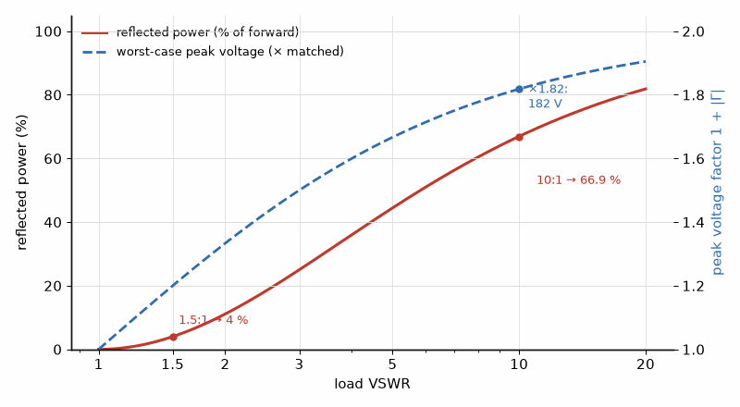
Figure 31.1 — What a mismatch does to the amplifier. At 1.5:1 only 4 % of the power returns; at 10:1, 66.9 % returns and the worst-case peak voltage is 1.82 times the matched value.

Worked Example 31.2
Problem. A 100 W amplifier into 50 Ω faces a 10:1 VSWR. Find the reflection coefficient, the reflected power, and the worst-case peak voltage on the line.
Solution. |Γ| = 9/11 = 0.818. Reflected power = 0.818² × 100 = 66.9 W. The matched peak voltage is √(2 × 100 × 50) = 100 V, so the worst case is 100 × 1.818 = 181.8 V, nearly twice the design value, applied through the matching network to the device. The return loss is only 1.74 dB.
Key idea. A severe mismatch reflects most of the power and nearly doubles the peak voltage or current somewhere in the output network. The amplifier survives either because the device is rated for it, because an isolator absorbs the reflection, or because protection cuts the drive before damage occurs.

31.3 Detecting faults and acting on them
A directional coupler at the output samples the forward and reflected waves separately, and diode or log detectors convert them to voltages. Comparing the two gives the VSWR continuously. Protection logic reduces the drive, the supply, or both, when the reflected power or the device temperature exceeds a threshold, and shuts down entirely on a severe fault. The response must be fast: a GaN device can be destroyed in microseconds by an overvoltage, so the first line of defense is often analog, with digital supervision setting the limits and logging events. The same coupler feeds the closed-loop power control that holds the output at its set value as temperature and supply vary.

Worked Example 31.3
Problem. The amplifier of Example 31.2 has a 30 dB reverse coupler. What power does the reflected-power detector see at a 10:1 VSWR, and at 1.5:1?
Solution. At 10:1 the reflected power is 66.9 W, 48.3 dBm, so the detector sees 18.3 dBm. At 1.5:1, |Γ| = 0.2 and the reflected power is 0.04 × 100 = 4 W, 36.0 dBm, so the detector sees 6.0 dBm. The 12 dB difference is easy to resolve, though the coupler's finite directivity, the forward signal leaking into the reverse port, limits how small a mismatch can be measured.

31.4 Supply, overdrive, and inrush
Other common failures come from the supply and the input. An overdrive pushes the device deep into compression, raising its dissipation and the voltage swing; input limiters and drive monitoring guard against it. A supply that overshoots at turn-on can exceed the drain breakdown rating, and the large decoupling capacitors at the drain draw a heavy inrush that soft-start circuits limit. Load pulling at turn-on, with the antenna switch or duplexer not yet settled, can momentarily present a bad load. A good design treats each of these as a specified condition, tested at the extremes of temperature and supply.
Where this continues. Chapter 44 sizes the emitter ballast of a GaAs HBT power stage from its thermal resistance, and Chapter 45 shows a GaN bias-sequencing circuit that enforces gate-first, drain-second.
From the Bench
Test ruggedness the way the field will: full drive into every phase of a high VSWR, at maximum supply and temperature. Sequence GaN bias correctly, negative gate first and drain last, and design the circuit so a missing gate supply can't turn the device fully on. A reflected-power detector is only useful if it acts quickly, so compare its response time with how long the device survives the fault.

Practice
1. Find |Γ|, the return loss, and the reflected fraction for a VSWR of 2:1.
2. A 50 W amplifier into 50 Ω sees a 5:1 VSWR. Find the matched and worst-case peak voltages.
3. At a 3:1 VSWR, how much of the forward power reaches the load, in dB?
4. Why must a depletion-mode GaN amplifier's gate be biased before its drain is powered?
5. What does a directional coupler's directivity limit?
6. Why do bipolar power stages use emitter ballast resistors?

What You’ll Actually Use
Everyday working tools
- Reflected power |Γ|² × P and peak voltage (1 + |Γ|) × V.
- Thermal runaway and ballast resistors.
- Bias sequencing for depletion-mode GaN.
Mostly for exams and deeper study
- Detailed breakdown physics of each device technology.

Chapter 32. Vacuum Tubes: Klystrons, TWTs, and Magnetrons
In 1940 John Randall and Harry Boot at the University of Birmingham built a cavity magnetron that produced centimeter waves at a power nobody had reached before, and compact airborne radar followed. The magnetron still heats the food in nearly every microwave oven, and tubes still handle much of the highest RF power in the world.
Where you meet this: Microwave ovens, satellite TWT amplifiers, weather and air-traffic radars, particle accelerators, and fusion-plasma heating.
Solid-state amplifiers have replaced vacuum tubes in most radios, but not everywhere. Where the power is kilowatts to megawatts, the frequency is very high, or the device must survive radiation and heat in orbit, electron beams in vacuum still win. Satellite transponders use traveling-wave tubes, particle accelerators and broadcast transmitters use klystrons and inductive output tubes, every microwave oven contains a magnetron, and fusion experiments heat plasma with gyrotrons. This chapter explains how a beam of electrons in vacuum amplifies a microwave signal and where each type fits.

32.1 The electron beam
A heated cathode emits electrons, and a high voltage accelerates them into a beam. The beam's DC power is its voltage times its current, and the tube's job is to convert part of that kinetic energy into RF. The current a gun can draw at a given voltage follows the Child-Langmuir law, I = K V^(3/2), where the constant K, the perveance, depends only on the gun's geometry; perveances around 0.5 to 2 microperveance (µperv, 10⁻⁶ A/V^1.5) are typical. At tens of kilovolts the electrons move at a sizable fraction of the speed of light, which is what lets the beam interact with a slow electromagnetic wave.
Pbeam = V I, I = K V^(3/2), v = c√(1 − 1/γ²), γ = 1 + eV/(mc²)

Worked Example 32.1
Problem. A tube's gun runs at 10 kV and 0.5 A. Find the beam power, the perveance, the electron velocity, and the RF output at 40% efficiency.
Solution. Beam power = 10⁴ × 0.5 = 5 kW. Perveance = 0.5 / (10⁴)^1.5 = 0.5 × 10⁻⁶, or 0.5 µperv. With mc² = 511 keV, γ = 1.0196 and v = 0.195c = 5.85 × 10⁷ m/s. At 40% efficiency the RF output is 2 kW and 3 kW must be removed as heat, mostly in the collector.

32.2 Klystrons
In a klystron the RF input drives a resonant cavity whose gap speeds up some electrons and slows others. Downstream, the fast electrons catch up with the slow ones and the beam bunches; at an output cavity the bunched current induces a large RF voltage, delivering power. Intermediate cavities increase the bunching and the gain, which can exceed 40 dB. Klystrons are narrowband, because the cavities are resonant, but they reach very high power: multi-megawatt pulsed klystrons drive linear accelerators, and continuous-wave tubes of tens of kilowatts drive broadcast and industrial heating. The inductive output tube, a hybrid of a klystron and a triode, is common in UHF television transmitters.
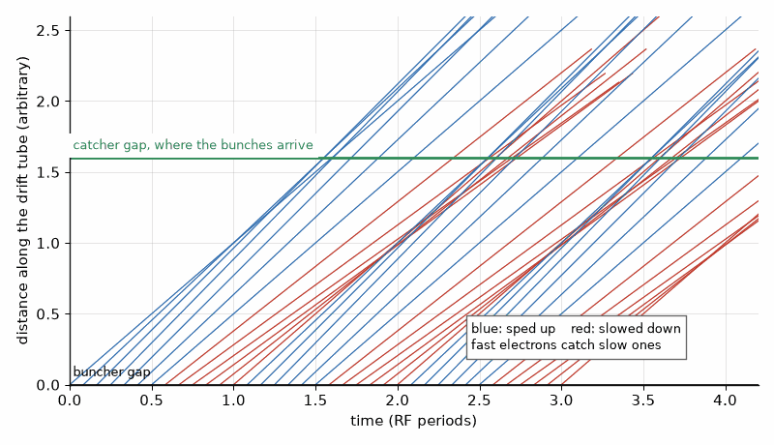
Figure 32.1 — Applegate diagram of klystron bunching (illustrative). Electrons sped up at the buncher gap catch the ones slowed half a cycle earlier, and they arrive at the catcher gap in bunches.

32.3 Traveling-wave tubes
A traveling-wave tube slows an RF wave along a helix or a coupled-cavity structure until its phase velocity nearly matches the beam's. Over the length of the tube the wave and the beam exchange energy continuously, and the wave grows. Because the helix is not resonant, a TWT can amplify over an octave or more, with gains of 40 to 60 dB. Space TWTs add multistage depressed collectors that recover energy from the spent beam by slowing the electrons before they land, raising overall efficiency to 60% to 70%, more than a comparable solid-state amplifier at Ku and Ka band. That efficiency is why most high-power satellite transponders still use TWT amplifiers.

Worked Example 32.2
Problem. The 5 kW beam of Example 32.1 delivers 2 kW of RF. A depressed collector recovers 60% of the 3 kW remaining in the spent beam. Find the overall efficiency.
Solution. The supply now provides 5000 − 0.6 × 3000 = 3200 W net, because the recovered energy returns to the collector supply. The efficiency rises from 40% to 2000 / 3200 = 62.5%, and the heat to be removed falls from 3 kW to 1.2 kW.
Key idea. A vacuum tube converts the kinetic energy of an electron beam into RF, so its power is limited by the beam, not by a semiconductor's breakdown field and junction temperature. Depressed collectors recover much of the energy the RF did not take.

32.4 Magnetrons and gyrotrons
The magnetron is an oscillator rather than an amplifier: electrons spiral in crossed electric and magnetic fields past a ring of resonant cavities and give up energy to the oscillation. It is cheap and efficient, about 65% to 75% at 2.45 GHz, which is why a microwave oven delivers about a kilowatt from a component costing a few dollars. Its frequency and phase are not well controlled, which limits it to heating and older radars. The gyrotron uses electrons gyrating in a strong magnetic field to generate megawatts at frequencies of 100 GHz and above, where conventional structures would be too small, and it heats the plasma in fusion experiments.

Worked Example 32.3
Problem. A 250 W Ku-band satellite amplifier is built either as a TWT at 60% efficiency or as a solid-state amplifier at 40%. Find the DC power and the heat in each case.
Solution. TWT: 250 / 0.6 = 417 W from the bus, 167 W of heat. Solid state: 250 / 0.4 = 625 W, 375 W of heat. On a spacecraft, where every watt of solar array and radiator costs mass, the tube saves 208 W of DC power and more than halves the heat, outweighing its high-voltage supply and finite cathode life.

32.5 Tubes against solid state
Solid-state amplifiers win on lifetime, low voltage, graceful degradation, and cost at moderate power. Reaching 2 kW from 150 W GaN devices takes 16 of them and a combiner; with 0.5 dB of combining loss that yields about 2.14 kW, a large, complex assembly. Tubes win at the highest powers and frequencies, in high-efficiency space amplifiers, and in harsh radiation environments. The boundary keeps moving as GaN improves, but in 2026 it still lies around the kilowatt level at X band and above.
Where this continues. Chapter 45 follows GaN solid-state amplifiers into satellites, where they now replace traveling-wave tubes at the lower powers and frequencies.
From the Bench
Tubes are the choice when the power is kilowatts to megawatts at high frequency, or when efficiency per kilogram in orbit decides. Their high-voltage supplies need serious respect: interlocks, discharge paths, and controlled access. Plan for cathode life, warm-up time, and the replacement cycle. Compare a tube with solid state on DC power and heat, not RF power, because the heat decides the size of the system.

Practice
1. A tube runs at 20 kV and 2 A. Find the beam power and perveance.
2. Find the electron velocity, as a fraction of c, at 20 kV.
3. A magnetron delivers 1 kW at 70% efficiency. Find the DC input and the heat.
4. Why is a klystron narrowband while a helix TWT is broadband?
5. What does a depressed collector do?
6. Combining 16 amplifiers of 150 W with 0.5 dB of loss gives how much power?

What You’ll Actually Use
Everyday working tools
- Beam power and perveance from voltage and current.
- Depressed collectors raise efficiency.
- Tubes vs solid state on DC power and heat.
Mostly for exams and deeper study
- Space-charge wave theory and magnetron electron dynamics.

Chapter 33. RF Exposure and Safety
Is it safe to stand in front of a cell-site antenna? A first-pass calculation for a sector antenna radiating 36 dBW at 3.5 GHz puts the general-public limit about 9 m away in the main beam when the usual conservative ground-reflection factor is included. That estimate is a screening calculation, not a compliance determination: actual assessment depends on the applicable rules, antenna pattern, averaging, installation, accessible locations, and exposure from other sources.
Where you meet this: Cell-site planning and rooftop access, SAR testing for phones and wearables, broadcast and radar sites, and the RF-exposure section of every radio filing.
A transmitter that radiates kilowatts of EIRP can expose people nearby to radio-frequency energy. For the frequency range covered here, the established adverse effect addressed by exposure limits is excessive heating; the limits include safety margins below levels associated with harmful temperature rises. Equipment authorization and site assessments must follow the rules that apply in their jurisdiction and use case. This chapter introduces power density and specific absorption rate, then shows how to estimate distance in a simplified far-field model.

33.1 The limits
Two bodies of rules dominate. In the United States the FCC limits of 47 CFR 1.1310, based on the IEEE and NCRP work of the 1980s and 1990s, set a maximum permissible exposure for the general public of 1 mW/cm², which is 10 W/m², from 1.5 to 100 GHz, and f/1500 mW/cm² between 300 and 1500 MHz, with f in megahertz. Occupational limits, for trained workers aware of the exposure, are five times higher. Internationally, the ICNIRP 2020 guidelines set 10 W/m² for the general public from 2 to 300 GHz, averaged over 30 minutes for whole-body exposure. Near the body, for phones and other devices held close, the limits are on the specific absorption rate: 1.6 W/kg averaged over 1 g of tissue under the FCC rules, and 2 W/kg over 10 g under ICNIRP.
FCC general public: S ≤ f/1500 mW/cm² (300–1500 MHz); 1 mW/cm² = 10 W/m² (1.5–100 GHz)

33.2 Power density in the far field
Far from an antenna the power density is the EIRP spread over a sphere, S = EIRP/(4πR²). Solving for R gives the distance beyond which the exposure is below a limit. Near the ground, the direct and ground-reflected waves can add; FCC guidance in OET Bulletin 65 uses a reflection factor of 2.56 in power density, corresponding to a field 1.6 times the free-space value, for a conservative estimate. The far-field formula overestimates the density in the near field of a large aperture antenna, where the beam has not yet spread; there the density is bounded by roughly four times the power divided by the aperture area.
S = EIRP/(4πR²), Rcompliance = √(F × EIRP / (4π Slimit)), F = 1 or 2.56
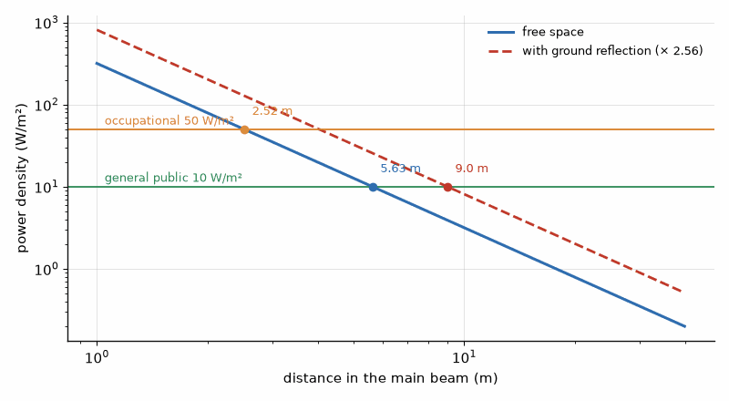
Figure 33.1 — Power density in front of a 36 dBW sector antenna at 3.5 GHz. The general-public limit of 10 W/m² is met at 5.63 m in free space and 9.0 m with ground reflection; the occupational limit at 2.52 m.

Worked Example 33.1
Problem. A sector antenna radiates an EIRP of 36 dBW (3981 W) at 3.5 GHz. Find the general-public compliance distance in the main beam, with and without the ground-reflection factor, and the occupational distance.
Solution. The limit at 3.5 GHz is 10 W/m². Without reflection, R = √(3981 / (4π × 10)) = 5.63 m. With the 2.56 factor, R = 5.63 × 1.6 = 9.0 m. For the occupational limit of 50 W/m², R = √(3981 / (4π × 50)) = 2.52 m. Because sector antennas are mounted high and the beam is narrow in elevation, people at ground level are usually far outside the main beam and well below the limit; the exclusion zone matters mostly to workers on the roof or tower.
Key idea. The power density from a transmitter falls as 1/R², so a compliance distance is the square root of the EIRP over 4π times the limit. Workers near the antenna, not the public on the ground, are the usual concern.

Worked Example 33.2
Problem. A 900 MHz transmitter has an EIRP of 100 W. Find the general-public limit and the compliance distance with the 2.56 factor.
Solution. The limit is 900/1500 = 0.6 mW/cm², 6 W/m². Without reflection R = √(100 / (4π × 6)) = 1.15 m; with the factor, 1.84 m.

33.3 Specific absorption rate
Close to the body, a device's field couples directly into tissue, and a far-field power-density estimate is not the right local metric. SAR is power absorbed per kilogram; handset test procedures use tissue-simulating liquid and defined phantoms and test positions. The FCC general-population limit for portable-device SAR is 1.6 W/kg averaged over 1 g. That is a regulatory exposure metric, not a prediction that a device raises the whole gram uniformly by a fixed temperature each minute: heat spreads and blood flow matters. Compliance can be achieved through antenna placement, operating-power limits, and, in some designs, proximity sensing with power reduction. Above 6 GHz the metric and procedure depend on the jurisdiction. FCC rules use maximum permissible exposure limits; ICNIRP 2020 uses local absorbed power density averaged over specified tissue areas and times. Do not substitute one regime for the other.

33.4 Compliance in practice
For a site assessment, the engineer accounts for relevant transmitters and sums exposure contributions under the applicable jurisdictional method, then checks accessible areas against the correct limits and averaging rules. If the assessment identifies an exceedance, controls may include signs, barriers, access restrictions, or reduced power. Measurements with suitable broadband or frequency-selective probes can validate an assessment. Massive-MIMO systems need methods that account for beam behavior and time averaging; an assumed maximum beam is not interchangeable with a measured or rule-defined exposure average.
From the Bench
Use the far-field power-density model early as a screening estimate, with the assumptions and ground-reflection factor shown on the site drawing. Treat the resulting distance as a prompt for the applicable full assessment, not as a certified boundary. For body-worn products SAR testing is expensive, and antenna position relative to the body can drive the result, so changing it late in a design is costly. Keep the calculation, limits, methods, and edition with the compliance file.

Practice
1. Convert 1 mW/cm² to W/m².
2. Find the general-public limit at 600 MHz under the FCC rules.
3. An antenna radiates 50 W EIRP. Find the power density at 3 m.
4. Find the compliance distance for 1000 W EIRP at 28 GHz, without the reflection factor.
5. What electric field, in V/m, corresponds to a far-field power density of 10 W/m²?
6. Why is SAR used instead of power density for a phone held to the head?

What You’ll Actually Use
Everyday working tools
- S = EIRP/(4πR²), with the 2.56 ground-reflection factor.
- General-public vs occupational limits.
- SAR as the measure for devices near the body.
Mostly for exams and deeper study
- Dosimetry and tissue-heating models.

Chapter 34. Transceiver Architectures and Isolation
A phone's transmitter puts out 25 dBm while its receiver, a few millimeters away on the same antenna, listens for signals near −100 dBm. The gap is about 125 dB. Building a radio that hears while it talks is mostly a matter of keeping those two apart, with filters, timing, or cancellation.
Where you meet this: FDD duplexers in every cellular phone, TDD switching in Wi-Fi and 5G, carrier-aggregation band combinations, and full-duplex research radios.
A transceiver puts a transmitter that delivers watts next to a receiver that must detect signals near −100 dBm, often sharing one antenna. The ratio between them can exceed 120 dB, and keeping the transmitter from deafening its own receiver is a central problem of transceiver design. This chapter compares the ways of sharing the antenna, time division, frequency division, and full duplex, and works out the isolation each requires.

34.1 Time division and frequency division
In time-division duplex, TDD, the transmitter and receiver take turns on the same frequency, and a switch connects the antenna to one or the other. The receiver never has to listen while the transmitter is on, so the isolation required is modest, but the switch must change state quickly and guard times must separate the bursts. Wi-Fi, most 5G mid-band and millimeter-wave systems, and many radars use TDD. In frequency-division duplex, FDD, the transmitter and receiver work at the same time on different frequencies, separated by a duplex gap, and a duplexer of two filters separates them, the subject of Chapter 24 and, for the acoustic filters inside a phone, of Chapter 47. FDD needs the duplexer to provide high isolation in two places: at the transmit frequency, to keep the carrier from overloading the receiver, and at the receive frequency, to keep the transmitter's noise out of the receive band.

34.2 Transmitter noise in the receive band
A power amplifier's output contains not only the carrier but broadband noise, and part of that noise falls in the receive band. The receiver cannot filter it, because it is at the wanted frequency, so the duplexer must attenuate it before it reaches the LNA. If the leaked noise equals the receiver's own noise floor, the floor rises by 3 dB, a 3 dB loss of sensitivity; designs usually keep the leak about 10 dB below the floor, which costs about half a decibel.
Nfloor = −174 + NF dBm/Hz, desense = 10 log10(1 + 10^((Nleak − Nfloor)/10))
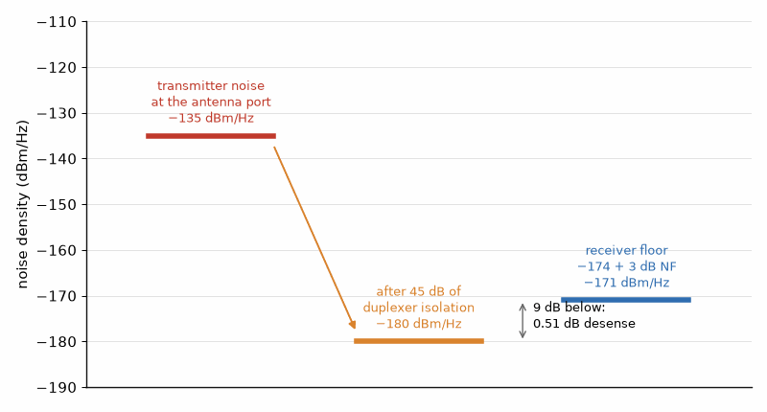
Figure 34.1 — Transmitter noise in the receive band (Worked Example 34.1). 45 dB of duplexer isolation brings −135 dBm/Hz down to −180 dBm/Hz, 9 dB below the receiver's −171 dBm/Hz floor, for 0.51 dB of desense.

Worked Example 34.1
Problem. An FDD receiver has a 3 dB noise figure. The transmitter's noise in the receive band is −135 dBm/Hz at the antenna port. What duplexer isolation at the receive frequency keeps the leak 9 dB below the receiver floor, and what is the desense?
Solution. The receiver floor is −174 + 3 = −171 dBm/Hz. The leak must be −180 dBm/Hz, so the isolation must be −135 − (−180) = 45 dB. The desense is 10 log10(1 + 10^(−0.9)) = 0.51 dB. With only 40 dB of isolation, the leak would be −175 dBm/Hz, 4 dB below the floor, and the desense would grow to 1.46 dB.
Key idea. In FDD, transmitter noise that lands in the receive band cannot be filtered at the receiver, so the duplexer's isolation at the receive frequency sets how much sensitivity the transmitter costs.

34.3 The transmit carrier as a blocker
The transmitter's carrier, attenuated by the duplexer's isolation at the transmit frequency, arrives at the LNA as a strong blocker just outside the receive band. It can compress the LNA, generate intermodulation with other signals, and, mixed with the oscillator's phase noise as in Chapter 25's reciprocal mixing, raise the noise floor. Its own modulation can also leak through second-order nonlinearity in a direct-conversion receiver, creating a baseband interferer. The receiver's linearity must be specified against this known blocker.

Worked Example 34.2
Problem. A handset transmits 25 dBm. The duplexer provides 50 dB of isolation at the transmit frequency. What carrier power reaches the LNA, and what does that imply?
Solution. 25 − 50 = −25 dBm at the LNA input. The LNA's input compression point must be well above −25 dBm, typically by 10 dB or more, and its IIP3 must keep intermodulation between this carrier and other blockers below the noise floor. A receiver that was designed for weak signals alone would be overloaded by its own transmitter.

34.4 Full duplex on one frequency
Transmitting and receiving at once on the same frequency, full duplex, would double spectral efficiency, but the receiver must then remove its own transmitted signal almost completely. The cancellation is done in stages: antenna separation or a circulator gives a few tens of decibels, an analog canceller that subtracts a tapped copy of the transmit signal gives more, and a digital canceller that models the residual channel and nonlinearities removes the rest. Each stage must track changes in the antenna and environment. Full duplex is used today in some cable systems and in-band relays, and it remains a research topic for cellular radios. The ferrite circulator of Chapter 15 is the passive starting point, and its leakage paths are worked there.

Worked Example 34.3
Problem. A full-duplex radio transmits 25 dBm and receives in a 20 MHz channel with a 5 dB noise figure. How much self-interference cancellation brings its own signal down to the noise floor?
Solution. The noise floor is −174 + 10 log10(2 × 10⁷) + 5 = −96 dBm. The cancellation must be 25 − (−96) = 121 dB, all in the same band as the wanted signal, which is why it must combine passive isolation, analog cancellation, and digital cancellation, each contributing a few tens of decibels.
From the Bench
Budget the transmitter's noise in the receive band as carefully as the transmit carrier. A clean-looking transmitter can still put −135 dBm/Hz into the receive channel, and only the duplexer stops it. Measure desense with the transmitter on at full power, on every band combination you support. Carrier aggregation and multiple antennas multiply the cases, so automate the test.

Practice
1. Find the receiver noise floor in dBm/Hz for a 4 dB noise figure.
2. A transmitter's noise leak is 6 dB below the receiver floor. Find the desense.
3. A transmitter at 23 dBm, 10 MHz channel, receiver noise figure 4 dB. How much cancellation does full duplex need?
4. The duplexer gives 55 dB of transmit-band isolation. What blocker reaches the LNA from a 28 dBm transmitter?
5. Why does TDD need less duplexer isolation than FDD?
6. Why can't the receiver simply filter the transmitter's noise in the receive band?

What You’ll Actually Use
Everyday working tools
- Duplexer isolation from transmitter noise and the receiver floor.
- Desense 10 log(1 + leak/floor).
- The transmit carrier as a blocker at the LNA.
Mostly for exams and deeper study
- Self-interference cancellation algorithms.

Chapter 35. Designing Class E and Class F Amplifiers
In 1975 Nathan and Alan Sokal published an amplifier whose transistor switches on only after the voltage across it has fallen to zero, with zero slope. The switch never discharges a capacitor through itself, so in theory it wastes nothing. In practice class E reaches 70 to 85 % at a few gigahertz, if the designer respects its peak voltage of 3.56 times the supply.
Where you meet this: Wireless-power transmitters, RFID readers, constant-envelope transmitters, plasma generators, and the saturated stages of polar transmitters.
Chapter 22 introduced the switching and harmonic-tuned classes as ideas. This chapter designs them. Both aim at the same thing, a drain voltage and current that never overlap, so that the device dissipates almost nothing, but they reach it differently. Class E shapes the voltage with a shunt capacitor and a tuned load so that the switch closes at zero voltage and zero slope. Class F shapes it with harmonic terminations so that the voltage is nearly square and the current nearly a half sine. The design equations below are the standard ones from Sokal's and Raab's work.

35.1 The class E conditions
In class E the transistor acts as a switch, on for half of each cycle. A capacitor across the switch, which may be partly or wholly the device's own output capacitance, charges while the switch is off, and a series resonant load with some excess inductance shapes the voltage so that it returns to zero, with zero slope, just as the switch closes. No energy stored in the capacitor is dumped into the switch, which is the loss that ruins a hard-switched amplifier at high frequency. For a 50% duty cycle and an ideal switch, the design equations fix the load resistance, the shunt capacitance, and the excess reactance in terms of the supply and the output power.
R = 0.5768 VDD²/P, C = 0.1836/(ωR), Xexcess = 1.1525 R, vpk = 3.562 VDD, ipk = 2.862 IDC
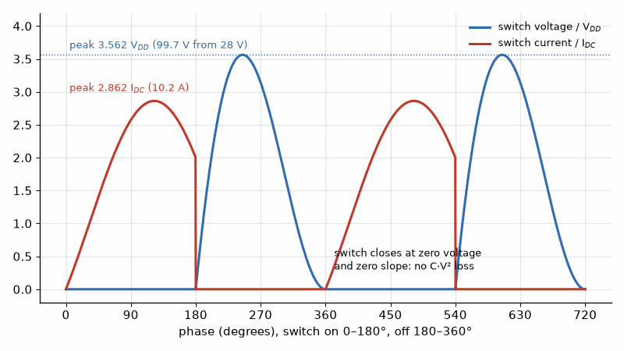
Figure 35.1 — Ideal class E waveforms. The switch closes when its voltage has returned to zero with zero slope; the voltage peaks at 3.562 VDD and the current at 2.862 IDC, 99.7 V and 10.2 A in Worked Example 35.1.

Worked Example 35.1
Problem. Design a class E stage for 100 W at 900 MHz from a 28 V supply. Find the load resistance, the shunt capacitance, the excess reactance, the peak switch voltage, and the peak current.
Solution. R = 0.5768 × 28² / 100 = 4.52 Ω. C = 0.1836 / (2π × 9 × 10⁸ × 4.52) = 7.18 pF. The excess reactance is 1.1525 × 4.52 = 5.21 Ω, an inductance of 0.92 nH at 900 MHz. The DC current is 100 / 28 = 3.57 A, so the peak current is 2.862 × 3.57 = 10.2 A, and the peak voltage is 3.562 × 28 = 99.7 V. The device must withstand about 100 V, which is why class E at this power suits GaN with its high breakdown voltage.
Key idea. Class E avoids switching loss by arranging for the switch voltage to fall to zero, with zero slope, at the instant the switch closes. The price is a peak voltage about 3.6 times the supply.

35.2 The frequency limit
The shunt capacitance in Example 35.1 must be at least the device's own output capacitance, because that capacitance is always there. The maximum frequency at which class E works at full power is therefore the one where the required C equals Cout. Above it, the design must reduce power, use a smaller device, or move to a different class. The power output capability, P/(vpk ipk), is 0.098 for class E against 0.125 for class B, so for the same device stresses class E delivers a little less power.
fmax = 0.1836/(2π R Cout), cp = P/(vpk ipk) = 0.0981

Worked Example 35.2
Problem. The device in Example 35.1 has an output capacitance of 10 pF. What is the highest frequency for the design?
Solution. fmax = 0.1836 / (2π × 4.52 × 10⁻¹¹) = 646 MHz. At 900 MHz the 10 pF device has more capacitance than the design allows, so the designer must accept less than 100 W, use a smaller device with less capacitance, or move to a class E variant or a different class.

35.3 Class F and its inverse
Class F leaves the device acting as a current source, as in class B, but presents short circuits at the even harmonics and open circuits at the odd ones. The current then contains the fundamental and even harmonics, approaching a half sine; the voltage contains the fundamental and odd harmonics, approaching a square wave. Neither waveform needs to be perfect: each added harmonic raises the efficiency. Inverse class F swaps the roles, a square current and a half-sine voltage, and suits devices whose voltage swing is limited by the knee. In practice, controlling the second and third harmonics captures most of the benefit.
η = ½ (V1/VDD)(I1/IDC)

Worked Example 35.3
Problem. Find the maximum drain efficiency of an ideal class F amplifier whose voltage contains the fundamental and the third harmonic and whose current contains the fundamental and the second harmonic. Compare with half-sine current.
Solution. With a third harmonic, the largest fundamental voltage that keeps the waveform non-negative is V1/VDD = 2/√3 = 1.155. With a second harmonic, the largest fundamental current is I1/IDC = √2 = 1.414. The efficiency is ½ × 1.155 × 1.414 = 81.6%. With the full half-sine current, I1/IDC = π/2, it rises to ½ × 1.155 × 1.571 = 90.7%. For comparison, class B, with no voltage harmonics, gives π/4 = 78.5%, and controlling only the second harmonic of the current with a sinusoidal voltage gives 70.7%.

35.4 Practical harmonic terminations
Real terminations are made with transmission-line stubs or lumped resonators placed at the device's internal current source, which means compensating for its output capacitance and package parasitics. At microwave frequencies only the first two or three harmonics can be controlled, and the device's capacitance shorts the higher ones anyway, which partly helps. Load-pull measurements at the fundamental and harmonics show how sensitive the efficiency is to each termination. Continuous class F and continuous class B/J modes relax the terminations so that high efficiency holds over a band, not only at one frequency.
Where this continues. Chapter 43 is a cookbook of complete designs class by class, including a 10 W class E stage at 6.78 MHz for wireless power and a class F stage with its quarter-wave stub at 2.45 GHz, each with a bipolar note.
From the Bench
Check the device's breakdown voltage first: class E puts about 3.6 VDD across the switch, so a 28 V design needs a transistor rated well above 100 V. Then look up its output capacitance; if that exceeds what the design allows at your frequency, the textbook design won't fit. Tune by watching the drain waveform, or the efficiency if you can't probe the drain, rather than by trusting the calculated values.

Practice
1. Design a class E stage for 10 W from a 12 V supply at 13.56 MHz. Find R and C.
2. What peak voltage must the switch in the previous problem withstand?
3. Find the maximum frequency for a 4.52 Ω class E design if Cout = 5 pF.
4. What is the efficiency of a class F amplifier with half-sine current and voltage limited to the fundamental?
5. Why does class E suit GaN devices?
6. Why does controlling a few harmonics capture most of class F's benefit?

What You’ll Actually Use
Everyday working tools
- Class E design factors for R, C, and the excess reactance.
- Peak switch voltage 3.56 VDD and current 2.86 IDC.
- Frequency limit from device output capacitance.
Mostly for exams and deeper study
- Class E design equations for duty cycles other than 50 %.

Chapter 36. Envelope Tracking, Polar, and Outphasing
Why does a base-station amplifier spend most of its time at less than half its rated efficiency? Because its signal sits 8 dB below the peaks on average. Henri Chireix in 1935 and Leonard Kahn in 1952 offered two different cures: combine two constant signals at a varying angle, or make the supply follow the signal.
Where you meet this: Envelope-tracking chips in phones, average-power tracking, polar transmitters, outphasing amplifiers, and every base station chasing efficiency at average power.
Chapter 23 showed that an amplifier with a fixed supply wastes most of its power when the signal's average sits well below its peak, and that the Doherty amplifier recovers some of that efficiency. This chapter takes up the other families of efficiency enhancement. Envelope tracking and polar transmitters change the supply voltage with the signal's envelope. Outphasing transmitters keep each amplifier saturated and create amplitude by combining two constant-envelope signals at varying phase. Each trades efficiency against bandwidth, linearity, and complexity.

36.1 Why back-off is expensive
An OFDM signal of Book 5 has a peak-to-average power ratio, PAPR, of 8 to 10 dB even after crest-factor reduction. An amplifier must handle the peak, so on average it runs 8 to 10 dB below its saturated power. A class B stage's efficiency falls with the square root of the output power, so at 8 dB back-off its ideal efficiency is 78.5% × 10^(−8/20) = 31%. Most of the supply power is heat.

36.2 Envelope tracking
An envelope-tracking transmitter drives the amplifier's supply from a fast modulator that follows the signal envelope, keeping the amplifier near compression at every instant. The amplifier still receives the full RF signal, amplitude and phase, so it remains a linear amplifier, but its supply voltage, and therefore its dissipation, falls with the envelope. The overall efficiency is the product of the amplifier's efficiency near compression and the modulator's efficiency. The modulator is the hard part: it must deliver watts with high efficiency and a bandwidth several times the signal's, because the envelope is a nonlinear function of the I and Q signals and is broader than either.
ηtotal = ηPA × ηmodulator, Benvelope ≈ 3 to 5 × Bsignal

Worked Example 36.1
Problem. A transmitter delivers 10 W average with an 8 dB PAPR. A fixed-supply class B stage achieves its ideal back-off efficiency; an envelope-tracking design holds the amplifier at 65% with an 85% modulator. Compare the supply power.
Solution. Fixed supply: 31.25% efficiency, so 10 / 0.3125 = 32.0 W of supply power and 22 W of heat. Envelope tracking: 0.65 × 0.85 = 55.3%, so 10 / 0.5525 = 18.1 W and 8.1 W of heat. The envelope tracker cuts the supply power by 43% and the heat by almost two-thirds.
Key idea. Envelope tracking keeps the amplifier near compression by lowering its supply when the signal is small. Its gain depends on a supply modulator that is both efficient and several times wider in bandwidth than the signal.

36.3 Polar transmitters and EER
Kahn's envelope elimination and restoration, and the modern polar transmitter, go further. The phase is applied to a constant-envelope RF signal that drives a switching amplifier, class E or D, into saturation, and the amplitude is restored by modulating its supply. The amplifier can then be as efficient as Chapter 35's designs, but the amplitude and phase paths must be aligned in time to a small fraction of the symbol period, and the amplitude path must reach down to zero without distortion. Polar transmitters work well for narrowband signals; for 100 MHz OFDM, the envelope bandwidth of several hundred megahertz is beyond an efficient supply modulator.

Worked Example 36.2
Problem. A 100 MHz 5G carrier is to be envelope-tracked. Estimate the bandwidth the supply modulator needs.
Solution. With the rule of thumb of three to five times the signal bandwidth, the modulator needs 300 to 500 MHz. Efficient switching supplies reach tens of megahertz, so wideband trackers combine a fast linear amplifier with a slower switcher; the linear part's lower efficiency pulls ηmodulator down. This is why handset envelope trackers are common for LTE and 5G channels up to about 100 MHz but are hard to extend to wider channels.

36.4 Outphasing
Chireix's outphasing transmitter splits the signal into two constant-envelope components whose phases are offset by ±φ. Each drives a saturated, efficient amplifier, and a combiner adds them; the sum's amplitude is proportional to cos φ, so the output power is Pmax cos²φ. A simple isolating combiner wastes the difference power in its load, so efficient outphasing uses a non-isolating Chireix combiner with compensating reactances, which lets each amplifier see a load that changes with φ. The efficiency then peaks at full power and at a chosen back-off, much as in a Doherty amplifier.
Pout = Pmax cos² φ, back-off (dB) = −20 log10 cos φ
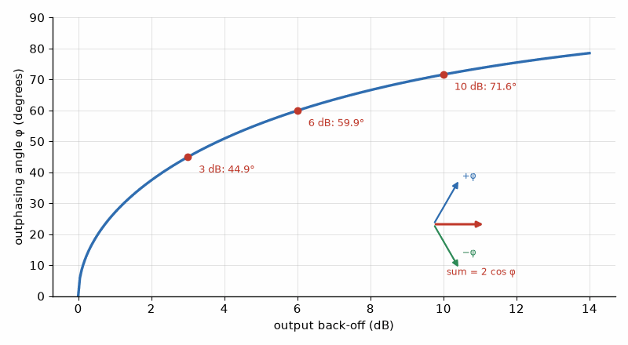
Figure 36.1 — Outphasing: two constant-amplitude signals at ±φ add to 2 cos φ. Backing off 3, 6, and 10 dB needs angles of 44.9°, 59.9°, and 71.6°.

Worked Example 36.3
Problem. Find the outphasing angle for 3, 6, and 10 dB of back-off.
Solution. cos φ = 10^(−back-off/20). For 3 dB, cos φ = 0.708 and φ = 44.9°. For 6 dB, cos φ = 0.501, φ = 59.9°, essentially 60°. For 10 dB, cos φ = 0.316 and φ = 71.6°. The phase modulators must therefore cover angles up to about 70° to 80° with precision, because small phase errors near large angles produce large amplitude errors.

36.5 Choosing an architecture
In 2026 the Doherty amplifier dominates base stations, where moderate bandwidth, robust linearity with predistortion, and no extra supply circuitry suit the job. Envelope tracking dominates handset power amplifiers, where the supply modulator can be integrated and the signals are narrower. Outphasing and polar transmitters appear in research and some niche products, and digital transmitters that combine switching amplifiers with digital control of amplitude and phase are a growing area. All of them rely on the digital predistortion of Chapter 23 to meet the emission masks of Book 7.
From the Bench
Envelope tracking is a system problem. The supply modulator, the amplifier, the delay alignment, and the predistortion have to be designed together, and a few nanoseconds of misalignment between envelope and RF costs both efficiency and ACLR. Check the modulator bandwidth against the signal bandwidth (three to five times is the rule of thumb) before you settle on the architecture.

Practice
1. Find the ideal class B efficiency at 10 dB back-off.
2. An ET system has a 70% amplifier and an 80% modulator. Find the total efficiency.
3. Find the outphasing angle for half power.
4. A 20 MHz LTE carrier is envelope-tracked. Estimate the tracker bandwidth.
5. Why does a polar transmitter struggle with wideband signals?
6. Why does a simple isolating combiner make outphasing inefficient?

What You’ll Actually Use
Everyday working tools
- Average efficiency with a fixed vs a tracking supply.
- Modulator bandwidth three to five times the signal's.
- Outphasing angle from cos φ = amplitude ratio.
Mostly for exams and deeper study
- Chireix compensation network analysis.

Chapter 37. Measuring a Power Amplifier
A data sheet says 62.5 % efficiency. Your stage has only 6 dB of gain, the drive power it needs comes off that number, and the power-added efficiency is 46.9 %. Measuring a power amplifier honestly means knowing which number you are quoting, and under what signal.
Where you meet this: Load-pull benches, amplifier data sheets, certification reports, and the efficiency and ACLR numbers in every customer specification.
The earlier chapters designed amplifiers from load lines and device models. The amplifier on the bench rarely matches the model exactly, and the numbers that go into a datasheet, a link budget, or a certification report must be measured. This chapter describes the four measurements that characterize a power amplifier: load-pull, which finds the best load; efficiency, which counts the watts; AM-AM and AM-PM, which describe the distortion; and adjacent-channel leakage, which tells the regulator how much of the signal leaks next door.

37.1 Load-pull
Chapter 21 found the optimum load resistance from the supply voltage, the knee voltage, and the output power. A real transistor has parasitic capacitance and package inductance, so the best load at the device's terminals is a complex impedance that the model only approximates. A load-pull system places a tuner, mechanical or active, at the transistor's output, sweeps the load impedance across the Smith chart, and records output power, efficiency, and gain at each point. The results form contours: closed curves of constant output power and of constant efficiency, whose optima are generally at different impedances. The designer chooses a compromise load and then designs a matching network of the kind built in Chapters 3 and 4 to present it.
Ropt ≈ (VDD − Vknee)² / (2 Pout)

Worked Example 37.1
Problem. A GaN transistor runs at VDD = 28 V with a knee of 3 V and must deliver 10 W. Find the load-line starting point for the load-pull sweep.
Solution. Ropt = (28 − 3)²/(2 × 10) = 625/20 = 31.25 Ω. The load-pull sweep is centered near 31 Ω plus the conjugate of the output capacitance's susceptance, and the measured contours then show how far the true optimum lies from that estimate.

37.2 Efficiency and power-added efficiency
Drain efficiency is the ratio of RF output to DC input. Power-added efficiency subtracts the RF input power, which matters when the gain is modest, as it is at millimeter wave or near compression. Both must be measured with the amplifier's real signal, not only a continuous wave, because modulated signals spend most of their time below peak, where efficiency is lower, as Chapter 23 showed.
ηD = Pout / PDC, PAE = (Pout − Pin) / PDC
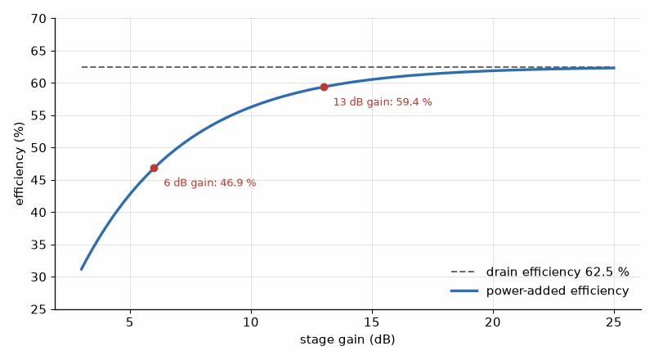
Figure 37.1 — Power-added efficiency against stage gain, for a drain efficiency of 62.5 %. At 13 dB of gain PAE is 59.4 %; at 6 dB it falls to 46.9 %.

Worked Example 37.2
Problem. An amplifier delivers 40 dBm with 13 dB of gain from a 16 W DC input. Find the drain efficiency and the PAE.
Solution. Pout = 10 W and Pin = 40 − 13 = 27 dBm = 0.50 W. ηD = 10/16 = 62.5%, and PAE = (10 − 0.5)/16 = 59.4%. With only 6 dB of gain, PAE would fall to (10 − 2.5)/16 = 46.9%, which is why PAE is the honest figure for low-gain stages.

37.3 AM-AM and AM-PM
As the input rises toward compression, the gain falls (AM-AM conversion) and the phase of the output shifts (AM-PM conversion). Both are measured by sweeping the input power and recording the gain and phase, or, with a modulated signal, by comparing every output sample with the corresponding input sample. They are the curves digital predistortion, the subject of Chapter 38, must invert. Each contributes directly to the error vector magnitude of Book 5.

Worked Example 37.3
Problem. At the peak of a signal, the amplifier is 1 dB compressed and shifts the phase by 5°. Estimate the error vector each causes at that peak.
Solution. The amplitude error is 1 − 10^(−1/20) = 10.9% of the peak. The phase error is 5° = 0.087 rad, which displaces the vector by 8.7% of its length. Together they are far above the 1.26% that Book 5 quotes for high-order QAM, which is why such peaks must be corrected or backed off.
Key idea. Load-pull measures the load that the model only estimates; PAE counts the drive power that drain efficiency ignores; AM-AM and AM-PM curves describe the distortion that predistortion must undo.

37.4 Adjacent-channel leakage and intermodulation
Distortion spreads the signal's spectrum into the neighboring channels. The adjacent-channel leakage ratio is the power in the wanted channel divided by the power in an adjacent channel of the same width, measured on a spectrum analyzer with channel-power integration. 3GPP requires about 45 dB for a base station and 30 dB for a handset in NR. A two-tone test gives a simpler figure, the third-order intercept, from which the third-order products follow: each output tone's product lies below the tone by twice the difference between the intercept and the tone power.
ACLR = Pmain / Padjacent, P_IM3 = 3Pout − 2 OIP3 (dBm)

Worked Example 37.4
Problem. An amplifier with OIP3 = 50 dBm delivers two tones of 30 dBm each. Find the third-order products and their level relative to the tones.
Solution. P_IM3 = 3 × 30 − 2 × 50 = −10 dBm, which is 40 dB below each tone. Every 1 dB of back-off improves that ratio by 2 dB, until other mechanisms, such as memory effects, dominate.
Measure it yourself. Book 9, Test and Measurement Instruments, treats each measurement of this chapter as an instrument procedure: "Scalar Analysis, Amplifier Test, and Load Pull", "RF Power Meters and Sensors", and "Transmitter Spectrum: Channel Power, ACLR, Emission Masks, and CCDF". Scripting the sweeps is covered in its "SCPI, VISA, IVI, and Programming Instruments in Python and C#".
From the Bench
State the conditions with every number: signal type and PAPR, frequency, supply, temperature, and whether the efficiency is drain or PAE. Calibrate power meters and spectrum analyzers at the device's reference plane, and measure ACLR with the specified bandwidth and filter. On a load-pull bench the tuner's own loss limits how low an impedance it can present, so make sure the optimum you found isn't simply the edge of the tuner's range.
On the Job
PA characterization engineers measure what the designers promised: load-pull contours, efficiency and PAE across supply and temperature, AM-AM and AM-PM, ACLR and EVM with real signals, and ruggedness into high VSWR. Much of the work is automation, sequencing instruments in Python or a test executive, and much is skepticism, finding the cable loss or the calibration step that made a number look too good. The role sits at semiconductor companies, module makers, and base-station vendors, and it is a common route into PA design.

Practice
1. Find Ropt for VDD = 48 V, Vknee = 4 V, and 50 W.
2. Find the PAE of an amplifier delivering 20 W with 10 dB gain from 32 W DC.
3. Find the amplitude error at 2 dB compression.
4. Find the IM3 level for 25 dBm tones and OIP3 = 45 dBm.
5. A channel at 30 dBm has −16 dBm in the adjacent channel. Find the ACLR.
6. By how much does a 3 dB back-off improve the two-tone IM3 ratio?

What You’ll Actually Use
Everyday working tools
- PAE = (Pout − Pin)/PDC.
- AM-AM and AM-PM as contributors to EVM.
- IM3 and ACLR, and how back-off changes them.
Mostly for exams and deeper study
- Behavioral model extraction from load-pull data.

Chapter 38. Digital Predistortion
How can a few lines of arithmetic in a digital chip make a nonlinear amplifier behave linearly? By distorting the signal first, in exactly the opposite direction. Where the amplifier compresses, the predistorter expands, and the combination stays straight until the amplifier runs out of output.
Where you meet this: Base-station transmitters, broadcast and satellite amplifiers, and a growing share of handset and Wi-Fi power amplifiers.
Chapter 23 showed that a linear amplifier must back off from compression, and that back-off costs efficiency. Digital predistortion recovers much of that efficiency. A digital block ahead of the transmitter distorts the signal in exactly the opposite way to the amplifier, so that the cascade of the two is linear. Every modern base station and many handsets use it. This chapter explains the model, the observation path that trains it, and the efficiency it buys.

38.1 The idea
If the amplifier compresses its peaks, the predistorter expands them; if the amplifier advances the phase at high amplitude, the predistorter retards it. In the simplest, memoryless case, the predistorter is a lookup table indexed by the input amplitude, holding the inverse of the AM-AM and AM-PM curves measured in Chapter 37. The correction cannot exceed the amplifier's saturated power: no predistorter can make an amplifier deliver more than its maximum, so the peaks of the signal must still fit below saturation, usually with help from crest-factor reduction.
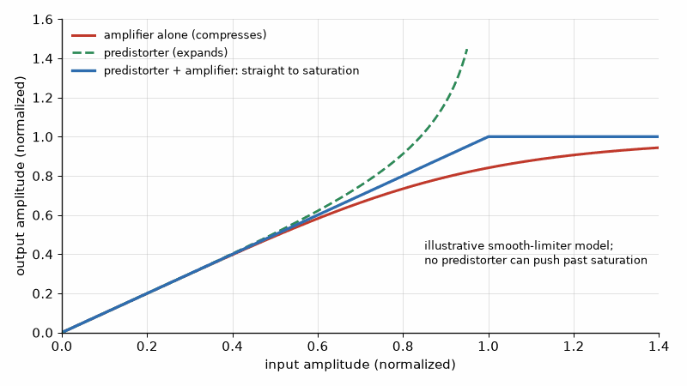
Figure 38.1 — The idea behind predistortion (illustrative model). The amplifier compresses, the predistorter expands by the same amount, and together they stay straight up to saturation, but not beyond it.

38.2 Memory and the memory polynomial
Wideband amplifiers have memory: their output depends on recent inputs as well as the present one, because of bias-network impedances, thermal changes, and trapping in GaN. A memoryless table then leaves residual distortion that grows with bandwidth. The memory polynomial models the amplifier, or its inverse, as a sum over nonlinear orders k and delays q, with complex coefficients fitted to measured data. With K orders and M delays it has K × M coefficients, a small number that a least-squares solver updates continuously.
y(n) = Σ_k Σ_q a_kq x(n − q) |x(n − q)|^(k − 1)

Worked Example 38.1
Problem. A memory polynomial uses orders k = 1 to 5 and memory depth M = 4. How many complex coefficients does it have, and how many if only odd orders are kept?
Solution. All orders give 5 × 4 = 20 coefficients. Odd orders only, k = 1, 3, 5, give 3 × 4 = 12. Including even orders usually improves the fit for real amplifiers, at a modest cost in computation.

38.3 The observation receiver
To fit the coefficients, the transmitter samples its own output through a coupler and an observation receiver, aligns the samples in time and amplitude with the input, and solves for the coefficients. Indirect learning fits the inverse directly, treating the amplifier's output as the input of a postdistorter whose coefficients are then copied to the predistorter. Because third-order distortion spreads the spectrum to three times the signal bandwidth, and fifth-order to five times, the observation path must capture several times the signal bandwidth, which sets the speed of its converters.
B_observation ≈ K × B_signal (K = highest odd order corrected)

Worked Example 38.2
Problem. A 100 MHz NR carrier is linearized up to fifth order. Find the observation bandwidth needed.
Solution. Fifth-order products extend over five times the signal bandwidth, so the observation receiver must capture about 500 MHz, and its ADC must sample at least that fast for complex sampling. This is one reason DPD for 400 MHz millimeter-wave carriers is difficult, and why those systems often use simpler schemes.
Key idea. Digital predistortion applies the inverse of the amplifier's nonlinearity and memory, fitted continuously from an observation receiver that captures several times the signal bandwidth. It linearizes the amplifier so that it can run closer to saturation.

38.4 What DPD buys
Without DPD a base-station amplifier might need 9 dB of back-off from its peak to meet ACLR; with DPD and crest-factor reduction, perhaps 6 dB. For an ideal class B amplifier, efficiency at back-off falls as π/4 times the voltage ratio, so the 3 dB change is substantial, and in a Doherty amplifier the gain is even greater because DPD corrects the Doherty's own nonlinearity, which would otherwise rule it out for linear signals.
η_classB(BO) = (π/4) × 10^(−BO/20)

Worked Example 38.3
Problem. Compare the ideal class B efficiency at 9 dB and at 6 dB of back-off.
Solution. At 9 dB, η = 0.785 × 0.355 = 27.9%. At 6 dB, η = 0.785 × 0.501 = 39.4%. DC power for the same average output falls by a factor of 39.4/27.9 = 1.41, a 29% reduction in the power the station draws for its amplifiers, before any Doherty improvement.

38.5 Practical limits
DPD adds a digital block, an observation receiver, and training software, which pay for themselves in base stations but are marginal in low-power devices. It cannot correct noise or distortion that originates before the amplifier, and it must track changes in temperature, supply, and load, the antenna mismatch of Chapter 31 included. Envelope-tracking transmitters of Chapter 36 depend on it, because the supply modulation itself creates distortion that only DPD removes.
Code. A memory-polynomial fit is a least-squares problem of a few dozen complex unknowns; the fixed-point arithmetic that runs it in real time is in Book 8, Firmware and Software for Electronics, "Fixed-Point Math and DSP".
From the Bench
DPD can't correct what its observation receiver can't see. Make sure that receiver captures five times the signal bandwidth for fifth-order products, and that its own linearity and noise beat the target. DPD can't push past saturation either, so pair it with crest-factor reduction. Check that the correction holds over temperature and power steps; memory effects from bias networks show up as asymmetric sidebands that a memoryless model leaves behind.

Practice
1. How many coefficients does a memory polynomial with K = 7 and M = 3 have?
2. Find the observation bandwidth for a 20 MHz carrier linearized to fifth order.
3. Find the ideal class B efficiency at 8 dB back-off.
4. Find the ideal class B efficiency at 0 dB back-off.
5. Why can a predistorter not raise the saturated power?
6. Name two physical causes of memory in a power amplifier.

What You’ll Actually Use
Everyday working tools
- Predistortion as the inverse of the AM-AM and AM-PM curves.
- Observation bandwidth five times the signal for fifth order.
- DPD plus crest-factor reduction to run closer to saturation.
Mostly for exams and deeper study
- Volterra series and generalized memory-polynomial theory.

Chapter 39. Frequency Synthesis: Fractional-N and DDS
A 40 MHz reference with a 24-bit fractional accumulator tunes in steps of 2.38 Hz, finer than any channel plan needs. Modern synthesizers get fine steps and low noise together by dividing by a number that changes from one cycle to the next, and then shaping the resulting error out of the band.
Where you meet this: Every phone and Wi-Fi local oscillator, signal generators, radar chirp sources, and test-equipment frequency references.
Chapter 26 introduced the phase-locked loop and its phase noise. A real radio needs more than one frequency: it must tune to any channel in its band in fine steps, quickly, with low spurs. This chapter describes the two main ways to make such a frequency: the fractional-N PLL, which multiplies a reference by a number that need not be an integer, and direct digital synthesis, which computes the waveform sample by sample. It then compares their noise and spurs.

39.1 Integer-N and its limits
An integer-N PLL produces fout = N × fref, so the channel step equals the reference frequency at the phase detector. Fine steps need a low reference, and a low reference forces a narrow loop bandwidth, for stability, and a large N. Both hurt: the narrow loop settles slowly and suppresses the VCO's noise over a smaller range, and the in-band phase noise rises as 20 log N.

39.2 Fractional-N
A fractional-N PLL switches its divider between neighboring integers so that the average division ratio is N + F/2^k, set by a k-bit accumulator. The reference can then be high, and the step is the reference divided by 2^k, which can be a few hertz. The switching pattern creates a periodic phase error that would produce spurs, so it is shaped by a delta-sigma modulator, Book 3's technique, that pushes the error to high offsets where the loop filters it out.
fout = (N + F/2^k) × fref, step = fref/2^k

Worked Example 39.1
Problem. A 40 MHz reference and a 24-bit fractional accumulator must produce 2441.5 MHz. Find the step, N, and F.
Solution. The step is 40×10⁶/2²⁴ = 2.38 Hz. The ratio is 2441.5/40 = 61.0375, so N = 61 and F = 0.0375 × 2²⁴ = 629,145.6, rounded to 629,146. The rounding leaves an error of 0.4 steps, under 1 Hz.

39.3 In-band phase noise and the figure of merit
Inside the loop bandwidth, the output phase noise is set by the phase detector and charge pump, referred to the output by the multiplication. Datasheets express this with a normalized figure of merit, the noise of a hypothetical 1 Hz loop at a 1 Hz detector rate, from which the in-band noise follows for any detector frequency and ratio. A good modern synthesizer has a figure of merit near −226 to −230 dBc/Hz.
L_in-band ≈ FOM + 10 log₁₀ f_PFD + 20 log₁₀ N (dBc/Hz)

Worked Example 39.2
Problem. With FOM = −226 dBc/Hz, find the in-band phase noise at 2441.5 MHz for a 40 MHz detector frequency and for a 10 MHz detector frequency.
Solution. At 40 MHz, N = 61.04, so L = −226 + 76.0 + 35.7 = −114.3 dBc/Hz. At 10 MHz, N = 244.15, so L = −226 + 70.0 + 47.8 = −108.2 dBc/Hz. Raising the detector frequency by four improves the in-band noise by 6 dB, the 20 log N term outweighing the 10 log f term, which is the main reason fractional-N synthesizers run their detectors as fast as possible.
Key idea. Fractional-N lets the detector run fast while the step stays fine; in-band noise improves 10 log f_PFD for every 20 log N it saves. Delta-sigma control hides the fractional pattern at offsets the loop filters away.

39.4 Direct digital synthesis
A DDS adds a frequency tuning word to a phase accumulator at each clock, converts the top bits of the phase to an amplitude through a lookup table, and drives a DAC. The output frequency is the tuning word times the clock over 2^n, so a 32-bit accumulator with a 1 GHz clock tunes in steps of 0.23 Hz, and the frequency can change at the next clock, with continuous phase. Its limits are spurs: truncating the phase to P bits before the table gives spurs of about −6.02P dBc, and the DAC's own nonlinearity adds more. The output is useful up to about 40% of the clock, beyond which the image near the clock cannot be filtered.
fout = FTW × fclk / 2^n, spur ≈ −6.02 P dBc
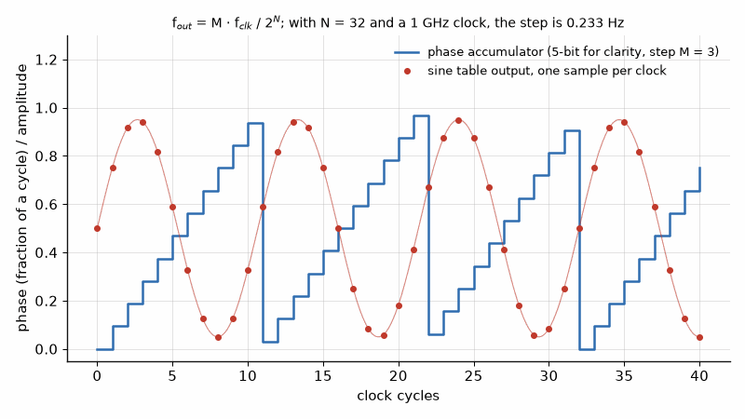
Figure 39.1 — How a DDS works. A phase accumulator adds a step M every clock and wraps around; a sine table turns each phase into one sample. The output frequency is M·fclk/2^N.

Worked Example 39.3
Problem. A DDS uses a 32-bit accumulator, a 1 GHz clock, and 14 bits of phase into the table. Find the step and the phase-truncation spur level, and the highest practical output frequency.
Solution. The step is 10⁹/2³² = 0.233 Hz. The truncation spur is about −6.02 × 14 = −84 dBc. The highest practical output is about 400 MHz. A common architecture uses a DDS as the fine-tuning reference of a PLL, combining the DDS's agility and resolution with the PLL's reach to gigahertz.
Code. A DDS phase accumulator and sine table are a few lines of hardware description; Book 8, Firmware and Software for Electronics, builds one in "HDL: Software That Becomes Hardware".
From the Bench
Run the phase-detector frequency as high as the part allows; the 20 log N term outweighs the 10 log f term, so higher is better. Expect fractional spurs when the fractional value sits near a simple ratio such as 1/2 or 1/4, and plan the frequency plan or dithering around them. In a DDS, the clock's phase noise and spurs carry straight to the output, so clean the clock first.

Practice
1. Find the step of a 50 MHz reference with a 20-bit fractional accumulator.
2. Find N and F for 5800 MHz from a 50 MHz reference with a 20-bit accumulator.
3. Find the in-band noise for FOM = −229 dBc/Hz, f_PFD = 100 MHz, N = 58.
4. Find the DDS step for a 48-bit accumulator and a 2.5 GHz clock.
5. Find the truncation spur for 12 bits of phase.
6. How much does the in-band noise improve when f_PFD doubles at fixed fout?

What You’ll Actually Use
Everyday working tools
- Fractional-N: N + F/2^k and step size f_ref/2^k.
- In-band noise from the figure of merit.
- DDS step f_clk/2^N and truncation spurs.
Mostly for exams and deeper study
- Sigma-delta modulator noise-shaping theory.

Chapter 40. Power Detection and Power Control
A power detector that reads correctly into a 50 Ω load can be wrong by almost half a decibel into a real antenna. With 20 dB of coupler directivity and an antenna at 6 dB return loss, the reading lands anywhere from +0.42 to −0.45 dB off, depending on phase. Power control is only as good as its coupler.
Where you meet this: Transmit power control in every phone and base station, regulatory power limits, SAR back-off, and the closed loop behind every output-power specification.
A transmitter must know how much power it is sending. Regulators cap it, link budgets assume it, RF-exposure limits from Chapter 33 depend on it, and cellular networks command each handset to raise or lower it many times a second. This chapter describes how a transmitter measures its own output with a coupler and detector, the errors that measurement suffers, and the control loops that hold the power where it should be.

40.1 The coupler and the detector
A directional coupler, Chapter 9, samples a fixed fraction of the forward wave, for example 20 dB below it, and sends it to a detector. Diode detectors respond to the square of the voltage at low levels, below about −20 dBm, and to its peak at higher levels; logarithmic amplifiers give a voltage proportional to the input in decibels over 60 dB or more; RMS detectors give the true average power regardless of the waveform. An attenuator between coupler and detector places the transmitter's power range inside the detector's range.

Worked Example 40.1
Problem. A 40 dBm transmitter uses a 20 dB coupler and a detector with a range of −30 to 0 dBm. What pad is needed, and over what output range can the power be measured?
Solution. The coupled power at full output is 40 − 20 = 20 dBm, so a 20 dB pad brings it to 0 dBm, the top of the detector's range. The bottom, −30 dBm at the detector, corresponds to 40 − 30 = 10 dBm at the output, a 30 dB control range. A log detector with 60 dB range would extend it to −20 dBm.

40.2 Directivity error
A real coupler also passes a little of the reflected wave to its forward port, suppressed by the coupler's directivity D in addition to the coupling. If the antenna reflects with return loss RL, the leaked reflection adds to or subtracts from the forward sample depending on phase, so the measured power is uncertain by an amount set by RL + D. Good directivity and a good antenna match keep the error small; a mismatched antenna, as from a hand on a phone, can make it large.
error = 20 log₁₀(1 ± 10^(−(RL + D)/20)) dB
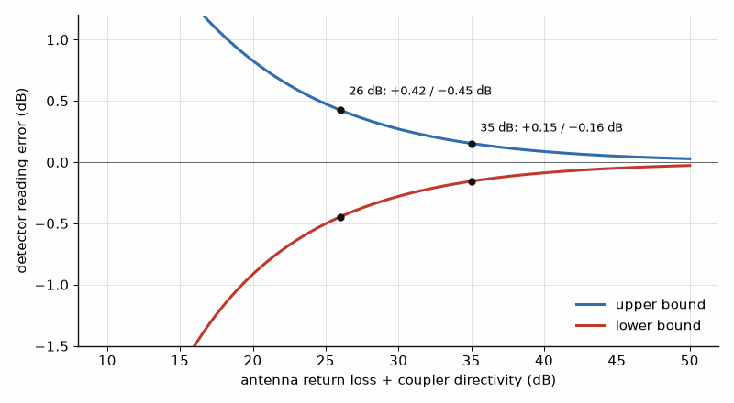
Figure 40.1 — How coupler directivity limits a power reading. With return loss plus directivity of 35 dB the error is within +0.15/−0.16 dB; at 26 dB it widens to +0.42/−0.45 dB.

Worked Example 40.2
Problem. A coupler with 25 dB directivity is used with an antenna whose return loss is 10 dB. Find the measurement uncertainty.
Solution. RL + D = 35 dB, so the leaked wave is 10^(−35/20) = 0.018 of the forward sample in voltage. The error lies between +0.15 dB and −0.16 dB, acceptable for most control loops. With the antenna at 6 dB return loss and 20 dB directivity, the bounds widen to +0.42 and −0.45 dB.
Key idea. A coupler and detector measure the forward power; the error from the coupler's finite directivity grows as the antenna's match worsens. RMS or log detectors are needed for modulated signals with high peak-to-average ratios.

40.3 Detecting modulated signals
A diode detector operated in its peak-responding region reads high for signals with a high peak-to-average ratio, and the error depends on the modulation. OFDM signals, with peak-to-average ratios of 8 to 10 dB, therefore need RMS detectors, or a diode kept in its square-law region, or digital measurement in the observation receiver of Chapter 38, which computes the average power from samples exactly.

40.4 The control loop
Closed-loop power control compares the detected power with a target and adjusts the gain of a variable attenuator or the drive of the amplifier. In cellular systems an outer loop runs through the network: the base station measures the handset's received signal and sends transmit-power-control commands, typically steps of ±1 dB, so that every handset arrives at about the same level and the near-far problem of Book 5's interference chapter is avoided. A handset's output range is large, from about −40 dBm to its maximum of 23 dBm in the common power class, 63 dB in total, so the control must work at low power where the detector is weakest.

Worked Example 40.3
Problem. A handset at 23 dBm receives eight consecutive −1 dB commands. Find its new power, and the factor by which its battery current for the amplifier might fall if the amplifier's efficiency stayed constant.
Solution. The power falls to 23 − 8 = 15 dBm, from 200 mW to 31.6 mW, a factor of 6.3. In practice efficiency falls at back-off, so the current falls by less unless the supply is reduced too, which is the purpose of the envelope-tracking and average-power-tracking supplies of Chapter 36.
Measure it yourself. Thermal, diode, and log power sensors, and their errors with modulated signals, are compared in Book 9, Test and Measurement Instruments, "RF Power Meters and Sensors".
One question remains open from Chapters 22, 23, 35, and 36: how the amplifier classes compare when they are set side by side, and how far the supply itself can be made to work for efficiency, including rising above its nominal rail on the signal's peaks. Chapter 41 closes Part II with that comparison, a complete design, and a look back over the whole radio.
From the Bench
Look at the coupler's directivity and the antenna's worst return loss together, because their sum sets the measurement error. Calibrate the detector over temperature and frequency, and decide whether you need peak, average, or true RMS before choosing the part. A logarithmic detector is easy to use but its reading depends on the modulation, so an RMS detector is often the safer choice for OFDM.

Practice
1. A 33 dBm transmitter uses a 30 dB coupler and a detector whose maximum is 0 dBm. What pad is needed?
2. Find the directivity error bounds for RL + D = 40 dB.
3. What is the handset output range from −40 dBm to 23 dBm?
4. Convert 15 dBm to milliwatts.
5. Why does a peak-responding detector read high for OFDM?
6. What does a log detector's output voltage track?

What You’ll Actually Use
Everyday working tools
- Coupled power and pad choice for the detector's range.
- Directivity error 20 log(1 ± 10^(−(RL+D)/20)).
- RMS vs log vs peak detectors.
Mostly for exams and deeper study
- Stability analysis of power-control loops.

Chapter 41. Power Amplifier Classes Side by Side, and Boosting the Supply on Peaks
A handset battery sags from 4.4 V when full to about 3.4 V near empty, and a power amplifier designed for the full battery loses its peaks as it drains. The fix sounds expensive: boost the supply above the battery. It turns out to be cheap, because an OFDM signal rises more than 5 dB above its average only about 4 % of the time.
Where you meet this: Envelope-tracking and boost supplies in phones, base-station supply modulators, and every comparison of power amplifier classes.
The power amplifier has appeared in pieces. Chapter 22 named the classes and gave the conduction-angle formula, Chapter 23 showed what back-off costs and how the Doherty amplifier recovers it, Chapter 35 designed class E and class F stages, Chapter 36 introduced envelope tracking, polar transmitters, and outphasing, and Chapter 38 linearized the result with digital predistortion. This chapter puts the classes side by side on one map, adds the members of the family that the earlier chapters only named, classes D, inverse F, J, the continuous modes, and S, and then turns to the other half of the efficiency problem: the supply.
A transistor's efficiency depends on how close its drain voltage swings to the supply rail, so a supply that follows the signal, switching between rails, tracking the envelope, or rising above its nominal value on the signal's rare peaks, can raise the average efficiency of any class. The chapter ends with a complete design that combines a load, a class, and a boosted, tracking supply, with every number declared.

41.1 The current-source classes and where their efficiency comes from
In classes A, AB, B, and C the transistor acts as a controlled current source, and the class is set by the bias, which fixes the conduction angle α, the part of each cycle during which current flows. The efficiencies follow from two Fourier coefficients of the drain current: its average, which sets the DC power, and its fundamental, which sets the RF power. Take a device whose drain voltage swings by V₁ = VDD around the supply, the full swing allowed by an ideal device with no knee. In class A the current is a full sine of peak Imax about a bias of Imax/2, so IDC = Imax/2 and I₁ = Imax/2. The output power is V₁I₁/2 = VDD Imax/4 and the DC power is VDD Imax/2, an efficiency of exactly 50 %. In class B the current is a half-wave rectified sine of peak Imax. Its average is Imax/π and its fundamental is Imax/2, so the efficiency is (VDD Imax/4)/(VDD Imax/π) = π/4 = 78.5 %. The same fundamental current is delivered from a smaller average current, and that is the whole of class B's advantage. Class C narrows the pulse further, so the average falls faster than the fundamental and the efficiency approaches 100 % as α approaches zero, but the fundamental output falls with it, and the gain falls because a larger drive is needed to reach the same peak current. Chapter 22's formula, repeated below, gives the efficiency for any angle.
class A: IDC = I₁ = Imax/2, η = 50 %; class B: IDC = Imax/π, I₁ = Imax/2, η = π/4
η(α) = (α − sin α) / [4 (sin(α/2) − (α/2) cos(α/2))]
A real device has a knee voltage Vk below which it cannot swing, so V₁ = VDD − Vk and every efficiency above is multiplied by (VDD − Vk)/VDD. For a 28 V gallium nitride device with a 3 V knee that factor is 0.89, so a class B stage reaches at most 70 % before any matching loss. The knee also fixes the optimum load: a class B stage that must deliver P with a swing of VDD − Vk needs Ropt = (VDD − Vk)²/(2P), a relation that returns at the end of this chapter when the supply is allowed to move.
Ropt = (VDD − Vk)² / (2P), η_real = η_ideal × (VDD − Vk)/VDD

Worked Example 41.1
Problem. Find the ideal efficiency at a conduction angle of 150°, between class B and the 120° class C of Worked Example 22.2. What efficiency remains for a 28 V device with a 3 V knee?
Solution. α = 150° = 2.618 rad. The numerator is 2.618 − sin 150° = 2.618 − 0.500 = 2.118. In the denominator, sin 75° = 0.9659 and 1.309 × cos 75° = 1.309 × 0.2588 = 0.3388, so 4 × (0.9659 − 0.3388) = 2.508. The efficiency is 2.118/2.508 = 84.4 %. The knee multiplies it by 25/28 = 0.893, leaving 75.4 %, which is about what a well-matched device delivers at saturation before harmonic tuning.
Key idea. In the current-source classes, efficiency comes from delivering the fundamental current with as little average current as possible. Narrowing the conduction angle does that at a cost in power and gain; the knee voltage takes its share from every class.

41.2 Class D: two switches and a filter
A switching amplifier abandons the current source. In voltage-mode class D, two transistors in a half bridge connect the output node alternately to the supply and to ground, producing a square wave, and a series-tuned filter passes only its fundamental to the load. The fundamental of a square wave between 0 and VDD has an amplitude of (2/π)VDD, so the output power into R is (2VDD/π)²/(2R). An ideal switch has either zero voltage or zero current, so the ideal efficiency is 100 %. The real loss comes from the output capacitance of the switches: every cycle the switch node, with capacitance C equal to the two output capacitances in parallel, is charged to VDD through one switch and discharged through the other, dissipating CVDD² per cycle, whatever the on-resistance. That loss grows in proportion to frequency, which is why voltage-mode class D dominates audio and the high-frequency industrial bands, 6.78 and 13.56 MHz, but not microwave amplifiers. Current-mode class D swaps the roles: it is fed through a choke, its output network is a parallel resonator, and its switches turn on and off at zero voltage, so the output capacitance is absorbed into the resonator instead of being discharged, at the cost of a peak voltage of πVDD.
V₁ = (2/π) VDD, Pout = (2VDD/π)² / (2R), P_Coss = C_node VDD² f

Worked Example 41.2
Problem. A voltage-mode class D stage runs from 50 V into a 12.5 Ω load at 13.56 MHz. Each switch has 20 pF of output capacitance. Find the output power, the capacitive switching loss, and the resulting efficiency. Repeat the loss calculation at 135.6 MHz.
Solution. V₁ = (2/π) × 50 = 31.83 V, so Pout = 31.83²/(2 × 12.5) = 40.5 W. The switch node has 40 pF, so the loss is 40 pF × 50² × 13.56 MHz = 1.36 W, and the efficiency, counting only this loss, is 40.5/41.9 = 96.8 %. At ten times the frequency the loss is 13.6 W and the efficiency falls to 40.5/54.1 = 74.9 %, which is why switching amplifiers above a few hundred megahertz move to class E, where the capacitance becomes part of the network.

41.3 Class E by the equations
Class E, designed in detail in Chapter 35, uses a single switch with a shunt capacitor and a series network tuned slightly above the operating frequency, so that the drain voltage rings back to zero, with zero slope, just as the switch closes. Its design equations fix everything from the supply and the power: the load R = 0.5768 VDD²/P, the shunt capacitance C = 0.1836/(ωR), an excess series reactance of 1.1525 R, a peak drain voltage of 3.562 VDD, and a peak current of 2.862 IDC. The shunt capacitance is the design's frequency limit: the device's own output capacitance must not exceed it, which gives the maximum frequency fmax = 0.1836/(2πR Cout). For a given device, a higher supply raises R and lowers the required C, so high-voltage devices reach higher frequencies in class E, but the peak voltage of 3.56 times the supply must stay inside the device's breakdown.
R = 0.5768 VDD²/P, C = 0.1836/(ωR), X_excess = 1.1525 R, v_pk = 3.562 VDD, i_pk = 2.862 IDC

Worked Example 41.3
Problem. Design a class E stage for 10 W at 2.4 GHz from 12 V. Find R, C, the excess inductance, the peak voltage and current, and the largest device output capacitance that allows the design. Find the Q of an L-network that matches R to 50 Ω.
Solution. R = 0.5768 × 144/10 = 8.31 Ω. With ω = 1.508 × 10¹⁰ rad/s, C = 0.1836/(1.508 × 10¹⁰ × 8.31) = 1.47 pF. The excess reactance is 1.1525 × 8.31 = 9.57 Ω, an inductance of 9.57/ω = 0.63 nH. The peak voltage is 3.562 × 12 = 42.7 V. With IDC = 10/12 = 0.833 A, the peak current is 2.862 × 0.833 = 2.39 A. The device's output capacitance must be below 1.47 pF: a device with 1.5 pF would limit the design to 0.1836/(2π × 8.31 × 1.5 pF) = 2.35 GHz, just short, while one with 1.2 pF reaches 2.93 GHz. The L-network Q is √(50/8.31 − 1) = 2.24.

41.4 Harmonic tuning: class F, inverse F, J, and the continuous modes
Class F, Chapter 35, keeps the transistor a current source but terminates the harmonics so that the voltage and current waveforms do not overlap. Open circuits at the odd harmonics flatten the voltage toward a square wave of peak 2VDD; short circuits at the even harmonics leave the current a half sine. Inverse class F swaps them: the current approaches a square wave and the voltage a half sine with a peak of πVDD, which suits devices with high breakdown, such as gallium nitride, and lowers the current for a given power. With infinitely many harmonics both reach 100 %; with the second and third controlled, as practical networks do, they reach roughly 80 to 90 % in theory and 70 to 80 % in practice at a few gigahertz.
Class J, introduced by Steve Cripps, reaches class B's efficiency and power without a short at the second harmonic. Its fundamental load is Ropt + jRopt and its second-harmonic load a pure reactance, −j(3π/8)Ropt, so the voltage waveform becomes a skewed half sine whose overlap with the current still averages to class B's dissipation. Because a reactive second harmonic is much easier to present over a band than a short, class J and its generalization, the continuous class B/J mode, are the basis of most broadband high-efficiency amplifiers. In the continuous mode a parameter α between −1 and +1 sets the fundamental load to Ropt(1 + jα) and the second harmonic to −j(3π/8)α Ropt, and every member of that family has the same 78.5 % ideal efficiency. A matching network whose impedances drift with frequency along that family keeps the efficiency over an octave. Continuous class F extends the same idea to the third harmonic.
continuous class B/J: Z₁ = Ropt (1 + jα), Z₂ = −j (3π/8) α Ropt, −1 ≤ α ≤ 1

Worked Example 41.4
Problem. A 28 V gallium nitride device with a 3 V knee must deliver 10 W. Find Ropt, the class J fundamental and second-harmonic impedances, and the class B drain efficiency with the knee included.
Solution. Ropt = (28 − 3)²/(2 × 10) = 625/20 = 31.3 Ω. Class J needs Z₁ = 31.3 + j31.3 Ω and Z₂ = −j(3π/8) × 31.3 = −j36.8 Ω. In the continuous mode the fundamental reactance may range from −j31.3 to +j31.3 Ω, with the second-harmonic reactance following in proportion. The efficiency is (π/4)(25/28) = 70.1 %, the same for class B, for class J, and for every point of the continuous family.
Key idea. Harmonic tuning reaches high efficiency by shaping waveforms instead of shortening conduction. Class J shows that the second harmonic need not be shorted, only made reactive in the right proportion, which is what makes broadband efficient amplifiers possible.

41.5 Class S, and the classes that act on the supply
Class S is a switching amplifier driven by a pulse-width-modulated or delta-sigma bit stream, followed by a low-pass filter that recovers the signal. As an RF amplifier it needs switching rates many times the carrier, which limits it to low frequencies, but as an amplifier of the envelope it is exactly the supply modulator that envelope elimination and restoration, Section 36.3, requires: a buck converter whose duty cycle follows the envelope. Classes G and H are the other supply-side classes. Class G switches the amplifier between two or more fixed rails, choosing at each moment the lowest one that still clears the signal's peak; class H, in the audio usage that RF engineers have borrowed, varies the rail continuously to follow the signal. Average power tracking, APT, is the slow version used in handsets: the supply is set once per transmission slot to the lowest value that passes that slot's peaks, so it recovers efficiency when the phone transmits below its maximum power but not at maximum. Envelope tracking, ET, follows the instantaneous envelope, Section 36.2, and envelope elimination and restoration, due to Leonard Kahn in 1952, goes furthest: it drives a saturated, switching amplifier with a constant-envelope phase signal and restores the amplitude entirely through the supply, so the supply modulator carries the full amplitude accuracy of the transmitter.

41.6 Load modulation: the Doherty and Chireix outphasing amplifiers
The supply-side classes keep the load fixed and move the supply. The load-modulation architectures do the opposite. The Doherty amplifier, Section 23.3, lets a peaking amplifier inject current into the main amplifier's load through a quarter-wave inverter, so the main amplifier sees a higher impedance at back-off and saturates earlier, holding its peak efficiency down to a back-off set by the ratio of the two amplifiers' currents. For a peaking amplifier able to supply r times the main amplifier's peak current, that second efficiency peak falls at 20 log₁₀(1 + r) below full power: 6.0 dB for the symmetric Doherty, r = 1, and 9.5 dB for r = 2. Chireix outphasing, Section 36.4, drives two saturated amplifiers with constant-envelope signals of opposite phase offsets and combines them in a non-isolating combiner, so each amplifier sees a load that varies with the outphasing angle. Both architectures pair naturally with digital predistortion, because the load modulation they rely on is itself nonlinear.
Doherty back-off peak: BO = 20 log₁₀(1 + r) dB

Worked Example 41.5
Problem. A signal has a 9.5 dB peak-to-average ratio after crest-factor reduction. Choose the asymmetry of a Doherty amplifier that puts its second efficiency peak at the average power, and compare the ideal efficiency there with a fixed-supply class B stage.
Solution. 20 log₁₀(1 + r) = 9.5 dB gives 1 + r = 2.99, so r ≈ 2: the peaking amplifier must deliver twice the main amplifier's current, typically by making its device twice as large. At the average power the main amplifier is saturated, so the ideal efficiency is 78.5 %. A class B stage at 9.5 dB back-off reaches (π/4) × 10^(−9.5/20) = 0.785 × 0.335 = 26.3 %, three times less.

41.7 The classes compared
Compare each class by its operating mode, ideal efficiency ceiling, typical practical range, linearity, peak drain voltage, and common use. The practical ranges below are orientation, not promises: device, frequency, matching, signal statistics, thermal design, and measurement conditions can move them substantially.
Class A: current source, full conduction; 50 %; 25 to 40 %; the most linear; 2VDD; low-power drivers and measurement amplifiers.
Class AB: current source, slightly more than half the cycle; between 50 and 78.5 %; 50 to 65 % at saturation; good, with gain expansion or compression near the bias point; 2VDD; most linear base-station and handset amplifiers, usually with predistortion.
Class B: current source, half the cycle; 78.5 %; 60 to 70 %; crossover distortion at low drive unless biased slightly into AB; 2VDD; push-pull and the main amplifier of a Doherty.
Class C: current source, less than half the cycle; up to 100 % as the angle shrinks, 89.7 % at 120°; 70 to 80 %; nonlinear, with low gain; 2VDD; constant-envelope FM and the peaking amplifier of a Doherty.
Class D, voltage mode: two switches and a series filter; 100 %; above 90 % at a few megahertz, falling with frequency through capacitive loss; linear only through the supply or pulse-width modulation; VDD across each switch; audio, induction heating, and the 13.56 MHz band.
Class E: one switch with shunt capacitor and tuned load; 100 %; 70 to 85 % up to a few gigahertz; nonlinear, amplitude only through the supply; 3.56VDD; constant-envelope transmitters, wireless power, and the saturated amplifier of polar and EER systems.
Class F and inverse F: current source with harmonic terminations; 100 % with all harmonics, about 80 to 90 % with the second and third; 70 to 80 %; moderate, used saturated; 2VDD for F, πVDD for inverse F; high-efficiency narrowband stages in base stations and satellites.
Class J and continuous modes: current source with reactive harmonic loads; 78.5 %, the same as class B; 60 to 75 % over an octave; similar to class B, with stronger AM-PM; above 2VDD; broadband military and test amplifiers, and wideband base stations.
Class S: switching with pulse-width or delta-sigma drive and a filter; 100 %; limited by switching rate; linear through modulation; VDD; envelope modulators and low-frequency transmitters.
Doherty and outphasing: two amplifiers with load modulation; 78.5 % at full power and at a chosen back-off; 45 to 55 % average with modulated signals; requires predistortion; set by the class of each amplifier; almost every macro base station, for the Doherty.
Supply modulation, classes G and H, APT, ET, and EER: any class with a moving supply; the class's peak efficiency held over the envelope, multiplied by the modulator's efficiency; 40 to 60 % average; requires calibration and usually predistortion; set by the peak supply; handsets for APT and ET, and some base stations.
Key idea. No class wins on every row. Switching classes win on peak efficiency, current-source classes on linearity, load and supply modulation on average efficiency with modulated signals, and predistortion is what lets an efficient amplifier meet a linearity mask.

41.8 Linearity, efficiency, and why the average is what counts
A modern transmitter is judged by two numbers that pull against each other. The spectral mask and adjacent-channel leakage ratio, ACLR, together with the error-vector magnitude, EVM, set how linear it must be; the battery or the electricity bill sets how efficient. A fixed-supply amplifier is most efficient at saturation and most linear well below it, and with OFDM and LTE signals, whose peak-to-average ratio is 7 to 10 dB after crest-factor reduction, the average output is far below saturation. For class B with a fixed supply the efficiency at an output amplitude v, normalized to the peak, is (π/4)v, because the DC current is proportional to the amplitude while the output power goes as its square. The efficiency at the average power of an 8 dB signal is therefore (π/4) × 10^(−8/20) = 31 %, the number Chapters 23 and 36 used. A truer average weights the efficiency by how often each amplitude occurs. The envelope of an OFDM signal is close to Rayleigh-distributed, and for class B the average efficiency is (π/4)⟨v²⟩/⟨v⟩, the ratio of average output power to average DC current, which is somewhat better than the efficiency at the average point, because the high-amplitude moments are efficient. Digital predistortion, Chapter 38, then lets the amplifier run closer to saturation for the same ACLR, typically improving ACLR by 15 to 20 dB and allowing several decibels less back-off.
η_B(v) = (π/4) v, ⟨η_B⟩ = (π/4) ⟨v²⟩ / ⟨v⟩; Rayleigh: ⟨v⟩ = √(π/4) × √⟨v²⟩

Worked Example 41.6
Problem. An LTE handset transmits 23 dBm average with an 8 dB peak-to-average ratio. Find the fixed-supply class B efficiency at the average power and averaged over a Rayleigh envelope, and the supply power in each case. Compare an envelope tracker that holds the amplifier at 65 % with an 85 % modulator.
Solution. Normalized to the peak, ⟨v²⟩ = 10^(−0.8) = 0.158, and the efficiency at the average power is 0.785 × 0.398 = 31.3 %. For a Rayleigh envelope, ⟨v⟩ = 0.886 × √0.158 = 0.353, so ⟨η⟩ = 0.785 × 0.158/0.353 = 35.3 %. At 200 mW out the supply power is 0.64 W at 31.3 % and 0.57 W at 35.3 %. The envelope tracker reaches 0.65 × 0.85 = 55.3 %, so 0.36 W, 36 % less than the Rayleigh-averaged class B and the difference between a warm phone and a cool one.

41.9 Raising the supply above its nominal rail on peaks
Every efficiency in this chapter was set by how close the drain swings to the supply, and supply modulation so far has only lowered the supply when the signal is small. The same modulator can also raise it, above the nominal rail, for the short moments when the signal peaks. The reason is the optimum-load relation of Section 41.1: the peak power available from a load Ropt is (V − Vk)²/(2Ropt), so a supply that rises from VDD to a boosted VB on the peaks delivers more peak power from the same load, or the same peak power from a higher load with less current. Handsets need this because the battery sags from 4.4 V when charged to about 3.4 V near empty, and a power amplifier designed for the full output at 4.4 V would otherwise lose its peaks, and with them its ACLR, as the battery discharges. Base stations use it to run a device designed for a 28 V or 48 V rail at a higher peak voltage, choosing a higher Ropt that is easier to match over a wide band.
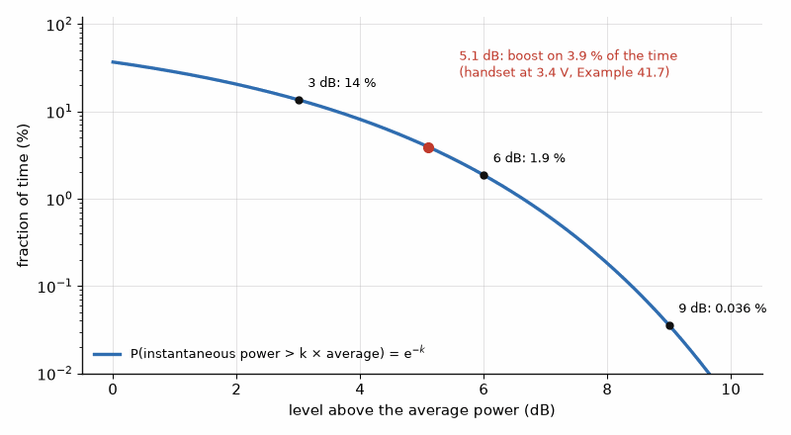
Figure 41.1 — How rarely an OFDM envelope needs the boost. The instantaneous power exceeds 3, 6, and 9 dB above average 14 %, 1.9 %, and 0.04 % of the time; the handset of Worked Example 41.7 needs its boost 3.9 % of the time.
Three circuits provide the boost. A buck-boost envelope tracker includes a boost stage, so its output can follow the envelope from well below the battery to well above it. A separate boost converter can charge a higher rail that a class G switch selects only when the envelope needs it. A bootstrap or flying-capacitor stage stacks a capacitor, charged to the battery voltage between peaks, in series with the supply for the duration of a peak, nearly doubling the rail for microseconds without a converter running at the full power. Because the OFDM envelope is close to Rayleigh, the probability that the instantaneous power exceeds the average by a factor k is exp(−k): 13.5 % at 3 dB above average, 1.9 % at 6 dB, 0.04 % at 9 dB. The boost circuit works only a small fraction of the time, so its own efficiency matters much less than that of the main modulator, and its capacitor needs to supply only the charge of the longest likely peak, C = I t/ΔV for a current I, a duration t, and an allowed droop ΔV.
P_peak = (V_B − Vk)² / (2 Ropt), Pr{p > k ⟨p⟩} = exp(−k), C = I t / ΔV

Worked Example 41.7
Problem. A handset amplifier must deliver 31 dBm peaks, 23 dBm average with an 8 dB peak-to-average ratio. It is designed for a 4.6 V peak supply with a 0.4 V knee. Find Ropt. Near empty the battery gives 3.4 V: what peak power remains without boost, and for what fraction of the time must a boost stage raise the supply? A bootstrap capacitor supplies the peak DC current for up to 1 µs with 0.2 V of droop. Find its value.
Solution. The peak power is 1.26 W, so Ropt = (4.6 − 0.4)²/(2 × 1.26) = 17.64/2.52 = 7.0 Ω. At 3.4 V the peak is (3.0)²/(2 × 7.0) = 0.64 W, or 28.1 dBm, 2.9 dB short of the requirement. The supply must therefore be boosted whenever the instantaneous power exceeds 28.1 dBm, 5.1 dB above the average, a factor of 3.24, which happens exp(−3.24) = 3.9 % of the time. At the peak the fundamental current is 2 × 1.26/4.2 = 0.60 A, and the class B DC current is (2/π) × 0.60 = 0.38 A, so C = 0.38 A × 1 µs / 0.2 V = 1.9 µF, a single small ceramic capacitor once its DC-bias derating is allowed for.
Key idea. A supply that rises above its nominal rail only on the rare peaks gives the amplifier its full peak power from a sagging battery or a lower rail, while the boost circuit works for only a few percent of the time. The envelope's statistics, not its peak, size the boost.

41.10 The supply modulator: bandwidth, efficiency, alignment, and predistortion
The supply modulator is a power amplifier for the envelope, and it inherits that problem's trade-offs. Its bandwidth must be about three to five times the RF signal's, Section 36.2, because the envelope, the magnitude of the complex signal, is spread wider than the signal itself. Switching converters are efficient, 90 % or more, but their bandwidth is limited to a fraction of their switching frequency, so most wideband trackers are hybrids: a switcher supplies the slow, high-power part of the envelope, and a fast class AB linear amplifier in parallel corrects the residual, with the combined efficiency typically 75 to 85 %. To relax the requirement, the shaping table that maps the envelope to the supply voltage is usually not exact: it holds a minimum voltage at low envelopes, where efficiency hardly matters and the linear stage would dominate, and it smooths the fastest excursions, accepting slight gain compression.
The envelope and the RF signal travel through different paths and must arrive at the transistor together. A delay error Δt between them makes the supply wrong by roughly its rate of change times Δt, and for an envelope with components up to half the RF bandwidth B the worst relative error is about πBΔt. Near compression the amplifier's gain and phase depend on the supply, so that error appears as AM-AM and AM-PM distortion, raising ACLR and EVM; the drain capacitance of the transistor varies with voltage, which makes AM-PM the more troublesome of the two. Predistortion can correct the distortion only if the supply trajectory is repeatable, which is a second reason for a fixed shaping table: when the supply is a fixed function of the input envelope, the amplifier with its modulator behaves as one nonlinear system with memory, and the memory polynomial of Chapter 38 fits it. The delay is then calibrated in production and tracked in operation, typically to a fraction of a nanosecond.
B_modulator ≈ 3 to 5 × B_signal, ε_delay ≈ π B Δt, η_total = η_PA × η_modulator

Worked Example 41.8
Problem. Estimate the worst relative supply error caused by a 1 ns misalignment for a 20 MHz LTE carrier, and the alignment needed to keep that error 40 dB below the signal. Repeat the requirement for a 100 MHz carrier.
Solution. For 20 MHz, πBΔt = π × 20 × 10⁶ × 10⁻⁹ = 0.063, an error 24 dB below the envelope, enough to dominate a −45 dBc ACLR budget. Keeping it 40 dB down, a ratio of 0.01, needs Δt ≤ 0.01/(π × 20 × 10⁶) = 0.16 ns. For 100 MHz the requirement shrinks five times, to 32 ps. The estimate is pessimistic, because near compression with a shaping table the amplifier's output depends only weakly on small supply errors, but it shows why alignment is calibrated in picoseconds and why tracking 100 MHz carriers is hard.

41.11 A worked design: a 10 W average base-station amplifier with a boosted tracking supply
The last example puts the chapter together. A small-cell base station must deliver 10 W average, 40 dBm, of a 20 MHz LTE or NR carrier whose peak-to-average ratio after crest-factor reduction is 8 dB, so the peaks are 48 dBm, 63.1 W. The device is a gallium nitride transistor normally used on a 28 V rail, with a 3 V knee and a breakdown voltage well above twice any supply the design uses. The design choice is whether to size the device and its load for 28 V, or to let an envelope tracker raise the supply to 40 V on the peaks.

Worked Example 41.9
Problem. Find Ropt and the peak fundamental current for 63.1 W peaks with a 28 V supply and with a 40 V boosted peak supply, and the L-network Q from each Ropt to 50 Ω. With Ropt chosen for 40 V, what peak power does a plain 28 V supply give, and for what fraction of the time must the tracker exceed 28 V? With the tracker holding the amplifier at 60 % and an 82 % efficient modulator, find the supply power and dissipation, and compare a fixed-supply class AB stage that reaches 25 % at this back-off. What modulator bandwidth is needed?
Solution. At 28 V, Ropt = 25²/(2 × 63.1) = 4.95 Ω and the peak fundamental current is 2 × 63.1/25 = 5.05 A; at 40 V, Ropt = 37²/126.2 = 10.85 Ω and the current is 126.2/37 = 3.41 A, a third less, with the drain swinging to about 80 V at the peaks. The L-network Q to 50 Ω falls from √(50/4.95 − 1) = 3.02 to √(50/10.85 − 1) = 1.90, a wider bandwidth and lower matching loss. With the 10.85 Ω load, a 28 V supply gives only 25²/(2 × 10.85) = 28.8 W, 44.6 dBm, 3.4 dB short of the peaks, so the tracker must exceed 28 V whenever the instantaneous power is more than 4.6 dB above average, a factor of 2.88, which happens exp(−2.88) = 5.6 % of the time. The overall efficiency is 0.60 × 0.82 = 49.2 %, so the supply power is 10/0.492 = 20.3 W and the dissipation 10.3 W, against 40 W and 30 W for the fixed-supply class AB stage: half the electricity and a third of the heat. The modulator needs three to five times 20 MHz, 60 to 100 MHz, within reach of a hybrid tracker.

41.12 The rest of the alphabet, and which class for which job
Three groups organize every amplifier letter in use. The conduction-angle classes, A, AB, B, and C, keep the transistor a current source and choose how much of the cycle it conducts, Section 41.1 and Chapter 22. The switching and harmonic-tuned classes, D, E, F, inverse F, J, inverse J, and S, shape the voltage and current so that they do not overlap, Sections 41.2 to 41.5 and Chapter 35. The efficiency-enhancement architectures, the Doherty, Chireix outphasing, envelope tracking, and Kahn's envelope elimination and restoration, are not classes at all but ways of combining amplifiers or moving their supply, Sections 41.5, 41.6, and 41.9 and Chapters 23 and 36. Figure 41.2 draws the drain waveforms of the main classes on one scale.
Inverse class J is the dual of class J: the current waveform carries the reactive second-harmonic shaping and the voltage approaches a half sine, which suits devices whose current, not voltage, is the tighter limit. Cripps and his colleagues developed the continuous class B/J family in the mid-2000s, and its inverse and continuous inverse class F forms followed; they are the working basis of most broadband GaN amplifiers and appear in CMOS research designs. Class T is not a physical class: it was Tripath's trademark for a digitally controlled switching audio amplifier, a class D variant. Classes G and H, the rail-switching and rail-tracking classes of Section 41.5, began as audio techniques and are the audio cousins of envelope tracking; audio amplifiers are outside this book.
The operating mode cuts across the classes. A saturated amplifier is driven until its output stops rising, which is efficient and acceptable only for constant-envelope signals such as FM, GFSK, and LoRa chirps. A linear amplifier stays below compression for signals with a varying envelope. Deep class AB biases close to class B for efficiency and leans on predistortion for linearity, and most modern communications amplifiers run in soft compression at their peaks, with crest-factor reduction and predistortion keeping the spectrum inside its mask.
Which class for which job. The choice follows the signal, the power, and the frequency more than any preference.
- Wi-Fi and Bluetooth in an ESP32-class chip: a CMOS class AB stage, backed off for OFDM and run nearer saturation for Bluetooth's constant envelope, Chapter 42.
- LoRa and sub-gigahertz IoT radios: constant-envelope chirps allow a saturated class AB, E, or F stage at +14 to +22 dBm; the efficiency gained shows up as battery life.
- Radio-control transmitters at 2.4 GHz: frequency-hopping GFSK, constant envelope, a saturated CMOS stage.
- Wireless charging: class E or class D inverters at 6.78 MHz for magnetic-resonance chargers, and half- or full-bridge class D inverters between about 100 and 200 kHz for Qi pads, Chapter 43.
- Audio: class D, with G and H in linear designs.
- Cellular handsets: GaAs HBT class AB modules with average-power or envelope tracking, Chapter 44.
- Base stations: GaN Doherty amplifiers with digital predistortion, Chapter 45; broadband test and military amplifiers in continuous class B/J.
- Radar and satellites: pulsed class AB or C GaN for radar, and GaN solid-state amplifiers or traveling-wave tubes for satellite downlinks, Chapters 32 and 45.
In modern RF CMOS for Wi-Fi, Bluetooth, LTE, and 5G, the classes that matter most are AB, C as the Doherty peaking device, E, F and inverse F, J, the Doherty with class AB main devices, and the envelope-tracked class AB stage. Class J, inverse F, and the Doherty dominate much current research, because they balance power, efficiency, linearity, and bandwidth better than any single class.
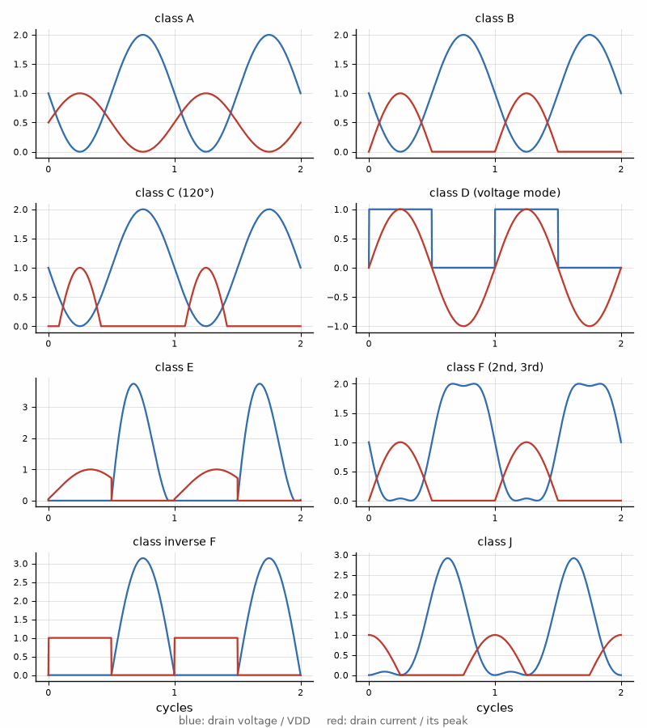
Figure 41.2 — Idealized drain voltage (blue) and current (red) over two cycles for classes A, B, C (120°), D, E, F, inverse F, and J, each normalized to VDD and to its own peak current. Overlap of voltage and current is dissipation; the switching and harmonic-tuned classes avoid it by shaping, and class C by conducting briefly.

Worked Example 41.10
Problem. A battery-powered node transmits LoRa at +22 dBm and Wi-Fi OFDM at +17 dBm average with an 8 dB peak-to-average ratio. For LoRa, compare a saturated stage at 60 % drain efficiency with a linear class AB stage held 3 dB below compression at an ideal class B efficiency. For Wi-Fi, find the ideal class B efficiency and DC power at the average output.
Solution. LoRa: 22 dBm is 158 mW. Saturated at 60 %, the stage draws 158/0.60 = 264 mW. Held 3 dB back, a class B stage reaches (π/4) × 10^(−3/20) = 55.6 % ideal, so 285 mW, and a practical AB stage at back-off does worse; saturation is free here because the chirp has a constant envelope. Wi-Fi: 17 dBm is 50 mW, and at 8 dB back-off the ideal class B efficiency is (π/4) × 10^(−8/20) = 31.3 %, so 160 mW of DC power for 50 mW of RF. The OFDM link costs a lower output a larger fraction of its supply, which is why the Wi-Fi side of such chips uses average-power tracking and why their LoRa and Bluetooth sides saturate.
Key idea. Group the letters by mechanism: conduction angle, waveform shaping, or architecture. Then choose by the signal: saturate constant envelopes, back off or load-modulate varying ones, and let predistortion buy back linearity where efficiency has been taken.

41.13 The whole radio
The core RF chain is now complete. The transmitter measures what it sends, the network tells it how much to send, and every decibel saved after the last amplifier is a decibel the transmitter did not have to generate. Looking back over Parts I and II, a few ideas carried every chapter: a line longer than a small fraction of a wavelength must be matched or it reflects; every match, filter, and antenna trades bandwidth against loss and size; and every amplifier trades linearity against efficiency. Part III identifies the device technologies behind these circuits; Part IV moves from measured data to sensing and bench radios. Book 2 introduces audio power-amplifier classes AB, D, G, and H, and explains Tripath's class T trade name; Book 6 covers their power-supply side.
Book 5 takes the RF chain as given and asks what to send through it: waveforms, coding, multiple antennas, and band plans. Book 6 supplies power to the amplifiers; Book 7 covers the board, package, emissions, and test chamber.
Key idea. A radio is a chain of passive structures and active circuits, and its performance is set by the weakest link: the loss after the last amplifier, the noise before the first one, and the linearity in between.
From the Bench
Compare classes by average efficiency at the real signal's statistics, not by peak efficiency on one tone. Size boost and bootstrap circuits from the envelope's probability, not from its peak alone, and allow for the capacitor's DC-bias derating. A good system uses each class and supply where it fits: a switching modulator for the slow part, a linear stage for the fast part, and a load-modulated amplifier for the RF.

Practice
1. Derive the class A efficiency from the DC and fundamental currents of a full sine about a bias of Imax/2.
2. Find the ideal efficiency at a conduction angle of 200°.
3. A voltage-mode class D stage runs from 24 V into 8 Ω. Find its output power.
4. Find the class E load resistance and shunt capacitance for 25 W at 1 GHz from 28 V.
5. Find Ropt and the class J second-harmonic reactance for 5 W from a 12 V device with a 1 V knee.
6. At what back-off does a Doherty amplifier with r = 1.5 have its second efficiency peak?
7. For what fraction of the time does a Rayleigh-envelope signal exceed its average power by 4 dB?
8. A boost stage must supply 0.5 A for 2 µs with 0.25 V of droop. Find the capacitance.
9. Find the alignment that keeps the delay error 40 dB down for a 40 MHz carrier.
10. Why does a fixed shaping table make predistortion of an envelope-tracking amplifier easier?
11. Name the class or architecture you would choose for each, and why: a 433 MHz constant-envelope remote at +10 dBm, a 3.5 GHz macro base station, and a 6.78 MHz wireless charger.

What You’ll Actually Use
Everyday working tools
- Class comparison by ideal and practical efficiency, linearity, and peak voltage.
- Rayleigh envelope: P(power > k × average) = e^(−k).
- Boost-capacitor sizing C = I t/ΔV.
Mostly for exams and deeper study
- Exact waveform theory of the harmonic-tuned classes.

Part III. Device Technologies and Power-Amplifier Design
Parts I and II treated the transistor as a source of current with a knee and a breakdown voltage. This part asks which transistor. Chapter 42 designs CMOS power amplifiers, the technology of nearly every integrated radio, and shows how they beat a breakdown voltage of a few volts. Chapter 43 is a cookbook: one complete design per amplifier class, with a note on what changes for a bipolar device. Chapters 44 and 45 give gallium arsenide and gallium nitride the full design treatment their markets demand, the handset module and the base station. Chapter 46 covers RF SOI switches and tuners, silicon-germanium and indium phosphide at millimeter waves, and the materials still in the laboratory. Chapter 47 turns to the filters that sit between all of them and the antenna, the acoustic resonators of the smartphone front end. Device physics stays in Book 3; this part designs circuits.

Chapter 42. CMOS Power Amplifiers: Beating the Breakdown Limit
A thick-oxide transistor in a CMOS process survives a few volts across its drain, yet a Wi-Fi chip in a phone delivers more than half a watt from it. No single transistor in that amplifier ever sees the full swing. The trick is to share the voltage among devices, add the power of several stages on chip, and choose the load by measurement instead of by formula.
Where you meet this: Wi-Fi and Bluetooth chips, IoT radios such as the ESP32 family, cellular transceivers with integrated drivers, and millimeter-wave beamformer ICs with an amplifier behind every antenna element.
Chapter 21 set the optimum load from the supply, the knee, and the power, and Chapter 22 showed which classes make the most of it. A CMOS designer meets both with a handicap: the transistors that are fast enough are the ones that break first. This chapter collects the techniques that push a CMOS amplifier's output power up, groups them by the limit each one beats, and finishes with a complete 2.4 GHz Wi-Fi amplifier in which every number is declared. Bipolar and compound-semiconductor amplifiers follow in Chapters 43 to 45.

42.1 What limits the output power
Five limits set how much power a CMOS amplifier can deliver. The supply voltage is bounded by breakdown and by reliability: a thin-oxide core device tolerates about 1 V, and even a thick-oxide input-output device only 2 to 3 times its nominal supply at the drain peak before oxide stress and hot carriers shorten its life, Book 3's "What Breaks a Chip: ESD, Latch-up, and Aging". The drain current is bounded by the device width and the current density the metal can carry. The load impedance follows from the first two through Ropt = (V − Vknee)²/(2P), and a low load means a high-ratio, lossy match. Efficiency and heat close the list, because a watt that does not leave as RF must leave through the die.
The techniques that beat these limits overlap, and the clearest way to hold them is by the limit each one attacks.
- Voltage: cascodes and stacks of devices, so that each sees part of the swing; thick-oxide and extended-drain devices with higher breakdown; and RF SOI, whose buried oxide removes the junction limits of a stack, Chapter 46.
- Current and size: wider devices, laid out as many short fingers to keep gate resistance and heat under control, with neutralization of the gate-drain capacitance to keep a large device stable.
- Load: load-pull to find the true optimum, and impedance transformation by L, pi, or transformer networks; on-chip transformers match, combine, and convert differential to single-ended at once.
- Combining: differential outputs, transformer and Wilkinson combiners, and corporate trees; current reuse, in which stacked stages share one DC current, belongs here too.
- Efficiency: the switching and harmonic-tuned classes of Chapter 35, the Doherty of Chapter 23, outphasing and envelope tracking of Chapter 36, and dynamic bias that lowers the quiescent current at low power.
- Heat and package: many fingers, copper pillars, thermal vias, and flip-chip mounting move heat out; advanced packages shorten the lossy path to the antenna.
- Process and system: RF CMOS, RF SOI, BiCMOS, and SiGe options trade cost for headroom, and multiple amplifiers and antennas add power in space, within the limits that regulators place on the total.
Five of these carry most commercial Wi-Fi, Bluetooth, and cellular CMOS amplifiers: cascode stacking, differential outputs, transformer power combining, load-pull-optimized matching, and envelope tracking or a dynamic supply. The rest of the chapter follows that spine.

42.2 Sharing the voltage: cascodes and stacks
In a cascode, a common-gate device sits on top of the common-source device and holds the lower drain near its own gate voltage minus a threshold, so the lower device sees only part of the swing. Stacking extends the idea to N devices, with the upper gates driven through capacitors so that each gate follows its own source and every device sees about 1/N of the drain swing. If each device may see a peak of Vmax, the stack's drain may swing to N·Vmax, and with the swing centered on the supply, the supply can rise to about N·Vmax/2. The load line then uses the larger swing, and the optimum load rises with its square.
Vdrain,peak ≤ N Vmax, VDD ≈ N Vmax / 2, Ropt = (VDD − Vknee)² / (2P)

Worked Example 42.1
Problem. A process offers core devices whose drain may safely peak at 2.4 V, with a 0.2 V knee for one device. Find the supply and Ropt for a 1 W stage built from one device and from a stack of three, taking the stack's knee as 0.6 V. Compare the single-section Q to 50 Ω.
Solution. One device: VDD = 2.4/2 = 1.2 V, Ropt = (1.2 − 0.2)²/2 = 0.50 Ω, a ratio of 100 to 50 Ω and a single-section Q of √99 = 9.9. Three devices: VDD = 3 × 2.4/2 = 3.6 V, Ropt = (3.6 − 0.6)²/2 = 4.5 Ω, a ratio of 11.1 and Q = 3.18. Stacking three devices raised the load nine times and cut the match's Q by a factor of three. A Q near 10 would lose a large fraction of a watt in on-chip inductors with Q of 10 to 20, so the single device is impractical at 1 W, and the stack is what makes a watt possible from a fine-line process.
Stacks have their own costs. Each added device adds a knee and parasitic capacitance at its source, which shifts the phase of its swing relative to the others and spoils the equal voltage sharing unless the gate capacitors are tuned for it. In bulk CMOS the source-to-body junctions of the upper devices limit the stack height; RF SOI removes them, which is why switch stacks of ten and more devices are routine there, Chapter 46. Thick-oxide devices and extended-drain, LDMOS-like devices offer the other route to voltage: fewer devices, each with more breakdown, at the cost of speed.

42.3 Differential outputs and combining on chip
A differential pair of amplifiers suppresses even harmonics, rejects supply and ground bounce, and doubles the voltage across a floating load. How much power that buys depends on what is held constant. With the same supply and the same load per side, a differential stage is two amplifiers and gives 3 dB more. With the full differential swing across the same total load, the voltage doubles and the power quadruples, 6 dB, but each device then carries twice the current. Combining several amplifiers adds 10 log N decibels, minus the combiner's loss, which on chip is often 1 dB or more: four amplifiers through a 1 dB combiner give 5.0 dB, not 6.

Worked Example 42.2
Problem. A single-ended stage swings 2.8 V peak into 20 Ω. Find its power. Then find the power of a differential pair of the same stages, first with each side driving its own 20 Ω, and then with both driving a single 20 Ω load connected between the drains. Find the peak current per device in each case.
Solution. Single-ended: P = 2.8²/(2 × 20) = 196 mW, with a peak current of 2.8/20 = 0.14 A. Two sides, each into 20 Ω: 392 mW, 3.0 dB more, with 0.14 A per device. Both into one 20 Ω load between the drains: the differential swing is 5.6 V, so P = 5.6²/(2 × 20) = 784 mW, 6.0 dB more than one side, but the load current is 5.6/20 = 0.28 A and each device must carry it. The second arrangement is the same as halving the load seen by each device to 10 Ω. The '+6 dB of a differential amplifier' therefore assumes double the current; at the same current per device, the gain is 3 dB.
A transformer combines amplifiers and matches them at the same time. In series combining, the secondaries of N transformers are connected in series, so their voltages add; each primary then sees the load divided among N secondaries and transformed by the turns ratio n, RL/(N n²). In parallel combining the currents add instead. Either way, the transformer also converts the differential amplifier output to the single-ended antenna port, and its magnetizing inductance can resonate the devices' output capacitance. Distributed amplifiers, which absorb the device capacitances into artificial lines as in Chapter 11, are used at millimeter waves mainly for bandwidth; the power they add is a secondary benefit.
series combining: Rprimary = RL / (N n²), combined power ≈ N P₁ × 10^(−Lcomb/10)

42.4 Large devices: fingers, gate resistance, and neutralization
Output power needs width, and a wide device is laid out as many parallel fingers. Each finger's gate is a resistive strip contacted at one end, with a resistance of about R□Wf/(3L) for a finger of width Wf and length L, the factor 3 coming from the distributed RC line. N fingers in parallel divide it by N, so at a fixed total width W = N Wf, the gate resistance is R□Wf²/(3WL): halving the finger width quarters it. Low gate resistance keeps fmax high and the input loss low, and many short fingers also spread the heat. The cost is the capacitance of the wiring that connects them.
A large device's gate-drain capacitance Cgd feeds the output back to the input, lowering the reverse isolation and inviting oscillation, and the Miller effect multiplies it at the input. In a differential stage, a pair of cross-coupled capacitors equal to Cgd, each from one drain to the opposite gate, injects an equal and opposite current and cancels the feedback. Neutralization raises the stable gain of a large stage by several decibels and is standard in CMOS amplifiers from Wi-Fi to millimeter waves.
Rg ≈ R□ Wf / (3 L N) = R□ Wf² / (3 W L), Cneutralization = Cgd

42.5 A 2.4 GHz Wi-Fi amplifier, designed
The design below uses the five techniques of Section 42.1 to reach 28 dBm of saturated output at the antenna port from a 3.3 V supply, enough for an OFDM average of 20 dBm with 8 dB of back-off. The numbers are idealized: class B current waveforms in each device, a stated knee, and a combiner loss of 1 dB. A real design starts from them and then moves the load by load-pull and simulation.

Worked Example 42.3
Problem. Two differential cascode cores of thick-oxide devices run from 3.3 V with a knee of 0.5 V per side and are combined by a series transformer with 1 dB of loss into 50 Ω. Find the power per core, the differential and per-side optimum loads, the turns ratio, the drain efficiency at saturation, and the per-side load to present if each drain has 1.5 pF of output capacitance at 2.45 GHz. Check the top device's peak drain-source voltage against an example reliability limit of 5.0 V, at 1:1 and at a 3:1 VSWR.
Solution. 28 dBm after 1 dB means 29 dBm, 794 mW, from the cores, 397 mW (26.0 dBm) each. Each side swings V1 = 3.3 − 0.5 = 2.8 V, so the differential amplitude is 5.6 V and Rdiff = 5.6²/(2 × 0.397) = 39.5 Ω, 19.7 Ω per side. With two secondaries in series on 50 Ω, each primary sees 50/(2n²), so n² = 50/(2 × 39.5) = 0.633 and n = 0.80, a 1:0.8 transformer. Per side the fundamental current is 0.397/2.8 = 0.142 A; in class B the DC current is (2/π) × 0.142 = 0.090 A per side, so a core draws 0.181 A, 0.596 W, and its drain efficiency is 0.397/0.596 = 66.6 %, the class B figure times the knee factor 2.8/3.3. After the combiner the amplifier delivers 631 mW from 1.19 W, 52.9 %. To absorb 1.5 pF, each side must see the load whose admittance plus jωC is 1/19.7 Ω: Z = 1/(1/19.74 − j0.0231) = 16.3 + j7.4 Ω, the starting point for load-pull; equivalently, 2.81 nH of magnetizing inductance per side resonates the capacitance. The drain of the top device peaks at 3.3 + 2.8 = 6.1 V; with its gate held at 3.3 V its source sits near 2.8 V, so it sees about 3.3 V and the lower device at most 2.8 V, inside the limit. At a 3:1 VSWR the swing can grow by 1 + |Γ| = 1.5 to 4.2 V, the drain peaks near 7.5 V, and the top device sees about 4.7 V, under 5.0 V with little margin. The design therefore needs a VSWR detector that lowers the drive or the supply, or a third device in the stack.
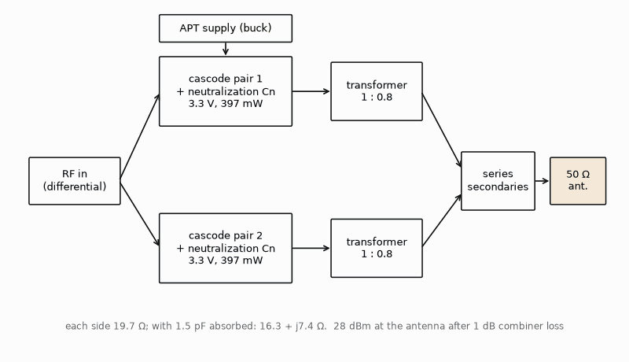
Figure 42.1 — The Wi-Fi amplifier of Worked Example 42.3: two differential cascode cores, each with neutralization capacitors, combined by series transformers into the 50 Ω antenna port, with an average-power-tracking supply. Each side sees 19.7 Ω, 16.3 + j7.4 Ω at the drain once 1.5 pF is absorbed.
Bipolar version. Built in SiGe or GaAs HBTs, the same amplifier needs less stacking, because BVCBO of a few volts to well over 10 V covers the swing; the bias moves from gate voltages to ballasted current mirrors with a temperature-tracking reference; each finger gets an emitter or base ballast resistor against current hogging; and the lower knee, 0.2 to 0.3 V, raises the per-side load slightly for the same power. The transformer combiner and the load-pull procedure are unchanged.

42.6 Efficiency at the average power
At the 20 dBm OFDM average the ideal class B efficiency of each core falls to 66.6 % × 10^(−8/20) = 26.5 %, and after the combiner to about 21 %. Three techniques recover part of it. Average-power tracking lowers the supply for the whole transmission when the requested power is low, so the swing again reaches close to the rail. Envelope tracking follows the envelope itself, Chapter 36. Dynamic bias lowers the quiescent current of a class AB stage at low drive. In CMOS a Doherty or outphasing combiner can be built from the same transformers, at the cost of area and bandwidth; at the power levels of Wi-Fi, average-power tracking with a buck converter is the common choice.

42.7 Reliability and ruggedness
A CMOS amplifier fails slowly before it fails suddenly. Hot carriers injected into the gate oxide during the high-voltage, high-current part of each cycle shift the threshold and lower the current over months; time-dependent dielectric breakdown accumulates while the gate-drain voltage is high. Both depend steeply on the peak voltage, so the reliability limit is set on the peak drain-source and gate-drain voltages over the worst load the antenna presents, not on the supply. Designers simulate every phase of the mismatch circle, add peak detectors at the drains, and fold back the drive or the supply when a peak approaches the limit, the protection schemes of Chapter 31.

42.8 More amplifiers and more antennas
A phased array or a MIMO radio adds power in space: N amplifiers, each feeding its own antenna, combine coherently in the beam direction, and each amplifier stays small enough for CMOS. Regulators limit the conducted power and the EIRP, and the array gain counts toward the EIRP, so the combined emission is limited however legal each amplifier is alone. The RF exposure limits of Chapter 33 apply to the combined beam, and certification, Book 7's subject, measures it as such.
Key idea. A CMOS amplifier reaches useful power by never asking one transistor for the whole swing: stack the voltage, split the power into differential halves and several cores, add them in a transformer that also matches, set the load by load-pull, and let the supply follow the average power.
From the Bench
Simulate the peak drain-source and gate-drain voltage of every device in the stack, not only the top one, at every phase of a 3:1 mismatch and at the highest supply, and keep each below its reliability limit. Measure the combiner's loss on its own, because a transformer that loses 1.5 dB instead of 1.0 takes 12 % of the output. Check stability with the neutralization capacitors at their process corners: a few femtofarads of mismatch is the difference between a neutralized stage and an oscillator.
On the Job
RFIC PA designers turn power, efficiency, and linearity specifications into transistor sizes, stacks, transformers, and CMOS or SOI layouts. They use circuit and electromagnetic simulators, collaborate with layout engineers, and validate returned silicon with load-pull and ruggedness tests. Useful preparation includes RFIC design, semiconductor devices, electromagnetic simulation, and laboratory measurement. Graduate study can help for research-heavy roles; requirements vary by employer, and relevant industry experience matters too.

Practice
1. A stack of four devices, each limited to a 2.4 V drain peak, runs with a total knee of 0.8 V. Find the supply and Ropt for 2 W.
2. Four identical 100 mW amplifiers are combined with 1.2 dB of loss. Find the output power in dBm.
3. A device has 64 fingers of 2 µm width. It is redrawn with 128 fingers of 1 µm at the same total width. By what factor does the gate resistance change?
4. Two cores of 400 mW each feed series transformers into 50 Ω with each primary required to see 40 Ω. Find the turns ratio n.
5. In Worked Example 42.3, by how many decibels would the antenna-port power fall if the combiner lost 1.5 dB instead of 1.0 dB?
6. Explain in one or two sentences why the reliability limit of a CMOS amplifier must be checked at the worst antenna mismatch rather than at 50 Ω.

What You’ll Actually Use
Everyday working tools
- Vdrain,peak ≤ N Vmax and VDD ≈ N Vmax/2 for an N-device stack.
- Differential gives +3 dB at the same current per device and +6 dB only at double the current.
- Series transformer combining: each primary sees RL/(N n²).
- Ropt = (VDD − Vknee)²/(2P), refined by load-pull.
Mostly for exams and deeper study
- Gate resistance of N fingers, R□Wf/(3LN).
- Neutralization capacitance equal to Cgd in a cross-coupled differential pair.

Chapter 43. A Design Cookbook, Class by Class
An amplifier class on a page is a waveform; an amplifier on a board is a transistor, a supply, a load, and four or five parts around it. This chapter turns each class into a complete recipe with every value computed, from a class A driver to a 10 W class E stage that charges a phone across a desk.
Where you meet this: IoT and LoRa transmitters, amateur HF and VHF radios, wireless chargers at 6.78 MHz, induction heaters, broadcast and base-station amplifiers, and every lab bench where an amplifier must be built rather than bought.
Chapters 22, 35, and 41 derived the classes; this chapter designs with them. Each recipe follows the same steps: state the specification, choose the class from the signal, compute the optimum load from the supply and the knee, design the match and the harmonic control, set the bias, and check the efficiency and the device stresses. The designs are CMOS or FET first, as in Chapter 42, and each closes with what changes for a bipolar device. The numbers assume ideal waveforms and stated knees; load-pull and simulation refine them.

43.1 Class A: a driver that needs no match
A class A stage conducts all the time and is the most linear, at a theoretical 50 % efficiency with an inductor feed. Its natural home is the driver of a larger stage and the output of a test source. A 10 mW CMOS driver on a 1.2 V supply with a 0.2 V knee has Ropt = (1.2 − 0.2)²/(2 × 0.01) = 50 Ω, so it drives a 50 Ω line directly. Its DC current equals the peak fundamental current, 2P/V1 = 20 mA, so it draws 24 mW and its efficiency is 41.7 %, the 50 % ideal times the knee factor 1.0/1.2. Bipolar version: the bias becomes a mirror setting about 20 mA, the knee drops to about 0.2 to 0.3 V, and the stage's higher transconductance gives more gain for the same current.

43.2 Class AB: a 915 MHz LoRa amplifier
Class AB biases the device slightly on, typically at 5 to 20 % of its peak current, to avoid class B's crossover distortion while keeping most of its efficiency. It is the default for any signal whose envelope varies, and it works saturated for constant-envelope signals such as LoRa chirps.

Worked Example 43.1
Problem. Design the output stage of a 915 MHz LoRa transmitter for +22 dBm from 3.3 V with a 0.3 V knee. Find Ropt, a low-pass L-network to 50 Ω, the ideal class B efficiency at saturation, and the frequency the harmonic filter must reject most.
Solution. 22 dBm is 158 mW. Ropt = 3.0²/(2 × 0.158) = 28.4 Ω. The L-network has Q = √(50/28.4 − 1) = 0.872: a series inductance on the device side of 0.872 × 28.4 = 24.8 Ω, 4.31 nH at 915 MHz, and a shunt capacitance across the 50 Ω side of 50/0.872 = 57.3 Ω, 3.03 pF. The ideal class B efficiency is 78.5 % × 3.0/3.3 = 71.4 %; a practical AB stage at saturation reaches 50 to 60 %. The strongest harmonic of a single-ended stage is the second, at 1830 MHz, and the low Q of this match filters it only weakly, so a separate low-pass filter follows. Bipolar version: an HBT stage would bias through a ballasted mirror with a diode-connected reference on the same die, its lower knee would raise Ropt slightly, to 30.3 Ω at a 0.2 V knee, and its exponential transfer would compress more abruptly near saturation.

43.3 Class B push-pull: 100 W on 13.8 V at HF
A push-pull pair of class B devices, each conducting half the cycle, combines two half-sine currents into a full sine in a center-tapped transformer and cancels the even harmonics. Amateur HF transceivers have long built their 100 W stage this way from the 13.8 V vehicle and station supply. With a 1 V knee each drain swings 12.8 V about the supply, so the drain-to-drain voltage amplitude is 25.6 V and the drain-to-drain load for 100 W is Rdd = 2 × 12.8²/100 = 3.28 Ω. A transmission-line transformer with a 1:4 turns ratio, 1:16 in impedance, presents 50/16 = 3.13 Ω, close enough to deliver 2 × 12.8²/3.125 = 105 W. The even harmonics cancel to the extent the halves match; the third harmonic does not, so each band has a switched low-pass filter that brings the spurious emissions to the 43 dB below the fundamental that U.S. amateur rules require below 30 MHz. Bipolar version: the classic bipolar push-pull needs a bias diode on the heat sink to track VBE, and emitter resistors of a fraction of an ohm against thermal runaway.
push-pull: Rdd = 2 (VDD − Vk)² / P, 1:n turns ⇒ Rdd = RL / n²

43.4 Class C: a narrowband FM transmitter
Class C narrows the conduction angle and accepts a lower gain for a higher efficiency, 89.7 % ideal at 120°. It suits constant-envelope FM and CW transmitters and the peaking device of a Doherty. For 25 W at VHF from 13.8 V with a 1 V knee, V1 = 12.8 V and the fundamental current is 2 × 25/12.8 = 3.91 A. At 120° the fundamental is 0.391 of the peak current, so the device must deliver a 9.99 A peak, against 7.81 A in class B for the same power: class C needs a bigger device for the same output. Its DC current is 2.18 A, so it draws 30.1 W and runs at 83.2 %, the ideal 89.7 % times 12.8/13.8. The load is V1/I1 = 3.28 Ω, the same as class B, because the load line depends on the fundamental. Bipolar version: a bipolar class C stage is often biased at zero, with the base returned through an RF choke, and the drive itself sets the conduction angle.

43.5 Class D at 6.78 MHz
A voltage-mode class D half bridge switches its output node between the supply and ground and passes the fundamental to the load through a series resonator. The 6.78 MHz band is used by magnetic-resonance wireless chargers. From 24 V the fundamental amplitude is (2/π) × 24 = 15.3 V, so a 10 W design needs R = 15.3²/(2 × 10) = 11.7 Ω. With 100 pF of output capacitance per switch, the node capacitance of 200 pF is charged and discharged every cycle, dissipating CVDD²f = 200 pF × 24² × 6.78 MHz = 0.78 W, and the efficiency counting only that loss is 10/10.78 = 92.8 %. Zero-voltage switching with a slightly inductive load and a dead time recovers most of it. Bipolar version: bipolar switches are rarely used at 6.78 MHz, because storage time limits how fast they turn off.

43.6 Class E at 6.78 MHz: a 10 W wireless-power stage

Worked Example 43.2
Problem. Design a class E stage for 10 W at 6.78 MHz from 24 V. Find the load resistance, shunt capacitance, excess inductance, DC and peak switch currents, and the peak switch voltage, and choose a voltage rating for the transistor.
Solution. R = 0.5768 × 24²/10 = 33.2 Ω. C = 0.1836/(2π × 6.78×10⁶ × 33.2) = 130 pF, which may include the switch's own output capacitance. The excess reactance is 1.1525 × 33.2 = 38.3 Ω, 0.90 µH. The DC current is 10/24 = 0.417 A and the peak switch current 2.862 × 0.417 = 1.19 A. The switch peaks at 3.562 × 24 = 85.5 V, so a 150 V device leaves the margin a resonant load that drifts with the receiver's position needs. The simulation in Figure 43.1 shows the drain voltage returning to zero with zero slope as the switch closes. A wireless charger's coil coupling changes the load, so practical designs use load-insensitive class E variants or a matching network that is retuned as the receiver moves. Bipolar version: no change in the network; the switch is a GaN or silicon MOSFET, because a bipolar switch's storage time would spoil the zero-voltage timing.
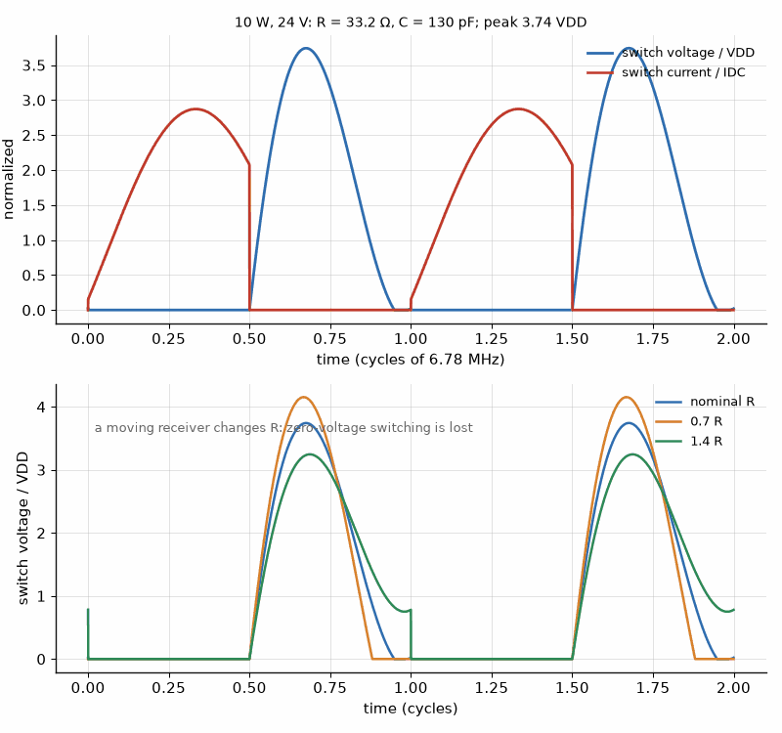
Figure 43.1 — Above: the 6.78 MHz class E stage of Worked Example 43.2, simulated in the time domain with an ideal switch, 24 V supply, R = 33.2 Ω, C = 130 pF, and a series tank of loaded Q 10; the drain voltage peaks near 3.7 VDD, against 3.56 VDD in the infinite-Q theory, and returns to zero with zero slope at switch closure. Below: the same stage with the load at 0.7 and 1.4 times its design value, as a moving receiver might present; the voltage no longer reaches zero at closure, or rings to the clamp of the switch's diode, and the switching loss returns.

43.7 Class F at 2.45 GHz

Worked Example 43.3
Problem. Design a 10 W class F stage at 2.45 GHz on 28 V GaN with a 3 V knee, controlling the second and third harmonics. Find V1, I1, and the fundamental load, the ideal drain efficiency, and the lengths of a quarter-wave line and a third-harmonic open stub on the book's reference microstrip, εeff = 2.79.
Solution. With the third harmonic set for a maximally flat voltage, V1 = 1.155 × (28 − 3) = 28.9 V, and with a half-sine current I1 = 2 × 10/28.9 = 0.693 A, so the fundamental load is R1 = 28.9/0.693 = 41.7 Ω, close to 50 Ω. The efficiency is ½ × (28.9/28) × (π/2) = 81.0 %, against 70.1 % for class B with the same knee. The guided wavelength at 2.45 GHz is 7.33 cm, so a quarter-wave line from the drain to a bypassed supply point is 1.83 cm long and shorts every even harmonic at the drain, and an open stub of λ/12, 0.61 cm, a quarter wave at 7.35 GHz, shorts the third harmonic where it joins and is placed so that the drain sees an open there. Both lengths are referred to the device's internal current source, so its output capacitance and package inductance shorten them in practice. Bipolar version: the HBT's collector-base capacitance and lower breakdown limit the swing; a bipolar class F stage is built at lower voltage, with the same terminations.
Inverse class F swaps the terminations: open at the second harmonic, short at the third. Its voltage approaches a half sine with a peak of about π times the swing and its current a square wave, which suits high-breakdown GaN. With infinitely many harmonics the load is R = (π²/4)(VDD − Vk)²/(2P); for the same 10 W design it is 2.47 × 31.25 = 77.1 Ω, and the drain peaks near 3 + π × 25 = 82 V, so the device needs a breakdown well above 100 V. Class J, which needs only a reactive second harmonic, is designed in Chapter 45 as a broadband GaN stage.
class F (2nd, 3rd): V1 = 1.155 (VDD − Vk), I1 = 2P/V1; inverse F: R = (π²/4)(VDD − Vk)² / (2P), vpk ≈ π (VDD − Vk)
Key idea. Every recipe starts from the same load line and the same five steps; the class only decides the waveforms, the harmonic terminations, and the stresses. Choose by the signal and the frequency, then check the peak voltage and current against the device before anything is built.
From the Bench
Before a class E or class F prototype is powered, measure the drain-to-ground capacitance of the board with the device fitted but unpowered, and compare it with the design's shunt C or the stub's assumed termination; a few picofarads of layout capacitance at 6.78 MHz and a fraction of a picofarad at 2.45 GHz move the zero-voltage point. Bring the supply up slowly with a current-limited source and watch the drain on a high-voltage probe: a waveform that rings below zero or peaks above 4 VDD means the tuning is off, not that the device is faulty.
On the Job
RF hardware engineers at radio, IoT-module, and wireless-power companies design discrete amplifiers from data sheets, simulation, and bench measurements. They choose devices, design matching networks, tune boards with network and spectrum analyzers, and complete emissions testing. Amateur radio and hands-on projects can build useful experience. Other preparation includes RF coursework and measurement, or experience in technician, test, or adjacent engineering roles. Employers set their own degree requirements.

Practice
1. Find Ropt and the L-network Q to 50 Ω for a class AB stage delivering +20 dBm from 3.3 V with a 0.3 V knee.
2. A 13.8 V push-pull pair with a 1 V knee must deliver 50 W. Find Rdd and the turns ratio of a transformer from 50 Ω.
3. Find the ideal efficiency and the load of a class C stage at 120° delivering 10 W from 12 V with a 1 V knee.
4. Design a class E stage for 5 W at 13.56 MHz from 12 V. Find R, C, and the peak switch voltage.
5. Find the length of a third-harmonic open stub (λ/12) at 5.8 GHz on microstrip with εeff = 2.79.
6. Explain in one or two sentences why a class C stage needs a larger device than a class B stage for the same output power.

What You’ll Actually Use
Everyday working tools
- Ropt = (VDD − Vk)²/(2P) for every class; push-pull Rdd = 2(VDD − Vk)²/P.
- Class E: R = 0.5768 VDD²/P, C = 0.1836/(ωR), vpk = 3.562 VDD.
- Class D: Pout = (2VDD/π)²/(2R), capacitive loss CVDD²f.
- Class F with 2nd and 3rd harmonics: V1 = 1.155(VDD − Vk).
Mostly for exams and deeper study
- Class C fundamental fraction (α − sin α)/(2π(1 − cos(α/2))).
- Inverse class F: R = (π²/4)(VDD − Vk)²/(2P).

Chapter 44. Gallium Arsenide: The Handset Amplifier and the pHEMT
Open almost any phone and the cellular power amplifier is not silicon. It is a few square millimeters of gallium arsenide heterojunction bipolar transistors, with a silicon controller beside it, and it has held that place against twenty years of CMOS progress. The reasons are a breakdown voltage that suits a lithium-ion battery, a gain that suits a two-stage module, and ruggedness into a hand-held antenna.
Where you meet this: Cellular power-amplifier modules in phones and modems, Wi-Fi front-end modules, low-noise amplifiers in GPS and satellite receivers, and the pHEMT amplifiers and switches in microwave links and test equipment.
Book 3's "GaAs, GaN, and InP Are Not One Transistor" explains the devices: the InGaP/GaAs heterojunction bipolar transistor, HBT, and the pseudomorphic high-electron-mobility transistor, pHEMT. This chapter designs with them. The handset amplifier comes first, because it is the largest market for gallium arsenide, and the pHEMT low-noise amplifier second, because it is where the material's low noise matters most.

44.1 Why the handset amplifier stayed in gallium arsenide
An InGaP/GaAs HBT for handset amplifiers has a cutoff frequency near 30 GHz, a collector-emitter breakdown BVCEO of about 15 to 20 V, and a collector-base breakdown BVCBO of 30 V or more. Against a battery that runs from about 3.0 to 4.4 V, that leaves room for the swing to grow several times under mismatch without breakdown, which a fine-line CMOS device lacks. The HBT's current density is high, so the output device is small, and its transconductance is high, so two stages give the 28 to 30 dB a module needs. The semi-insulating substrate keeps the passive losses low, and the process is mature and cheap per die. CMOS has won the Wi-Fi and Bluetooth amplifier, Chapter 42, but the cellular one, with its higher power, higher linearity, and harder mismatch requirements, has mostly stayed in GaAs.

44.2 Sizing the output stage
A cellular handset in power class 3 must deliver 23 dBm at the antenna. The duplexer, switch, and tuner between the amplifier and the antenna cost 2 to 4 dB, and the linear signal of LTE and 5G needs a few decibels of back-off from saturation, so the output stage is sized for about 31 dBm saturated. The load line and the area follow from the supply, the knee, and a current density the emitter can carry for years.

Worked Example 44.1
Problem. Size a 1.95 GHz HBT output stage for 31 dBm saturated from 3.4 V with a 0.3 V knee in class B. Find Ropt, the peak collector current, and the emitter area at 0.2 mA/µm². Design a two-section match to 50 Ω and give each section's Q.
Solution. 31 dBm is 1.26 W. Ropt = 3.1²/(2 × 1.26) = 3.82 Ω. The fundamental current is 2 × 1.26/3.1 = 0.812 A and the class B peak twice that, 1.62 A, which needs 1.62/(0.2 × 10⁻³) = 8,100 µm² of emitter, for example 100 fingers of about 81 µm². A single L-section from 3.82 Ω to 50 Ω would need Q = √(50/3.82 − 1) = 3.48. Two sections through the geometric mean, √(3.82 × 50) = 13.8 Ω, need Q = √(13.8/3.82 − 1) = 1.62 each, wider in bandwidth and less lossy, which is why modules use two or three sections, often with the first one on the die or the laminate right at the collector.

44.3 Bias, ballast, and thermal runaway
A bipolar transistor's base-emitter voltage falls by about 1.4 to 2 mV for every kelvin at constant current, so a finger that runs hotter than its neighbors draws more current, heats further, and can take the whole current, a failure called current hogging. A ballast resistor in each emitter or base breaks the loop. A finger with thermal resistance Rth that dissipates IcVCE warms by RthIcVCE, which would raise its current as if its VBE had been increased by φRthIcVCE, with φ the VBE temperature coefficient. The emitter resistance and the junction's own small-signal resistance VT/Ic oppose that, so the finger is stable when the total exceeds the thermal term.
Re + VT/Ic > φ Rth VCE ⇒ Re > φ Rth VCE − VT/Ic

Worked Example 44.2
Problem. The output stage of Worked Example 44.1 has 100 fingers, each with Rth = 2,000 K/W, φ = 1.4 mV/K, and VCE = 3.4 V. Find the emitter ballast needed at the peak current per finger, and the equivalent base ballast for a current gain of 80.
Solution. Per finger the peak current is 1.62 A/100 = 16.2 mA, so VT/Ic = 0.0259/0.0162 = 1.59 Ω, and φRthVCE = 1.4×10⁻³ × 2,000 × 3.4 = 9.52 Ω. Re must exceed 9.52 − 1.59 = 7.9 Ω; at the class B DC current per finger, 1.62/π/100 = 5.2 mA, the requirement relaxes to 4.5 Ω. A designer would choose about 9 Ω. In the emitter that costs 16.2 mA × 9 Ω = 0.15 V of swing and some gain, so modules usually put the ballast in the base, where β × Re = 80 × 9 = 720 Ω per finger has the same effect with no loss of collector swing, at the cost of bias drop that the bias circuit must supply.
The bias circuit is a current mirror: a diode-connected reference transistor on the same die, at the same temperature, sets the base voltage of the power stage so that the quiescent current tracks temperature and process. A silicon controller beside the GaAs die sets the reference current, switches power modes, and handles the mobile industry processor interface, MIPI RFFE, through which the transceiver commands the module.

44.4 Linearity, tracking, and harmonic terminations
Handset amplifiers run in class AB with the second harmonic shorted near the collector, a step toward class F that raises efficiency a few points. Linearity is specified as adjacent-channel leakage ratio, ACLR, with the error-vector magnitude of the modulated signal. Average-power tracking with a DC-DC converter lowers the collector supply at low power, and envelope tracking, Chapter 36, follows the envelope on high-bandwidth signals; both set the supply below the battery and so use the HBT's breakdown margin for efficiency rather than for headroom.

44.5 Ruggedness into a hand-held antenna
A hand on a phone detunes its antenna, and a module must survive a 10:1 VSWR at every phase at the highest battery voltage. The collector swing can grow by 1 + |Γ|, here 1 + 9/11 = 1.82 times, so with a 4.35 V battery and a 0.3 V knee the collector peaks near 4.35 + 1.82 × 4.05 = 11.7 V, well below a BVCEO of 15 to 20 V. Breakdown at high current is lower than the DC rating suggests, because avalanche and heating interact, so modules add voltage-clamping diode stacks at the collector and limit the drive when a mismatch is detected, Chapter 31.

44.6 The pHEMT: low-noise amplifiers and switches
The pHEMT carries its current in a two-dimensional electron gas with no base current and therefore no shot-noise source at the input, so its minimum noise figure is tenths of a decibel at a few gigahertz and its noise resistance is small. Enhancement-mode pHEMTs, which turn on at a positive gate voltage, run from a single supply, and they are the input devices of most GPS, satellite, and microwave-link low-noise amplifiers. Worked Example 28.3 designs with one at 2 GHz, and Chapter 48 reads its Touchstone file and presents its optimum noise source. pHEMTs once made every handset switch; RF SOI has taken most of that market, Chapter 46, but pHEMT switches and amplifiers remain in microwave and millimeter-wave modules, and pHEMT power amplifiers serve Wi-Fi 5 and 6 GHz front ends where their gain at high frequency helps.
Bipolar version, in reverse. Because this chapter's amplifier is already bipolar, the comparison runs the other way: a CMOS version of Worked Example 44.1 would need a stack, Section 42.2, because no single fine-line device survives an 11.7 V peak, and it would need a separate high-voltage protection scheme where the HBT relies on its breakdown margin.
Key idea. The GaAs HBT keeps the handset amplifier because its breakdown suits a battery with margin to spare under mismatch, its current density makes a small output stage, and ballasting tames its thermal runaway. Size it by the load line, ballast every finger, and qualify it at a 10:1 VSWR.
From the Bench
On a module evaluation board, measure the quiescent current against temperature from −30 °C to +85 °C before any RF test; a mirror that does not track will show up as a drifting gain and ACLR long before it shows up as a failure. Run the ruggedness test with a mismatch tuner at every phase in steps of 15° at the highest battery voltage and maximum drive, and measure the output power at 50 Ω after each step: a module that survives but loses a few tenths of a decibel has damaged fingers.
On the Job
Power-amplifier module engineers at front-end companies design and qualify the GaAs dies, laminates, and controllers used in phones. Their work combines harmonic-balance simulation, substrate layout reviews, and bench testing of ACLR, efficiency, and ruggedness across bands and temperatures. Useful preparation includes RF circuit design, load-pull measurement, and thermal simulation. Some roles favor graduate study; requirements vary by employer and product.

Practice
1. Find Ropt for an HBT stage delivering 29 dBm saturated from 3.4 V with a 0.3 V knee.
2. For the stage of Problem 1 in class B, find the peak collector current and the emitter area at 0.25 mA/µm².
3. Find the emitter ballast for a finger with Rth = 2,500 K/W, φ = 1.4 mV/K, VCE = 3.4 V, and Ic = 10 mA.
4. Find the collector peak voltage at a 10:1 VSWR with a 4.35 V battery and a 0.3 V knee, in the worst phase.
5. Design a two-section match from 6.05 Ω to 50 Ω through the geometric mean. Find the intermediate resistance and the Q of each section.
6. Explain in one or two sentences why a pHEMT, not an HBT, is the usual choice for a GPS low-noise amplifier.

What You’ll Actually Use
Everyday working tools
- Ropt = (VCC − Vk)²/(2P); class B peak current 4P/(VCC − Vk).
- Ballast: Re > φRthVCE − VT/Ic; base ballast β·Re.
- Multi-section match through the geometric mean √(R1R2).
- Collector peak under mismatch: VCC + (1 + |Γ|)(VCC − Vk).
Mostly for exams and deeper study
- Emitter area from peak current and allowed current density.
- Second-harmonic termination at the collector.

Chapter 45. Gallium Nitride: Broadband, Doherty, and Space Amplifiers
A gallium nitride transistor the size of a grain of rice delivers tens of watts at 3.5 GHz from a 48 V rail, and an amplifier built from a few of them drives a 5G sector, an airborne radar module, or a satellite downlink. The material's high breakdown and high electron velocity make that possible; its traps, its negative gate bias, and its heat make it demanding.
Where you meet this: 5G and 4G base-station amplifiers, radar transmit-receive modules, satellite solid-state power amplifiers, electronic warfare and test amplifiers spanning octaves, and the fast power switches of Book 6.
Book 3 explains why a GaN high-electron-mobility transistor, HEMT, holds a high voltage and a high current at once: a wide bandgap gives a breakdown field near 3.3 MV/cm, and a two-dimensional electron gas at the AlGaN/GaN interface carries a dense, fast channel. On silicon carbide substrates, which conduct heat well, the result is a power density of about 4 to 6 W per millimeter of gate periphery at 28 V and around 10 W/mm at 48 to 50 V in production devices; laboratory devices have exceeded 30 W/mm at much higher voltages. This chapter designs three amplifiers: a broadband class J stage, a Doherty for a 3.5 GHz base station, and a space amplifier.

45.1 The device and its load line
A GaN device's high supply raises its optimum load toward 50 Ω, Section 22.4, which shrinks the matching networks and widens their bandwidth. The gate periphery follows from the power and the power density; the output capacitance, about 0.3 to 0.5 pF per millimeter, grows with it and sets the bandwidth limit of Chapter 11. GaN HEMTs are depletion-mode devices: they conduct at zero gate voltage and pinch off at a negative one, typically −2 to −4 V, so the gate must be biased negative before the drain is powered.
gate periphery = P / (power density), Ropt = (VDD − Vk)²/(2P)

45.2 A broadband class J stage

Worked Example 45.1
Problem. Design a 25 W class J stage covering 1.8 to 3.4 GHz from 28 V with a 3 V knee. Find the periphery at 5 W/mm, Ropt, the fundamental and second-harmonic impedances at the class J point, and the continuous-mode range. Check that the second harmonic of the lowest frequency stays out of the band.
Solution. Periphery 25/5 = 5 mm. Ropt = 25²/(2 × 25) = 12.5 Ω. At the class J point Z₁ = 12.5 + j12.5 Ω and Z₂ = −j(3π/8) × 12.5 = −j14.7 Ω; across the continuous mode Z₁ = 12.5(1 + jα) Ω and Z₂ = −j14.7α Ω for α between −1 and +1, all at 70.1 % ideal efficiency with the knee. The output network need only keep the fundamental inside this region and the second harmonic on the matching reactive arc over the band, which a stepped low-pass network achieves over close to an octave. The lowest second harmonic, 3.6 GHz, sits above the top of the band at 3.4 GHz, so the network can treat fundamental and harmonic separately; a band wider than an octave would put harmonics inside the band, which is the practical limit of the method.

45.3 A Doherty for a 3.5 GHz base station
A 5G sector at 3.5 GHz transmits OFDM with a peak-to-average ratio of about 8 dB after crest-factor reduction. An asymmetric Doherty, Sections 23.3 and 41.6, puts its second efficiency peak at that back-off when 20 log(1 + r) = 8 dB.

Worked Example 45.2
Problem. Design a Doherty for 20 W average with an 8 dB peak-to-average ratio on 48 V GaN with a 4 V knee. Find r, the peak power, the main amplifier's share and its load at peak, the inverter impedance, the common load, and the peaking amplifier's load at peak. Give the ideal efficiency at the average power.
Solution. 1 + r = 10^(8/20) = 2.512, so r = 1.512. The peak is 20 × 10^0.8 = 126.2 W. The main amplifier delivers the fraction 1/(1 + r) at peak, 50.2 W, and with a 44 V swing its load at peak is Rm = 44²/(2 × 50.2) = 19.3 Ω, which is also the inverter's characteristic impedance ZT. The common load is Rm/(1 + r) = 7.67 Ω, and the peaking amplifier, carrying r times the main current at peak, sees 7.67 × (1 + r)/r = 12.7 Ω. At the average power the main amplifier saturates into ZT²/RL = 48.4 Ω, 2.51 times its peak load, and the ideal efficiency is 78.5 % × 44/48 = 72.0 %. Measured amplifiers of this kind reach 45 to 55 % with predistortion; the inverter's bandwidth, the peaking device's gradual turn-on, and the 7.67 Ω common load, transformed to 50 Ω by a further network, account for most of the difference.
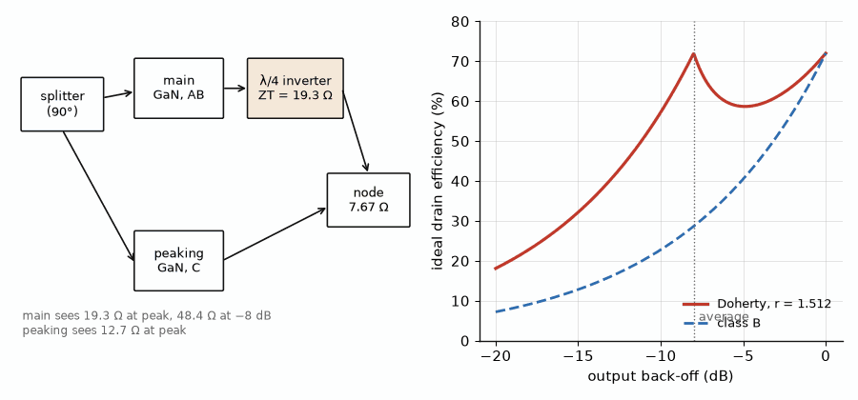
Figure 45.1 — Left: the asymmetric Doherty of Worked Example 45.2, with main and peaking GaN devices, a 19.3 Ω quarter-wave inverter, and a 7.67 Ω common node. Right: ideal drain efficiency against output back-off for this Doherty (r = 1.512, peaks at 0 and −8 dB) and for a class B stage with the same knee.

45.4 Traps, memory, and bias sequencing
Charge trapped in the buffer and at the surface of a GaN device after a high-voltage excursion reduces the channel current for microseconds to seconds afterward. The effect, called current collapse or drain lag, makes the device's gain depend on the recent history of the signal, and it appears as memory in the predistortion of Chapter 38 and as pulse-to-pulse droop in radar. Field plates and surface passivation reduce it; predistortion models with long memory terms and bias held during gaps in a burst handle what remains.
Because the device conducts at zero gate voltage, the supply sequence matters. Power up the negative gate supply first, to pinch-off, then the drain, then raise the gate to its quiescent point; power down in the reverse order. A drain applied with the gate at zero passes a current limited only by the supply and the device, which is usually enough to destroy it.

45.5 Heat
GaN's power density concentrates heat. A 25 W class J stage at 65 % efficiency draws 38.5 W and dissipates 13.5 W in a few square millimeters. With 3.5 K/W from channel to case and the case at 85 °C, the channel runs at 85 + 13.5 × 3.5 = 132 °C, comfortably below the 225 °C maximum many data sheets give, and below the lower temperatures their lifetime curves recommend for decades of service. Silicon carbide substrates make that possible; GaN on silicon, cheaper, conducts heat less well and is used where the power density is lower. GaN on diamond, in development, lowers the thermal resistance further, Chapter 46.

45.6 Space and radar amplifiers
Satellites have carried traveling-wave tubes for decades, Chapter 32, and still do at high power and high frequency, where a tube's efficiency of 60 % and more is hard to beat. GaN solid-state power amplifiers, SSPAs, have taken over at moderate power and in phased arrays, where hundreds of small amplifiers replace one tube and fail gracefully. A space amplifier is designed with extra margin: the channel temperature derated well below the terrestrial limit, radiation tolerance verified, and the supply sequencing built into the hardware. Radar transmit-receive modules run GaN in pulsed class AB or C at duty cycles of a few to about 20 %, which lets each device deliver more peak power than it could continuously.
Bipolar version. No bipolar technology competes with GaN at these powers and frequencies; LDMOS is the silicon alternative below about 3.5 GHz, with a similar load line at 28 to 50 V but lower power density and lower efficiency at the high end of its range.
Key idea. GaN's high supply raises the load toward 50 Ω and makes broadband and Doherty amplifiers practical at tens of watts. Its traps, negative gate bias, and concentrated heat are the price: predistort for memory, sequence the supplies, and design the thermal path as carefully as the match.
From the Bench
Build the bias sequencer before the amplifier and test it alone: with the drain supply connected to a resistive dummy load, confirm that the drain cannot rise until the gate is below pinch-off and that it falls before the gate returns to zero on power-down, including when the gate supply fails first. Then measure the quiescent current drift over the first minutes after power-up; a drift of a few percent is trapping and self-heating settling, and the bias loop or the predistortion must allow for it.
On the Job
Base-station and radar amplifier engineers design GaN stages and Doherty combiners from device models and load-pull data, tune them on the bench, and work with predistortion teams to meet emission and efficiency targets. Defense and space applications add pulsed operation, environmental testing, and extensive documentation. Useful preparation includes RF coursework, device modeling, and bench testing. Degree requirements vary; relevant technician or adjacent engineering experience can also apply.

Practice
1. Find the gate periphery for 40 W at 5 W/mm.
2. Find Ropt and the class J second-harmonic reactance for a 48 V device with a 4 V knee delivering 50 W.
3. Find the Doherty asymmetry r that places the second efficiency peak 7 dB below full power.
4. A GaN stage dissipates 30 W with 2.5 K/W from channel to case and the case at 80 °C. Find the channel temperature.
5. A 100 W SSPA combines 8 equal amplifiers through a combiner with 0.5 dB of loss. Find the power each amplifier must deliver.
6. Explain in one or two sentences why the gate supply of a GaN amplifier must be applied before the drain supply.

What You’ll Actually Use
Everyday working tools
- Ropt = (VDD − Vk)²/(2P); periphery = P/(W/mm).
- Class J: Z₁ = Ropt(1 + jα), Z₂ = −j(3π/8)αRopt.
- Doherty: back-off peak 20 log(1 + r); Rm = ZT, RL = Rm/(1 + r).
- Channel temperature = Tcase + Pdiss Rth.
Mostly for exams and deeper study
- Peaking-amplifier load at peak RL(1 + r)/r.
- Combiner loss shared over N amplifiers.

Chapter 46. RF SOI, SiGe, InP, and the Materials Still in the Lab
Between a phone's amplifiers and its antennas sit dozens of switches, each a stack of a dozen transistors on a thin film of silicon over glass-like oxide. At the other end of the spectrum, silicon-germanium radar chips see the road at 77 GHz and indium phosphide transistors have amplified at a terahertz. This chapter designs the switch, sets the limits of the fast technologies, and surveys what comes next.
Where you meet this: Antenna and band switches and antenna tuners in phones, automotive and industrial radar chips, optical-link and instrument front ends, sub-terahertz research systems, and the tunable components of reconfigurable radios.
Chapter 19 introduced RF switches and their figures of merit; Chapter 42 used stacks to raise a CMOS amplifier's voltage. Silicon on insulator, SOI, makes stacks practical, and it now builds nearly every switch and tuner in a phone. SiGe heterojunction bipolar transistors and InP devices extend silicon and compound technologies to millimeter and sub-millimeter waves. The figure of merit for each is different, and the chapter keeps them apart.

46.1 The RF SOI switch
In RF SOI the transistors sit in a thin silicon film over a buried oxide on a high-resistivity, trap-rich substrate. With no junction to the substrate, a transistor's body floats or is tied through a resistor, so a stack of many devices shares the RF voltage without any one junction breaking down, and the substrate adds little loss or nonlinearity. A switch arm is a series stack, turned on with a positive gate voltage and off with a negative one. Its figure of merit is the product Ron·Coff of one device, which does not depend on width: wider devices lower Ron and raise Coff in proportion. Leading processes reach about 80 to 90 fs.
Vpk = √(2 P Z0), N ≥ (1 + |Γ|) Vpk / Vdevice, IL ≈ 20 log(1 + Ron/(2Z0)), Coff = (Ron·Coff)/Ron

Worked Example 46.1
Problem. Size a series switch arm for 35 dBm in a 50 Ω system with a 3:1 VSWR margin, each device holding 2.5 V. With a total on-resistance of 1.5 Ω and Ron·Coff = 100 fs, find the insertion loss, the off capacitance, and the isolation of the series arm alone at 2 GHz.
Solution. 35 dBm is 3.16 W, so Vpk = √(2 × 3.16 × 50) = 17.8 V. At 3:1, |Γ| = 0.5 and the voltage can reach 1.5 × 17.8 = 26.7 V, so N ≥ 26.7/2.5 = 10.7, and 11 devices are stacked. The loss is 20 log(1 + 1.5/100) = 0.13 dB. The off capacitance is 100 fs/1.5 Ω = 66.7 fF, a reactance of 1,190 Ω at 2 GHz, and the isolation of the series arm alone is 20 log(|100 − j1,190|/100) = 21.6 dB. That is too little for most specifications, which is why practical switches add a shunt arm to ground on the off path, the series-shunt topology of Chapter 19, raising the isolation to 35 to 45 dB.
An antenna tuner is the same technology used as a switched capacitor or inductor bank across the antenna's feed or aperture. A small, high-Q antenna stores energy, so the voltage across the tuning capacitors can exceed the transmitted signal's voltage several times, and the stack height is set by that voltage. Tuners let one compact antenna cover bands from 600 MHz to 6 GHz in turn.

46.2 SiGe: radar and millimeter waves
SiGe HBTs grade germanium into the base to accelerate electrons, reaching fT around 300 GHz and fmax around 500 GHz in the fastest production BiCMOS processes, with the CMOS logic of a radar chip on the same die. The price is a low breakdown, BVCEO about 1.5 V for the fastest devices, so SiGe amplifiers deliver tens of milliwatts, not watts. A transistor's maximum available gain falls about 6 dB per octave toward fmax, roughly 20 log(fmax/f), so a 500 GHz fmax gives about 16 dB at 77 GHz, enough for two or three stages of a radar receiver and the voltage-controlled oscillators of Chapter 49.

46.3 InP: toward a terahertz
Indium phosphide HEMTs and double-heterojunction bipolar transistors have the highest electron velocities of the mature technologies. InP HEMTs give the lowest noise figures at millimeter waves, which places them in radio-astronomy receivers, and in 2014 a ten-stage InP HEMT amplifier gained 9 dB at 1.0 THz, a record. InP DHBTs drive the fastest optical-link electronics. The wafers are small and expensive, so InP is used where nothing else performs.

46.4 The figure of merit across materials
The Johnson figure of merit, the product of breakdown field and saturated velocity divided by 2π, bounds the product of a transistor's breakdown voltage and its cutoff frequency. With representative values it is about 480 GHz·V for silicon, 640 GHz·V for gallium arsenide, and 7.9 THz·V for gallium nitride, which is why GaN holds tens of volts at frequencies where GaAs holds a few. It is a bound, not a design rule: SiGe's fast devices sit close to silicon's limit, and real GaN devices reach a fraction of theirs.
JFOM = Ec vsat / (2π) ≥ BV × fT
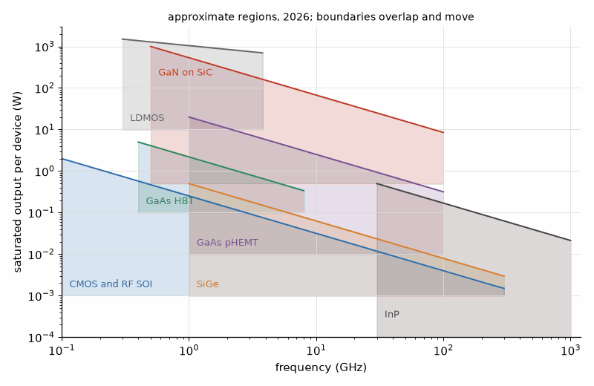
Figure 46.1 — An approximate map of where each technology delivers its power: saturated output per device against frequency for LDMOS, GaN on SiC, GaAs HBT and pHEMT, CMOS and RF SOI, SiGe, and InP. Regions are representative of 2026 production and research devices, not limits; they overlap, and the boundaries move every year.

46.5 Tunable components: BST and MEMS
Two technologies make reconfigurable filters and matching networks. Barium strontium titanate, BST, is a ferroelectric whose permittivity falls with applied field, so a thin-film capacitor tunes by about 2 to 3 to 1 with tens of volts, continuously but with some loss and nonlinearity. Microelectromechanical, MEMS, switches and capacitors move a metal beam electrostatically: they have almost no loss or distortion, but need tens of volts, switch in microseconds, and must survive billions of cycles. An electrostatic actuator is stable only until the gap closes to two-thirds of its rest value; beyond that, the beam snaps down, at the pull-in voltage.
Vpull-in = √(8 k g0³ / (27 ε0 A))

Worked Example 46.2
Problem. A MEMS switch has a spring constant of 10 N/m, a 2 µm gap, and a 100 µm × 100 µm electrode. Find its pull-in voltage.
Solution. Vpi = √(8 × 10 × (2×10⁻⁶)³/(27 × 8.854×10⁻¹² × 10⁻⁸)) = √(6.4×10⁻¹⁶/2.39×10⁻¹⁸) = √268 = 16.4 V. A charge pump on the controller supplies it. The cube of the gap dominates: halving the gap would lower the voltage by 2.8 times, but would also lower the off-state isolation and the power the switch can hold before the RF voltage itself pulls the beam down.

46.6 Materials still in the laboratory
Gallium oxide, Ga2O3, has a bandgap near 4.8 eV and a projected breakdown field near 8 MV/cm, attractive for power switching, but its thermal conductivity is poor. Diamond has the highest thermal conductivity of any material and a wide bandgap; diamond transistors are research devices, while diamond heat spreaders under GaN, GaN on diamond, already lower channel temperatures in demonstrations. Aluminum nitride and high-aluminum AlGaN channels push the breakdown field higher still. Graphene, carbon nanotubes, and other two-dimensional materials have shown high carrier mobilities and cutoff frequencies in research, but no power gain at the frequencies that matter and no manufacturing path yet. For a designer, these are reasons to watch the literature, not to change a design.
Bipolar version. Among these technologies the bipolar ones are SiGe and InP DHBTs; their designs follow the HBT rules of Chapter 44, ballast and all, at much lower voltages.
Key idea. Each technology has its own figure of merit: Ron·Coff and stack voltage for SOI switches, fmax and breakdown for SiGe and InP, the Johnson limit for power at frequency. Choose the technology by the figure that matters for the block, and check it against the voltage the block will see under mismatch.
From the Bench
When characterizing a stacked switch, measure the second and third harmonics at the highest specified power and at the worst VSWR, not only the insertion loss. A stack whose voltage division is uneven, because of a gate resistor or a body-tie fault on one device, still passes small signals with normal loss but distorts or breaks down long before its rated power.
On the Job
Front-end module integration engineers combine power amplifiers, SOI switches and tuners, acoustic filters, and low-noise amplifiers in phone modules. They manage module specifications and interactions, such as a switch harmonic landing in a receive band or a filter detuning when a tuner moves. The work uses system budgets, circuit and electromagnetic simulation, and test campaigns. Experience in a component specialty can be useful; degree requirements vary by employer.

Practice
1. Find the number of stacked devices for a switch handling 38 dBm in 50 Ω at a 4:1 VSWR, with 2.5 V per device.
2. Find the insertion loss of a series switch with a total on-resistance of 2 Ω in a 50 Ω system.
3. A switch has Ron = 1.5 Ω and Ron·Coff = 120 fs. Find Coff and the isolation of the series arm alone at 3 GHz.
4. Estimate the maximum available gain at 140 GHz of a SiGe device with fmax = 500 GHz.
5. Find the pull-in voltage of a MEMS switch with k = 20 N/m, a 3 µm gap, and a 100 µm × 100 µm electrode.
6. Explain in one or two sentences why SOI, rather than bulk CMOS, builds switch stacks of ten or more devices.

What You’ll Actually Use
Everyday working tools
- Vpk = √(2PZ0); stack N ≥ (1 + |Γ|)Vpk/Vdevice.
- Series switch loss 20 log(1 + Ron/(2Z0)); Coff = (Ron·Coff)/Ron.
- MAG ≈ 20 log(fmax/f) as a first estimate.
- MEMS pull-in √(8kg0³/(27ε0A)).
Mostly for exams and deeper study
- Johnson figure of merit Ec vsat/(2π).
- BST tuning ratio and MEMS gap scaling.

Chapter 47. Acoustic and Micro-Mechanical Filters: SAW, BAW, XBAR, and the Smartphone Front End
A 5G phone holds dozens of filters, and almost every one is a piece of vibrating crystal. Sound in a solid travels about a hundred thousand times slower than light, so an acoustic resonator at 2.5 GHz is a few micrometers across, has a Q near a thousand or more, and costs a few cents. Without it, a phone that talks on many bands at once could not exist.
Where you meet this: Duplexers and multiplexers in every phone, Wi-Fi coexistence filters, GPS and satellite receivers, the 433.92 MHz resonator in a garage-door remote, and the MEMS oscillators that keep time in watches, cars, and servers.
Book 3's "Piezoelectric Films and Acoustic Resonators" derives the acoustic resonator from its material: the Butterworth-Van Dyke model, the coupling coefficient kt², the SAW finger period, temperature drift, and the ladder that turns resonators into a band filter. This chapter designs with them, from a single resonator to a band filter, a duplexer, and the front-end module, and then surveys the acoustic and micromechanical devices beyond the filter.

47.1 The resonator as a design element
The model of Book 3 has a motional branch Lm, Cm, Rm in parallel with the plate capacitance C0. A designer sets C0 for the impedance level, the frequency fs by the film thickness or the finger period, and accepts the coupling kt² and the Q the technology gives. The spacing between series and parallel resonance, (fp − fs)/fp ≈ (4/π²) kt², bounds the widest band filter a technology can build.
(fp − fs)/fp ≈ (4/π²) kt², Cm = C0 [(fp/fs)² − 1], Lm = 1/(ωs² Cm), Rm = ωs Lm / Q

Worked Example 47.1
Problem. A BAW resonator at 3.5 GHz has kt² = 7 %, C0 = 1 pF, and Q = 1000. Find fp, the motional elements, and the fractional spacing, and decide whether a ladder of such resonators can pass the 5G band n78, 3.3 to 3.8 GHz.
Solution. (fp − fs)/fp = (4/π²) × 0.07 = 2.84 %, so fp = 3.5/(1 − 0.0284) = 3.602 GHz. Cm = 1 pF × (1.0292² − 1) = 59.2 fF, Lm = 1/((2π × 3.5×10⁹)² × 59.2×10⁻¹⁵) = 34.9 nH, and Rm = 2π × 3.5×10⁹ × 34.9×10⁻⁹/1000 = 0.77 Ω. n78 is 500 MHz wide, 14 % of its center, five times the resonator's spacing, so no ladder of these resonators can pass it. Wide 5G bands use XBAR resonators in thin lithium niobate, whose coupling of roughly 25 % or more gives a spacing near 10 %, or lumped-element filters in glass and ceramic, or a split of the band.
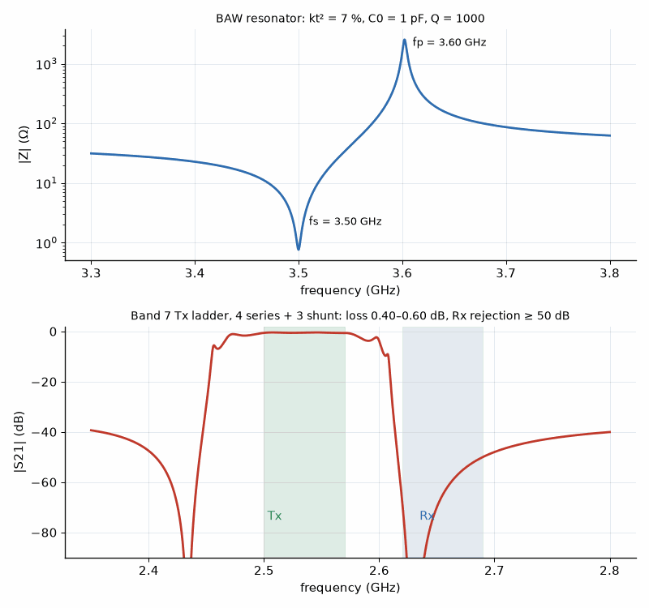
Figure 47.1 — Above: impedance magnitude of the 3.5 GHz BAW resonator of Worked Example 47.1, minimum at fs = 3.50 GHz and maximum at fp = 3.60 GHz. Below: transmission of the seven-resonator Band 7 transmit ladder of Worked Example 47.2 (BVD model, kt² = 9 %, Q = 1500), with the transmit band 2500 to 2570 MHz and the receive band 2620 to 2690 MHz marked.

47.2 From resonators to a band filter
A ladder places series resonators in the signal path and shunt resonators to ground, with the shunt resonators lowered in frequency so that their parallel resonance falls on the series resonators' series resonance. The passband sits between the shunt series resonance, which shorts the path below the band, and the series parallel resonance, which opens it above. The steepest skirt can be placed on whichever side matters by choosing the resonator frequencies; a transmit filter puts it on the side toward the receive band.

Worked Example 47.2
Problem. Design a Band 7 transmit filter, 2500 to 2570 MHz, which must reject the receive band, 2620 to 2690 MHz, by at least 50 dB, using AlScN BAW resonators with kt² = 9 % and Q = 1500 in a ladder of four series and three shunt resonators. Choose the resonator frequencies and plate capacitances and report the simulated loss, return loss, and rejection.
Solution. The spacing is (4/π²) × 0.09 = 3.65 %. To put the upper skirt between the bands, the series resonators' parallel resonance must sit near 2.63 GHz, so their series resonance is about 2.534 GHz; the shunt resonators are lowered by the spacing to about 2.434 GHz, putting their parallel resonance, 2.526 GHz, near the series fs. Plate capacitances of 0.81 pF in series and 1.74 pF in shunt set the impedance level near 50 Ω. A circuit simulation of the BVD ladder, Figure 47.1, gives 0.40 to 0.60 dB of loss across the transmit band, return loss better than 13 dB, and at least 50 dB of rejection across the receive band, 68 dB at its lower edge. The model omits electrode resistance, package parasitics, and coupling between input and output, which in a real part raise the loss toward 1 to 2 dB and limit the far rejection; the design is a starting point that an electromagnetic and acoustic simulation then refines.

47.3 Duplexers, multiplexers, and their budget
A duplexer joins a transmit and a receive filter at the antenna, each designed to look like an open circuit in the other's band. Two numbers set its isolation. The transmitter's own noise in the receive band must fall below the receiver's noise floor, and the transmitted signal must not overload the receiver's low-noise amplifier.

Worked Example 47.3
Problem. A handset amplifier produces +27 dBm in the transmit band and −135 dBm/Hz of noise in the receive band. The receiver's noise figure is 3 dB. Find the isolation the duplexer needs in the receive band to keep the transmitter's noise 10 dB below the receiver's floor, and the transmit-band power at the low-noise amplifier with 50 dB of isolation in the transmit band.
Solution. The receiver's floor is −174 + 3 = −171 dBm/Hz, so the transmitter noise must reach the receiver at no more than −181 dBm/Hz, and the receive-band isolation must be at least −135 − (−181) = 46 dB. With 50 dB of transmit-band isolation, the transmitted signal reaches the low-noise amplifier at 27 − 50 = −23 dBm, which its compression point must absorb without blocking. A duplexer of about 50 dB in both bands therefore suits this phone; the 2620 MHz edge is the hard one, because the duplex gap of Band 7 is only 50 MHz, 1.9 % of the frequency.
Carrier aggregation transmits or receives on several bands at once, so a phone's antenna port joins several filters in a multiplexer, each of which must look open in all the others' bands. Quadplexers and hexaplexers are built from acoustic filters with phase-shifting networks at the common node, and the front-end module packs them with switches, amplifiers, and tuners.

47.4 Temperature, guard bands, and technology choice
A filter's frequency drifts by its temperature coefficient of frequency, TCF, times the temperature range, and a phone works from about −30 °C to +85 °C, 115 K. With Book 3's values, a lithium tantalate SAW at −35 ppm/K moves 4,025 ppm, 10.3 MHz at 2.57 GHz, and an AlN BAW at −25 ppm/K moves 2,875 ppm, 7.4 MHz, each a large fraction of Band 7's 50 MHz gap once manufacturing spread is added. Temperature-compensated SAW, TC-SAW, which covers the fingers with silicon dioxide, cuts the drift to a third or less, and thin-film SAW on bonded substrates, sold under names such as I.H.P. SAW, raises Q and lowers drift together.
The result is a working division of the spectrum. SAW and TC-SAW cover most bands below about 2 GHz and many up to 2.7 GHz at the lowest cost. BAW, in its free-standing FBAR and solidly mounted SMR forms, covers 1.5 to about 6 GHz and the hardest duplex gaps. XBAR and other laterally excited lithium niobate resonators cover the wide 5G bands n77, n78, and n79 and the 5 to 7 GHz Wi-Fi bands. Integrated passive devices in glass and LTCC cover very wide bands where acoustic coupling runs out. In 2022 Murata acquired Resonant, the developer of XBAR, for about $290 million, which signals how much these wide bands are worth.
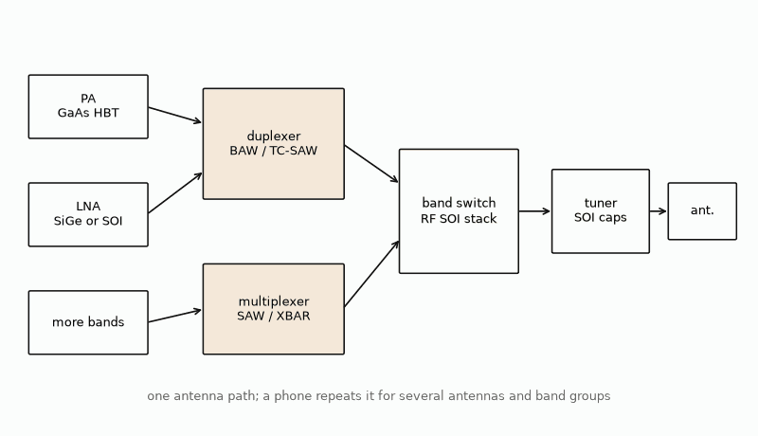
Figure 47.2 — A simplified smartphone front end for one antenna: power amplifiers and low-noise amplifiers connect through acoustic duplexers and multiplexers to an RF SOI band switch, an antenna tuner, and the antenna. Each technology appears in its usual place; real modules repeat this chain for several antennas and band groups.

47.5 Hobby filters and resonators
The cheapest acoustic devices are the ones a hobbyist meets first. Garage-door remotes, weather stations, and key fobs at 433.92 MHz use a one-port SAW resonator as the frequency reference of a one-transistor oscillator, and SAW filters clean up the receivers. On ST-cut quartz, with a velocity near 3,158 m/s, a 433.92 MHz resonator has an electrode period of 7.28 µm and fingers 1.82 µm wide, coarse by modern standards, which is why these parts cost cents. A NanoVNA, Chapter 52, measures their series and parallel resonances directly.

47.6 Beyond the filter
- MEMS timing: silicon resonators replace quartz crystals in many oscillators, with electronic temperature compensation and much better shock resistance; they are now in cars, servers, and wearables.
- Thin-film lithium niobate, TFLN: the material of XBAR is also the platform of fast electro-optic modulators, Chapter 50, so acoustic, optical, and RF functions may meet on one chip.
- Reconfigurable filters: banks of fixed acoustic filters selected by SOI switches dominate today; tunable acoustic resonators, using ferroelectric films whose coupling changes with bias, are in research.
- Acoustic delay lines: a SAW delay line stores microseconds of signal in millimeters, once the basis of radar pulse compression and still used in sensors and identification tags.
- Acoustic and modulated circulators: modulating a resonator's properties in time and space breaks reciprocity without a magnet, a research path to integrated circulators, Chapter 15.
The outlook is more bands, wider bands, higher frequencies, and more filters per phone, with XBAR and other lithium niobate structures growing fastest and BAW holding the hardest gaps.
Key idea. An acoustic filter is a ladder of resonators whose coupling sets the widest band it can pass and whose Q and temperature drift set how close it can sit to its neighbor. Choose SAW, TC-SAW, BAW, or XBAR by band, width, and gap, and size the duplexer from the transmitter's noise and the receiver's floor.
From the Bench
Measure an acoustic filter on a VNA with the test fixture de-embedded, and then again with the board heated and cooled across the temperature range; a passband that looks comfortable at room temperature can slide into the duplex gap at +85 °C. Keep the drive level low when you measure the resonances, because a few hundred milliwatts can shift a small SAW resonator by heating, and record the level with the data.
On the Job
Acoustic filter design engineers turn band specifications into resonator layouts, ladders, and multiplexers using finite-element simulation, circuit optimization, and wafer-level measurement. They work with process engineers on film thickness and trimming, and with module engineers on packaged performance. Useful preparation includes acoustics, materials, circuits, simulation, and measurement. Graduate study can help in research-heavy positions; degree requirements vary by employer.

Practice
1. A resonator at fs = 2.0 GHz has kt² = 6.5 %. Find fp and the resonance spacing in megahertz.
2. Find the drift of a SAW filter with TCF = −35 ppm/K at 1.9 GHz over 115 K.
3. Find the electrode period and finger width of a 433.92 MHz SAW resonator on ST-cut quartz at 3,158 m/s.
4. A transmitter has −135 dBm/Hz of noise in the receive band and the receiver's noise figure is 3 dB. Find the isolation that keeps the noise 10 dB below the receiver's floor.
5. Find Rm for the resonator of Worked Example 47.1 if its Q rises to 1500.
6. Explain in one or two sentences why XBAR resonators, rather than AlN BAW, serve the band n78.

What You’ll Actually Use
Everyday working tools
- (fp − fs)/fp ≈ (4/π²)kt²; Cm = C0[(fp/fs)² − 1], Lm = 1/(ωs²Cm), Rm = ωsLm/Q.
- SAW period = v/f, fingers a quarter of the period.
- Drift = TCF × ΔT × f.
- Duplexer isolation = transmitter noise − (receiver floor − margin).
Mostly for exams and deeper study
- Ladder rule: shunt fp at the series fs.
- Technology map by band, width, and gap.

Part IV. Measured Data, Sensing, Light, and the Bench Radio
The last part of the book works from the outside in. Chapter 48 reads the measured data files that vendors ship in place of models, Touchstone S-parameter files with their noise parameters, and designs an LNA input from one. Chapter 49 builds FMCW radar front ends at 24, 60, and 77 GHz, the radio as a sensor. Chapter 50 carries microwave signals on light and steers optical beams with phased arrays. Chapters 51 and 52 bring the book to the bench: receivers and transmitters a reader can build and measure, and antennas for LoRa, GPS, weather and amateur satellites, and the hydrogen line of the Milky Way.

Chapter 48. Touchstone Files and Noise Parameters: Designing from Measured Data
For most RF transistors there is no model you would trust at 2 GHz. What the vendor ships instead is a text file of measured numbers, a few hundred lines that begin with a hash mark and a handful of letters. Read it correctly and it gives you gain, stability, and the best noise figure the device can reach; read it in the wrong order and an amplifier with 17 dB of gain becomes one with a loss of 24 dB.
Where you meet this: Vendor download pages for transistors, amplifiers, filters, and connectors; the output of every vector network analyzer; circuit simulators from ngspice to commercial suites; and scripts that check a design against measured data.
Chapter 5 defined S-parameters and Chapter 28 the noise parameters NFmin, Γopt, and Rn. This chapter is about the file that carries both. The Touchstone format, named after the simulator that introduced it and now maintained as an open specification, is the common language of measured RF data. A designer who can read one by eye, check it with a few lines of Python, and load it into a simulator can design from any vendor's measurements.

48.1 The format
A Touchstone file's extension gives its number of ports: .s1p, .s2p, .s4p. Lines beginning with an exclamation mark are comments, and vendors put the bias point, the reference planes, and the test fixture there; read them, because the data mean nothing without them. The option line, beginning with #, gives the frequency unit, the parameter type, the number format, and the reference resistance. Its defaults are GHz, S, MA, and 50 Ω, so a file whose option line is a bare # means exactly that.
- Frequency unit: Hz, kHz, MHz, or GHz.
- Parameter: S, Y, Z, H, or G; S is by far the most common.
- Format: MA for magnitude and angle in degrees, DB for decibels and angle, RI for real and imaginary parts.
- Reference: R followed by the resistance in ohms.
Each data line of a two-port file holds a frequency and eight numbers, four complex parameters in the order S11, S21, S12, S22. That order is the trap: it is not the order of a matrix read row by row, and files with three or more ports use the row order instead, S11, S12, S13 and so on. Version 2.0 of the specification, ratified in 2009, adds keywords in square brackets, [Version] 2.0, [Number of Ports], [Two-Port Data Order] with the values 12_21 or 21_12, [Number of Frequencies], [Reference], [Network Data], [Noise Data], and [End], which make the order explicit and allow different reference impedances per port. Version 2.1 was ratified by the IBIS Open Forum on January 26, 2024; its files are identical to version 2.0 except for the [Version] string, though tools should still be checked against the vendor file and required features. The included parser is intentionally limited to legacy Touchstone 1.x two-port syntax; it does not parse sectioned 2.0 or 2.1 files. The numerical examples below explain the data ordering but are not parser tests for those versions. Most vendor files encountered by the authors were version 1.1.
# GHz S MA R 50 f |S11| ∠S11 |S21| ∠S21 |S12| ∠S12 |S22| ∠S22
A two-port file can carry the noise parameters after the S-parameters. The noise block begins at the first line whose frequency is less than or equal to the previous one, and each of its lines holds five numbers: frequency, NFmin in decibels, the magnitude and angle of Γopt, and the noise resistance normalized to the reference, Rn/Z0. In version 2.0 the block follows the [Noise Data] keyword and Rn is given in ohms.

48.2 Reading a real file
The listing below is five frequencies of the Broadcom ATF-54143 enhancement-mode pHEMT at 3 V and 60 mA, transcribed from its data sheet tables, the device of Worked Example 28.3. The full vendor file has more points; this excerpt ships with the book's scripts.
# GHz S MA R 50
2.0 0.62 −168.3 7.31 73.3 0.06 33.3 0.17 −117.0
! noise: f NFmin |Γopt| ∠Γopt Rn/50
1.9 0.42 0.27 116.3 0.04
2.0 0.45 0.27 120.1 0.04

Worked Example 48.1
Problem. From the 2.0 GHz line, find the gain |S21|² in decibels, the input return loss, and the reverse isolation. Then find what a reader who assumed the row order S11, S12, S21, S22 would report as the gain.
Solution. |S21| = 7.31, so the gain is 20 log 7.31 = 17.3 dB. The input return loss is −20 log 0.62 = 4.2 dB, a poor match, as is usual for an unmatched transistor. The isolation is −20 log 0.06 = 24.4 dB. A reader using the row order would take the third and fourth numbers, 0.06, as S21 and report a gain of −24.4 dB, a device that loses signal. The check is physical: a transistor biased at 60 mA at 2 GHz has gain, and |S21| larger than |S12| by more than ten times is the normal pattern. If a parsed file says otherwise, the order is wrong.

48.3 Stability and the gain the device can give
With the four S-parameters, Chapter 5's stability factor and the gain bounds follow at every frequency. Where K < 1 the device is potentially unstable and the best stable gain is the maximum stable gain, MSG = |S21|/|S12|; where K > 1 and |Δ| < 1 the maximum available gain exists. The single-test factor μ, the distance from the center of the Smith chart to the nearest unstable source or load, says the same thing in one number: μ > 1 means unconditionally stable.
K = (1 − |S11|² − |S22|² + |Δ|²)/(2|S12 S21|), μ = (1 − |S11|²)/(|S22 − Δ S11*| + |S12 S21|), MSG = |S21|/|S12|

Worked Example 48.2
Problem. Find K, μ, |Δ|, and MSG at 2.0 GHz from the ATF-54143 file.
Solution. Δ = S11S22 − S12S21 has magnitude 0.354. K = 0.811 and μ = 0.766, both below 1, so the device is potentially unstable at 2 GHz: some source or load impedances would make it oscillate. MSG = 7.31/0.06 = 121.8, 20.9 dB. A design either stays away from the unstable regions of the Smith chart or lowers the gain with a small resistor at the output or inductance in the source leads until K exceeds 1 at every frequency, including those far outside the band, where the file's full frequency range is needed.

48.4 Noise from the file
With Γopt and Rn, the noise figure for any source reflection Γs follows from Chapter 28's formula, written for reflection coefficients. The contours of constant noise figure are circles on the Smith chart, centered on the line from the origin toward Γopt, which shrink to the point Γopt as the noise figure approaches NFmin.
F = Fmin + (4 Rn/Z0) |Γs − Γopt|² / ((1 − |Γs|²) |1 + Γopt|²), N = (F − Fmin)|1 + Γopt|²/(4Rn/Z0), center Γopt/(1 + N), radius √(N² + N(1 − |Γopt|²))/(1 + N)

Worked Example 48.3
Problem. At 2.0 GHz find the noise figure with a 50 Ω source and at Γopt, the available gain with Γs = Γopt, and the centers and radii of the 0.6, 0.8, and 1.0 dB noise circles. Design a two-element network that presents Γopt from 50 Ω.
Solution. Rn = 0.04 × 50 = 2.0 Ω. With Γs = 0 the noise figure is 0.51 dB, with Γs = Γopt it is NFmin = 0.45 dB, and the available gain at Γopt is 18.3 dB. The circles are 0.6 dB: center −0.113 + j0.195, radius 0.392; 0.8 dB: center −0.092 + j0.159, radius 0.550; 1.0 dB: center −0.077 + j0.133, radius 0.641. Γopt = 0.27∠120.1° corresponds to Zopt = 50(1 + Γopt)/(1 − Γopt) = 34.5 + j17.4 Ω. A shunt capacitor of 1.07 pF across the 50 Ω source followed by a series inductor of 3.22 nH presents exactly that: the shunt branch with Q = √(50/34.5 − 1) = 0.670 lowers the resistance to 34.5 Ω, and the series inductor supplies the remaining reactance. The 0.06 dB between 50 Ω and Γopt is small for this device; the network is worth building when Rn is larger or the source far from Γopt, and it must be checked against the stability circles before it is accepted.
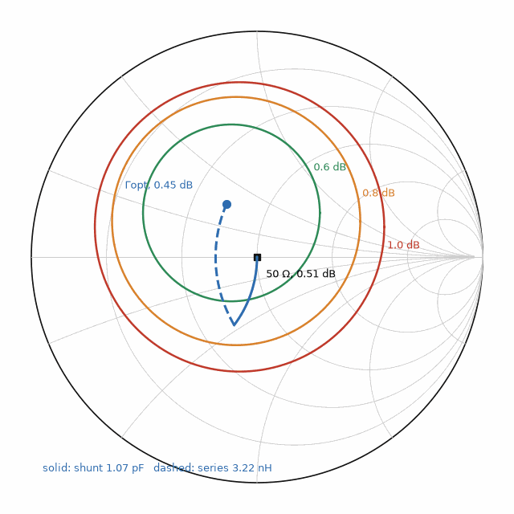
Figure 48.1 — The ATF-54143 at 2.0 GHz on the Smith chart, computed from the book's Touchstone excerpt: Γopt = 0.27∠120.1° (NFmin 0.45 dB), the 0.6, 0.8, and 1.0 dB noise circles, the 50 Ω point at 0.51 dB, and the path of the shunt-C, series-L network of Worked Example 48.3.

48.5 Python, simulators, and the fit-not-truth rule
The book's script touchstone_atf.py, about a hundred lines of standard Python with no packages, reads legacy Touchstone 1.x two-port S-parameter files in MA, DB, or RI format, detects the noise block, and computes K, μ, MSG, noise figure, available gain, and noise circles; it produced every number in this chapter. The open-source scikit-rf package does the same and more: rf.Network('ATF-54143_3V_60mA.s2p') loads the file. Its separate f_noise axis gives the raw noise-point frequencies; nfmin_db, g_opt, and rn are exposed on the S-parameter grid, so check for interpolation before comparing them with the vendor's original noise rows. Its plotting functions draw Smith charts. Book 8, Firmware and Software for Electronics, teaches the Python behind such scripts in "Python on the Bench".
Simulators read the same files. Commercial RF suites load them as S-parameter blocks with noise, ngspice added S-parameter analysis in version 39 and later releases add Touchstone support, and Qucs-S provides an S-parameter file component with its Qucsator engine; LTspice has no native S-parameter element, so a measured device must be approximated there by an equivalent circuit. Check the manual of the version installed before relying on any of them, especially for the noise block.
A Touchstone file is a measurement, not a model. It holds at the bias, temperature, and reference planes in its comments and at its frequency points, and nothing between or beyond them is certain: interpolation between points is a guess, extrapolation outside the range is a hope, and a fixture that differs from the vendor's moves every number. The same rule that Book 3 applies to SPICE models applies here: a fit is not the truth. Measure the first prototype, and compare.
Key idea. A Touchstone file is the measured device. Read its comments for the bias and reference planes, its option line for the units and format, and its data in the order S11, S21, S12, S22; then gain, stability, and noise circles follow in a few lines of code, valid only where the measurement was made.
From the Bench
Before using any vendor file, plot |S21| and |S12| against frequency and confirm that the gain falls with frequency and stays well above the isolation; that one plot catches a wrong data order, a wrong unit on the option line, and a file for a different bias. When you measure your own device on a VNA, save the file with the bias, temperature, fixture, and calibration in the comments, because six months later nobody will remember them.
On the Job
Device modeling and characterization engineers measure transistors and passives on probe stations and fixtures, extract S-parameter and noise-parameter files and compact models, and publish data for design engineers. Their work includes calibration, de-embedding, automation, and checking models across stated bias and temperature ranges. Microwave measurement experience is central; some positions ask for graduate study, while others emphasize relevant lab, test, or device-characterization experience.

Practice
1. A file has the option line '# MHz S DB R 50' and the data line '2000 −4.15 −168.3 17.28 73.3 −24.44 33.3 −15.39 −117.0'. Find |S11| and |S21| as magnitudes.
2. A noise line reads '2.4 0.52 0.26 145.8 0.04'. Find Rn in ohms and Zopt.
3. With the 2.0 GHz data, find the noise figure for Γs = 0.5∠120.1°, the right angle at nearly twice the magnitude.
4. Why must a three-port file be read in the row order S11, S12, S13 when a two-port file is not?
5. A design uses the ATF-54143 file up to 3 GHz and the circuit is simulated to 10 GHz to check stability. What is wrong, and what should be done?
6. Find the series inductance and shunt capacitance that present Zopt = 34.5 + j17.4 Ω from 50 Ω at 2.4 GHz, using the same topology as Worked Example 48.3.

What You’ll Actually Use
Everyday working tools
- Option line: # [unit] [S|Y|Z|H|G] [MA|DB|RI] R [ohms]; defaults GHz S MA R 50.
- Two-port data order: S11, S21, S12, S22; three or more ports: row order.
- Noise block: f, NFmin (dB), |Γopt|, ∠Γopt, Rn/Z0 (version 1.1).
- K, μ, MSG = |S21|/|S12|; F = Fmin + (4Rn/Z0)|Γs − Γopt|²/((1 − |Γs|²)|1 + Γopt|²).
Mostly for exams and deeper study
- Noise circle center Γopt/(1 + N) and radius √(N² + N(1 − |Γopt|²))/(1 + N).
- Version 2.0 keywords and the [Two-Port Data Order] option.

Chapter 49. FMCW Radar Front Ends at 24, 60, and 77 GHz
A car's corner radar, a smart speaker that sees a hand wave, and a sensor that counts the breaths of a sleeping patient all use the same trick: transmit a chirp whose frequency climbs linearly, mix the echo with the chirp still being sent, and read the distance from a beat tone a few megahertz wide. The hard part, a millimeter-wave front end, now fits on one chip.
Where you meet this: Automotive adaptive cruise control and corner radars at 76 to 81 GHz, industrial level and occupancy sensors at 60 GHz, motion detectors and door openers at 10 and 24 GHz, gesture sensing, and vital-sign monitoring.
Chapter 27 developed the radar equation and the FMCW principle. This chapter designs the front end: the chirp generator, the transmit and receive chains, the mixer and its intermediate-frequency, IF, filter, and the antenna arrays, using numbers typical of single-chip radar sensors. The signal processing, range and Doppler FFTs and the angle estimate, is treated here only as far as it sets the front-end specification.

49.1 The chirp and the beat
A chirp of bandwidth B swept in a time Tc has a slope S = B/Tc. A target at range R returns the chirp delayed by τ = 2R/c, and mixing it with the transmitted chirp gives a beat at fb = Sτ = 2SR/c. The range resolution depends only on the bandwidth, ΔR = c/(2B); the maximum range is set by the highest beat the IF chain passes; and the velocity follows from the phase change between successive chirps.
fb = 2 S R / c, ΔR = c / (2B), Rmax = fIF,max c / (2S), Δv = λ / (2 N Tc), vmax = λ / (4 Tc)

Worked Example 49.1
Problem. A 77 GHz sensor has an IF bandwidth of 10 MHz. Compare a 4 GHz chirp and a 1 GHz chirp, each 40 µs long, for range resolution and maximum range. For the 1 GHz chirp, find the beat of a car at 50 m, and the velocity resolution and maximum unambiguous velocity for 128 chirps.
Solution. 4 GHz: S = 100 MHz/µs, ΔR = 3.75 cm, and the 10 MHz IF limits the range to 10⁷ × 3×10⁸/(2 × 10¹⁴) = 15 m, a short-range corner sensor. 1 GHz: S = 25 MHz/µs, ΔR = 15 cm, Rmax = 60 m, and a car at 50 m beats at 2 × 2.5×10¹³ × 50/2.998×10⁸ = 8.34 MHz, inside the IF. With λ = 3.89 mm, Δv = 0.00389/(2 × 128 × 40×10⁻⁶) = 0.38 m/s and vmax = 0.00389/(4 × 40×10⁻⁶) = 24 m/s. The bandwidth trades resolution for range at a fixed IF; a long-range mode uses a shallow slope, a short-range mode a steep one, and real sensors interleave both.

49.2 The front end on one chip
A single-chip sensor such as the TI IWR6843, at 60 to 64 GHz, or the IWR1843, at 76 to 81 GHz, integrates three transmit and four receive chains, a ramp generator built from a fractional-N synthesizer, Chapter 39, mixers, IF amplifiers and filters, ADCs, and a signal processor, in 45 nm RF CMOS. The IWR6843 data sheet lists 12 dBm of transmit power, 4 GHz of chirp bandwidth, ramp slopes up to about 250 MHz/µs, and a 10 MHz maximum IF. SiGe BiCMOS, Chapter 46, builds the same functions with more transmit power and lower noise, and it remains common in long-range automotive sensors.
Three transmitters and four receivers form a virtual array of twelve elements when the transmitters take turns, by time or by code, so a small antenna on the package resolves angle to about 2/N radians, 9.5° for twelve elements in a line. The antennas are patch or slot arrays printed on the package or the board, fed by lines whose loss at 77 GHz, several tenths of a decibel per centimeter, keeps them short.

49.3 The budget and phase noise
The radar equation of Chapter 27 sets the received power, and the integration over a chirp and over many chirps sets the signal-to-noise ratio. Phase noise matters less in FMCW than its level suggests, because the transmitted and received chirps come from the same oscillator: for a delay τ, phase noise at offset fm is suppressed by the factor 2 sin(πfmτ), which at short range is tiny. Leakage from transmitter to receiver and strong close reflections, the bumper or a radome, are the cases where phase noise still sets the floor.

Worked Example 49.2
Problem. A 77 GHz sensor transmits 12 dBm through antennas of 10 dBi each, transmit and receive. Find the received power from a car of 10 m² radar cross section at 50 m, and the signal-to-noise ratio for one 40 µs chirp and for 128 chirps, assuming a 12 dB receiver noise figure. Find the range at which the 128-chirp SNR falls to 13 dB, and the suppression of the oscillator's phase noise at 1 MHz offset for a reflection at 1 m.
Solution. With λ = 3.89 mm, Pr = PtG²λ²σ/((4π)³R⁴) = −107.1 dBm. The noise in the 25 kHz bandwidth of one 40 µs chirp is −174 + 12 + 44.0 = −118.0 dBm, so the SNR is 10.9 dB per chirp and 10.9 + 10 log 128 = 32.0 dB after 128 chirps. The SNR falls as R⁴, 40 dB per decade, so 13 dB is reached at 50 × 10^(19/40) = 149 m. A reflection at 1 m has τ = 6.67 ns and 2 sin(π × 10⁶ × 6.67×10⁻⁹) = 0.042, a suppression of 27.6 dB. TI lists 12 dB as the typical receiver noise figure for the IWR6843 at 60 to 64 GHz. This example uses that value only as an illustrative proxy for a generic 77 GHz front end, not as a 77 GHz device specification.
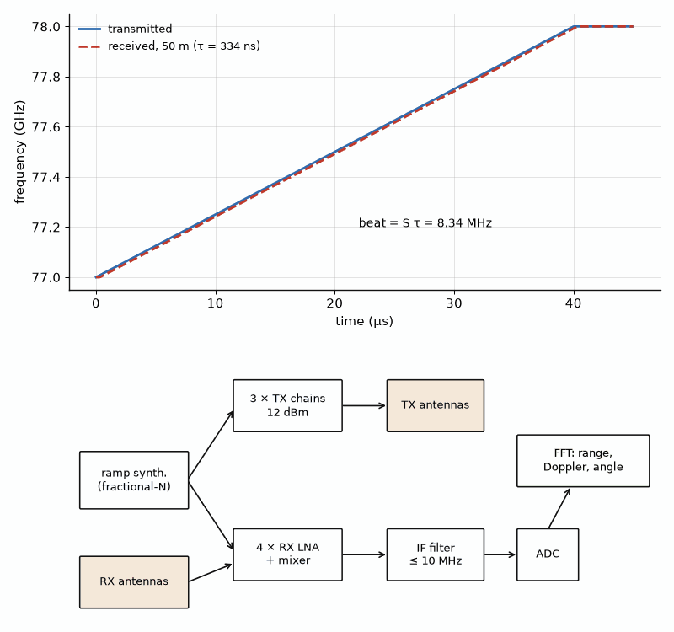
Figure 49.1 — Above: transmitted and received chirps of Worked Example 49.1 (1 GHz in 40 µs) for a target at 50 m; the beat is the constant frequency difference, 8.34 MHz. Below: the single-chip front end, with ramp synthesizer, three transmit chains, four receive chains with mixers, IF filters, and ADCs.

49.4 Sensors a reader can build
Hobby modules make the principle tangible. The HB100, a 10.525 GHz Doppler module, and 24 GHz modules such as the CDM324 output the Doppler beat directly: fd = 2v/λ is 702 Hz for a target moving at 10 m/s toward a 10.525 GHz module and 1.61 kHz at 24.125 GHz, in the audio range, so a sound card or a microcontroller's ADC measures speed. Single-chip 60 GHz evaluation boards measure range, angle, and even breathing, since chest motion of a few millimeters is a large phase change at a 5 mm wavelength. Google's Soli gesture radar, described by Lien and colleagues in 2016, used a 60 GHz chip with about 7 GHz of bandwidth, a range resolution of 2.1 cm, and relied on fine phase tracking for gestures smaller than that.
Bipolar version. The same front end in SiGe has higher transmit power per chain and lower flicker noise in the mixers, which helps at the low IF frequencies of short-range and vital-sign sensing; the architecture does not change.
Where this continues. Measuring chirps, their linearity, and pulsed RF is covered in Book 9, Test and Measurement Instruments, "Bursts, Chirps, and Pulses: BLE, LoRa, FMCW Radar, and Pulsed RF". The FFTs, tracking filters, and point clouds that turn the beat into objects belong to Book 8, Firmware and Software for Electronics, in "Fixed-Point Math and DSP" and "Cameras, Point Clouds, and Edge AI".
Key idea. In FMCW the bandwidth sets the range resolution, the IF bandwidth and the slope set the maximum range, and the shared oscillator cancels most of the phase noise. A one-chip front end with a few transmit and receive chains forms a virtual array that resolves angle as well.
From the Bench
Before measuring targets, record the radar's response with nothing in front of it in a room lined with absorber or pointed at open sky: the bumps that remain are leakage, the radome, and the mounting bracket, and they set the floor every real target must clear. Check the chirp's linearity with a delay line or a corner reflector at a known distance; a nonlinear ramp smears the beat into several range bins and looks like a bad antenna.
On the Job
Radar systems engineers at automotive suppliers and sensor companies define chirp plans, antenna arrays, and link budgets, then verify them in chambers and on test tracks. The role spans RF front ends, signal processing, safety standards, and extensive measurement. Useful preparation includes RF and signal-processing coursework, measurement, and experience with radar data. Degree requirements vary by employer, and related engineering or test experience can also be relevant.

Practice
1. Find the range resolution of a 24 GHz radar with 250 MHz of bandwidth.
2. A chirp sweeps 2 GHz in 50 µs. Find the beat frequency for a target at 20 m.
3. A 77 GHz radar sends 256 chirps of 30 µs. Find its velocity resolution and maximum unambiguous velocity.
4. Find the Doppler shift of a person walking at 1.5 m/s toward a 24.125 GHz module.
5. By how many decibels does the received power from a target fall when its range doubles?
6. Find the phase-noise suppression at 100 kHz offset for a reflection at 0.3 m.

What You’ll Actually Use
Everyday working tools
- fb = 2SR/c; ΔR = c/(2B); Rmax = fIF,max c/(2S).
- Δv = λ/(2NTc); vmax = λ/(4Tc).
- Doppler fd = 2v/λ.
- Received power ∝ R⁻⁴, 12 dB per doubling of range.
Mostly for exams and deeper study
- Phase-noise range correlation 2 sin(πfmτ).
- Virtual array of NTX × NRX elements; angle resolution about 2/N radians.

Chapter 50. Microwave Photonics: Radio over Light and Optical Phased Arrays
A radio signal can ride on a laser beam through kilometers of fiber that weighs grams and loses a fraction of a decibel per kilometer, where coaxial cable would lose everything. The same marriage of optics and microwaves steers radar beams without squint, generates oscillators with record-low phase noise, and points the laser beams of solid-state lidar with no moving parts.
Where you meet this: Radio-over-fiber links in cellular networks and stadiums, antenna remoting in radio telescopes and ships, wideband phased-array radar, optoelectronic oscillators, and optical phased arrays for lidar.
Book 3's "Lasers, VCSELs, APDs, SPADs, and Image Pixels" covers the devices: lasers, modulators, and photodiodes. This chapter uses them as RF components with gain, noise, and bandwidth, in the language of the rest of this book.

50.1 The analog optical link
The simplest link modulates the intensity of a laser with the RF signal, carries it over fiber, and recovers the RF current in a photodiode. With a continuous laser and a Mach-Zehnder modulator, MZM, biased at quadrature, the small-signal link gain depends on the average photocurrent Idc, the modulator's half-wave voltage Vπ, and the resistances at the two ends. For a modulator with a matched input and a photodiode driving a load R directly, the gain is (πIdcR/Vπ)²; a matched photodiode output gives a quarter of it, 6 dB less. The gain rises with the square of the photocurrent, so a link is a power budget in optical milliwatts as much as an RF one.
G = (π Idc R / Vπ)² (quadrature MZM, matched modulator input, photodiode into R)

Worked Example 50.1
Problem. A link uses an MZM with Vπ = 3 V and a photodiode current of 10 mA into 50 Ω. Find its gain, the gain with a matched detector, and the photocurrent needed for 0 dB.
Solution. G = (π × 0.01 × 50/3)² = 0.524² = 0.274, −5.6 dB; with a matched detector, −11.6 dB. For 0 dB, πIdcR/Vπ = 1 gives Idc = 3/(π × 50) = 19.1 mA. Links reach positive gain with lower-Vπ modulators, thin-film lithium niobate devices reach about a volt, or with more optical power, limited by what the photodiode can absorb without compressing. The noise figure of such a link is typically 20 to 40 dB unless the optical power is high, so an RF amplifier usually precedes it.

50.2 Radio over fiber in networks
Cellular networks carry radio between baseband units and antennas over fiber, mostly as digitized samples, the CPRI and eCPRI interfaces, and in some systems as analog radio over fiber, which keeps the remote unit simple. Distributed antenna systems in stadiums and buildings, and antenna remoting for radio telescopes, use analog links where bandwidth and phase stability matter more than noise figure. Book 5, Communications, Wireless, and SDR, covers the network side in "Massive MIMO and Beamforming".

50.3 True time delay and beam squint
A phased array steered with phase shifters, Chapter 8, sets a phase that is correct at one frequency. At another frequency the same phase points the beam elsewhere, an effect called beam squint, which limits the bandwidth of wideband arrays. A true time delay, TTD, is correct at every frequency. Optical fiber provides delays of picoseconds to microseconds with low loss and no dispersion in the RF sense, so photonic beamformers switch lengths of fiber, or tune dispersion, to set each element's delay.
phase steering: sin θ(f) = sin θ0 · f0 / f, TTD: τ = d sin θ0 / c, fiber length = c τ / ng

Worked Example 50.2
Problem. An array with half-wavelength spacing at 10 GHz, 15 mm, is steered to 30° by phase shifters. Find the beam direction at 11 GHz. Find the true time delay per element that holds 30° at all frequencies and its length in fiber with group index 1.468.
Solution. The phase shifters hold 90° per element. At 11 GHz, sin θ = 0.5 × 10/11 = 0.455, θ = 27.0°, a squint of 3°, larger than the beamwidth of a large array. The delay per element is τ = 0.015 × 0.5/3×10⁸ = 25.0 ps, 5.1 mm of fiber. A 16-element array needs delays up to 15 × 25 = 375 ps, 7.7 cm of fiber, easily switched in steps; the same delays in coaxial cable would weigh far more and lose more at 10 GHz.
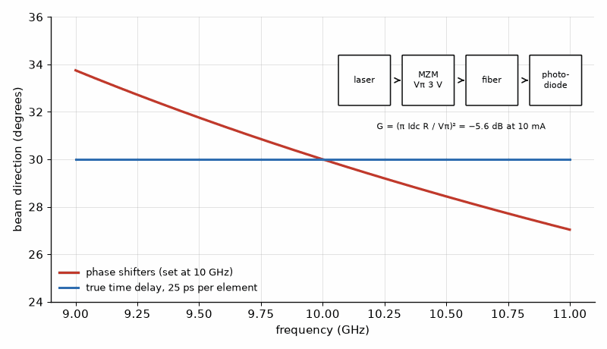
Figure 50.1 — Beam direction against frequency for the 16-element array of Worked Example 50.2 steered to 30° at 10 GHz: phase-shifter steering squints from 33.7° at 9 GHz to 27.0° at 11 GHz, while true time delay holds 30°. Inset: the link of Worked Example 50.1, laser, MZM, fiber, photodiode.

50.4 Optoelectronic oscillators and photonic signal generation
An optoelectronic oscillator, OEO, closes a loop through a modulator, a kilometer or more of fiber, a photodiode, an amplifier, and a filter. The fiber's long delay acts as a resonator with an enormous effective Q, so OEOs reach phase noise at 10 GHz far below quartz-referenced synthesizers at offsets of a few kilohertz and above. Beating two lasers on a fast photodiode generates millimeter and terahertz signals, and optical frequency combs, locked to optical references, give the lowest-noise microwave signals yet made. These are laboratory and specialist instruments; Chapter 26's oscillators remain the working tools.

50.5 Optical phased arrays
An optical phased array, OPA, is the antenna array of Chapter 8 at a wavelength of 1550 nm, built in silicon photonics: a row of waveguide antennas, each with a thermo-optic or electro-optic phase shifter, steers a beam in one direction, and tuning the laser wavelength steers it in the other through grating emitters. The grating-lobe rule is the same as for microwave arrays, d < λ/(1 + sin θmax), so steering to ±30° without grating lobes needs a pitch below 1.033 µm, close to the size of a single waveguide. That is why OPAs with large apertures use non-uniform spacing or accept a limited field of view. OPAs are a candidate for solid-state lidar; most lidars in production still use mechanical or MEMS scanning, Book 3's "Sensing Devices: MEMS, Hall, Gas, and Quantum" covers the detectors they use.
Key idea. A microwave photonic link is an RF component with a gain set by optical power and modulator voltage; its strengths are low loss over distance, wide bandwidth, and true time delay, and its weakness is noise figure. Optical phased arrays follow the same array rules as microwave ones at a wavelength two thousand times smaller.
From the Bench
Optical power at a photodiode is invisible and can be enough to damage an eye or the detector. Measure it with an optical power meter before connecting the photodiode, keep connectors capped, and clean every fiber end face with the proper tool before mating it; a speck of dust on a connector can cost several decibels of RF gain, because the link gain falls as the square of the optical loss.
On the Job
Microwave photonics engineers work across optics and RF at test-equipment makers, fiber-network companies, research laboratories, and defense or space contractors. They design links and beamformers, characterize modulators and photodiodes, and model noise across both domains. Useful preparation includes RF, optics, measurement, and noise analysis. Graduate study can help for research-heavy roles; relevant design and laboratory experience can also be valuable.

Practice
1. Find the gain of a link with Vπ = 1.5 V, Idc = 10 mA, and R = 50 Ω.
2. A link has 1 dB of extra optical loss at a dirty connector. By how many decibels does the RF gain fall?
3. Find the beam direction at 9 GHz of the phase-steered array of Worked Example 50.2.
4. Find the true time delay per element for an array with 10 mm spacing steered to 45°.
5. Find the maximum pitch of an optical phased array at 1550 nm that steers to ±45° without grating lobes.
6. Explain in one or two sentences why a photonic beamformer does not squint.

What You’ll Actually Use
Everyday working tools
- MZM link gain (πIdcR/Vπ)²; a matched detector gives 6 dB less.
- Beam squint: sin θ(f) = sin θ0 f0/f.
- True time delay τ = d sin θ0/c; fiber length cτ/ng.
- Grating-lobe rule d < λ/(1 + sin θmax).
Mostly for exams and deeper study
- RF gain falls 2 dB per dB of optical loss.
- Optoelectronic oscillator: fiber delay as a high-Q resonator.

Chapter 51. Receivers and Transmitters You Can Build
A coil, a variable capacitor, a germanium diode, and a long wire will pull a radio station out of the air with no battery at all. A few more parts make a Morse transmitter that can reach across a continent on a watt when propagation and the antenna cooperate, and a twenty-dollar USB dongle can receive signals from aircraft and weather satellites.
Where you meet this: Amateur radio, school and maker projects, emergency communication, and the first instruments of a home RF lab.
This chapter applies earlier chapters to four builds a reader can finish on a kitchen table: a crystal radio, an FM superheterodyne, a low-power Morse transmitter, and a software-defined receiver. Each comes with the numbers that make it work and a measurement that confirms it. A transmitter needs a license; receivers do not.

51.1 The crystal radio
A crystal radio is a resonator, Chapter 6, a detector, and an antenna. A coil of 230 µH tuned by a 30 to 365 pF variable capacitor resonates from 549 kHz to 1.92 MHz, covering the AM broadcast band, 530 to 1700 kHz, once the antenna's capacitance is added. A germanium or Schottky diode rectifies the signal, and high-impedance earphones convert the audio current to sound. The selectivity is the loaded Q of the tank: tap the antenna and the diode onto the coil to load it less and the stations separate. With a long wire and a good ground a strong local station is loud; the radio is also a sensitive test of the antenna theory of Chapter 13.
f = 1 / (2π√(LC)): 230 µH with 365 pF → 549 kHz; with 30 pF → 1.92 MHz

51.2 An FM superheterodyne
Broadcast FM, 88 to 108 MHz, uses a peak deviation of 75 kHz and audio up to 15 kHz, so Carson's rule gives a bandwidth of 2(75 + 15) = 180 kHz. A superheterodyne converts the station to an intermediate frequency of 10.7 MHz, where ceramic filters set the selectivity. With the local oscillator above the signal, a station at 88.0 MHz needs an oscillator at 98.7 MHz, and the image, 2 × 10.7 = 21.4 MHz above the station, lands at 109.4 MHz, 1.4 MHz outside the band, where the front-end filter must reject it. Single-chip FM receivers do all this, often with a low IF and digital demodulation, but building the classic version with a mixer, a ceramic filter, and a quadrature detector shows each block of Chapter 29.

51.3 A Morse transmitter for 40 meters
A crystal oscillator, a buffer, and a class C or E output stage, Chapter 43, make a one- to five-watt CW transmitter for the 40 m amateur band; 7.030 MHz is a common low-power calling frequency. Keying the oscillator or the buffer on and off sends Morse code. The output must pass a low-pass filter, because the harmonics of a saturated stage are strong and U.S. rules require spurious emissions below 30 MHz to be at least 43 dB below the fundamental. In the United States a Technician-class amateur licensee may transmit CW in part of the 40 m band, 7.025 to 7.125 MHz; other countries have their own rules and licenses, and nobody may transmit without one.

Worked Example 51.1
Problem. Design a seven-element Chebyshev low-pass filter with 0.1 dB ripple and a 7.5 MHz cutoff for a 50 Ω, 7.030 MHz transmitter, with capacitors at the ends. Find the element values and the attenuation at the second and third harmonics.
Solution. The prototype values are g = 1.1811, 1.4228, 2.0966, 1.5733, 2.0966, 1.4228, 1.1811. With ωc = 2π × 7.5 MHz, capacitors are g/(ωcR) and inductors gR/ωc: C1 = C7 = 501 pF, L2 = L6 = 1.51 µH, C3 = C5 = 890 pF, L4 = 1.67 µH. The attenuation is 10 log(1 + ε² cosh²(7 cosh⁻¹(f/fc))) with ε² = 10^0.01 − 1: at 14.06 MHz it is 53.1 dB, and at 21.09 MHz 80.6 dB. A saturated stage whose second harmonic is 20 dB below the carrier ends near 73 dB below, well inside the 43 dB rule. Standard values of 470 pF plus 33 pF, 820 pF plus 68 pF, and toroidal inductors wound and checked on a NanoVNA make it buildable.

51.4 The software-defined receiver
An RTL-SDR dongle combines a tuner chip, the R820T2 in most versions, covering about 24 to 1766 MHz, with an 8-bit ADC sampling at up to about 2.4 million samples per second without dropped samples. Eight bits give an ideal dynamic range of 6.02 × 8 + 1.76 = 49.9 dB in the full bandwidth, and filtering to a 12.5 kHz voice channel adds a processing gain of 10 log(2.4×10⁶/12.5×10³) = 22.8 dB. With a laptop it receives FM broadcast, aircraft, marine, and amateur signals, ADS-B at 1090 MHz, and weather-satellite images at 137 MHz. A propagation monitor that logs the signal strength of distant beacons through the day turns the receiver into an instrument for Chapter 14. Book 5, Communications, Wireless, and SDR, develops the receiver architecture in "The 2026 Band Plan and the Software-Defined Receiver", and Book 9, Test and Measurement Instruments, uses SDRs as instruments in "The Budget Bench: NanoVNA, tinySA, SDRs, and Low-Cost Scopes and Supplies".
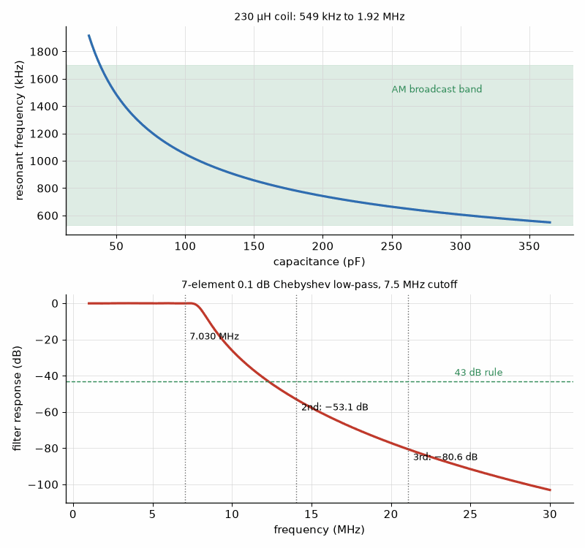
Figure 51.1 — Above: the crystal radio's tuning range, resonant frequency against capacitance for 230 µH, with the AM broadcast band shaded. Below: attenuation of the seven-element 0.1 dB Chebyshev low-pass filter of Worked Example 51.1 against frequency, with the 7.030 MHz carrier and its second and third harmonics marked.
Key idea. Every radio a reader can build is a resonator, an amplifier, a mixer, a filter, and a detector arranged in a familiar order; the numbers of earlier chapters size each one, and a transmitter adds the duty of a clean spectrum and a license.
From the Bench
Before a homebuilt transmitter ever meets an antenna, connect it to a 50 Ω dummy load through an attenuator rated for its power, and look at its output on a spectrum analyzer or a tinySA: confirm the carrier frequency, the harmonics below the 43 dB line, and the absence of spurious oscillations when the key is up. A transmitter that looks clean on a scope can still oscillate at 150 MHz.
On the Job
Amateur radio can provide hands-on experience with antennas, transmitters, interference, and measurement, and that experience can help in RF work. It is one route among several: coursework, technician and test roles, and adjacent engineering experience can also build relevant skills.

Practice
1. Find the inductance that tunes 530 kHz with a maximum capacitance of 365 pF.
2. Find the Carson bandwidth of an FM signal with 5 kHz deviation and 3 kHz audio, as used by narrowband FM voice.
3. An FM receiver with a 10.7 MHz IF and the LO above the signal is tuned to 100.1 MHz. Find the LO and the image frequency.
4. Find the element values of a seven-element 0.1 dB Chebyshev low-pass filter for 50 Ω with a 15 MHz cutoff, capacitors at the ends.
5. Find the ideal dynamic range of a 12-bit ADC and the processing gain from 2.4 MHz to 2.4 kHz.
6. Explain in one or two sentences why a transmitter's low-pass filter is needed even if the output stage is tuned.

What You’ll Actually Use
Everyday working tools
- f = 1/(2π√(LC)).
- Carson bandwidth 2(Δf + fm); image = signal ± 2 IF.
- Low-pass prototype: C = g/(ωcR), L = gR/ωc.
- ADC dynamic range 6.02N + 1.76 dB; processing gain 10 log(Bin/Bout).
Mostly for exams and deeper study
- Chebyshev attenuation 10 log(1 + ε² cosh²(n cosh⁻¹(f/fc))).
- U.S. spurious rule below 30 MHz: 43 dB below the fundamental.

Chapter 52. Antennas and the Sky: LoRa, GPS, Satellites, and the Hydrogen Line
The International Space Station passes overhead several times a day, and its amateur radio can be heard with a handheld receiver and a stick antenna, its frequency sliding by a few kilohertz as it goes. The hydrogen in our galaxy glows at 1420 MHz, faintly enough that a small dish and a careful receiver are needed, and brightly enough that a backyard telescope can map the spiral arms.
Where you meet this: LoRa and IoT gateways, GPS receivers and their antennas, amateur and weather-satellite stations, model rocket and balloon telemetry, and amateur radio astronomy.
This chapter turns the antennas of Chapters 7, 13, and 16 and the link budget of Chapter 30 into projects. A NanoVNA, Chapter 16's instrument at the price of a meal, is the measuring tool throughout.

52.1 Trimming a dipole with a NanoVNA
A half-wave dipole is about 95 % of a free-space half wavelength long, because the end effect of a wire of finite thickness shortens it. For the 2 m amateur band at 145.8 MHz that is 0.95 × 1.028 m = 0.977 m tip to tip. Cut it a little long, measure the frequency of minimum SWR with the NanoVNA, and shorten both halves by the fraction the resonance sits low: a minimum at 141.4 MHz, 3 % low, means removing 3 % of the length.

52.2 Antennas for LoRa and GPS readers
A 915 MHz LoRa reader with a quarter-wave whip needs 299.79/915/4 = 8.19 cm of wire over a ground plane at least that large in radius; shorter ground planes raise the resonant frequency and lower the efficiency, and the NanoVNA shows both. A GPS receiver needs a right-hand circularly polarized antenna for L1 at 1575.42 MHz. The ceramic patch common in GPS modules is shortened by its high-permittivity substrate: with εr ≈ 20, the half-wave patch is c/(2f√εr) = 21 mm across, and fringing makes it somewhat smaller in practice. Two orthogonal modes fed 90° apart, or a nearly square patch with trimmed corners, make the polarization circular.

Worked Example 52.1
Problem. GPS L1 C/A signals arrive at a minimum of −128.5 dBm. With a 3 dBic patch and a receiver noise figure of 2 dB, find C/N0. Then find the link margin of a 915 MHz LoRa telemetry link from a rocket at 10 km, with +20 dBm transmitted, dipole-class antennas of 2.15 dBi at both ends, and a receiver sensitivity of −132 dBm at spreading factor 10 and 125 kHz.
Solution. GPS: C/N0 = −128.5 + 3 − (−174 + 2) = 46.5 dB-Hz, enough to track, though a receiver indoors loses 20 dB or more. LoRa: the free-space loss at 10 km and 915 MHz is 20 log(10⁴) + 20 log(9.15×10⁸) − 147.55 = 111.7 dB, so the received power is 20 + 4.3 − 111.7 = −87.4 dBm and the margin to −132 dBm is 44.6 dB. The margin is needed: a rocket's whip has a null along its axis, which points at the ground station at launch and during descent, and spin and polarization mismatch cost more. Check the legal limits for the band and the antenna gain before flying.

52.3 Satellites overhead
A satellite in low Earth orbit moves at about 7.7 km/s, and the component along the line of sight changes from about +7 km/s at rise to −7 km/s at set, so its signal shifts by f × v/c: at 145.8 MHz, a 7.2 km/s radial velocity is a 3.50 kHz shift, and at 436.795 MHz, the downlink of the long-lived amateur satellite SO-50, it is 10.5 kHz. Receivers retune during the pass, by hand or by software that computes the orbit from published two-line element sets. When active, the ISS voice downlink at 145.800 MHz and SO-50's 436.795 MHz downlink can be received with a handheld radio and small directional antenna pointed by hand; verify current ARISS/AMSAT status before a live pass; weather-satellite images near 137 MHz need a turnstile or quadrifilar antenna and an SDR. NOAA ended operational POES data delivery on June 16, 2025; NOAA-15 and NOAA-19 were decommissioned on August 19 and August 13, 2025, respectively. NOAA left APT/LRPT enabled but said not to use it for operational purposes, so do not assume a live POES signal is available. Some Meteor-M spacecraft have carried digital LRPT broadcasts near 137 MHz; spacecraft and downlink availability can change, so check current operator information before planning a live capture. The receiver method remains useful with a recorded pass or simulated signal.
Doppler shift Δf = f · vradial / c; 145.8 MHz at 7.2 km/s → 3.50 kHz

52.4 A backyard radio telescope
Neutral hydrogen emits at 1420.405751768 MHz, the 21 cm line. A 1.2 m dish has a beamwidth of about 70λ/D = 12.3°, a low-noise amplifier at the feed and an SDR record the spectrum, and the galaxy's rotation Doppler-shifts the line by up to a few hundred kilohertz, which maps the spiral arms as the sky drifts through the beam. The signal is a small rise of the system noise, so the radiometer equation sets what can be seen: the smallest detectable temperature change is the system temperature divided by the square root of the bandwidth-time product.
ΔTmin = Tsys / √(B τ): 100 K, 2.4 MHz, 10 s → 0.020 K

Worked Example 52.2
Problem. A backyard system has Tsys = 100 K, a 2.4 MHz bandwidth, and integrates for 10 s. Find ΔTmin. Then find the frequency shift of hydrogen gas moving away at 100 km/s, and the beamwidth of the 1.2 m dish.
Solution. ΔTmin = 100/√(2.4×10⁶ × 10) = 100/4,899 = 0.020 K. The shift is 1420.4 MHz × 10⁵/3×10⁸ = 474 kHz, to a lower frequency, so the 2.4 MHz bandwidth holds the whole line. The beamwidth is 70 × 0.211/1.2 = 12.3°. The hydrogen line from the galactic plane raises the antenna temperature by tens of kelvins in a beam this wide, far above 0.02 K, which is why the project works with modest equipment; the difficulty is interference and the stability of the gain over the integration.
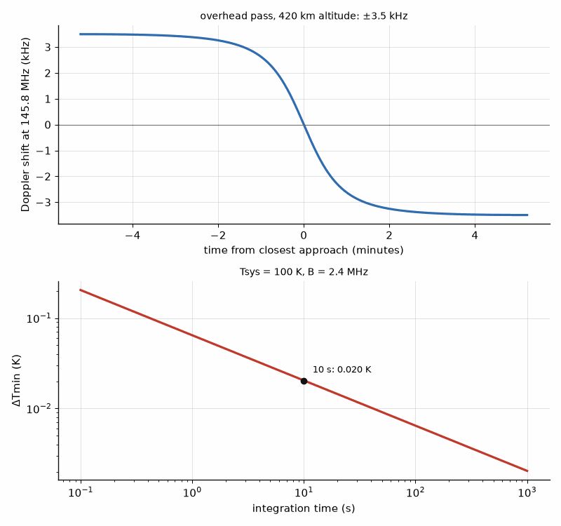
Figure 52.1 — Above: Doppler shift of a 145.8 MHz downlink during an overhead pass of a satellite at 420 km altitude, from +3.5 kHz at rise to −3.5 kHz at set. Below: minimum detectable temperature against integration time for Tsys = 100 K and 2.4 MHz bandwidth.
Where this continues. Book 5 treats satellite links and positioning as systems in "Satellites and Non-Terrestrial Networks" and "Ranging and Positioning"; Book 8, Firmware and Software for Electronics, programs the GPS and LoRa radios in "BLE, LoRa, and GPS Firmware"; and Book 9, Test and Measurement Instruments, describes the home lab in "Building the Home Lab, and Instruments You Make Yourself".
Key idea. Every sky project is a link budget and an antenna: the satellite's Doppler, the GPS signal's C/N0, the rocket's margin, and the hydrogen line's radiometer equation are each one line of arithmetic, and a NanoVNA confirms the antenna before the sky does.
This chapter closes the book where radio began, with a wire, a tuned circuit, and a signal from far away. Parts I and II built the passive and active circuits, Part III chose the devices and designed with them, and Part IV read measured data, built sensors, carried RF on light, and pointed antennas at the sky. The same few ideas, impedance, the load line, noise, and the link budget, carried every step.
From the Bench
Measure an antenna where it will be used. A whip measured on the bench without its ground plane, or a patch measured without the enclosure lid, resonates somewhere else in the finished product. Hold the NanoVNA's cable away from the antenna with a ferrite choke or clamp-on beads at the feed, and repeat the measurement with your hand near the cable: if the reading moves, the cable is part of the antenna.
On the Job
Ground-station and satellite communications engineers design and operate antennas, receivers, and tracking systems for university CubeSat stations and commercial networks. The work combines link budgets, antennas, orbit-prediction and control software, and launch operations. Useful preparation includes electrical or aerospace engineering, antennas, and hands-on satellite links. Amateur radio, CubeSat, and test roles can provide relevant experience; degree requirements vary by employer.

Practice
1. Find the length of a half-wave dipole for 435 MHz with a 0.95 end-effect factor.
2. A dipole cut for 145.8 MHz shows its SWR minimum at 150.2 MHz. Should it be lengthened or shortened, and by what percentage?
3. Find the length of a quarter-wave whip for 868 MHz.
4. Find the Doppler shift at 437 MHz for a radial velocity of 5 km/s.
5. How long must a 100 K, 2.4 MHz system integrate to reach ΔTmin = 0.005 K?
6. Find the beamwidth of a 3 m dish at the hydrogen line.

What You’ll Actually Use
Everyday working tools
- Half-wave dipole ≈ 0.95 λ/2; quarter-wave whip λ/4.
- Patch length ≈ c/(2f√εr).
- Doppler Δf = f vr/c.
- C/N0 = Pr + Gant − (−174 + NF) dB-Hz; free-space loss 20 log d + 20 log f − 147.55.
Mostly for exams and deeper study
- Radiometer equation ΔTmin = Tsys/√(Bτ).
- Beamwidth 70λ/D degrees.

Appendix A. Constants and Formulas Used in This Book
Speed of light c = 2.998 × 10⁸ m/s. Reference impedance Z0 = 50 Ω unless stated.
Reference stripline laminate: εr = 3.55, so λg = λ0/1.884; at 2.45 GHz, λ0 = 12.24 cm and λg = 6.49 cm. Reference microstrip: 0.508 mm thick, εr = 3.55, 50 Ω width 1.14 mm, εeff ≈ 2.79.
Decibels: P(dBm) = 10 log₁₀(P/1 mW); 0 dBm in 50 Ω is 0.224 V rms.
Reflection: Γ = (ZL − Z0)/(ZL + Z0); VSWR = (1 + |Γ|)/(1 − |Γ|); RL = −20 log₁₀|Γ|; ML = −10 log₁₀(1 − |Γ|²).
Line input impedance: Zin = Z0 (ZL + jZ0 tan βl)/(Z0 + jZL tan βl); quarter wave: Zin = Z0²/ZL.
L-network: Q = √(Rhigh/Rlow − 1), Xseries = Q Rlow, Xshunt = Rhigh/Q.
S-parameters: Zin = Z0(1 + S₁₁)/(1 − S₁₁); stability K = (1 − |S₁₁|² − |S₂₂|² + |Δ|²)/(2|S₁₂S₂₁|), Δ = S₁₁S₂₂ − S₁₂S₂₁.
Filter prototypes, third order: Butterworth g = 1, 2, 1; Chebyshev 0.1 dB g = 1.0316, 1.1474, 1.0316. Midband loss ≈ 4.343 Σgₖ/(FBW Qu) dB.
Rectangular waveguide TE₁₀ cutoff fc = c/2a; WR-90 a = 22.86 mm (6.56 GHz); WR-28 a = 7.112 mm (21.1 GHz).
Antennas: half-wave dipole Rrad ≈ 73 Ω, D = 1.64 (2.15 dBi); short dipole Rrad = 80π²(l/λ)²; Ae = Gλ²/4π; dish G = ηap(πD/λ)², θ₃dB ≈ 70λ/D degrees.
Link anchor: Pr/Pt = Gt Gr (λ/4πR)²; at 2.45 GHz and 100 m the path factor is 9.48 × 10⁻⁹ (−80.2 dB).
Arrays: β = −kd sin θ₀; no grating lobes for d/λ < 1/(1 + |sin θmax|); broadside beamwidth ≈ 0.886λ/(Nd) rad.
Wilkinson: lines √2 Z0, resistor 2Z0. Branch-line: Z0/√2 series arms. Coupled lines: Z0e = Z0√((1 + C)/(1 − C)), Z0o = Z0√((1 − C)/(1 + C)).
Microstrip: εeff = (εr + 1)/2 + (εr − 1)/(2√(1 + 12h/W)). 50 Ω on εr 3.55, h 0.508 mm: W = 1.14 mm. Stripline: Z0 = 30πb/[√εr(W + 0.441b)].
Bode-Fano (parallel RC): ∫ln(1/|Γ|)dω ≤ π/(RC). Chu: Qmin = 1/(ka)³ + 1/(ka). TE101: f = (c/2)√(1/a² + 1/d²).
Fresnel r1 = √(λd1d2/(d1 + d2)); two-ray breakpoint 4hthr/λ; knife edge J(0) = 6 dB; rain γ = kR^α dB/km.
Ferrite resonance f = γH, γ ≈ 28 GHz/T. Far field R = 2D²/λ. Gain comparison G = Gref + PAUT − Pref. Passive loss Te = (L − 1)T. Coupled filters Qe = g₀g₁/FBW, M = FBW/√(gᵢgᵢ₊₁). Series switch IL = 20 log|1 + Z/2Z₀|; ideal mixer loss 3.92 dB.
dBm = 10 log₁₀(P/1 mW); 1 W = 30 dBm; 1 dB of loss leaves 0.794 of the power. EIRP = Pout − Lfeed + Gant.
Load line: Ropt = (VDD − Vknee)²/(2P). 100 W: 10.13 Ω at 50 V/5 V knee; 3.13 Ω at 28 V/3 V knee.
Efficiency: ηD = Pout/PDC; PAE = (Pout − Pin)/PDC. Class A 50%; class B π/4 = 78.5%; η(α) = (α − sin α)/[4(sin(α/2) − (α/2)cos(α/2))].
Back-off: class A η ∝ Pout; class B η = (π/4)√(Pout/Pmax); ideal symmetric Doherty 78.5% at peak and at 6 dB back-off.
OIP3 = Ptone + ΔIM3/2. SFDR = (2/3)(IIP3 − Nfloor).
Thermal: Tj = Tamb + Pdiss Σθ. Ideal N-way combiner: Pout = (Σ√Pi)²/N; one of N failed leaves (N − 1)²/N².
Noise: kT0 = −174 dBm/Hz at 290 K; Te = T0(F − 1); F = F1 + (F2 − 1)/G1 + (F3 − 1)/(G1G2) + ….
PLL: fout = N fref; in-band noise = Lref + 20 log₁₀N. Leeson: L(Δf) ≈ 10 log₁₀{(2FkT/Ps)[1 + (f0/(2QLΔf))²]}. σφ = √(2∫L df); jitter = σφ/(2πf0).
Radar: Pr = PtG²λ²σ/[(4π)³R⁴]; ΔR = c/(2B); Runamb = c·PRI/2; fd = 2v/λ; FMCW fb = 2RS/c.
LNA: F = Fmin + (4Rn/Z0)|Γs − Γopt|²/[(1 − |Γs|²)|1 + Γopt|²]. Mixer image = fRF ∓ 2fIF; spurs at |m fLO ± n fRF| = fIF.
Link: Lpath = 20 log₁₀(4πdf/c); C/N0 = EIRP − Lpath + G/T + 228.6 dBHz. 12 GHz, 38,000 km: 205.6 dB.
|Γ| = (VSWR − 1)/(VSWR + 1); 10:1 gives 0.818, 66.9% reflected. Beam P = VI; perveance K = I/V^1.5.
Exposure: S = EIRP/(4πR²); FCC public 10 W/m² (1.5–100 GHz), f/1500 mW/cm² (300–1500 MHz); ground factor 2.56.
Class E (50% duty): R = 0.5768 VDD²/P, C = 0.1836/(ωR), vpk = 3.562 VDD. Outphasing: Pout = Pmax cos²φ.
Class A η = 50 %, class B π/4; Ropt = (VDD − Vk)²/(2P). Class D V₁ = (2/π)VDD, capacitive loss C VDD² f. Class J: Z₁ = Ropt(1 + jα), Z₂ = −j(3π/8)αRopt. Doherty back-off peak 20 log₁₀(1 + r). Rayleigh envelope: Pr{p > k⟨p⟩} = exp(−k); class B average ⟨η⟩ = (π/4)⟨v²⟩/⟨v⟩. Boost capacitor C = It/ΔV; delay error ≈ πBΔt.
PAE = (Pout − Pin)/PDC; P_IM3 = 3Pout − 2·OIP3; class B η = (π/4)10^(−BO/20). Fractional-N: fout = (N + F/2^k)fref; in-band L ≈ FOM + 10 log f_PFD + 20 log N. DDS: fout = FTW·fclk/2^n, spur ≈ −6.02P dBc. Directivity error 20 log(1 ± 10^(−(RL + D)/20)).
Stacked devices: Vdrain,peak ≤ N Vmax, VDD ≈ N Vmax/2. Series transformer combining: each primary sees RL/(N n²). Combined power N P₁ less combiner loss.
Class recipes: push-pull Rdd = 2(VDD − Vk)²/P; class E R = 0.5768 VDD²/P, C = 0.1836/(ωR), vpk = 3.562 VDD; class D Pout = (2VDD/π)²/(2R), loss CVDD²f; class F (2nd, 3rd) V1 = 1.155(VDD − Vk); inverse F R = (π²/4)(VDD − Vk)²/(2P).
HBT ballast: Re > φ Rth VCE − VT/Ic. Doherty: back-off peak 20 log(1 + r), Rm = ZT, RL = Rm/(1 + r). Channel temperature Tcase + Pdiss Rth.
Switch stack N ≥ (1 + |Γ|)√(2PZ0)/Vdevice; series loss 20 log(1 + Ron/(2Z0)). MEMS pull-in √(8kg0³/(27ε0A)). Johnson figure Ec vsat/(2π).
Acoustic resonator: (fp − fs)/fp ≈ (4/π²)kt², Cm = C0[(fp/fs)² − 1], Lm = 1/(ωs²Cm), Rm = ωsLm/Q. Drift = TCF ΔT f.
Touchstone 1.1: # GHz S MA R 50 by default; two-port order S11 S21 S12 S22; noise lines f, NFmin (dB), |Γopt|, ∠Γopt, Rn/Z0. μ = (1 − |S11|²)/(|S22 − ΔS11*| + |S12S21|); MSG = |S21|/|S12|.
FMCW: fb = 2SR/c, ΔR = c/(2B), Δv = λ/(2NTc), vmax = λ/(4Tc); phase-noise correlation 2 sin(πfmτ).
Microwave photonics: MZM link G = (πIdcR/Vπ)²; true time delay τ = d sin θ/c; beam squint sin θ(f) = sin θ0 f0/f; grating lobes d < λ/(1 + sin θmax).
Bench radio: Carson B = 2(Δf + fm); ADC 6.02N + 1.76 dB; Doppler Δf = f vr/c; radiometer ΔTmin = Tsys/√(Bτ); hydrogen line 1420.405751768 MHz.

Appendix B. Answers to the Practice Problems
Every practice problem is worked in full below: the idea that solves it, the numbers, a check that the result makes sense, and the mistake that most often goes wrong. Work each problem before reading its solution.

Chapter 1
1. Idea: the free-space wavelength is c/f, and in stripline the whole field sits in the dielectric, so the guided wavelength is shorter by √εr. λ0 = 2.998×10⁸/5.8×10⁹ = 5.17 cm. √3.55 = 1.884, so λg = 5.17/1.884 = 2.74 cm. Check: at 2.45 GHz Worked Example 1.1's numbers scale by 2.45/5.8, and 5.8 GHz is about 2.4 times higher, so a wavelength near 2.7 cm is about right. The usual mistake is to divide by εr instead of its square root.
2. Idea: a trace starts to behave as a transmission line when it reaches about a tenth of a guided wavelength, so set λg = 10 × 2 cm = 20 cm and solve for f. f = c/(√εr λg) = 2.998×10⁸/(1.884 × 0.20) = 0.80 GHz. Check: at 0.80 GHz the free-space wavelength is 37.5 cm and the stripline wavelength 37.5/1.884 = 19.9 cm, a tenth of which is 2 cm. The usual mistake is to use the free-space wavelength, which would put the limit at 1.5 GHz, nearly twice too high.
3. Idea: dBm is 10 log of power in milliwatts, and power in a resistor is V²/R. 27 dBm = 10^2.7 mW = 501 mW. −90 dBm = 10^(−9) mW = 10⁻¹² W, so V = √(PR) = √(10⁻¹² × 50) = 7.07 µV rms. Check: 0 dBm in 50 Ω is 224 mV rms, and −90 dB in power is −90 dB in voltage terms too, a factor of 31,600 down: 224 mV/31,600 = 7.08 µV. The usual mistake is to use 20 log for a power ratio.
4. Idea: a real capacitor is a series RLC; it is capacitive below self-resonance and inductive above. f = 1/(2π√(LC)) = 1/(2π√(0.6×10⁻⁹ × 100×10⁻¹²)) = 650 MHz. Check: at 650 MHz the reactance of 100 pF is 2.45 Ω and that of 0.6 nH is 2.45 Ω, equal and opposite. The usual mistake is to keep treating the part as a capacitor above 650 MHz, where it is an inductor.
5. Idea: in decibels gains add and losses subtract. −30 + 20 − 2 − 6 = −18 dBm. Check: in linear terms 1 µW × 100 × 0.631 × 0.251 = 15.8 µW, which is −18.0 dBm. The usual mistake is to add a loss as a positive gain because it is written as a positive number.
6. Idea: at series resonance the capacitive and inductive reactances cancel, leaving only the small ESR. A coupling or bypass capacitor chosen to resonate at the operating frequency is the lowest impedance any single part can offer there, a fraction of an ohm. Check: Problem 4's part has 2.45 Ω of reactance from each element at 650 MHz but only its ESR in total. The usual mistake is to choose the largest capacitance available, whose lower self-resonance makes it an inductor at the operating frequency.

Chapter 2
1. Idea: Z0 = √(L/C) and vp = 1/√(LC) give C = 1/(Z0 vp) and L = Z0/vp. vp = 0.85 × 2.998×10⁸ = 2.55×10⁸ m/s. C = 1/(75 × 2.55×10⁸) = 52.3 pF/m, L = 75/2.55×10⁸ = 294 nH/m. Check: √(L/C) = √(294×10⁻⁹/52.3×10⁻¹²) = 75.0 Ω and 1/√(LC) = 2.55×10⁸ m/s. The usual mistake is to use the free-space velocity, which gives values 15 % too small.
2. Idea: Γ = (ZL − Z0)/(ZL + Z0); VSWR, return loss and mismatch loss all follow from |Γ|. Γ = 25/125 = 0.20. VSWR = 1.2/0.8 = 1.5. RL = −20 log 0.20 = 14.0 dB. ML = −10 log(1 − 0.04) = 0.18 dB. Check: 4 % of the power is reflected and 96 % delivered, and −10 log 0.96 = 0.18 dB. The usual mistake is to confuse return loss, a large number for a good match, with mismatch loss, a small one.
3. Idea: the same formula, with a load below Z0. Γ = (25 − 50)/(25 + 50) = −0.333, so |Γ| = 0.333 and VSWR = 1.333/0.667 = 2.0. The negative sign means the load is below Z0, a voltage minimum at the load. Check: VSWR for a resistive load is the ratio of the larger resistance to the smaller, 50/25 = 2. The usual mistake is to report a negative VSWR or drop the sign of Γ, which carries the information about where the voltage minimum lies.
4. Idea: a quarter-wave line inverts the load about Z0: Zin = Z0²/ZL. Zin = 50²/200 = 12.5 Ω. Check: the normalized load 4 becomes 1/4, and 0.25 × 50 = 12.5 Ω. The usual mistake is to forget that the inversion holds only at the frequency where the line is a quarter wavelength.
5. Idea: an open stub shorter than a quarter wave is capacitive, Zin = −jZ0 cot βl. At one eighth of a wavelength βl = 45° and cot 45° = 1, so Zin = −j50 Ω. C = 1/(ωX) = 1/(2π × 2.45×10⁹ × 50) = 1.30 pF. Check: a 1.30 pF capacitor has 50 Ω of reactance at 2.45 GHz. The usual mistake is to use tan instead of cot, which describes a shorted stub and would give an inductor.
6. Idea: a line of length l rotates the reflection coefficient by 2βl, so the impedance seen depends on where it is measured. The same load reads differently at every plane along the line, and a number has meaning only at a stated plane, usually the package lead or the device pad. Check: 0.1λ of line rotates Γ by 72°, which can turn a resistive load into a strongly reactive one. The usual mistake is to copy a load-pull impedance from a data sheet without its reference plane and then add the board's line length twice.

Chapter 3
1. Idea: an L-network's Q is set by the impedance ratio, Q = √(Rhigh/Rlow − 1); the series element goes on the low side and the shunt element on the high side. Q = √(50/5 − 1) = 3.0. Series reactance Q × 5 = 15 Ω, L = 15/(2π × 900×10⁶) = 2.65 nH. Shunt reactance 50/3 = 16.7 Ω, C = 1/(2π × 900×10⁶ × 16.7) = 10.6 pF. Check: 5 + j15 Ω in parallel with −j16.7 Ω gives 50 Ω real. The usual mistake is to put the shunt element on the 5 Ω side, where it would have to be smaller than 5 Ω and the network could not reach 50 Ω.
2. Idea: the high-pass L swaps the element types: a shunt inductor and a series capacitor. Q = √(200/50 − 1) = √3 = 1.73. The shunt element goes across the higher resistance, the 200 Ω side, and the series capacitor faces the 50 Ω side. Check: a shunt reactance of 200/1.73 = 115 Ω reduces 200 Ω to a series equivalent of 50 Ω with 86.6 Ω of inductive reactance, which the series capacitor cancels. The usual mistake is to choose the side by element type rather than by resistance.
3. Idea: a pi network is two back-to-back L-networks meeting at a virtual resistance Rv = Rhigh/(Q² + 1), which must be below both terminations. Rv = 50/(8² + 1) = 50/65 = 0.77 Ω. Check: Rv is still below 10 Ω, so the 10 Ω side can be matched to it; raising Q from 5 to 8 lowered Rv from 1.92 Ω and narrowed the bandwidth. The usual mistake is to use Q² instead of Q² + 1.
4. Idea: a finite-Q inductor adds a series resistance X/QL, which appears in series with the low-side load and takes its share of the power. R = 15/30 = 0.5 Ω in series with 5 Ω, so the load receives 5/5.5 = 0.909 of the power, a loss of −10 log 0.909 = 0.41 dB. Check: the network Q is 3, and the loss estimate Q/QL = 3/30 = 10 % agrees. The usual mistake is to compare 0.5 Ω with 50 Ω; on the low side it is compared with 5 Ω, which is why high-ratio matches are lossy.
5. Idea: the network must present the series reactance that Worked Example 3.1 placed next to the load, 20 Ω, and the load already supplies part of it. The network supplies 20 − 8 = 12 Ω of inductive reactance, 0.78 nH at 2.45 GHz. Check: 10 + j8 + j12 = 10 + j20 Ω, the impedance Worked Example 3.1 matched. The usual mistake is to design for the resistive part alone and leave the load reactance to detune the match.
6. Idea: an L-network's Q, and with it the bandwidth and the loss in its parts, is fixed by the impedance ratio. Two sections, each transforming by the square root of the total ratio, each have a lower Q, so the cascade is wider and loses less. Check: for 50 to 5 Ω a single section has Q = 3.0; two sections through 15.8 Ω each have Q = √(3.16 − 1) = 1.47. The usual mistake is to think the second section doubles the loss; at half the Q each loses about half as much.

Chapter 4
1. Idea: a quarter-wave transformer's impedance is the geometric mean of the two it joins. Zq = √(100 × 50) = 70.7 Ω. Check: 70.7²/100 = 50 Ω. The usual mistake is to use the arithmetic mean, 75 Ω, which leaves Γ = 0.03 at the center frequency.
2. Idea: the single-section bandwidth formula depends on the ratio of the two impedances, so 100 to 50 Ω behaves as 25 to 50 Ω. Δf/f0 = 2 − (4/π) arccos[(Γm/√(1 − Γm²)) × 2√(Z0RL)/|RL − Z0|] = 2 − (4/π) arccos(0.1005 × 2.828) = 2 − (4/π)(1.282) = 0.367, or 36.7 %. Check: a ratio of 2 is mild, and a third of an octave of bandwidth at |Γ| < 0.1 is about what a single section gives. The usual mistake is to treat 100 to 50 Ω as a different problem from 25 to 50 Ω.
3. Idea: a shunt stub at the load works only if the load conductance already equals 1/Z0. YL = 1/(25 − j25) = (25 + j25)/1250 = 0.02 + j0.02 S. The conductance is 0.02 S = 1/50 Ω, so only the susceptance +j0.02 S must be cancelled. A shorted stub has Y = −j(1/Z0) cot βl, so cot βl = 1, βl = 45° and l = λ/8. Check: a λ/8 shorted stub has Zin = jZ0 tan 45° = j50 Ω, admittance −j0.02 S. The usual mistake is to work in impedances, where the stub's parallel connection does not add.
4. Idea: moving toward the generator by d rotates Γ by 2βd, clockwise on the chart. 2βd = 2 × 360° × 0.1 = 72°. Check: a full circle is half a wavelength, 0.5λ, so 0.1λ is a fifth of a circle, 72°. The usual mistake is to rotate by βd, 36°, forgetting the round trip.
5. Idea: a binomial transformer steps the logarithm of impedance in binomial proportions, so the section next to each end is closest to that end's impedance. For two sections from 25 to 50 Ω, ln Z1 = ln 25 + ln 2/4 and ln Z2 = ln 25 + 3 ln 2/4, giving Z1 = 29.7 Ω next to the 25 Ω load and Z2 = 42.0 Ω next to the 50 Ω line. Check: Z1 × Z2 = 1250 = 25 × 50, the symmetry every binomial design has. The usual mistake is to reverse the order, which puts the largest step at each end.
6. Idea: a line's reactance changes with frequency in proportion to its electrical length, so a short stub and a short line section drift less from their design values as frequency moves. Check: a 45° stub moves to 49.5° at +10 %, a 135° stub to 148.5°; the second's cot changes several times as much. The usual mistake is to choose the stub solution that is easier to lay out without looking at the bandwidth.

Chapter 5
1. Idea: return loss and insertion loss are −20 log of |S11| and |S21|, and a lossless two-port has |S11|² + |S21|² = 1. RL = −20 log 0.1 = 20 dB. IL = −20 log 0.995 = 0.04 dB. |S11|² + |S21|² = 0.010 + 0.990 = 1.000, so it is lossless within the precision given. Check: the 0.04 dB is the 1 % of power that is reflected, not absorbed. The usual mistake is to call 0.04 dB of insertion loss a dissipation; here it is all mismatch.
2. Idea: Z = Z0(1 + Γ)/(1 − Γ). Γ = 0.3∠−45° = 0.212 − j0.212. Zin = 50 (1.212 − j0.212)/(0.788 + j0.212) = 68.3 − j31.9 Ω. Check: the angle −45° puts the point in the lower half of the chart, capacitive, and |Γ| = 0.3 keeps it near the center, so a resistance above 50 Ω with modest negative reactance is right. The usual mistake is to drop the complex arithmetic and use |Γ| alone.
3. Idea: the error bounds of a mismatched source and load are 20 log(1 ± |ΓS||ΓL|). |ΓS||ΓL| = 0.3 × 0.2 = 0.06. 20 log 1.06 = +0.51 dB and 20 log 0.94 = −0.54 dB. Check: the bounds are not symmetric because the log is not; for small products both approach ±8.7 × 0.06 = ±0.52 dB. The usual mistake is to add the two return losses instead of multiplying the reflection coefficients.
4. Idea: Rollett's K = (1 − |S11|² − |S22|² + |Δ|²)/(2|S12S21|), and K > 1 with |Δ| < 1 means unconditional stability. K = (1 − 0.25 − 0.25 + 0.41²)/(2 × 0.1 × 2.0) = 0.668/0.4 = 1.67. With |Δ| = 0.41 < 1, the device is unconditionally stable. Check: Δ = S11S22 − S12S21 = 0.25∠−100° − 0.2∠130°, whose magnitude computes to 0.408. The usual mistake is to test K alone; K > 1 with |Δ| > 1 is not stable.
5. Idea: a reciprocal network has S12 = S21. S12 = 0.7∠−30°. Check: passive networks built of resistors, capacitors, inductors and lines are reciprocal; ferrites and transistors are not. The usual mistake is to conjugate the phase, which is the lossless condition on a different matrix product.
6. Idea: open and short circuits are hard to make at microwave frequencies, because an open radiates and has fringing capacitance and a short has inductance, and an active device terminated in them may oscillate. Matched loads are realizable and keep the device stable while it is measured, and waves are what the instruments measure. Check: every VNA calibration standard set includes a load. The usual mistake is to think S-parameters are only a convenience; for a transistor at 10 GHz the open-circuit measurement may not exist.

Chapter 6
1. Idea: scale the normalized prototype by impedance and frequency: C = g/(R0 ωc), L = g R0/ωc. For the third-order Butterworth, g1 = g3 = 1 and g2 = 2. ωc = 2π × 500×10⁶ = 3.14×10⁹ rad/s. C1 = C3 = 1/(50 × 3.14×10⁹) = 6.37 pF; L2 = 2 × 50/3.14×10⁹ = 31.8 nH. Check: at 500 MHz the 6.37 pF capacitors have 50 Ω of reactance and the inductor 100 Ω. The usual mistake is to forget the 2π and scale by f.
2. Idea: a Butterworth filter of order n has attenuation 10 log[1 + (f/fc)^(2n)]. At three times the cutoff, 10 log(1 + 3⁶) = 10 log 730 = 28.6 dB. Check: far beyond cutoff the slope is 6n = 18 dB per octave, and 3 is 1.58 octaves, giving 28.5 dB. The usual mistake is to use (f/fc)^n, which halves the decibels.
3. Idea: the midband loss of a coupled-resonator filter is about 4.343 Σg/(FBW Qu). For the 0.1 dB third-order prototype Σg = 1.0316 + 1.1474 + 1.0316 = 3.21. Loss = 4.343 × 3.21/(0.02 × 500) = 1.39 dB. Check: halving the bandwidth from Chapter 18's 4 % doubles the loss for the same Qu. The usual mistake is to use the unloaded Q of one resonator as if it set the loss alone; the narrower the filter, the more each resonator's loss counts.
4. Idea: λg = λ0/√(1 − (fc/f)²), with fc = 6.56 GHz for WR-90's 22.86 mm broad wall. λ0 = 2.998×10⁸/12×10⁹ = 24.98 mm. λg = 24.98/√(1 − (6.56/12)²) = 24.98/0.838 = 29.8 mm. Check: λg is always longer than λ0 in a hollow guide and approaches it far above cutoff. The usual mistake is to forget the square inside the root.
5. Idea: the TE10 cutoff is where the broad wall is half a wavelength, fc = c/(2a). fc = 2.998×10⁸/(2 × 0.0158) = 9.49 GHz. Check: 15.8 mm is the broad wall of WR-62, used from about 12.4 to 18 GHz, well above its 9.49 GHz cutoff. The usual mistake is to use the narrow wall.
6. Idea: the midband loss of a filter is inversely proportional to its resonators' Qu, and after a power amplifier that loss is heat. A cavity's Q is roughly ten times that of microstrip, so it dissipates about a tenth of the power, and its size handles the voltage and the heat. Check: Worked Example 18.2 gave 1.74 dB at Qu = 200 and 0.17 dB at Qu = 2000; at 100 W, 1.74 dB is 33 W of heat. The usual mistake is to size the filter for rejection alone.

Chapter 7
1. Idea: a practical half-wave dipole is cut about 4 % short of λ/2 to cancel its reactance; the problem gives 0.48λ. λ = 2.998×10⁸/5.8×10⁹ = 5.17 cm, so 0.48λ = 2.48 cm tip to tip. Check: half of 5.17 cm is 2.58 cm, and the shortened length sits a little below it. The usual mistake is to cut it to the full λ/2 and find the resonance a few percent low.
2. Idea: gain is efficiency times directivity, and efficiency is the radiation resistance's share of the total. η = 5/(5 + 3) = 0.625. G = 0.625 × 1.5 = 0.94, or 10 log 0.94 = −0.28 dBi. Check: 1.76 dBi of directivity minus 10 log(1/0.625) = 2.04 dB of loss gives −0.28 dBi. The usual mistake is to quote directivity as gain for a small antenna, where the loss resistance is comparable to the radiation resistance.
3. Idea: the path factor between isotropic antennas is (λ/4πR)². λ = 0.1224 m. (0.1224/(4π × 1000))² = (9.74×10⁻⁶)² = 9.48×10⁻¹¹, or −100.2 dB. Check: Worked Example 8.4 gave −80.2 dB at 100 m; ten times the distance adds 20 dB. The usual mistake is to drop the square and get half the decibels.
4. Idea: a dish's gain is ηap(πD/λ)² and its beamwidth about 70λ/D degrees. λ = 3.0 cm. G = 0.6 × (π × 0.3/0.03)² = 0.6 × 987 = 592, or 27.7 dBi. θ3dB ≈ 70 × 0.03/0.3 = 7.0°. Check: a common rule gives G ≈ 27,000/θ² for a pencil beam, 27,000/49 = 551, close to 592. The usual mistake is to use the radius in place of the diameter, which costs 6 dB.
5. Idea: effective aperture and gain are tied by Ae = Gλ²/(4π). G = 10^0.6 = 3.98. Ae = 3.98 × 0.1224²/(4π) = 4.74×10⁻³ m², about 47 cm². Check: an isotropic antenna at 2.45 GHz has λ²/4π = 11.9 cm², and 4 times that is 48 cm². The usual mistake is to use the gain in dBi directly in the formula.
6. Idea: a circular wave is the sum of two equal linear components at right angles, 90° apart in time. A linear antenna at any angle responds to one combination of them that carries exactly half the power, so the loss is 3 dB whatever its orientation. Check: if the two components have amplitude 1, a linear antenna at angle φ sees cos φ and sin φ in quadrature, whose powers sum to 1 of the total 2. The usual mistake is to try to recover the 3 dB by rotating the antenna.

Chapter 8
1. Idea: to steer to θ0 the progressive phase must be β = −kd sin θ0. With d = 0.5λ, kd = 180°, so β = −180° × sin 45° = −127.3°. Check: at θ0 = 90° the step would be −180°, endfire, and at 0° it is zero, broadside; 45° lies between. The usual mistake is to use the element spacing in meters without converting kd to degrees.
2. Idea: an array's gain is about the element gain plus 10 log N, because the power of N elements adds coherently in the beam direction. 6 + 10 log 64 = 6 + 18.1 = 24.1 dBi. Check: 64 elements is six doublings, 6 × 3 dB = 18 dB. The usual mistake is to use 20 log N, which describes the coherent voltage sum, not the gain: the power in the beam rises as N², but the power fed in rises as N too.
3. Idea: a uniform linear array's broadside beamwidth is about 0.886λ/(Nd) radians. 0.886/(32 × 0.5) = 0.0554 rad = 3.2°. Check: the aperture is 16λ long, and 51°/16 = 3.2°, the same rule written in degrees. The usual mistake is to forget that the beam broadens as 1/cos θ0 when it is steered away from broadside.
4. Idea: no grating lobe appears while d/λ < 1/(1 + |sin θmax|). For ±30°, d/λ < 1/(1 + 0.5) = 0.667. Check: at broadside only the limit is 1λ, and at ±90° it falls to 0.5λ. The usual mistake is to design for broadside and discover a grating lobe when the beam is steered.
5. Idea: a b-bit phase shifter has a step of 360°/2^b, and a uniformly distributed error of that width has σ = step/√12; the gain loss is about σ² in nepers, 4.343σ² dB with σ in radians. Step = 360°/32 = 11.25°. σ = 11.25°/√12 = 3.25° = 0.0567 rad. Loss = 4.343 × 0.0567² = 0.014 dB. Check: each extra bit cuts the loss by four, so 4 bits would give 0.056 dB. The usual mistake is to treat the quantization error as a beam-pointing error; with random rounding it is a small loss and a raised sidelobe floor.
6. Idea: with fixed apertures each antenna's gain rises as f² and the path factor falls as 1/f², so the link factor rises as f². Change = 20 log(60/2.45) = 27.8 dB in favor of 60 GHz. At 100 m, oxygen absorption of about 15 dB/km at 60 GHz takes back 1.5 dB, leaving about 26 dB. Check: Worked Example 8.4 found 21 dB for 28/2.45, and 20 log(60/28) = 6.6 dB more gives 27.8 dB. The usual mistake is to compare fixed-gain antennas, for which the higher frequency loses 20 log of the ratio instead.

Chapter 9
1. Idea: a Wilkinson divider uses quarter-wave lines of √2 Z0 and a resistor of 2Z0. √2 × 75 = 106.1 Ω lines and a 150 Ω resistor. Check: the two 106.1 Ω arms, each transforming the 75 Ω output to 106.1²/75 = 150 Ω, appear in parallel as 75 Ω at the input. The usual mistake is to keep the 50 Ω values of 70.7 Ω and 100 Ω.
2. Idea: each two-way stage halves the power, so N equal stages give 2^N outputs at 3 dB per stage. An eight-way divider is three stages: 3 × 3.01 = 9.03 dB, or 10 log 8. Check: each output carries 1/8 of the input power, 12.5 %. The usual mistake is to call this a loss; it is the division the network is built for, and dissipation comes on top.
3. Idea: isolation is coupling plus directivity in decibels. 20 + 25 = 45 dB. Check: the isolated port sees the input signal 45 dB down, while the coupled port sees it 20 dB down, and the 25 dB difference is the directivity. The usual mistake is to think directivity and isolation are the same number.
4. Idea: finite directivity adds a leakage term of 10^(−D/20) to the true reflection coefficient with unknown phase. True Γ = 10^(−20/20) = 0.1; leakage 10^(−25/20) = 0.0562. The reading lies between 0.1 + 0.0562 = 0.156, a return loss of 16.1 dB, and 0.1 − 0.0562 = 0.044, a return loss of 27.2 dB. Check: the error is asymmetric, larger toward a falsely good reading. The usual mistake is to trust a return loss measured within 10 dB of the coupler's directivity.
5. Idea: in a balanced amplifier the input hybrid splits the signal with a 90° difference. Each amplifier's reflection makes a second pass through the hybrid, so the two reflections arrive at the input port 180° apart and cancel, and at the isolated port in phase, where its load absorbs them. Check: if each amplifier has Γ = 0.3, the input port sees zero reflection in the ideal case and the isolated load absorbs 9 % of the power. The usual mistake is to think the amplifiers must be matched individually; only their reflections must be equal.
6. Idea: the scattering matrix of a lossless network is unitary, and of a reciprocal one symmetric. For three ports with all diagonal terms zero, the unitarity conditions force at least two of the three transmission terms to be zero, which contradicts the remaining conditions, so no such network exists. A matched three-port must be lossy, like the Wilkinson with its resistor, or nonreciprocal, like the circulator. Check: the Wilkinson is matched at all three ports precisely because its resistor can absorb power. The usual mistake is to look for a cleverer lossless T-junction.

Chapter 10
1. Idea: Hammerstad's simple formula: εeff = (εr + 1)/2 + (εr − 1)/2 × (1 + 12/u)^(−1/2), with u = W/h. (3.55 + 1)/2 = 2.275 and (3.55 − 1)/2 = 1.275. (1 + 12/2.24)^(−1/2) = (6.357)^(−1/2) = 0.397. εeff = 2.275 + 1.275 × 0.397 = 2.78. Check: εeff must lie between (εr + 1)/2 = 2.28 and εr = 3.55, nearer the top for a wide line. The usual mistake is to use εr for microstrip, whose field is partly in air.
2. Idea: λg = λ0/√εeff. λ0 = 2.998×10⁸/28×10⁹ = 10.7 mm. λg = 10.7/√2.78 = 10.7/1.667 = 6.42 mm. Check: a quarter wave at 28 GHz is then 1.6 mm, which is why millimeter-wave matching elements are drawn in fractions of a millimeter. The usual mistake is to use εr = 3.55, giving 5.68 mm.
3. Idea: the wide-strip stripline formula W/b = 30π/(√εr Z0) − 0.441, valid for W/b above about 0.35. 30π/(√3 × 50) = 94.25/86.6 = 1.088, minus 0.441 gives 0.647, so W = 0.647 × 0.8 mm = 0.52 mm. Check: W/b = 0.647 is inside the formula's range. The usual mistake is to use a microstrip formula with b as the substrate height.
4. Idea: dielectric loss per unit length is proportional to frequency at a constant loss tangent, because αd ∝ f √εeff tan δ. 2 × 0.037 = 0.074 dB/cm at 20 GHz. Check: conductor loss, by contrast, rises only as √f from skin effect, so at high frequency the dielectric term takes the larger share. The usual mistake is to scale the dielectric loss by √f.
5. Idea: stripline's field lies wholly within the homogeneous dielectric between its two ground planes, so the wave sees only εr, and εeff = εr. Check: the stripline wavelength in Chapter 1 used √εr directly. The usual mistake is to apply microstrip's partial-filling formula to stripline.
6. Idea: on a thick substrate, surface waves and higher-order modes start at lower frequencies, and a 50 Ω line becomes wide compared with the structures it must connect. Thin substrates push those modes above the operating frequency and keep 50 Ω traces narrow enough for millimeter-wave pads and bumps. Check: a 50 Ω line is about twice as wide as the substrate is thick on common laminates, so a 0.1 mm core gives a trace of about 0.2 mm. The usual mistake is to keep a 0.8 mm substrate and find the traces wider than the chip's pads.

Chapter 11
1. Idea: Q = √(Rhigh/Rlow − 1). Q = √(50/10 − 1) = 2. Check: this is the Q of Worked Example 3.1, whose 10 dB bandwidth was 38 %, about 1/Q in the loose sense this chapter uses. The usual mistake is to invert the ratio and take the square root of a negative number.
2. Idea: a two-section binomial transformer steps ln Z by a quarter, a half and a quarter of the total. Ratio 4, so the steps are 4^(1/4) = 1.414 each in the outer sections: Z1 = 50 × 1.414 = 70.7 Ω and Z2 = 50 × 4^(3/4) = 141.4 Ω. Check: Z1 × Z2 = 10,000 = 50 × 200. The usual mistake is to space the impedances linearly, 100 and 150 Ω.
3. Idea: Bode-Fano for a parallel RC load: the best flat in-band reflection over a band Δω is Γ = exp(−π/(Δω RC)). RC = 50 × 2×10⁻¹² = 100 ps. Δω RC = 2π × 2×10⁹ × 10⁻¹⁰ = 1.257, so the exponent is π/1.257 = 2.5 and Γ = e^(−2.5) = 0.082, a return loss of 21.7 dB. Check: the chapter's 50 Ω ∥ 5 pF load reached 17 dB across 1 GHz with exponent 2; this load stores less energy and does better over twice the band. The usual mistake is to think a better network beats the limit; no lossless network can.
4. Idea: rearrange Bode-Fano for bandwidth: Δf = 1/(2RC ln(1/Γ)). For 10 dB, Γ = 0.316 and ln(1/Γ) = 1.151. Δf = 1/(2 × 10⁻¹⁰ × 1.151) = 4.34 GHz. Check: put back into Problem 3's form, Δω RC = 2π × 4.34×10⁹ × 10⁻¹⁰ = 2.73 and exp(−π/2.73) = 0.316. The usual mistake is to forget the 2π between ω and f.
5. Idea: a binomial transformer is maximally flat, with all its reflection zeros at the center frequency. A Chebyshev transformer accepts a controlled ripple and spreads those zeros across the band, so the same number of sections holds |Γ| below the ripple level over a wider band. Check: the same trade appears in filters, where Chebyshev beats Butterworth in selectivity for a stated ripple. The usual mistake is to think the Chebyshev design is worse because it is not perfect at the center.
6. Idea: Bode-Fano limits a lumped reactance matched by a network. A distributed amplifier absorbs each transistor's capacitance into the shunt capacitance of an artificial transmission line, whose characteristic impedance √(L/C) is resistive up to the line's cutoff, so no single capacitance has to be matched. Its bandwidth is then set by the cutoff of the line sections. Check: the gains of the devices add rather than multiply, which is the price of the bandwidth. The usual mistake is to think the distributed amplifier breaks the limit; it changes the network the limit applies to.

Chapter 12
1. Idea: f101 = (c/2)√(1/a² + 1/d²) with a = 22.86 mm for WR-90. 1/a² = 1914 m⁻², 1/d² = 1600 m⁻². f = 1.499×10⁸ × √3514 = 1.499×10⁸ × 59.3 = 8.89 GHz. Check: the guide's cutoff is 6.56 GHz, and closing it at 25 mm raises the resonance above that, as it must. The usual mistake is to use the narrow wall b in place of a.
2. Idea: QL = Qu/(1 + β), and critical coupling means β = 1. QL = 5000/2 = 2500. Check: at critical coupling the external circuit dissipates as much as the resonator, so the loaded bandwidth doubles. The usual mistake is to assume the loaded Q equals the unloaded Q at a match.
3. Idea: the same loss formula as Chapter 6: 4.343 Σg/(FBW Qu). 4.343 × 5/(0.005 × 10,000) = 21.7/50 = 0.43 dB. Check: a 0.5 % filter with microstrip resonators at Qu = 200 would lose 21.7 dB, which is why narrow filters need cavities. The usual mistake is to enter the bandwidth as 0.5 instead of 0.005.
4. Idea: wall loss is set by the surface resistance Rs = √(ωμ0/2σ), so Q ∝ 1/Rs ∝ √σ. A quarter of copper's conductivity halves Q: 6000 × √0.25 = 3000. Check: silver plating gains only √(6.3/5.8) = 1.04 over copper, about 4 %. The usual mistake is to scale Q linearly with conductivity.
5. Idea: a closed metal cavity encloses its fields completely, so energy can leave only through the walls, the dielectric, or the coupling ports. There is no radiation term in its Q. Check: an open microstrip resonator does radiate, and that loss is part of why its Q is near 200. The usual mistake is to add a radiation term for a closed cavity with small coupling holes; at the holes it is part of the external Q.
6. Idea: a resonator's size scales with the wavelength of the wave it stores. Electromagnetic waves at 2 GHz have wavelengths of centimeters; acoustic waves at sound speeds of a few thousand to about 11,000 m/s have wavelengths of a few micrometers, tens of thousands of times smaller. Handsets therefore use the acoustic filters of Chapter 47. Check: c/v = 3×10⁸/4000 = 75,000 for a surface wave on lithium tantalate. The usual mistake is to think the obstacle is Q; cavities have plenty of it but are far too large.

Chapter 13
1. Idea: a quarter-wave monopole over a ground plane is λ/4 long. λ = 2.998×10⁸/868×10⁶ = 0.3454 m, so λ/4 = 86.3 mm. Check: at 915 MHz the same antenna is 81.9 mm, the familiar 8 cm whip of a LoRa module. The usual mistake is to cut it to λ/2, which is a dipole's total length.
2. Idea: Chu's limit, Qmin = 1/(ka)³ + 1/(ka), with a the sphere's radius. k = 2π/0.3454 = 18.2 rad/m, so ka = 18.2 × 0.030 = 0.546. Qmin = 1/0.163 + 1/0.546 = 6.14 + 1.83 = 8.0. Check: Worked Example 13.1's 20 mm radius at 915 MHz gave ka = 0.384 and Q = 20.3; a larger sphere at a slightly lower frequency gives the lower Q expected. The usual mistake is to use the diameter as a, which here would give ka = 0.273 and Q = 53.
3. Idea: an aperture's gain is ηap 4πA/λ². λ = 1.50 cm at 20 GHz. G = 0.51 × 4π × 0.050 × 0.040/0.0150² = 57.0, or 17.6 dBi. Check: this horn is half the size in each dimension of a horn at 10 GHz with the same efficiency, so its area in square wavelengths, and its gain, are unchanged. The usual mistake is to think a smaller horn must have less gain; gain depends on size in wavelengths.
4. Idea: a small loop's radiation resistance is proportional to the square of its area in square wavelengths, Rrad ∝ (A/λ²)². Area goes as diameter squared, so Rrad goes as the fourth power of the diameter. Check: halving the diameter of a small loop divides its radiation resistance by 16, which is why tiny loops in key fobs have efficiencies of a few percent. The usual mistake is to scale it with the area, a square law.
5. Idea: the ground plane acts as a mirror, so a monopole and its image form a dipole that radiates only into the upper half-space. The same power fills half the solid angle, so the directivity doubles: 2 × 1.64 = 3.28, or 5.15 dBi, against 2.15 dBi for the dipole. Check: the monopole's radiation resistance is half the dipole's, 36.5 Ω against 73 Ω, for the same reason. The usual mistake is to expect the gain on a small ground plane, which tilts the beam upward and loses most of the advantage.
6. Idea: a small antenna's Q, and so its bandwidth, is limited by Chu's bound for a lossless antenna. Adding loss lowers the total Q, Q = Qrad η, and widens the bandwidth beyond the lossless limit, at the cost of radiating less of the power. Check: an antenna at twice Chu's minimum Q with 50 % efficiency has a total Q equal to the minimum and the bandwidth of an ideal one. The usual mistake is to read a small product antenna's wide bandwidth as good design rather than as loss.

Chapter 14
1. Idea: the first Fresnel zone radius is r1 = √(λ d1 d2/(d1 + d2)). λ = 1.25 cm at 24 GHz, and at the midpoint d1 = d2 = 1000 m. r1 = √(0.0125 × 1000 × 1000/2000) = √6.25 = 2.50 m. Check: the radius grows as √d and falls as √f; at 6 GHz the same path would need 5.0 m of clearance. The usual mistake is to use the full path length in place of d1d2/(d1 + d2).
2. Idea: beyond the breakpoint dbp = 4hthr/λ, the two-ray loss steepens to 40 dB per decade. λ = 8.57 cm at 3.5 GHz. dbp = 4 × 30 × 2/0.0857 = 2.80 km. Check: raising the base-station antenna to 60 m would double the breakpoint to 5.6 km. The usual mistake is to omit the factor 4.
3. Idea: free-space loss is 20 log(4πd/λ), and gaseous absorption adds a loss per kilometer. λ = 5.00 mm at 60 GHz. 20 log(4π × 500/0.005) = 20 log(1.257×10⁶) = 122.0 dB. Oxygen adds 15 × 0.5 = 7.5 dB, for 129.5 dB. Check: 500 m at 60 GHz has 60/2.45 = 24.5 times the frequency of a 2.45 GHz link, so it loses 27.8 dB more in free space, as Problem 6 of Chapter 8 found. The usual mistake is to apply the 15 dB/km to the whole path in decibels per 100 m.
4. Idea: at grazing incidence the Fresnel-Kirchhoff parameter ν = 0, and the knife-edge loss there is 6.0 dB because half of the first Fresnel zone is blocked. Check: J(0) = 6.9 + 20 log(√(0.01 + 1) − 0.1) = 6.9 + 20 log 0.905 = 6.9 − 0.87 = 6.0 dB from the chapter's approximation. The usual mistake is to think a path that barely clears the obstacle by line of sight is free of loss; it needs about 60 % of the first zone clear.
5. Idea: rain attenuation per kilometer is kR^α with the ITU-R coefficients for the frequency and polarization. At 30 GHz horizontal, k = 0.2403 and α = 0.9485. 0.2403 × 25^0.9485 = 0.2403 × 21.2 = 5.09 dB/km, so 10.2 dB over 2 km. Check: Worked Example 14.3 used the same coefficients. The usual mistake is to forget that real rain cells are smaller than long paths, which ITU-R handles with a path reduction factor; at 2 km it is close to 1.
6. Idea: beyond the breakpoint the direct and reflected waves nearly cancel, and the small residual depends on the path difference 2hthr/d, measured in wavelengths. The received power is Pt Gt Gr (hthr)²/d⁴: the λ² of the free-space factor cancels against the 1/λ² from the phase difference squared. Check: in the formula, doubling either antenna height adds 6 dB, while frequency does not appear. The usual mistake is to apply the frequency-independent result inside the breakpoint, where free-space behavior still holds.

Chapter 15
1. Idea: the gyromagnetic resonance of a ferrite is f = γB, with γ = 28 GHz/T for the electron. f = 28 × 0.05 = 1.4 GHz. Check: a circulator biased below resonance at 0.05 T works above about 2 GHz, and one biased above resonance works below 1.4 GHz. The usual mistake is to operate a device near the resonance itself, where the ferrite's loss peaks.
2. Idea: |Γ| = (VSWR − 1)/(VSWR + 1) and the reflected fraction is |Γ|². |Γ| = 1/3, so 1/9 = 11.1 % of the forward power returns. Check: the return loss is 9.5 dB, and 10^(−0.95) = 0.112. The usual mistake is to think 2:1 means half the power is reflected.
3. Idea: an isolator returns reflected power to the source attenuated by its isolation, so the source sees |Γ|eff = |ΓL| × 10^(−I/20). With |ΓL| = 1 and 25 dB isolation, |Γ|eff = 10^(−1.25) = 0.056. Check: a 0.056 reflection is a 25 dB return loss and a VSWR of 1.12, which the amplifier tolerates easily. The usual mistake is to subtract the isolation from the return loss in voltage terms twice.
4. Idea: an ideal circulator routes each port to the next in its sense of rotation. Power entering port 2 leaves at port 3, and none reaches port 1. Check: in a radar front end the transmitter enters port 1, the antenna is port 2, and the echo entering port 2 goes to the receiver at port 3. The usual mistake is to think port 3 is isolated from every input.
5. Idea: the reflected power is the forward power reduced by the return loss, and the circulator routes it from the antenna port to the receiver port. 33 − 12 = 21 dBm, 126 mW, arrives at the receiver, plus any direct leakage. Check: 12 dB return loss means 6.3 % reflected, 0.063 × 2 W = 126 mW. The usual mistake is to count only the circulator's isolation, which protects against the direct path, not against the antenna's own reflection.
6. Idea: the isolator's termination absorbs all reflected power. If the antenna is disconnected, shorted or iced, all the forward power is reflected and routed to the termination, which must survive it continuously. Check: a 100 W amplifier into an open circuit puts 100 W into the load. The usual mistake is to rate the load for the reflection at the normal VSWR, 11 W at 2:1, and lose it on the first fault.

Chapter 16
1. Idea: the far-field distance is 2D²/λ. λ = 6.0 cm at 5 GHz. 2 × 0.3²/0.06 = 3.0 m. Check: at this distance the phase error across the aperture is π/8, 22.5°. The usual mistake is to use D instead of D².
2. Idea: the same formula. λ = 5.0 mm at 60 GHz. 2 × 0.1²/0.005 = 4.0 m. Check: a third of the diameter of Problem 1 at twelve times the frequency gives a slightly larger distance, as 12/9 = 1.33 predicts. The usual mistake is to assume a small antenna always has a short far-field distance; at millimeter waves a 10 cm array needs meters.
3. Idea: the gain-substitution method: replace the reference antenna with the antenna under test and add the difference in received power to the reference gain. G = 20.0 + (−43.5 − (−40.0)) = 16.5 dBi. Check: nothing else in the link changed, so only the gain difference can explain the 3.5 dB. The usual mistake is to forget to correct for a different mismatch between the two antennas.
4. Idea: the path factor is (λ/4πR)². λ = 3.0 cm. 20 log(0.03/(4π × 10)) = 20 log(2.39×10⁻⁴) = −72.4 dB. Check: at 1 m it would be −52.4 dB, and ten times the range costs 20 dB. The usual mistake is to use 10 log on a voltage-like ratio.
5. Idea: the two-antenna method: with identical antennas, Pr/Pt = G² × path factor, so 2G(dBi) = −52.4 − (−72.4) = 20.0 dB and G = 10.0 dBi each. Check: 10 + 10 − 72.4 = −52.4 dB. The usual mistake is to assign the whole 20 dB to one antenna.
6. Idea: a planar near-field scanner samples the field on a grid and transforms it to the far field; the samples must be no more than half a wavelength apart to avoid aliasing in angle. Check: at 10 GHz that is 15 mm, and at 60 GHz 2.5 mm, which sets the scan time. The usual mistake is to sample coarser to save time and fold energy from wide angles into the main beam.

Chapter 17
1. Idea: Te = T0(F − 1). F = 10^0.2 = 1.585, so Te = 290 × 0.585 = 169.6 K. Check: Chapter 25's 3 dB gives 288.6 K, so 2 dB should be a little over half of that. The usual mistake is to use the noise figure in decibels in the formula.
2. Idea: invert the relation: F = 1 + Te/T0. F = 1 + 75/290 = 1.259, so NF = 10 log 1.259 = 1.00 dB. Check: Chapter 25 lists 1 dB as 75.1 K. The usual mistake is to forget the 1 and take 10 log(75/290).
3. Idea: a matched attenuator at physical temperature T has Te = (L − 1)T. L = 10^0.3 = 1.995. Te = 0.995 × 290 = 288.6 K. Check: at T0 the attenuator's noise figure equals its loss, 3 dB, and a 3 dB noise figure is 288.6 K. The usual mistake is to say a passive part adds no noise.
4. Idea: N = kTB, and kT0 is −174 dBm/Hz. −174 + 10 log 10⁶ = −174 + 60 = −114.0 dBm. Check: kTB = 1.381×10⁻²³ × 290 × 10⁶ = 4.00×10⁻¹⁵ W = −114.0 dBm. The usual mistake is to use 20 log for the bandwidth.
5. Idea: loss at 290 K ahead of an amplifier adds its decibels to the noise figure, since F = L × Famp. 1.5 + 0.8 = 2.3 dB. Check: in linear terms 1.413 × 1.202 = 1.698, which is 2.30 dB. The usual mistake is to add the cable's noise after dividing by a gain it does not have.
6. Idea: Tout = Tin/L + (1 − 1/L)T. L = 1.995. Tout = 10/1.995 + (1 − 0.501) × 290 = 5.0 + 144.7 = 149.7 K. Check: an attenuator moves its output halfway toward its own temperature for 3 dB, from 10 K toward 290 K, which lands near 150 K. The usual mistake is to subtract the loss in kelvin as if it were decibels.

Chapter 18
1. Idea: Qe = g0g1/FBW, with g0 = 1 and g1 = 1.0316 for the 0.1 dB third-order prototype. Qe = 1.0316/0.05 = 20.6. Check: Worked Example 18.1 gave 25.8 at 4 %, and a wider filter needs proportionally heavier loading. The usual mistake is to use the Butterworth g1 = 1.
2. Idea: M12 = FBW/√(g1g2). M12 = 0.05/√(1.0316 × 1.1474) = 0.05/1.088 = 0.0460. Check: 4 % gave 0.0368, and the coupling scales with bandwidth, 0.0368 × 1.25 = 0.0460. The usual mistake is to use the product g1g2 without the root.
3. Idea: a half-wave resonator is λg/2 = c/(2f√εeff). c/(2 × 5×10⁹ × √2.79) = 2.998×10⁸/(1.670×10¹⁰) = 1.80 cm, before end-effect corrections. Check: Section 18.3 found 3.66 cm at 2.45 GHz, and 5.0 GHz is a little over twice that frequency. The usual mistake is to forget that the open ends' fringing makes the line look longer, so the drawn length must be a little shorter.
4. Idea: loss ≈ 4.343 Σg/(FBW Qu), with Σg = 3.2106. 4.343 × 3.2106/(0.04 × 500) = 13.94/20 = 0.70 dB. Check: Worked Example 18.2 gave 1.74 dB at Qu = 200, and 2.5 times the Q divides it by 2.5. The usual mistake is to use a fractional bandwidth in percent.
5. Idea: the bandpass transformation maps f to Ω = (1/FBW)(f/f0 − f0/f). f/f0 = 2.30/2.45 = 0.9388 and f0/f = 1.0652, so the difference is −0.1264 and Ω = −0.1264/0.04 = −3.16, |Ω| = 3.16. Check: the lower stopband is a little more selective than the upper at the same offset, since 2.60 GHz, 150 MHz above, gave 2.97. The usual mistake is to use the arithmetic offset 150/98 = 1.53, which ignores the geometric symmetry of a bandpass filter.
6. Idea: A = 10 log[1 + ε² cosh²(n arccosh|Ω|)], with ε² = 0.0233 and n = 3. arccosh 3.16 = 1.818, so cosh(5.455) = 117.0. A = 10 log(1 + 0.0233 × 13,690) = 10 log 320 = 25.0 dB. Check: 2.60 GHz, with |Ω| = 2.97, gave 23.4 dB, and the lower side with the larger |Ω| gives a little more. The usual mistake is to use cos in place of cosh outside the passband.

Chapter 19
1. Idea: a series element Z between matched 50 Ω ports has IL = 20 log|1 + Z/2Z0|. IL = 20 log(1 + 2/100) = 0.17 dB. Check: Worked Example 19.1's 1 Ω gave 0.086 dB, and the loss is close to proportional to R while it is small. The usual mistake is to compare R with 50 Ω instead of 100 Ω, the source and load in series.
2. Idea: the off-state capacitance's reactance sets the isolation, 20 log|1 + Z/2Z0| with Z = 1/(jωC). X = 1/(2π × 5.8×10⁹ × 0.1×10⁻¹²) = 274 Ω, so |1 − j2.74| = 2.92 and the isolation is 9.3 dB. Check: at 2.45 GHz it was 16.4 dB, and isolation falls about 6 dB per octave as the reactance falls. The usual mistake is to quote a switch's isolation at a lower frequency than it is used at.
3. Idea: a shunt element Z gives S21 = 2Z/(2Z + Z0). |S21| = 4/(4 + 50) = 0.0741, an isolation of 22.6 dB. Check: Worked Example 19.2's 1 Ω gave 28.3 dB, and doubling R costs about 6 dB. The usual mistake is to think the shunt switch isolates by absorbing power; it mostly reflects it.

Chapter 20
1. Idea: P(dBm) = 10 log(P/1 mW). 5 W = 5000 mW, 10 log 5000 = 37.0 dBm. 250 W gives 10 log 250,000 = 54.0 dBm. 2 kW gives 10 log 2×10⁶ = 63.0 dBm. Check: 1 W is 30 dBm, and 5, 250 and 2000 are 7.0, 24.0 and 33.0 dB above 1 W. The usual mistake is to forget the 30 dB between watts and milliwatts.
2. Idea: EIRP = Pout − Lfeed + Gant, all in decibels. 20 W = 43.0 dBm, so EIRP = 43.0 − 3 + 12 = 52.0 dBm, 158 W. 3 dB leaves half the power, so the cable delivers 10.0 W and turns 10.0 W into heat. Check: 10 W into a 12 dBi antenna is 10 × 15.8 = 158 W EIRP. The usual mistake is to add the antenna gain to the amplifier power before the cable loss and to forget that the lost half heats the cable.
3. Idea: a loss of L dB leaves 10^(−L/10) of the power. 10^(−0.2) = 0.631, so 63.1 % remains and 36.9 % becomes heat. Check: 3 dB leaves 50 %, and 2 dB must leave more. The usual mistake is to use 20 log, which gives 0.794 and describes voltage, not power.
4. Idea: match the device family to frequency, power and supply. At 3.5 GHz and 200 W, GaN-on-SiC is the choice: it works well above 3 GHz from 28 to 50 V with high power density and good heat removal through the silicon-carbide substrate. LDMOS is at or beyond its practical upper frequency there, and GaAs would need many devices and a large combiner. Check: 5G mid-band macro radios at 3.5 GHz are built on GaN, Chapter 45. The usual mistake is to pick LDMOS on cost alone at a frequency where its gain and efficiency have fallen.
5. Idea: losses in series add in decibels; divide the wanted output by the linear factor. 0.5 + 0.5 = 1.0 dB, a factor of 0.794, so the amplifier must deliver 40/0.794 = 50.4 W. Check: 50.4 W is 47.0 dBm, and 47.0 − 1.0 = 46.0 dBm = 40 W. The usual mistake is to multiply 40 W by 1.1 or by 1.26 without working in decibels.
6. Idea: Ropt = (VDD − Vknee)²/(2P) grows as the square of the supply at a given power. A higher supply means a smaller current and a higher optimum load, closer to 50 Ω, so the matching network needs a smaller ratio, a lower Q, a wider band and less loss. Check: Worked Example 21.1 found ratios of 4.9 at 50 V and 16 at 28 V for 100 W. The usual mistake is to think a higher voltage helps only by giving more power; at a fixed power it mostly helps the match.

Chapter 21
1. Idea: Ropt = (VDD − Vknee)²/(2P). At 50 V with a 5 V knee and 200 W, Ropt = 45²/400 = 5.06 Ω. At 28 V with a 3 V knee and 50 W, Ropt = 25²/100 = 6.25 Ω. Check: the 50 V device delivers four times the power at a slightly lower load, consistent with Ropt ∝ V²/P: (45/25)² × (50/200) = 0.81, and 6.25 × 0.81 = 5.06. The usual mistake is to use VDD in place of VDD − Vknee.
2. Idea: the peak fundamental current is 2P/(VDD − Vknee). 200/45 = 4.44 A. Check: P = ½ × 45 V × 4.44 A = 100 W. The usual mistake is to use the DC current, which in class B is the average of the half-sine current, (2/π) × 4.44 = 2.83 A, not the fundamental amplitude.
3. Idea: an L-section's Q is √(Rhigh/Rlow − 1). Q = √(50/3.125 − 1) = √15 = 3.87. Check: this is the 28 V design of Worked Example 21.1, whose ratio of 16 gives a Q almost twice the 50 V design's 1.98. The usual mistake is to stop at one section with a Q this high; two sections through 12.5 Ω would each have Q = 1.73.
4. Idea: the same load-line formula at handset voltages. Ropt = (3.4 − 0.3)²/(2 × 1) = 9.61/2 = 4.8 Ω. Check: the ratio to 50 Ω is 10.4, so a single L-section would need Q = 3.1. The usual mistake is to use the full-battery 4.4 V and find the amplifier compressing as the battery sags.
5. Idea: with a negligible knee, Ropt = VDD²/(2P), so doubling VDD at constant P multiplies Ropt by four. Check: 25 V to 50 V at 100 W takes Ropt from 3.125 to 12.5 Ω. The usual mistake is to say it doubles, confusing the load with the current, which halves.
6. Idea: the device's output resistance, hundreds of ohms in a large transistor, is the load a conjugate match would present. With that load the voltage would reach the knee and the supply long before the current reached its maximum, so the device would deliver a small fraction of its available power. The load-line match uses the full voltage and current ranges at once. Check: the difference measured by load-pull is typically 2 to 3 dB of output power. The usual mistake is to apply small-signal matching rules to a power stage.

Chapter 22
1. Idea: ηD = Pout/PDC, PAE = (Pout − Pin)/PDC, and Pdiss = PDC + Pin − Pout. ηD = 50/75 = 66.7 %. PAE = (50 − 1)/75 = 65.3 %. Pdiss = 75 + 1 − 50 = 26 W. Check: energy balance: 76 W in, 50 W out as RF, 26 W as heat. The usual mistake is to forget that the drive power also ends up as heat in the device.
2. Idea: η(α) = (α − sin α)/[4(sin(α/2) − (α/2)cos(α/2))]. α = 270° = 4.712 rad. Numerator 4.712 − (−1) = 5.712. Denominator 4 × (sin 135° − 2.356 cos 135°) = 4 × (0.7071 + 1.666) = 9.493. η = 5.712/9.493 = 60.2 %. Check: the result lies between class A's 50 % at 360° and class B's 78.5 % at 180°. The usual mistake is to work in degrees inside the α − sin α term.
3. Idea: in class C the device conducts for only part of the cycle, so a given drive produces a smaller fundamental current. Reaching full current needs a larger input swing, part of which only drives the device further below cutoff, and the gain falls. Check: at 120° the fundamental per unit peak current is about 0.39 against 0.5 for class B, and the drive needed rises further because the device is biased off. The usual mistake is to think class C's lower gain is a device limitation; it is a property of the bias.
4. Idea: PDC = Pout/η and the dissipation is the difference. PDC = 200/0.6 = 333.3 W, so 133.3 W is dissipated. Check: 60 % out and 40 % as heat, 0.4 × 333.3 = 133.3 W. The usual mistake is to compute 40 % of the output, 80 W, rather than of the input.
5. Idea: convert to watts and apply PAE = (Pout − Pin)/PDC. Pout = 1 W, Pin = 30 − 8 = 22 dBm = 0.158 W, PDC = 1/0.5 = 2 W. PAE = (1 − 0.158)/2 = 42.1 %. Check: with 8 dB of gain the drive is 16 % of the output, so PAE falls about 8 points below the 50 % drain efficiency. The usual mistake is to subtract decibels, 30 − 22, inside the PAE formula.
6. Idea: class E is defined by two conditions at the instant the switch closes: the switch voltage is zero, and its slope is zero. No charge is then dumped from the shunt capacitor through the switch, and small timing errors cost little. Check: Chapter 35's design equations are the ones that satisfy both conditions for a 50 % duty cycle. The usual mistake is to state only the zero-voltage condition; without the zero slope the design is sensitive to timing and component tolerance.
7. Idea: Ropt = (V − Vk)²/(2P) for each technology. Battery: 3.1²/4 = 2.40 Ω. GaN: 25²/4 = 156.3 Ω. The ratio is 65.0. Check: the ratio equals (25/3.1)², the squared ratio of the swings, independent of the power. The usual mistake is to compare the supply ratio, 28/3.4 = 8.2, instead of its square.
8. Idea: bipolar fingers need ballast against thermal runaway and a bias that tracks VBE with temperature, which a MOSFET's negative temperature coefficient of current at high bias does not need. A CMOS stage instead worries about gate resistance per finger and the oxide's voltage limit. Check: Sections 44.3 and 42.4. The usual mistake is to copy a CMOS layout for an HBT without ballast resistors.

Chapter 23
1. Idea: OIP3 = Pout,tone + ΔIM3/2. OIP3 = 20 + 46/2 = 43 dBm. Check: P_IM3 = 3 × 20 − 2 × 43 = −26 dBm, which is 46 dB below each 20 dBm tone. The usual mistake is to add the whole 46 dB.
2. Idea: the tones fall 1 dB per decibel and the products 3 dB, so the ratio improves by 2 dB per decibel of back-off. 46 + 2 × 3 = 52 dBc. Check: P_IM3 = 3 × 17 − 2 × 43 = −35 dBm, and 17 − (−35) = 52 dB. The usual mistake is to improve the ratio by 3 dB per decibel, forgetting that the tones fall too.
3. Idea: for class B, η = (π/4)v with v the normalized amplitude, v = 10^(−BO/20). v = 10^(−0.5) = 0.316. η = 0.785 × 0.316 = 24.8 %. Check: at 6 dB it is 39.4 % and at 10 dB about 25 %, the steady fall of a fixed-supply stage. The usual mistake is to use 10^(−BO/10), which gives 7.9 %, class A's figure.
4. Idea: below 6 dB back-off the ideal symmetric Doherty behaves as a class B stage whose peak efficiency is reached at half amplitude: η = (π/4)(v/0.5). v = 0.316, so η = 0.785 × 0.632 = 49.7 %. Check: exactly twice Problem 3's class B figure. The usual mistake is to use 78.5 % at all back-offs; the Doherty holds that figure only down to 6 dB.
5. Idea: the average output is the peak reduced by the PAPR, and the DC power is the average divided by the average efficiency. 200 × 10^(−0.9) = 25.2 W average. PDC = 25.2/0.55 = 45.8 W, and 20.6 W is dissipated. Check: an ideal class B at 9 dB back-off would be 27.9 % efficient and draw 90 W. The usual mistake is to divide the peak power by the efficiency.
6. Idea: the fundamental output rises 1 dB per decibel of input, while third-order products, proportional to the cube of the input amplitude, rise 3 dB. Backing off by 1 dB lowers the tones 1 dB and the products 3 dB, widening the ratio by 2 dB. Check: Problem 2. The usual mistake is to expect the rule to hold near compression, where higher orders bend the curves.

Chapter 24
1. Idea: Tj = Tambient + Pdiss θtotal. Tj = 45 + 30 × 2.5 = 120 °C. Check: the rise of 75 °C is far below a GaN part's 225 °C rating but would matter for a silicon part rated at 150 °C on a hotter day. The usual mistake is to use the case temperature as the ambient.
2. Idea: two equal signals with phase error θ combine to a fraction cos²(θ/2) of their ideal sum. cos²(7.5°) = 0.9914² = 98.3 %. Check: Section 24.2 gave 99.2 % at 10° and 97.0 % at 20°, and 15° falls between. The usual mistake is to use cos²θ, which gives 93.3 %.
3. Idea: with one of N inputs dead, the ideal output falls to ((N − 1)/N)² of full power. (7/8)² = 0.766, a fall of 10 log 0.766 = −1.16 dB. Check: Section 24.2 gives 77 % for N = 8. The usual mistake is to expect 7/8, −0.58 dB, forgetting that the combiner also dumps part of the survivors' power.
4. Idea: |Γ| = (VSWR − 1)/(VSWR + 1), reflected fraction |Γ|². |Γ| = 0.5/2.5 = 0.2, so 4.0 % is reflected. Check: the return loss is 14.0 dB. The usual mistake is to think a 1.5 VSWR is serious; it reflects only 4 % and costs 0.18 dB.
5. Idea: cable loss scales with length in decibels. 45 × 6.6/100 = 2.97 dB. 40 × 10^(−0.297) = 20.2 W at the antenna. Check: close to 3 dB, so close to half, 20 W. The usual mistake is to scale the power linearly with length.
6. Idea: in normal operation the isolation resistors absorb only the small imbalance between the inputs. When a device fails, they absorb a large part of the surviving devices' power: for N = 4 with one failed, 75 W of 300 W in Worked Example 24.2. They must be rated for that, continuously, until the fault is cleared. Check: (N − 1)P − (N − 1)²P/N = 300 − 225 = 75 W. The usual mistake is to rate them for normal imbalance and lose them, and the combiner, on the first device failure.

Chapter 25
1. Idea: Te = T0(F − 1). F = 10^0.2 = 1.585. Te = 290 × 0.585 = 170 K. Check: Chapter 17's Problem 1 found 169.6 K. The usual mistake is to use 2 directly as the noise factor.
2. Idea: Friis: F = F1 + (F2 − 1)/G1. F1 = 10^0.08 = 1.202, F2 = 10^1.2 = 15.85, G1 = 100. F = 1.202 + 14.85/100 = 1.351, a noise figure of 1.30 dB. Check: the second stage adds only half a decibel despite its 12 dB noise figure, because 20 dB of gain shields it. The usual mistake is to add the noise figures in decibels.
3. Idea: Nfloor = −174 dBm/Hz + 10 log B + NF. 10 log(2×10⁷) = 73.0 dB. Nfloor = −174 + 73.0 + 2 = −99.0 dBm. Check: Worked Example 34.3's 20 MHz receiver with 5 dB gave −96 dBm, 3 dB higher. The usual mistake is to use 20 log for bandwidth.
4. Idea: SFDR = (2/3)(IIP3 − Nfloor). SFDR = (2/3)(0 − (−99.0)) = 66.0 dB. Check: at the top of the range the third-order products equal the floor: input tones at −99 + 66 = −33 dBm give products at 3(−33) − 2(0) = −99 dBm. The usual mistake is to use the full IIP3-to-floor span, 99 dB.
5. Idea: reciprocal mixing moves the oscillator's noise skirt onto the blocker, giving a noise of Pblocker + L(Δf) + 10 log B. −30 − 120 + 60 = −90 dBm. Check: this is 9 dB above Problem 3's −99 dBm floor and would dominate it; the oscillator, not the LNA, sets the sensitivity in the presence of this blocker. The usual mistake is to forget the bandwidth term.
6. Idea: a passive loss at T0 attenuates the signal but still delivers kT0B of noise at its output, so the SNR falls by the full loss. Nothing ahead of it provides gain to make its contribution small, so its noise figure, equal to its loss, adds directly. Check: Worked Example 25.1's filter-first case lost 1.5 dB of sensitivity. The usual mistake is to think a low-loss filter is noise-free.

Chapter 26
1. Idea: inside the loop bandwidth the reference's phase noise is multiplied by N, which is 20 log N in decibels. 20 log 145 = 43.2 dB. Check: N = 100 would be 40 dB and N = 200 46 dB. The usual mistake is to use 10 log N; phase deviations multiply, so their power rises as N².
2. Idea: in Leeson's model every term is proportional to 2FkT/Ps, so doubling the resonator power Ps lowers the phase noise by 3 dB at all offsets where the model holds. Check: the flat far-out floor −161 dBc/Hz of Worked Example 26.1 becomes −164 dBc/Hz at 2 mW. The usual mistake is to expect 6 dB; it is a power ratio.
3. Idea: σφ = √(2∫L df) with L linear, and jitter = σφ/(2πf0). 2 × 10⁻¹⁰ × (10⁶ − 10³) = 2.0×10⁻⁴ rad², so σφ = 0.0141 rad = 0.81°. Jitter = 0.0141/(2π × 10⁹) = 2.25 ps rms. Check: Worked Example 26.3's −110 dBc/Hz over ten times the band gave the same σφ, and the jitter here is 2.4 times larger because the carrier is 2.4 times lower. The usual mistake is to omit the factor 2 for the two sidebands.
4. Idea: N = fout/fref, and the in-band noise is Lref + 20 log N. N = 5800/40 = 145. In-band noise = −150 + 43.2 = −106.8 dBc/Hz. Check: Problem 1. The usual mistake is to forget that a fractional-N design at 40 MHz still multiplies by about 145; fine steps come from the fractional part, not from a lower N.
5. Idea: the settling time is about −ln(ε√(1 − ζ²))/(ζωn), inversely proportional to fn at fixed ζ. Halving fn from 100 kHz to 50 kHz doubles 31.9 µs to 63.8 µs. Check: −ln(10⁻⁶ × 0.707) = 14.16, and 14.16/(0.707 × 2π × 50,000) = 63.8 µs. The usual mistake is to narrow the loop for noise and forget the channel-switching time.
6. Idea: the divider makes the loop multiply the reference's phase by N, so every reference phase deviation appears N times larger at the output, raising its noise by 20 log N. A smaller N, which needs a higher reference frequency at the detector, multiplies it less. Check: Worked Example 26.2 gained 32 dB by moving from N = 2400 to N ≈ 60. The usual mistake is to blame the VCO for in-band noise, which inside the loop bandwidth comes from the reference and detector.

Chapter 27
1. Idea: the radar equation gives Pr ∝ Pt/R⁴, so the maximum range scales as Pt^(1/4). Doubling the range needs 2⁴ = 16 times the power, 12 dB. Check: Worked Example 27.1 found that doubling the power extends the range only by 2^(1/4) = 1.19. The usual mistake is to use the one-way inverse-square law and answer 4.
2. Idea: range resolution is c/(2B), set by bandwidth, not by pulse length. c/(2 × 150×10⁶) = 1.0 m. Check: Worked Example 27.2's 10 MHz chirp gave 15 m, and fifteen times the bandwidth gives a fifteenth of it. The usual mistake is to forget the factor 2 for the round trip.
3. Idea: an echo must return before the next pulse leaves: Runamb = c × PRI/2. 2.998×10⁸ × 500×10⁻⁶/2 = 75 km. Check: 1 ms gave 150 km in Worked Example 27.2. The usual mistake is to use the pulse repetition frequency in place of the interval.
4. Idea: average power is peak power times duty cycle, τ/PRI. Duty = 1 µs/1 ms = 0.001, so Pavg = 1 kW × 0.001 = 1 W. Check: the energy per pulse is 1 mJ, a thousand times a second. The usual mistake is to size the power supply and heat sink for the peak.
5. Idea: fd = 2v/λ. λ = 2.998×10⁸/77×10⁹ = 3.89 mm. fd = 2 × 30/0.00389 = 15.4 kHz. Check: Worked Example 27.3 found the same; at 10 GHz the same target would give only 2.0 kHz. The usual mistake is to use v/λ, the one-way shift.
6. Idea: the slope S = B/Tc and the beat frequency fb = 2RS/c. S = 4×10⁹/40×10⁻⁶ = 10¹⁴ Hz/s. fb = 2 × 100 × 10¹⁴/2.998×10⁸ = 66.7 MHz. Check: the range resolution of this sweep is 3.75 cm, and 100 m is 2667 resolution cells; a beat frequency this high needs a fast ADC, which Chapter 49 discusses. The usual mistake is to use the sweep time alone, without the bandwidth.

Chapter 28
1. Idea: F = Fmin + (4Rn/Z0)|Γs − Γopt|²/[(1 − |Γs|²)|1 + Γopt|²], with Γs = 0 for a 50 Ω source. Fmin = 10^0.1 = 1.259. 4Rn/Z0 = 0.8. |Γs − Γopt|² = 0.16 and |1 + j0.4|² = 1.16. F = 1.259 + 0.8 × 0.16/1.16 = 1.259 + 0.110 = 1.369, or 1.36 dB. Check: the penalty for skipping the noise match is 0.36 dB here, against 0.34 dB in Worked Example 28.1 with a smaller Rn and a larger |Γopt|. The usual mistake is to forget the |1 + Γopt|² term.
2. Idea: loss before the LNA multiplies the noise factor of everything after it: F = L × (F1 + (F2 − 1)/G1). L = 10^0.05 = 1.122, F1 = 1.259, F2 = 10, G1 = 100. F = 1.122 × (1.259 + 0.09) = 1.122 × 1.349 = 1.514, or 1.80 dB. Check: 0.5 dB of loss plus 1.30 dB for the LNA and second stage gives 1.80 dB. The usual mistake is to apply the 0.5 dB after the LNA.
3. Idea: an inductance Ls in the source of a FET whose gate sees its own capacitance Cgs produces an input impedance with a real part ωT Ls, made by the device's transconductance, not by a resistor. That real part is noiseless, so it moves the input match toward the conjugate of the device's input without adding noise. Check: with fT = 50 GHz and Ls = 0.16 nH, ωT Ls = 2π × 50×10⁹ × 0.16×10⁻⁹ = 50 Ω. The usual mistake is to think the 50 Ω is a physical resistor; a real resistor there would add noise.
4. Idea: the second stage adds (F2 − 1)/G1 to the noise factor. F2 = 10^1.2 = 15.85, G1 = 10^1.5 = 31.6. (15.85 − 1)/31.6 = 0.47. Check: with F1 = 1.26 the total would be 1.73, or 2.4 dB; the second stage dominates. The usual mistake is to use the gain in decibels in the denominator.
5. Idea: the system noise figure includes the following stages divided by the first stage's gain. A lower-noise device with less gain divides them by a smaller number, and the system can get worse. Check: Worked Example 28.2's device B, 0.6 dB with 6 dB of gain, gave 2.78 dB, against 1.76 dB for device A at 0.8 dB with 10 dB of gain. The usual mistake is to choose the LNA from its own noise figure alone.
6. Idea: each half of a balanced LNA is driven through a 90° hybrid. The reflections from the two identical halves return through the same hybrid with a further 90°, so they arrive at the input port 180° apart and cancel, and at the isolated port in phase, where the load absorbs them. Each half can therefore be noise-matched while the pair presents a good input match. Check: the cost is the hybrid's loss ahead of the devices, which adds to the noise figure, and twice the devices. The usual mistake is to think the hybrid improves the noise; it only fixes the match.
7. Idea: F = Fmin + (4Rn/Z0)|Γs − Γopt|²/((1 − |Γs|²)|1 + Γopt|²). |Γs − Γopt| = 2 × 0.27 × sin 30° = 0.27, so |Γs − Γopt|² = 0.0729, 1 − |Γs|² = 0.927, and F = 1.109 + 0.16 × 0.0729/(0.927 × 0.803) = 1.125, 0.51 dB. Check: the same 0.0729 distance as the 50 Ω source gives about the same noise figure. The usual mistake is to think the right magnitude is half of the noise match; the angle matters as much.

Chapter 29
1. Idea: with a high-side LO, fLO = fRF + fIF and the image is fLO + fIF = fRF + 2fIF. fLO = 5.8 + 1.0 = 6.8 GHz, image 6.8 + 1.0 = 7.8 GHz. Check: the image is 2 GHz from the wanted signal, twice the IF. The usual mistake is to put the image at fLO − fIF, which is the wanted signal.
2. Idea: the half-IF spur, m = n = 2, lies halfway between the wanted signal and the LO: fRF ± fIF/2 toward the LO. fLO = 900 − 70 = 830 MHz; the spur is at 900 − 35 = 865 MHz. Check: 2 × 865 − 2 × 830 = 70 MHz, the IF. The usual mistake is to look for it on the far side of the wanted signal, where the LO is not.
3. Idea: the image must be rejected by its excess over the wanted signal plus the margin required. 30 + 15 = 45 dB. Check: after 45 dB the interferer is at −15 dB relative to the wanted signal. The usual mistake is to subtract the two numbers.
4. Idea: a passive mixer with conversion loss L behaves like an attenuator at about room temperature, so its noise figure is about equal to its loss, here about 6.5 dB, plus a little from the LO's noise and the switches. Check: datasheets for passive diode mixers list noise figures within a few tenths of a decibel of the conversion loss for single-sideband measurements. The usual mistake is to assume a mixer adds no noise because it has no gain.
5. Idea: the image lies 2fIF from the wanted signal. A higher IF moves it farther, where the front-end filter's skirt attenuates it more easily. Check: Worked Example 29.1's 400 MHz IF put the image 800 MHz away; a 40 MHz IF would put it 80 MHz away. The usual mistake is to forget the cost: a high IF makes the channel filter at the IF harder.
6. Idea: in a direct-conversion transmitter the LO is at the carrier, so any leakage lands in the middle of the transmitted channel, where it raises EVM and cannot be filtered. It must be nulled by trimming DC offsets, and kept low by layout and shielding. Check: a leak 30 dB below the signal alone limits EVM to about −30 dB, 3.2 %. The usual mistake is to treat LO leakage as an out-of-band emission that the harmonic filter will remove.
7. Idea: multiplying by a square wave of amplitude ±1 is a fundamental of 4/π, which puts (2/π) of the RF voltage into each of the sum and difference products. The fraction of power at the wanted IF is (2/π)² = 0.405, a conversion loss of 20 log(π/2) = 3.92 dB. Check: real diode mixers show 6 to 7 dB because of diode resistance, baluns and imperfect switching. The usual mistake is to expect 6 dB from splitting into two sidebands; the ideal switch does better.
8. Idea: Section 29.4's rule of thumb puts a diode mixer's IIP3 about 10 dB above its LO drive. With +7 dBm of LO, about +17 dBm. Check: level-7 mixers are listed with input intercepts in the mid-teens of dBm, and higher-level mixers with +13 or +17 dBm of LO reach +20 dBm and more. The usual mistake is to raise the RF level instead of the LO level when more linearity is needed.

Chapter 30
1. Idea: Lpath = 20 log(4πd f/c). 4π × 2000 × 24×10⁹/2.998×10⁸ = 2.01×10⁶, so 20 log = 126.1 dB. Check: Worked Example 30.1's 10 km at 5.8 GHz gave 127.7 dB; a fifth of the distance (−14.0 dB) at 4.14 times the frequency (+12.3 dB) gives 126.0 dB. The usual mistake is to mix units, kilometers with gigahertz, in a formula written for meters and hertz.
2. Idea: Pr = Pt + Gt − Lpath + Gr. 20 + 30 − 120 + 30 = −40 dBm. Check: 60 dB of antenna gain recovers half of the 120 dB of path loss. The usual mistake is to subtract the receiving antenna's gain.
3. Idea: C/N0 = EIRP − Lpath + G/T − k, and C/N = C/N0 − 10 log B. Lpath = 20 log(4π × 3.6×10⁷ × 2×10¹⁰/2.998×10⁸) = 209.6 dB. C/N0 = 50 − 209.6 + 10 + 228.6 = 79.0 dBHz. C/N = 79.0 − 70.0 = 9.0 dB. Check: Worked Example 30.2's Ku link reached 90.0 dBHz with more G/T and a lower frequency. The usual mistake is to subtract Boltzmann's −228.6 rather than add 228.6.
4. Idea: Te = 290(F − 1). F = 10^0.15 = 1.413. Te = 290 × 0.413 = 119.6 K. Check: between 1 dB (75 K) and 2 dB (170 K). The usual mistake is to forget the minus one and quote 410 K.
5. Idea: free-space loss grows 20 dB per decade of distance, so a factor of 3 adds 20 log 3 = 9.5 dB. Check: doubling adds 6.0 dB, as Worked Example 30.1 found. The usual mistake is to use 10 log, 4.8 dB.
6. Idea: the received C/N0 depends on the receiving antenna's gain and the system noise temperature only through their ratio, G/T, so one number describes the whole receiving station. A larger dish and a quieter LNA are interchangeable ways to raise it. Check: Worked Example 30.3 showed that 1.4 dB of lower Tsys equals a 17 % larger dish. The usual mistake is to compare stations by dish size alone.

Chapter 31
1. Idea: |Γ| = (s − 1)/(s + 1), RL = −20 log|Γ|, reflected fraction |Γ|². |Γ| = 1/3 = 0.333, RL = 9.5 dB, 11.1 % reflected. Check: Chapter 15's Problem 2. The usual mistake is to read 2:1 as 50 % reflected.
2. Idea: the matched peak voltage is √(2PR), and the worst-case peak on a mismatched line is (1 + |Γ|) times it. √(2 × 50 × 50) = 70.7 V. |Γ| = 4/6 = 0.667, so the worst case is 70.7 × 1.667 = 117.9 V. Check: at 10:1 Worked Example 31.2 found 1.818 times the matched value. The usual mistake is to multiply by the VSWR, 5, which gives 354 V and overdesigns the device.
3. Idea: the delivered fraction is 1 − |Γ|². |Γ| = 2/4 = 0.5, so 75 % reaches the load, −1.25 dB. Check: the return loss is 6.0 dB. The usual mistake is to think a 3:1 VSWR loses two thirds of the power.
4. Idea: a depletion-mode GaN HEMT is on at zero gate voltage. Powering the drain first lets an uncontrolled current flow, limited only by the supply and the circuit, which can destroy the device in microseconds. The gate must be pulled negative first, and on shutdown the drain removed first. Check: Chapter 45's bias-sequencing note shows a circuit that enforces the order. The usual mistake is to rely on a power-up order that the supplies happen to have on the bench.
5. Idea: a coupler's directivity sets how much forward power leaks into the reverse port. A reflection weaker than that leakage cannot be distinguished from it, so directivity limits the smallest mismatch that can be measured. Check: Worked Example 40.2: with 25 dB of directivity a 10 dB return loss is read within about ±0.16 dB, but a 25 dB return loss would be uncertain by several decibels. The usual mistake is to buy a coupler for its coupling value and ignore its directivity.
6. Idea: a bipolar device's base-emitter voltage falls about 2 mV per kelvin at constant current, so a hot cell draws more current, heats more, and hogs the current of its neighbors. An emitter ballast resistor drops more voltage as the current rises, providing negative feedback that holds each cell's current. Check: Worked Example 31.1's 10 K rise doubled the current of an unballasted stage; Chapter 44 sizes a ballast for a GaAs HBT. The usual mistake is to make the ballast too small to beat the thermal feedback, or so large that it costs output power.

Chapter 32
1. Idea: beam power is VI and perveance K = I/V^(3/2). 20 kV × 2 A = 40 kW. K = 2/(2×10⁴)^1.5 = 2/2.83×10⁶ = 0.71×10⁻⁶, 0.71 µperv. Check: within the 0.5 to 2 µperv typical of guns. The usual mistake is to take the square root instead of the 3/2 power.
2. Idea: γ = 1 + eV/(mc²) and v = c√(1 − 1/γ²). γ = 1 + 20/511 = 1.039. 1/γ² = 0.926, so v = c√0.074 = 0.272c. Check: at 10 kV Worked Example 32.1 found 0.195c, and doubling the voltage raises v by about √2 at these energies, to 0.276c, a little less because of relativity. The usual mistake is to use the classical ½mv² = eV, which gives 0.280c.
3. Idea: PDC = Pout/η and the heat is the difference. 1000/0.7 = 1429 W in, 429 W of heat. Check: 70 % out, 30 % heat: 0.3 × 1429 = 429 W. The usual mistake is to compute 30 % of the output.
4. Idea: a klystron exchanges energy with the beam through resonant cavities, whose bandwidth is narrow. A helix TWT exchanges energy along a nonresonant slow-wave structure whose phase velocity is nearly constant over a wide band, so it stays synchronized with the beam over an octave or more. Check: Section 32.3 lists octave bandwidths for helix TWTs against a few percent for klystrons. The usual mistake is to think the TWT's bandwidth comes from its gain.
5. Idea: a depressed collector is held below the beam's accelerating voltage, so the spent electrons are slowed by a retarding field before they land. Energy they would have dumped as heat returns to the supply, and the efficiency rises. Check: Worked Example 32.2 recovered 60 % of 3 kW and raised the efficiency from 40 % to 62.5 %. The usual mistake is to depress the collector so far that slow electrons are turned back into the interaction region.
6. Idea: combined power is the sum minus the combining loss. 16 × 150 W = 2400 W, and 0.5 dB leaves 10^(−0.05) = 0.891, so 2.14 kW. Check: the 0.26 kW lost is the price of the combiner tree. The usual mistake is to use 20 log for the loss factor.

Chapter 33
1. Idea: 1 mW/cm² is 10⁻³ W per 10⁻⁴ m², which is 10 W/m². Check: this is the FCC general-public limit above 1.5 GHz. The usual mistake is to convert cm² to m² with a factor of 100 instead of 10,000.
2. Idea: between 300 and 1500 MHz the FCC general-public limit is f/1500 mW/cm² with f in megahertz. 600/1500 = 0.4 mW/cm² = 4 W/m². Check: at 1500 MHz the formula reaches 1 mW/cm², joining the flat limit above. The usual mistake is to use the 10 W/m² limit at all frequencies.
3. Idea: far-field power density S = EIRP/(4πR²). 50/(4π × 9) = 0.44 W/m². Check: far below 10 W/m², so compliance is met at 3 m in the main beam even with the 2.56 reflection factor (1.13 W/m²). The usual mistake is to use the transmitter power when the antenna has gain.
4. Idea: R = √(EIRP/(4πSlimit)). At 28 GHz the limit is 10 W/m². R = √(1000/(4π × 10)) = 2.82 m. Check: S = 1000/(4π × 2.82²) = 10.0 W/m². The usual mistake is to forget that a millimeter-wave array's beam moves, so the time-averaged exposure in any direction is usually much less.
5. Idea: in the far field S = E²/η0 with η0 = 376.7 Ω. E = √(10 × 376.7) = 61.4 V/m rms. Check: 61.4²/377 = 10.0 W/m². The usual mistake is to use E²/(2η0), which applies to peak, not rms, field.
6. Idea: a phone at the head puts the tissue in the antenna's reactive near field, where power density is not well defined and energy couples directly into the tissue. What matters biologically there is the power absorbed per kilogram, the SAR. Check: 1.6 W/kg over 1 g would warm tissue by about 0.027 K per minute without blood flow, Section 33.3. The usual mistake is to apply the far-field formula at a few millimeters.

Chapter 34
1. Idea: the receiver's noise floor density is kT0 plus its noise figure: −174 + NF dBm/Hz. −174 + 4 = −170 dBm/Hz. Check: in a 1 MHz channel that is −110 dBm. The usual mistake is to forget that the floor density is quoted per hertz, before any bandwidth is added.
2. Idea: a leak at a given level below the floor raises it by 10 log(1 + 10^(ΔdB/10)). 10 log(1 + 10^(−0.6)) = 10 log 1.251 = 0.97 dB. Check: at 9 dB below, Worked Example 34.1 found 0.51 dB, and at 0 dB it would be 3 dB. The usual mistake is to think a leak below the floor costs nothing.
3. Idea: full duplex must cancel the transmitter down to the receiver's noise floor. Floor = −174 + 10 log(10⁷) + 4 = −174 + 70 + 4 = −100 dBm. Cancellation = 23 − (−100) = 123 dB. Check: Worked Example 34.3's 25 dBm in 20 MHz with 5 dB gave 121 dB. The usual mistake is to stop at the receiver's sensitivity, which would leave the self-interference at the level of the wanted signal.
4. Idea: the blocker at the LNA is the transmit power minus the duplexer's isolation in the transmit band. 28 − 55 = −27 dBm. Check: the LNA's input compression point must be comfortably above −27 dBm, 10 dB or more, as Worked Example 34.2 argued. The usual mistake is to use the receive-band isolation, which governs the noise, not the carrier.
5. Idea: in TDD the receiver is not listening while the transmitter is on. Only the switch's isolation and its settling between bursts matter, not continuous isolation during transmission. Check: Wi-Fi and 5G TDD radios use a T/R switch of a few tens of decibels of isolation where an FDD handset needs a duplexer of 50 dB and more. The usual mistake is to forget the guard time the switch needs, which costs throughput.
6. Idea: the transmitter's noise in the receive band lies at the same frequencies as the wanted signal. Any filter in the receiver that removed it would remove the signal too, so it has to be stopped before it reaches the receiver, by the duplexer's receive-band rejection on the transmit side. Check: Worked Example 34.1 sets that isolation from the noise level and the receiver floor. The usual mistake is to look for the cure in the receiver's channel filter.

Chapter 35
1. Idea: class E design equations: R = 0.5768 VDD²/P and C = 0.1836/(ωR). R = 0.5768 × 144/10 = 8.31 Ω. C = 0.1836/(2π × 13.56×10⁶ × 8.31) = 259 pF. Check: at 13.56 MHz the capacitor's reactance is 45.3 Ω, 5.45 R, the class E ratio 1/0.1836. The usual mistake is to forget the 2π and get a capacitance six times too large.
2. Idea: the class E switch peak is 3.562 VDD. 3.562 × 12 = 42.7 V. Check: a 60 V-rated MOSFET leaves about 30 % margin, the usual choice for 12 V class E. The usual mistake is to pick a 40 V part because the supply is only 12 V.
3. Idea: full-power class E is possible only while the device's output capacitance does not exceed the required shunt C: fmax = 0.1836/(2πR Cout). 0.1836/(2π × 4.52 × 5×10⁻¹²) = 1293 MHz. Check: Worked Example 35.2 found 646 MHz for 10 pF, and half the capacitance doubles it. The usual mistake is to forget that package and layout add capacitance to the data sheet's Cout.
4. Idea: η = ½(V1/VDD)(I1/IDC). With the voltage limited to the fundamental, V1/VDD = 1, and a half-sine current has I1/IDC = π/2. η = ½ × 1 × 1.571 = 78.5 %, the class B value. Check: class F's gain over class B comes entirely from the voltage harmonics that raise V1 above VDD, Worked Example 35.3. The usual mistake is to credit harmonic tuning with efficiency when only the current is shaped.
5. Idea: class E's switch voltage peaks at about 3.6 times the supply. A device with high breakdown voltage tolerates that swing at a supply high enough to give a useful load resistance and power. GaN, with breakdown voltages of 100 V and more at 28 V supplies, fits; thin-oxide CMOS needs stacking, Chapter 42. Check: Worked Example 35.1's 100 W design at 28 V peaks at 99.7 V. The usual mistake is to choose the device for the supply voltage, not the peak.
6. Idea: each added harmonic contributes less to the fundamental's amplitude than the one before: with the third harmonic V1/VDD reaches 1.155, and the full square wave only 1.273. The first two or three harmonics do most of the shaping, and the device's output capacitance shorts the higher ones anyway. Check: Worked Example 35.3 reached 81.6 % with the second and third harmonics, and 90.7 % with a full half-sine current; the ideal is 100 %. The usual mistake is to add harmonic traps whose loss costs more than the harmonic gains.

Chapter 36
1. Idea: class B efficiency at back-off is (π/4) × 10^(−BO/20). 78.5 % × 10^(−0.5) = 78.5 % × 0.316 = 24.8 %. Check: Chapter 23's Problem 3 gave the same number. The usual mistake is to divide by the power ratio, 10, instead of the voltage ratio, 3.16.
2. Idea: the efficiencies of cascaded energy conversions multiply. 0.70 × 0.80 = 0.56, 56 %. Check: the fixed-supply alternative at 8 dB back-off is 31 %, so the tracker gains 25 points. The usual mistake is to average the two efficiencies.
3. Idea: outphasing output power is Pmax cos²φ. cos²φ = 0.5 gives cos φ = 0.707 and φ = 45°. Check: Worked Example 36.3 found 44.9° for 3 dB. The usual mistake is to set cos φ = 0.5, which is 6 dB.
4. Idea: the envelope's bandwidth is about three to five times the signal's. For 20 MHz, about 60 to 100 MHz. Check: Worked Example 36.2 found 300 to 500 MHz for 100 MHz. The usual mistake is to use the signal bandwidth, which leaves the fast envelope transitions unfollowed and distorts the peaks.
5. Idea: in a polar transmitter all the amplitude information passes through the supply. The envelope is several times wider than the signal, the amplitude and phase paths must be aligned to a small fraction of the symbol time, and the amplitude path must reach down to zero cleanly. Efficient supply modulators cannot follow a wideband envelope. Check: for 100 MHz OFDM the envelope needs several hundred megahertz, Section 36.3. The usual mistake is to assume an ET tracker's bandwidth is enough; ET keeps the RF path linear, polar does not.
6. Idea: at back-off the two outphased amplifiers' outputs partly cancel. An isolating combiner turns the cancelled power into heat in its isolation resistor, so each amplifier keeps delivering full power and the efficiency falls with output. A non-isolating Chireix combiner instead changes each amplifier's load, reducing its current. Check: at 6 dB back-off with an isolating combiner, three quarters of the amplifiers' power is dissipated. The usual mistake is to think outphasing is efficient regardless of the combiner.

Chapter 37
1. Idea: the load-line starting point, Ropt = (VDD − Vknee)²/(2P). (48 − 4)²/(2 × 50) = 1936/100 = 19.4 Ω. Check: Chapter 45's Doherty uses the same 48 V and 4 V knee. The usual mistake is to treat this as the final load; load-pull moves it.
2. Idea: PAE = (Pout − Pin)/PDC. Pin = 20 W/10 = 2 W. PAE = (20 − 2)/32 = 56.3 %, against a drain efficiency of 62.5 %. Check: 10 dB of gain costs a tenth of the output, 6.2 points. The usual mistake is to subtract the gain in decibels from the efficiency.
3. Idea: at n dB of compression the output amplitude is 10^(−n/20) of the uncompressed value, so the error is 1 − 10^(−n/20). 1 − 10^(−0.1) = 1 − 0.794 = 20.6 %. Check: 1 dB gave 10.9 % in Worked Example 37.3. The usual mistake is to use 10^(−n/10), the power ratio.
4. Idea: P_IM3 = 3Pout − 2 OIP3 per tone. 3 × 25 − 2 × 45 = −15 dBm, 40 dB below each tone. Check: OIP3 − Pout = 20 dB, and the ratio is twice that. The usual mistake is to use the sum of the two tone powers.
5. Idea: ACLR is the main channel's power over the adjacent channel's, in decibels a difference. 30 − (−16) = 46 dB. Check: 1 dB above the 45 dB that 3GPP asks of an NR base station. The usual mistake is to measure the two channels with different integration bandwidths.
6. Idea: the IM3 ratio improves 2 dB per decibel of back-off. 3 dB of back-off gives 6 dB. Check: Problem 4's tones at 22 dBm would give products at −24 dBm, 46 dB down. The usual mistake is to expect 9 dB, the fall of the products alone.

Chapter 38
1. Idea: a memory polynomial has K × M complex coefficients. 7 × 3 = 21. Check: with odd orders only, k = 1, 3, 5, 7, it would have 4 × 3 = 12. The usual mistake is to count real numbers; each coefficient is complex.
2. Idea: fifth-order distortion spreads over about five times the signal bandwidth. 5 × 20 MHz = 100 MHz. Check: Worked Example 38.2's 100 MHz carrier needed 500 MHz. The usual mistake is to size the observation receiver for the signal alone, which hides the distortion it must see.
3. Idea: class B efficiency is (π/4) × 10^(−BO/20). 0.785 × 10^(−0.4) = 0.785 × 0.398 = 31.3 %. Check: the same as Chapter 23's 8 dB figure. The usual mistake is to use 10^(−0.8).
4. Idea: at no back-off v = 1, so η = π/4 = 78.5 %. Check: this is the ideal peak of class B. The usual mistake is to expect a modulated signal ever to sit there; only its peaks do.
5. Idea: a predistorter changes only the input. The amplifier's maximum output is fixed by its supply, knee and device size, so a peak beyond saturation cannot be restored however much the input is expanded. The peaks must fit below saturation, usually with crest-factor reduction. Check: driving harder near saturation only adds distortion. The usual mistake is to expect DPD to extend P1dB.
6. Idea: memory arises wherever the amplifier's state depends on recent signal history. Two causes: the bias network's impedance at envelope frequencies, which lets the supply or gate voltage follow the envelope, and thermal changes in the device as the dissipation varies; charge trapping in GaN is a third. Check: each produces distortion that depends on the past signal and so cannot be fixed by a memoryless table. The usual mistake is to blame all memory on the matching network.

Chapter 39
1. Idea: a fractional-N synthesizer's step is fref/2^k. 50×10⁶/2²⁰ = 47.7 Hz. Check: Worked Example 39.1's 24-bit accumulator at 40 MHz gave 2.38 Hz. The usual mistake is to forget that the output step is the detector frequency divided by 2^k, which may differ from the crystal if a reference divider is used.
2. Idea: N + F/2^k = fout/fref. 5800/50 = 116 exactly, so N = 116 and F = 0. Check: an integer ratio puts the fractional accumulator at zero, which also avoids fractional spurs at this channel. The usual mistake is to look for a fractional part where there is none.
3. Idea: L = FOM + 10 log f_PFD + 20 log N. −229 + 80.0 + 35.3 = −113.7 dBc/Hz. Check: 20 log 58 = 35.27. The usual mistake is to use 20 log for the detector frequency.
4. Idea: the DDS step is fclk/2^n. 2.5×10⁹/2⁴⁸ = 8.9×10⁻⁶ Hz, about 8.9 µHz. Check: 2⁴⁸ = 2.81×10¹⁴. The usual mistake is to think the step is the useful resolution; spurs and the clock's stability limit the frequency accuracy long before.
5. Idea: truncating the phase to P bits gives spurs about −6.02P dBc. −6.02 × 12 = −72 dBc. Check: Worked Example 39.3's 14 bits gave −84 dBc. The usual mistake is to use the DAC's bit count, which sets a different limit.
6. Idea: at fixed fout, doubling f_PFD halves N, so 10 log f rises by 3 dB while 20 log N falls by 6 dB: a net 3 dB improvement. Check: Worked Example 39.2 gained 6 dB for a factor of four. The usual mistake is to expect 6 dB per doubling.

Chapter 40
1. Idea: the detector sees the transmit power less the coupling, and the pad must bring it below the detector's maximum. 33 − 30 = 3 dBm, so a 3 dB pad brings it to 0 dBm. Check: a 6 dB pad would leave 3 dB of headroom for peaks, often a better choice. The usual mistake is to forget the signal's peak-to-average ratio, which a peak detector sees.
2. Idea: the leaked wave is 10^(−(RL + D)/20) of the forward sample, and the bounds are 20 log(1 ± that). 10^(−2) = 0.01. 20 log 1.01 = +0.09 dB and 20 log 0.99 = −0.09 dB. Check: Worked Example 40.2's 35 dB gave about ±0.16 dB. The usual mistake is to forget that the bounds are set by the sum RL + D, so a good antenna match helps as much as a good coupler.
3. Idea: a range in decibels is the difference of the endpoints. 23 − (−40) = 63 dB. Check: 63 dB is a power ratio of two million. The usual mistake is to think the detector must cover it all; at low power, open-loop gain control usually takes over.
4. Idea: P(mW) = 10^(dBm/10). 10^1.5 = 31.6 mW. Check: 15 dBm is 8 dB below 23 dBm's 200 mW, and 200/6.3 = 31.6. The usual mistake is to use 10^(dBm/20).
5. Idea: a peak-responding diode detector charges its capacitor to the signal's peaks. OFDM's peaks are 8 to 10 dB above its average power, so the detector reads high by an amount that depends on the modulation. Check: an RMS detector or a calibrated square-law diode reads the average correctly. The usual mistake is to calibrate a peak detector with a CW signal and use it with OFDM.
6. Idea: a logarithmic detector produces an output voltage proportional to the logarithm of the input power, so it tracks the input power in decibels, at a fixed slope in mV/dB, over a range of 40 to 60 dB or more. Check: a 25 mV/dB slope gives 1.5 V over 60 dB. The usual mistake is to expect it to read RMS power correctly for every modulation; that is the RMS detector's job.

Chapter 41
1. Idea: efficiency follows from the DC and fundamental currents with V1 = VDD. The current Imax/2 + (Imax/2) sin ωt has IDC = Imax/2 and a fundamental amplitude I1 = Imax/2. Pout = V1I1/2 = VDD Imax/4. PDC = VDD IDC = VDD Imax/2. η = (VDD Imax/4)/(VDD Imax/2) = 50 %. Check: the DC current never falls with the signal, which is why class A's efficiency falls in proportion to output power at back-off. The usual mistake is to use a resistive load, which gives 25 %; the 50 % assumes an inductor feed.
2. Idea: η(α) = (α − sin α)/[4(sin(α/2) − (α/2)cos(α/2))]. α = 200° = 3.491 rad. Numerator 3.491 − (−0.342) = 3.833. Denominator 4 × (sin 100° − 1.745 cos 100°) = 4 × (0.985 + 0.303) = 5.152. η = 3.833/5.152 = 74.4 %. Check: between class B's 78.5 % at 180° and Problem 2 of Chapter 22's 60.2 % at 270°. The usual mistake is to use degrees in α − sin α.
3. Idea: a voltage-mode class D's fundamental is (2/π)VDD, and Pout = V1²/(2R). V1 = (2/π) × 24 = 15.3 V. Pout = 15.3²/(2 × 8) = 14.6 W. Check: (2/π)²/2 = 0.203, and 0.203 × 24²/8 = 0.203 × 72 = 14.6 W. The usual mistake is to use 4/π for a square wave from 0 to VDD; that applies to ±VDD.
4. Idea: class E equations: R = 0.5768 VDD²/P and C = 0.1836/(ωR). R = 0.5768 × 784/25 = 18.1 Ω. C = 0.1836/(2π × 10⁹ × 18.1) = 1.62 pF. Check: a GaN die for 25 W typically has an output capacitance of a few picofarads, so at 1 GHz this design is near its frequency limit, Section 35.2. The usual mistake is to forget the device's own Cout, which must be part of the 1.62 pF.
5. Idea: Ropt = (VDD − Vk)²/(2P), and class J's second harmonic is −j(3π/8)Ropt. Ropt = 11²/10 = 12.1 Ω. Z2 = −j1.178 × 12.1 = −j14.3 Ω; the fundamental is 12.1 + j12.1 Ω. Check: Worked Example 41.4 had the same ratio at 31.3 Ω. The usual mistake is to present a short at the second harmonic, which is class B, not J.
6. Idea: the Doherty's second efficiency peak is at 20 log(1 + r) below full power. 20 log 2.5 = 8.0 dB. Check: r = 1 gives 6.0 dB and r = 2 gives 9.5 dB. The usual mistake is to use 10 log, which gives 4 dB.
7. Idea: for a Rayleigh envelope, Pr{p > k⟨p⟩} = exp(−k). 4 dB is k = 10^0.4 = 2.51. exp(−2.51) = 8.1 %. Check: Section 41.9 gave 13.5 % at 3 dB and 1.9 % at 6 dB. The usual mistake is to use k = 4.
8. Idea: a capacitor supplying I for time t droops by ΔV = It/C, so C = It/ΔV. C = 0.5 × 2×10⁻⁶/0.25 = 4.0 µF. Check: Worked Example 41.7's 0.38 A for 1 µs with 0.2 V gave 1.9 µF. The usual mistake is to forget the DC-bias derating of a ceramic capacitor, which can take away half of its nominal value.
9. Idea: the worst relative supply error from misalignment is about πBΔt. For −40 dB the error must be 0.01, so Δt = 0.01/(π × 40×10⁶) = 80 ps. Check: Worked Example 41.8 found the corresponding figure for 20 MHz, twice as long. The usual mistake is to scale the alignment with the symbol time rather than the bandwidth.
10. Idea: with a fixed shaping table the supply voltage is a fixed function of the input envelope, so the amplifier and its modulator behave as one nonlinear system with memory. A memory polynomial can model and invert that system. An independently varying supply would be a second input the predistorter cannot see. Check: Section 41.10 makes the same argument for the hybrid modulator. The usual mistake is to retune the shaping table without retraining the predistorter.
11. Idea: choose by the signal envelope, the power, and the frequency. The 433 MHz remote sends a constant envelope at low power, so a saturated class C or E stage from a single transistor is cheapest and most efficient. The 3.5 GHz macro cell sends OFDM with a high peak-to-average ratio at tens of watts, so a GaN Doherty with predistortion, Chapter 45. The 6.78 MHz charger delivers a constant sine to a varying coil load, so a class E or class D inverter, Chapter 43. Check: Section 41.12's list. The usual mistake is to pick one class for everything because it has the highest ideal efficiency.

Chapter 42
1. Idea: an N-device stack may swing N·Vmax at its drain, centered on VDD = N·Vmax/2. VDD = 4 × 2.4/2 = 4.8 V. Ropt = (4.8 − 0.8)²/(2 × 2) = 16/4 = 4.0 Ω. Check: Worked Example 42.1's three-device stack gave 4.5 Ω at 1 W; one more device and twice the power land at a similar load. The usual mistake is to set VDD = N·Vmax, which puts the drain peak at twice the limit.
2. Idea: N equal amplifiers combine to 10 log N above one, less the combiner loss. One is 20 dBm, so 20 + 6.02 − 1.2 = 24.8 dBm, 303 mW. Check: 400 mW × 10^(−0.12) = 303 mW. The usual mistake is to count the ideal 6 dB and forget the loss.
3. Idea: at fixed total width the gate resistance scales as the square of the finger width. Halving Wf divides it by 4. Check: each finger's resistance halves and twice as many are in parallel, a factor of 2 × 2 = 4. The usual mistake is to think more fingers at the same total width leave the resistance unchanged.
4. Idea: in series combining each primary sees RL/(N n²). 40 = 50/(2n²), so n² = 0.625 and n = 0.79. Check: 50/(2 × 0.625) = 40 Ω. The usual mistake is to forget that the load is shared between the N secondaries.
5. Idea: the extra loss subtracts directly in decibels from the antenna-port power. 0.5 dB more loss lowers 28 dBm to 27.5 dBm, from 631 mW to 562 mW, 11 % less. Check: 10^(−0.05) = 0.891. The usual mistake is to think half a decibel is negligible; it is the difference between meeting and missing a 28 dBm specification.
6. Idea: a mismatched antenna changes the load the devices see, and at some phases the drain swing grows by up to 1 + |Γ| of its matched value. Hot-carrier damage and oxide breakdown depend steeply on that peak voltage, so the reliability check must cover the whole mismatch circle. Check: Worked Example 42.3's top device rose from 3.3 V to 4.7 V at 3:1. The usual mistake is to qualify the amplifier into 50 Ω and lose it in a user's hand.

Chapter 43
1. Idea: Ropt = (VDD − Vk)²/(2P) and Q = √(Rhigh/Rlow − 1). 20 dBm is 100 mW. Ropt = 3.0²/0.2 = 45.0 Ω. Q = √(50/45 − 1) = 0.33. Check: at this power the stage is almost matched to 50 Ω already, which is why low-power IoT amplifiers often need only a harmonic filter. The usual mistake is to design a high-Q match where almost none is needed.
2. Idea: Rdd = 2(VDD − Vk)²/P and a 1:n transformer gives RL/n². Rdd = 2 × 12.8²/50 = 6.55 Ω. n² = 50/6.55 = 7.63, n = 2.76, so a 1:3 transformer (1:9, 5.56 Ω) or a tapped design. Check: 1:3 would give 2 × 12.8²/5.56 = 58.9 W, slightly above target, so the drive is backed off. The usual mistake is to use the single-ended formula and get a quarter of the right load.
3. Idea: the efficiency is the ideal 120° value times the knee factor, and the load is V1/I1. η = 89.7 % × 11/12 = 82.2 %. I1 = 2 × 10/11 = 1.82 A, so R = 11/1.82 = 6.05 Ω. Check: the load equals the class B load for the same swing and power, (11)²/(2 × 10) = 6.05 Ω. The usual mistake is to think class C needs a different load line; it needs a different drive.
4. Idea: R = 0.5768 VDD²/P, C = 0.1836/(ωR), vpk = 3.562 VDD. R = 0.5768 × 144/5 = 16.6 Ω. C = 0.1836/(2π × 13.56×10⁶ × 16.6) = 130 pF. vpk = 3.562 × 12 = 42.7 V. Check: compared with Chapter 35's Problem 1, half the power at the same supply doubles R and halves C. The usual mistake is to choose a 30 V device for a 12 V supply.
5. Idea: λg = c/(f√εeff), and the stub is λg/12. λg = 2.998×10⁸/(5.8×10⁹ × 1.670) = 3.10 cm, so λg/12 = 0.258 cm, 2.6 mm. Check: at 2.45 GHz it was 6.1 mm, and the length scales as 1/f. The usual mistake is to forget that the device's capacitance shortens the stub further.
6. Idea: class C delivers its fundamental from a narrow current pulse whose fundamental is a smaller fraction of its peak, 0.391 at 120° against 0.5 in class B. The same output needs a higher peak current, and the device must be sized for that peak. Check: Section 43.4 found 9.99 A against 7.81 A for 25 W. The usual mistake is to choose class C to save a device; it saves DC power, not silicon.

Chapter 44
1. Idea: Ropt = (VCC − Vk)²/(2P). 29 dBm is 0.794 W. Ropt = 3.1²/(2 × 0.794) = 9.61/1.589 = 6.05 Ω. Check: 2 dB less power than Worked Example 44.1 raises the load by 10^0.2 = 1.585, from 3.82 to 6.05 Ω. The usual mistake is to use the battery voltage without the knee.
2. Idea: the class B peak is twice the fundamental current, 2 × 2P/V1. I1 = 2 × 0.794/3.1 = 0.512 A, so Ipk = 1.02 A, and the area is 1.02/(0.25 × 10⁻³) = 4,100 µm². Check: Worked Example 44.1 needed 8,100 µm² at 0.2 mA/µm² for 1.58 times the power; 8,100/1.585 × 0.2/0.25 = 4,090 µm². The usual mistake is to size the area from the average current.
3. Idea: Re > φRthVCE − VT/Ic. φRthVCE = 1.4×10⁻³ × 2,500 × 3.4 = 11.9 Ω; VT/Ic = 0.0259/0.010 = 2.6 Ω. Re > 9.3 Ω. Check: a hotter finger (larger Rth) needs more ballast, here more than Worked Example 44.2's 7.9 Ω. The usual mistake is to drop the VT/Ic term, which over-ballasts and wastes swing.
4. Idea: the swing grows by 1 + |Γ| under mismatch. |Γ| = 9/11 = 0.818. The peak is 4.35 + 1.818 × 4.05 = 11.7 V. Check: the result matches Section 44.5 and stays below a BVCEO of 15 to 20 V. The usual mistake is to use the 3.4 V nominal supply when the specification says the highest battery voltage.
5. Idea: two equal-ratio L-sections through √(R1R2). √(6.05 × 50) = 17.4 Ω. Q = √(17.4/6.05 − 1) = 1.37 for each section. Check: one section would need √(50/6.05 − 1) = 2.70. The usual mistake is to pick an intermediate value by eye; the geometric mean minimizes the largest Q.
6. Idea: an HBT's base current carries shot noise at the input, which a pHEMT, with no base current and a two-dimensional channel, does not have, so the pHEMT reaches a lower NFmin and a smaller Rn at the GPS frequency. Check: Worked Example 28.3's pHEMT has NFmin 0.45 dB and Rn 2 Ω at 2 GHz. The usual mistake is to choose the device with the higher gain; at the antenna, the noise figure decides.

Chapter 45
1. Idea: periphery = power/power density. 40/5 = 8 mm. Check: Worked Example 45.1 needed 5 mm for 25 W. The usual mistake is to use the laboratory record power density, which no production device sustains.
2. Idea: Ropt = (VDD − Vk)²/(2P) and Z₂ = −j(3π/8)Ropt. Ropt = 44²/100 = 19.4 Ω. Z₂ = −j1.178 × 19.4 = −j22.8 Ω. Check: Worked Example 41.4's 28 V, 10 W device had 31.3 Ω and −j36.8 Ω; the ratio of the two Z₂ values equals the ratio of the loads. The usual mistake is to drop the knee.
3. Idea: 20 log(1 + r) = back-off. 1 + r = 10^(7/20) = 2.239, r = 1.24. Check: 20 log 2.239 = 7.00 dB. The usual mistake is to use 10 log, which gives r = 4.0.
4. Idea: Tch = Tcase + PdissRth. 80 + 30 × 2.5 = 155 °C. Check: below a 225 °C maximum by 70 K. The usual mistake is to compute from the output power instead of the dissipated power.
5. Idea: the combiner's loss raises the total each amplifier must supply. 100 × 10^0.05 = 112.2 W in total, so 14.0 W each. Check: 8 × 14.0 W = 112 W, and 0.5 dB less is 100 W. The usual mistake is to divide 100 by 8 and miss the target by 11 %.
6. Idea: a GaN HEMT is a depletion-mode device that conducts fully at zero gate voltage. If the drain rises first, the device passes a current limited only by the supply and destroys itself; the negative gate supply must hold it pinched off first. Check: Section 45.4. The usual mistake is to treat the gate supply as a bias adjustment rather than a safety interlock.

Chapter 46
1. Idea: Vpk = √(2PZ0), increased by 1 + |Γ|, divided by the device voltage. 38 dBm is 6.31 W, Vpk = 25.1 V. At 4:1, |Γ| = 0.6, so 1.6 × 25.1 = 40.2 V, and N ≥ 40.2/2.5 = 16.1, so 17 devices. Check: 3 dB more power and a worse VSWR than Worked Example 46.1 raise the count from 11 to 17. The usual mistake is to round 16.1 down.
2. Idea: a series resistance R in a matched line loses 20 log(1 + R/(2Z0)). 20 log(1.02) = 0.17 dB. Check: 1.5 Ω gave 0.13 dB; the loss is close to proportional for small R. The usual mistake is to use R/Z0 and double the loss.
3. Idea: Coff = 120 fs/1.5 Ω and the series isolation is 20 log(|2Z0 + Z|/(2Z0)). Coff = 80 fF, X = 1/(2π × 3×10⁹ × 80×10⁻¹⁵) = 663 Ω, and the isolation is 20 log(√(100² + 663²)/100) = 16.5 dB. Check: higher frequency and a worse figure of merit both lower the isolation from Worked Example 46.1's 21.6 dB. The usual mistake is to forget the shunt arm a real switch adds.
4. Idea: MAG falls about 20 dB per decade toward fmax. 20 log(500/140) = 11.1 dB. Check: at 77 GHz the same device gave 16.2 dB; 140 GHz is 5.2 dB lower, the ratio of frequencies in decibels. The usual mistake is to use fT in place of fmax for power gain.
5. Idea: Vpi = √(8kg0³/(27ε0A)), so Vpi scales as √(k g0³). From 16.4 V at 10 N/m and 2 µm: 16.4 × √(2 × 3.375) = 42.6 V; directly, √(8 × 20 × 27×10⁻¹⁸/(27 × 8.854×10⁻¹² × 10⁻⁸)) = 42.5 V. Check: the two agree within rounding. The usual mistake is to scale with the gap squared rather than cubed.
6. Idea: in bulk CMOS every stacked device's source and drain form junctions with the shared substrate, so the upper devices' junctions see the full stack voltage and break down. SOI isolates each device on oxide, so each sees only its share and the stack height is limited by the voltage per device. Check: Section 46.1. The usual mistake is to blame gate oxide breakdown, which limits each device, not the stack.

Chapter 47
1. Idea: (fp − fs)/fp = (4/π²)kt². The fraction is 2.63 %, so fp = 2.0/(1 − 0.0263) = 2.054 GHz, a spacing of 54 MHz. Check: Book 3's 2.45 GHz AlN example gave 66 MHz; scaling by 2.0/2.45 gives 54 MHz. The usual mistake is to use kt² itself as the spacing.
2. Idea: drift = TCF × ΔT × f. 35 × 115 = 4,025 ppm; 4,025×10⁻⁶ × 1.9 GHz = 7.6 MHz. Check: at 2.57 GHz the same part drifts 10.3 MHz, Section 47.4. The usual mistake is to use the 25 °C to 85 °C range only.
3. Idea: the period is one acoustic wavelength, v/f, and each finger is a quarter of it. 3,158/433.92×10⁶ = 7.28 µm, and the fingers are 1.82 µm. Check: the 2 GHz tantalate SAW of Book 3 had a 2.08 µm period; at a lower frequency and velocity the period scales as v/f. The usual mistake is to make the finger half a wavelength.
4. Idea: the transmitter's noise must reach the receiver 10 dB below −174 + NF. The floor is −171 dBm/Hz, the target −181 dBm/Hz, so the isolation is −135 + 181 = 46 dB. Check: the same as Worked Example 47.3. The usual mistake is to subtract the transmitter's carrier power instead of its noise density.
5. Idea: Rm = ωsLm/Q. Rm = 2π × 3.5×10⁹ × 34.9×10⁻⁹/1500 = 0.51 Ω. Check: 0.77 Ω × 1000/1500 = 0.51 Ω. The usual mistake is to change Lm with Q; Q changes only the loss.
6. Idea: n78 spans 14 % of its center, and an AlN BAW resonator's spacing is only about 2.8 %, far too narrow. XBAR resonators in thin lithium niobate have couplings of roughly 25 % or more, a spacing near 10 %, which with band splitting and design tricks covers these wide bands. Check: Worked Example 47.1. The usual mistake is to think a higher Q widens a filter; coupling sets the width, Q sets the loss.

Chapter 48
1. Idea: DB format gives 20 log of the magnitude. |S11| = 10^(−4.15/20) = 0.62 and |S21| = 10^(17.28/20) = 7.31. Check: these are the MA values of the 2.0 GHz line in Section 48.2, in MHz this time. The usual mistake is to use 10^(x/10), which treats the entry as a power ratio.
2. Idea: version 1.1 gives Rn normalized to the reference, and Zopt = Z0(1 + Γopt)/(1 − Γopt). Rn = 0.04 × 50 = 2.0 Ω. Γopt = 0.26∠145.8° = −0.215 + j0.146, so Zopt = 50(0.785 + j0.146)/(1.215 − j0.146) = 31.1 + j9.8 Ω. Check: a Γopt near the negative real axis means a resistance below 50 Ω with little reactance. The usual mistake is to read 0.04 as ohms.
3. Idea: F = Fmin + (4Rn/Z0)|Γs − Γopt|²/((1 − |Γs|²)|1 + Γopt|²). |Γs − Γopt| = 0.23, so |Γs − Γopt|² = 0.0529; 1 − |Γs|² = 0.75; |1 + Γopt|² = 0.803. F = 1.109 + 0.16 × 0.0529/(0.75 × 0.803) = 1.109 + 0.0141 = 1.123, 0.50 dB. Check: the same distance from Γopt as the 50 Ω point gives about the same noise figure, 0.51 dB; the (1 − |Γs|²) term raises the penalty slightly for a source near the edge. The usual mistake is to think a larger reflection must be worse; distance from Γopt is what counts.
4. Idea: version 1.1 kept the two-port order S11, S21, S12, S22 for compatibility with the original simulator, while files with more ports were defined with one matrix row per line. Check: version 2.0 makes the two-port order explicit with [Two-Port Data Order]. The usual mistake is to write one parser for all port counts.
5. Idea: the file holds no data beyond 3 GHz, so the simulator extrapolates or holds the last value, and the stability check there is meaningless. Obtain the vendor's full file, which for this device runs well beyond 10 GHz, or measure the device, and check K and μ over the whole range where the device has gain. Check: Section 48.5's fit-not-truth rule. The usual mistake is to trust a plot that the simulator drew without complaint.
6. Idea: the same Q = √(50/34.5 − 1) = 0.670; the reactances do not change, only the frequency. The shunt capacitor B = 0.670/50 = 0.0134 S gives C = 0.0134/(2π × 2.4×10⁹) = 0.89 pF. The series reactance is 17.4 + 0.670 × 34.5 = 40.5 Ω, L = 40.5/(2π × 2.4×10⁹) = 2.69 nH. Check: both values scale as 2.0/2.4 from Worked Example 48.3, 1.07 pF and 3.22 nH. The usual mistake is to reuse the 2 GHz values; at 2.4 GHz Γopt itself has also moved, so the real design starts from the 2.4 GHz noise line.

Chapter 49
1. Idea: ΔR = c/(2B). 3×10⁸/(2 × 250×10⁶) = 0.60 m. Check: 4 GHz gave 3.75 cm; 16 times less bandwidth gives 16 times coarser resolution. The usual mistake is to use the carrier frequency.
2. Idea: fb = 2SR/c with S = B/Tc. S = 2×10⁹/50×10⁻⁶ = 4×10¹³ Hz/s; fb = 2 × 4×10¹³ × 20/3×10⁸ = 5.33 MHz. Check: τ = 133 ns and S τ = 5.33 MHz. The usual mistake is to forget the factor 2 of the round trip.
3. Idea: Δv = λ/(2NTc), vmax = λ/(4Tc). λ = 3.89 mm. Δv = 0.00389/(2 × 256 × 30×10⁻⁶) = 0.25 m/s; vmax = 0.00389/(4 × 30×10⁻⁶) = 32 m/s. Check: shorter chirps raise vmax and more chirps sharpen Δv. The usual mistake is to use the chirp bandwidth in the velocity formulas.
4. Idea: fd = 2v/λ = 2vf/c. 2 × 1.5 × 24.125×10⁹/3×10⁸ = 241 Hz. Check: 10 m/s gave 1.61 kHz; 1.5/10 of it is 241 Hz. The usual mistake is to drop the factor 2.
5. Idea: Pr ∝ R⁻⁴. 40 log 2 = 12.0 dB. Check: one-way links fall 6 dB per doubling, radar twice that. The usual mistake is to use the one-way 6 dB.
6. Idea: suppression 2 sin(πfmτ) with τ = 2R/c. τ = 2 ns; 2 sin(π × 10⁵ × 2×10⁻⁹) = 1.26×10⁻³, 58.0 dB. Check: shorter delay and lower offset both deepen the suppression compared with the 27.6 dB of Worked Example 49.2. The usual mistake is to use the one-way delay.

Chapter 50
1. Idea: G = (πIdcR/Vπ)². (π × 0.01 × 50/1.5)² = 1.047² = 1.097, +0.4 dB. Check: halving Vπ from 3 V raises the gain by 6 dB, from −5.6 to +0.4 dB. The usual mistake is to forget the square.
2. Idea: the photocurrent is proportional to optical power, and the RF gain to the square of the photocurrent. 1 dB less optical power lowers the RF gain by 2 dB. Check: G ∝ Idc², so 20 log of the photocurrent ratio. The usual mistake is to count 1 dB.
3. Idea: sin θ = sin θ0 f0/f. 0.5 × 10/9 = 0.556, θ = 33.7°. Check: below the design frequency the beam squints away from broadside, above it toward broadside, as Figure 50.1 shows. The usual mistake is to scale the angle itself instead of its sine.
4. Idea: τ = d sin θ0/c. 0.010 × 0.707/3×10⁸ = 23.6 ps. Check: compared with 25 ps for 15 mm at 30°, a smaller spacing and larger angle nearly offset. The usual mistake is to use cos θ.
5. Idea: d < λ/(1 + sin θmax). 1.55/(1 + 0.707) = 0.908 µm. Check: ±30° allowed 1.033 µm; a wider field of view needs a finer pitch. The usual mistake is to use λ/2, which is the limit for steering to ±90°.
6. Idea: a true time delay produces a phase proportional to frequency at every element, exactly what a fixed direction requires, while a phase shifter gives the same phase at all frequencies. Check: Worked Example 50.2. The usual mistake is to think optical delay lines are phase shifters; they delay the envelope and the carrier together.

Chapter 51
1. Idea: L = 1/((2πf)²C). (2π × 530×10³)² = 1.109×10¹³; L = 1/(1.109×10¹³ × 365×10⁻¹²) = 247 µH. Check: 230 µH reached 549 kHz; a slightly larger coil reaches 530 kHz. The usual mistake is to ignore the antenna's added capacitance, which lowers the needed inductance in practice.
2. Idea: B = 2(Δf + fm). 2(5 + 3) = 16 kHz. Check: it fits the 12.5 kHz or 25 kHz channel plans with the usual allowance, and 16 kHz is the common figure for 5 kHz deviation. The usual mistake is to use 2Δf only.
3. Idea: high-side LO is f + IF; the image is f + 2 IF. LO = 110.8 MHz; image = 121.5 MHz, in the aircraft band, which the front-end filter must reject. Check: 121.5 − 110.8 = 10.7 MHz. The usual mistake is to put the image below the signal for a high-side LO.
4. Idea: scale Worked Example 51.1 by 7.5/15. C1 = C7 = 251 pF, L2 = L6 = 0.755 µH, C3 = C5 = 445 pF, L4 = 0.835 µH. Check: doubling the cutoff halves every element. The usual mistake is to scale the inductors by the frequency ratio squared.
5. Idea: 6.02N + 1.76 and 10 log(Bin/Bout). 6.02 × 12 + 1.76 = 74.0 dB; 10 log(1000) = 30 dB. Check: four more bits add 24 dB over the RTL-SDR. The usual mistake is to add processing gain to an ADC dynamic range already quoted in a narrow bandwidth.
6. Idea: a tuned output network has a loaded Q of only a few, so it attenuates the second harmonic by perhaps 10 to 20 dB, not the 43 dB the rules require; a dedicated multi-pole filter provides the rest. Check: Worked Example 51.1's filter adds 53 dB at the second harmonic. The usual mistake is to trust the tank alone.

Chapter 52
1. Idea: L = 0.95 × c/(2f). c/(2 × 435×10⁶) = 0.345 m; × 0.95 = 0.327 m. Check: three times the frequency of the 2 m dipole, a third of its 0.977 m length. The usual mistake is to forget the end-effect factor and cut 5 % long.
2. Idea: a resonance above the target means the antenna is too short; lengthen by the fractional error. (150.2 − 145.8)/145.8 = 3.0 %, so lengthen by about 3 %. Check: length scales as 1/f. The usual mistake is to shorten it further because the SWR looked too high.
3. Idea: λ/4 = c/(4f). 299.79/868/4 = 8.63 cm. Check: 915 MHz gave 8.19 cm; 868 MHz is lower, so longer. The usual mistake is to apply a dipole's 0.95 factor to a whip over a small ground plane without measuring.
4. Idea: Δf = f v/c. 437×10⁶ × 5×10³/3×10⁸ = 7.28 kHz. Check: 10.5 kHz at 7.2 km/s scales to 7.28 kHz at 5 km/s. The usual mistake is to use the satellite's orbital speed instead of its radial component.
5. Idea: ΔTmin = Tsys/√(Bτ), so τ = (Tsys/ΔTmin)²/B. (100/0.005)² = 4×10⁸; τ = 4×10⁸/2.4×10⁶ = 167 s. Check: four times finer than 0.020 K needs sixteen times longer than 10 s, 160 s. The usual mistake is to scale the time linearly.
6. Idea: θ ≈ 70λ/D degrees. 70 × 0.211/3 = 4.9°. Check: 2.5 times the 1.2 m dish's diameter gives 2.5 times narrower than 12.3°. The usual mistake is to use the 1420 MHz frequency in place of the 21.1 cm wavelength.

Appendix C. Sources
Chris Bowick, RF Circuit Design, 2nd edition, for the practical start of Chapters 1 to 3.
David M. Pozar, Microwave Engineering, 4th edition; Michael Steer, Microwave and RF Design, volumes 1 to 3 (open textbook), for lines, matching, S-parameters, filters, and waveguide.
Guillermo Gonzalez, Microwave Transistor Amplifiers, for stability and gain from S-parameters.
George Matthaei, Leo Young, and E. M. T. Jones, Microwave Filters, Impedance-Matching Networks, and Coupling Structures, and Jia-Sheng Hong, Microstrip Filters for RF/Microwave Applications, for Chapter 6.
Constantine Balanis, Antenna Theory, 4th edition, and John Volakis (editor), Antenna Engineering Handbook, for Chapters 7 and 8; Robert Mailloux, Phased Array Antenna Handbook, for arrays.
E. Hammerstad and Ø. Jensen, "Accurate Models for Microstrip Computer-Aided Design" (IEEE MTT-S, 1980), for the microstrip numbers. The MIT Radiation Laboratory Series is the historical record of the field.
ITU-R Recommendations P.676 (gaseous attenuation) and P.838 (rain) for millimeter-wave propagation.
E. J. Wilkinson, "An N-Way Hybrid Power Divider," IRE Transactions on Microwave Theory and Techniques, 1960, for Chapter 9.
E. O. Hammerstad, "Equations for Microstrip Circuit Design," European Microwave Conference, 1975, and H. A. Wheeler, "Transmission-Line Properties of a Strip on a Dielectric Sheet on a Plane," IEEE MTT, 1977, for Chapter 10.
R. M. Fano, "Theoretical Limitations on the Broadband Matching of Arbitrary Impedances," Journal of the Franklin Institute, 1950, for Chapter 11.
L. J. Chu, "Physical Limitations of Omni-Directional Antennas," Journal of Applied Physics, 1948, and Constantine A. Balanis, Antenna Theory, 4th edition, for Chapter 13.
ITU-R Recommendations P.526 (diffraction), P.676 (gaseous attenuation), and P.838 (rain), for Chapter 14.
Benjamin Lax and Kenneth J. Button, Microwave Ferrites and Ferrimagnetics, and Pozar, Chapter 9, for Chapter 15; IEEE Std 149, Test Procedures for Antennas, and Gary E. Evans, Antenna Measurement Techniques, for Chapter 16.
Jia-Sheng Hong, Microstrip Filters for RF/Microwave Applications, for the coupling-matrix design of Chapter 18; Stephen A. Maas, Microwave Mixers, for Chapter 19.
Steve C. Cripps, RF Power Amplifiers for Wireless Communications, 2nd edition, and Advanced Techniques in RF Power Amplifier Design, for the load line, classes, and Doherty (Chapters 21 to 23).
Andrei Grebennikov, Nathan O. Sokal, and Marc J. Franco, Switchmode RF and Microwave Power Amplifiers, for classes E and F.
Peter B. Kenington, High-Linearity RF Amplifier Design, for intermodulation and predistortion.
Kevin McClaning, Wireless Receiver Design for Digital Communications, and Behzad Razavi, RF Microelectronics, 2nd edition, for noise cascades, dynamic range, and oscillators (Chapters 25 and 26).
Floyd M. Gardner, Phaselock Techniques, 3rd edition, and Roland E. Best, Phase-Locked Loops, for the PLL; D. B. Leeson, "A Simple Model of Feedback Oscillator Noise Spectrum," Proceedings of the IEEE, 1966.
Merrill I. Skolnik, Introduction to Radar Systems, 3rd edition, and Mark A. Richards, Fundamentals of Radar Signal Processing, for Chapter 27.
W. H. Doherty, "A New High Efficiency Power Amplifier for Modulated Waves," Proceedings of the IRE, 1936.
Les Besser and Rowan Gilmore, Practical RF Circuit Design for Modern Wireless Systems, and Guillermo Gonzalez, Microwave Transistor Amplifiers, 2nd edition, for the LNA and mixers (Chapters 28 and 29).
David M. Pozar, Microwave Engineering, 4th edition, for the link equation (Chapter 30).
Jerry C. Whitaker, Power Vacuum Tubes Handbook, and A. S. Gilmour, Klystrons, Traveling Wave Tubes, Magnetrons, Crossed-Field Amplifiers, and Gyrotrons, for Chapter 32.
IEEE C95.1-2019; ICNIRP Guidelines for Limiting Exposure to Electromagnetic Fields (100 kHz to 300 GHz), 2020; 47 CFR 1.1310; and FCC OET Bulletin 65, for Chapter 33.
N. O. Sokal and A. D. Sokal, "Class E: A New Class of High-Efficiency Tuned Single-Ended Switching Power Amplifiers," IEEE JSSC, 1975; Marian K. Kazimierczuk, RF Power Amplifiers, 2nd edition; and F. H. Raab, "Maximum Efficiency and Output of Class-F Power Amplifiers," IEEE MTT, 2001, for Chapter 35.
F. H. Raab et al., "Power Amplifiers and Transmitters for RF and Microwave," IEEE MTT, 2002, and H. Chireix, "High Power Outphasing Modulation," Proceedings of the IRE, 1935, for Chapter 36.
Steve C. Cripps, RF Power Amplifiers for Wireless Communications, 2nd edition, and Fadhel M. Ghannouchi, Oualid Hammi, and Mohamed Helaoui, Behavioral Modeling and Predistortion of Wideband Wireless Transmitters, for Chapters 37 and 38; 3GPP TS 38.104 and 38.101-1 for ACLR and power-control requirements.
Dean Banerjee, PLL Performance, Simulation, and Design, and Analog Devices, A Technical Tutorial on Digital Signal Synthesis, for Chapter 39; Analog Devices and Texas Instruments application notes on RF power detectors, for Chapter 40.
Steve C. Cripps, RF Power Amplifiers for Wireless Communications, 2nd edition, and P. Wright, J. Lees, J. Benedikt, P. J. Tasker, and S. C. Cripps, "A Methodology for Realizing High Efficiency Class-J in a Linear and Broadband PA," IEEE Trans. MTT, 2009, for class J and the continuous modes; L. R. Kahn, "Single-Sideband Transmission by Envelope Elimination and Restoration," Proceedings of the IRE, 1952; Zhancang Wang, Envelope Tracking Power Amplifiers for Wireless Communications, Artech House, 2014; and F. H. Raab et al. (IEEE MTT, 2002) for the comparison of classes, for Chapter 41.
Ali M. Niknejad and colleagues' papers on CMOS power amplifiers with transformer combining, and Hossein Hashemi and Sanjay Raman (editors), mm-Wave Silicon Power Amplifiers and Transmitters, for Chapter 42; Andrei Grebennikov, RF and Microwave Power Amplifier Design, 2nd edition, for the class recipes of Chapter 43.
Frank Ellinger, Radio Frequency Integrated Circuits and Technologies, and Broadcom and Qorvo application notes on HBT module design, for Chapter 44; S. C. Cripps et al., "On the Continuity of High Efficiency Modes in Linear RF Power Amplifiers," IEEE MWCL, 2009, and Wolfspeed GaN application notes on bias sequencing, for Chapter 45.
GlobalFoundries and STMicroelectronics RF SOI process briefs for Ron·Coff, IHP SG13G2 documentation for SiGe, W. R. Deal et al., "First Demonstration of Amplification at 1 THz Using 25-nm InP High Electron Mobility Transistor Process," IEEE EDL, 2015, and Gabriel M. Rebeiz, RF MEMS: Theory, Design, and Technology, for Chapter 46.
Ken-ya Hashimoto, Surface Acoustic Wave Devices in Telecommunications, and Robert Aigner's reviews of BAW filters; V. Plessky et al., "5 GHz Laterally-Excited Bulk-Wave Resonators (XBARs) Based on Thin Platelets of Lithium Niobate," Electronics Letters, 2019; and 3GPP TS 36.101 and 38.101 for band edges, for Chapter 47.
IBIS Open Forum, Touchstone File Format Specification, Version 2.1, ratified 26 January 2024. Touchstone File Format Specification, Version 2.0, IBIS Open Forum, 2009; Broadcom ATF-54143 data sheet; the scikit-rf documentation; and the ngspice manual, for Chapter 48.
Texas Instruments IWR6843 and IWR1843 data sheets and the white paper "The Fundamentals of Millimeter Wave Sensors"; J. Lien et al., "Soli: Ubiquitous Gesture Sensing with Millimeter Wave Radar," ACM Transactions on Graphics, 2016, for Chapter 49.
Charles H. Cox III, Analog Optical Links; Jianping Yao, "Microwave Photonics," Journal of Lightwave Technology, 2009; and Christopher V. Poulton et al. on silicon optical phased arrays, for Chapter 50.
The ARRL Handbook for Radio Communications; 47 CFR Part 97 (sections 97.301 and 97.307); and the RTL-SDR and NanoVNA project documentation, for Chapter 51. ARRL, "HF Propagation: The Basics" (ionospheric propagation depends on band, time, and solar conditions): https://www.arrl.org/files/file/Technology/tis/info/pdf/8312011.pdf (accessed 13 October 2026).
IS-GPS-200 for the L1 C/A signal level; Semtech SX1276 data sheet for LoRa sensitivity; AMSAT satellite database and live FM satellite status; ARISS current ISS station status; NOAA NESDIS, "A Legacy in Orbit: NOAA Decommissions the POES Satellite Constellation," 2025; and John D. Kraus, Radio Astronomy, 2nd edition, for Chapter 52.
If this book gave you something, a laugh, an idea, or a better question, I'd love to hear about it. A short review on Amazon, even a sentence or two, helps other curious readers find it, and I read every one.

About the Author
Lothar J. Musiol is a graduate of Munich University of Applied Sciences who spent more than forty years in the semiconductor industry, first at Germany's largest company in the field, then at a string of American start-ups. He studied physics alongside all of it, seriously enough to know exactly how much he is simplifying. Dual citizenship, put to its most sensible use, lets him split his time between San Clemente, California, and Passau, Bavaria, where Austria begins at the garden fence. The household includes one married daughter, one grumpy Teacup Pomeranian named Gucci, and eleven chickens, listed in order of seniority rather than volume.
He writes to make complex ideas clearer and more engaging than most treatments manage, without ever pretending they are simpler than they actually are.

Also by Lothar J. Musiol
Physics, Actually
Physics, Actually, Volume 1: Motion, Forces, Time, and Relativity
Physics, Actually, Volume 2: Gravity, Cosmology, and the Limits of Spacetime
Physics, Actually, Volume 3: The Standard Model, Chaos, and the Edge of Knowledge
Life, Actually: From the First Cell to the Edited Genome and the Search for Life Elsewhere
More Actually Books
Gravity, Actually: Einstein’s Relativity in Plain Words: Falling, Time, Black Holes, and the Waves We Finally Heard
The Universe, Actually: What Humanity Currently Understands About Reality
Math, Actually
Math, Actually, Volume 1: From Arithmetic to Calculus
Math, Actually, Volume 2: From Multivariable Calculus to Set Theory & Logic
Math, Actually, Volume 3: From Differential Equations to Abstract Algebra
Math, Actually, Volume 4: From Category Theory to the Frontier
Quantum, Actually
Quantum, Actually, Volume 1: Questions and Answers from the Double Slit to the Superconducting Wire
Quantum, Actually, Volume 2: A QED Course
Science Sparks
Science Sparks: Physics, Life, and Mathematics — The Same Few Rules, Told in Highlights
Look First
Look First, Volume 1: The Universe Has No Now
Look First, Volume 2: A Trip Is Not a New Life
Electrical Engineering Series
Foundations of Electronics (Book 1)
Circuits, Components, and Control (Book 2)
Semiconductor Physics and Devices (Book 3)
Communications, Wireless, and SDR (Book 5)
Power and Energy (Book 6)
Packaging, Layout, EMC, and Test (Book 7)
Firmware and Software for Electronics (Book 8)
Test and Measurement Instruments (Book 9)
History
The Dolphins’ View of History
Fiction
The Murder That Hadn’t Happened Yet (The Relativistic Investigation Bureau, Book 1), Lothar J. Musiol writing as Spezala Genara Relavi (S.G.R.)
The Warning That Was Sent Too Late (The Relativistic Investigation Bureau, Book 2), Lothar J. Musiol writing as Spezala Genara Relavi (S.G.R.)
Schrödinger’s Paperwork (Lolly Wren’s Curious Science Adventures, Book 1), Lothar J. Musiol writing as Quentin Edmund Darling (Q.E.D.)
The Permitted Options (Lolly Wren’s Curious Science Adventures, Book 2), Lothar J. Musiol writing as Quentin Edmund Darling (Q.E.D.)
Protocol Flamingo (The Invasion Storybooks, Book 1), Lothar J. Musiol writing as George Herbert Fontaine
In Love with Murder, Actually: A Derailed Mystery in Provence, Lothar J. Musiol writing as Romuald Livingston
In German
Auswandern – Ab in die USA, Kanada, Australien oder Neuseeland?

